SSII 2019 MATH 2060 NAME:
Quiz 9

1. Calculate 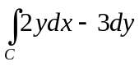, where C is the ellipse parametrized counterclockwise by for 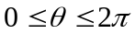

2. Find a potential function for

3. Find the work 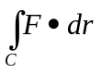 done by the force 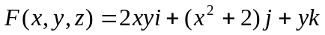 on an object moving along the line segment from (1,0,2) to (3,4,1)

4. Use Green's Theorem to evaluate the line integral 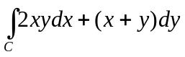
C: boundary of the region lying between the graphs of 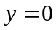 and 