Title of the Paper – Centered,
More Than One Line if Necessary (font 17)

First A. Author¹, Second B. Author¹ and Third C. Author² (12)

¹University/Company, City, Country (11)
²University/Company, City, Country (11)

Text of the Abstract goes first – about 5 to 10 lines clearly stating the state of the field and your contribution. Highlight one-two major results. (Use font 11 for the Abstract.)

Introduction (12)

The text of the paper (single spacing, font 12) follows the Abstract. Divide the text into sections to improve its readability and clarity. Do not change the page setup of this template (Letter paper size, 1.1″ top, 1″ bottom, left and right margins); do not exceed 6 pages. All illustrations will be reproduced in full color, however, try to avoid using light colors (yellow, light blue, etc.) as well as too small symbols/letters/numbers in the graphical material.
In this section, clearly explain what this paper is all about – what was the problem, how you dealt with it, and what you did. Provide references to your predecessors/prior publications in order to highlight your contribution compared to what was done before/by others.
Refer to publications in the References section below by a number in brackets [1], [2] and follow the suggested format for the referred books and papers.

Technique

Consider this publication as an extended summary in the format which appears to be most suitable for your material – something that you would like the participants to remember about your Seminar talk back home. As such, it is up to the authors to make it short, long (up to 6 pages), loaded with many (or, with minimum) specific results, etc. It is, however, important to make each paper a constructive and informative input capable of producing fruitful and useful seminar (and post-seminar) discussions.
Also, keep in mind that after the meeting, a PDF version of your paper will be put on the seminar web site and could be downloaded by interested viewers.

Results

Place figures and any graphical illustrations on the top (like Fig. 1) or on the bottom of the page rather than in the center between the lines.
It would be a good idea to provide the presented results with sufficient amount of related details – e.g., computational resources (RAM, CPU time, etc.) required for simulations, important practical features of the experimentation performed – especially if these details make your work different from the works of others.
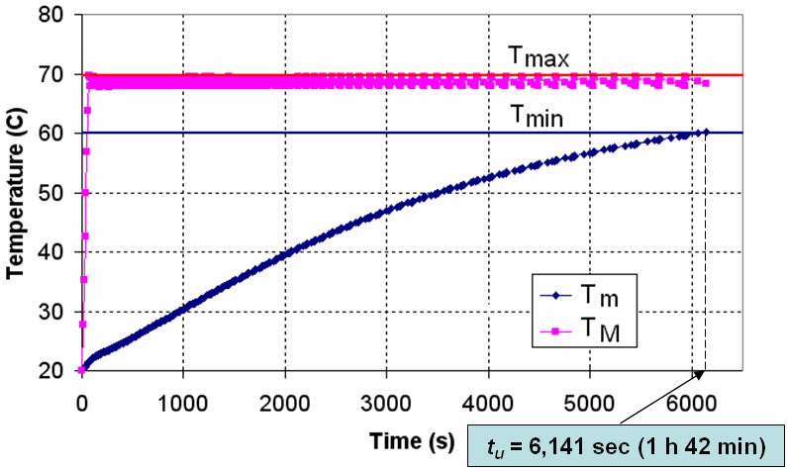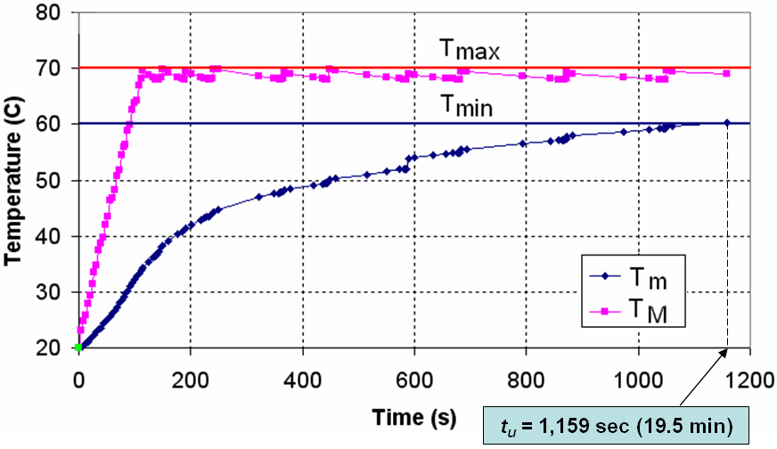
(a) (b)

Fig. 1. Characteristic of heating processes using a pulsing regime (a) and the optimization technique (b)

Conclusion

Publication of the Seminar proceedings is arranged solely with the purpose of making the Seminar output more productive and constructive. The papers will not be copyrighted, so no permission for repeated use of the material will be necessary. Furthermore, it is not expected that your materials will be published at this forum for the first time. It is rather important to clearly describe the innovative nature of your approaches and the originality of your accomplishments with respect to the topics of the Seminar.

References

- R.L. Ramey and T.S. Lewis, Properties of thin metal films at microwave frequencies, J. Appl. Phys., vol. 39, no 2, pp. 1747-1752, 1968.
- J.D. Jackson, Classical Electrodynamics, Wiley, N.Y., 1998.

