Rbd 4/6/26
Step by Step instructions on verifying reads and writes to dual port memory with XSCT debugger
- After installing tools on linux and building the with the xsa in vitis we are ready to proceed with
Debugging the dual port memory

- Open up a terminal
- $: source /tools/Xilinx/Vitis/2022.2/settings64.sh
- hw_server
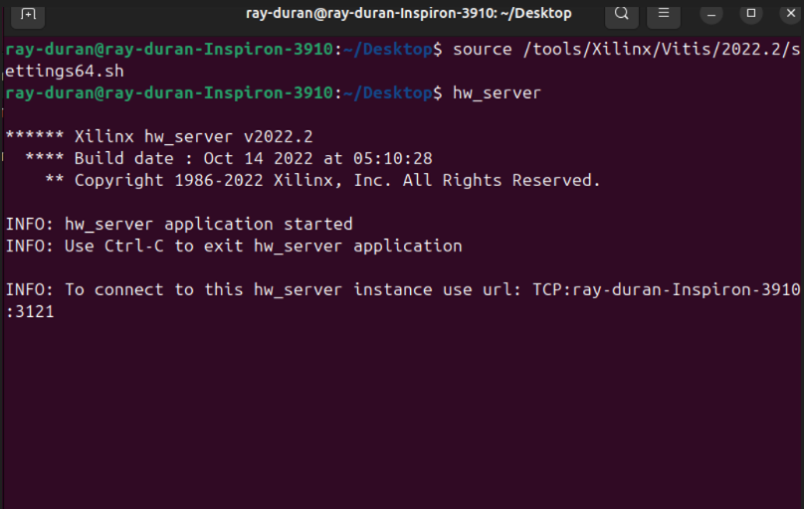

- Open up another terminal in linux
- At bash $: export TERM = xterm
- $: source /tools/Xilinx/Vitis/2022.2/settings64.sh
- $: xsct
- connect
- On terminal 1
- $: jtag targets ( Find the one that references PL)
- Pick PL target
- $: fpga -file /home/path/to_your/bitfile.bit
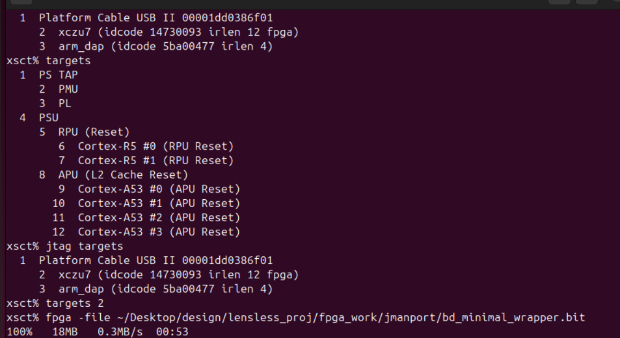
- Make the PMU MicroBlaze visible
- $: targets -set -filter {name =~ "PSU"}
- $: mwr 0xffca0038 0x1ff
- $: after 500
- Confirm MicroBlaze PMU now appears
- $: targets
- Load and run PMU firmware
- $: targets -set -filter {name =~ "MicroBlaze PMU"}
- $: dow /home/ray-duran/workspace/zcu104_hw_dpmem_platform/export/zcu104_hw_dpmem_platform/sw/zcu104_hw_dpmem_platform/boot/pmufw.elf
- $: con
- $: after 500
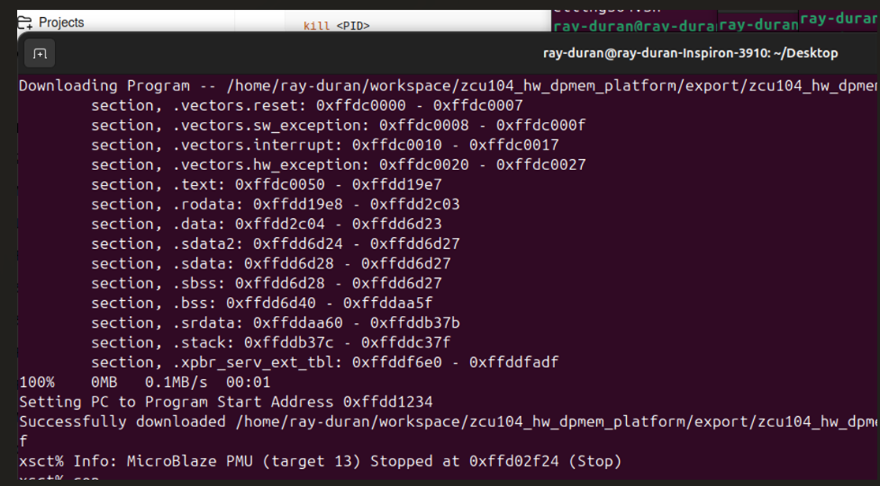
- Reset, load, and run FSBL on A53 #0
- $: targets -set -filter {name =~ "Cortex-A53 #0"}
- $: rst -processor
- $: dow /home/ray-duran/Desktop/zcu104_hw_dpmem_platform/export/zcu104_hw_dpmem_platform/sw/zcu104_hw_dpmem_platform/boot/fsbl.elf
- $: con
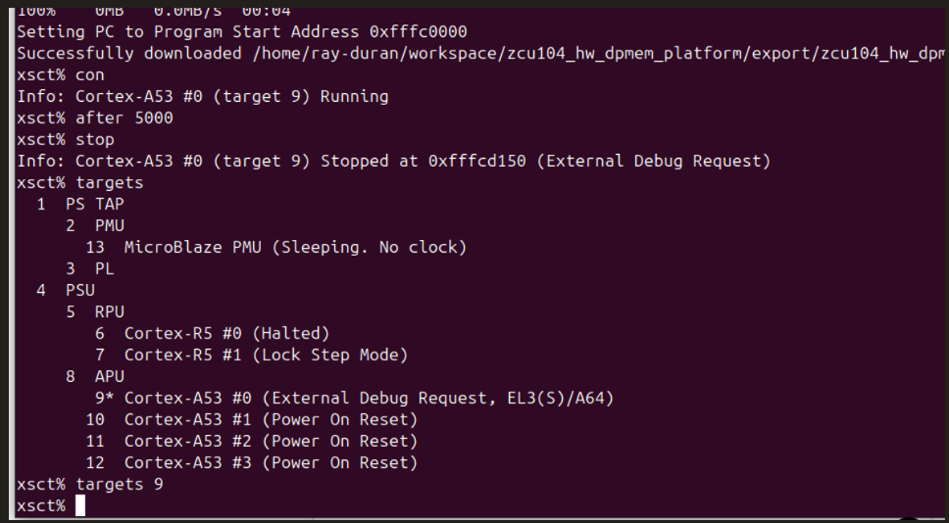
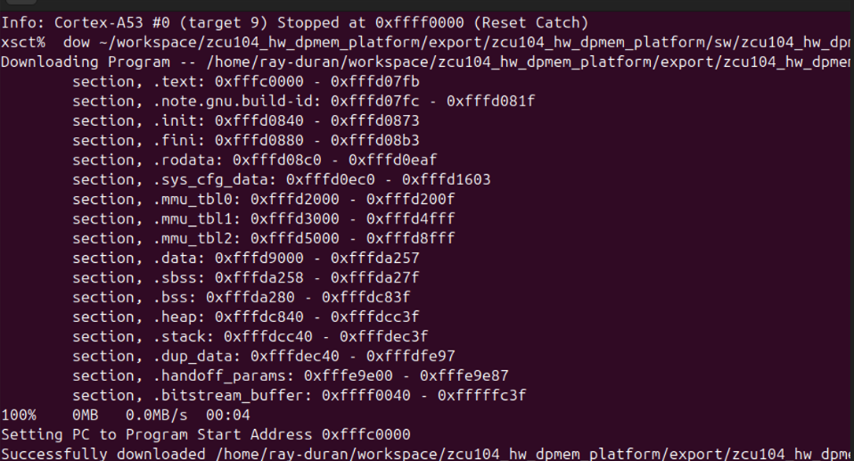
- Give FSBL time to initialize the PS/DDR/interconnect
- $: after 5000
- Halt the A53 so XSCT is back under debugger control
- $: stop
- Retarget the A53( should already be there, this is just being cautious)
- $: targets ( Fond one that targets A53 #0)
- $: targets 10 ( As an example)
- $: memmap -addr 0xA0000000 -size 0x1000 ( This is the size of our space 4K)

- Do one write sequence
- $: mwr 0xA0000000 0x00000003 ( Reg 0 : This sets write enable)
- $: mwr 0xA0000004 0x00080000 ( Reg 1: Upper 16 bit are for Mem A)
- $: mwr 0xA0000008 0x12345678 ( Reg 2: Our Data)
- Do one read back sequence
- $: mwr 0xA0000000 0x00000004 ( Reg 0: This sets read enable)
- $: mwr 0xA0000004 0x00080000 ( Reg 1: Upper 16 bits are for Meme A)
- $: mrd 0xA000000C ( Reg 3: This should return 0x12345678)
