Factorial

$$\left[symbol\right]$$

$$n!$$

$$\left[def\right]$$

$$Let^{'}s take it into two domains.$$

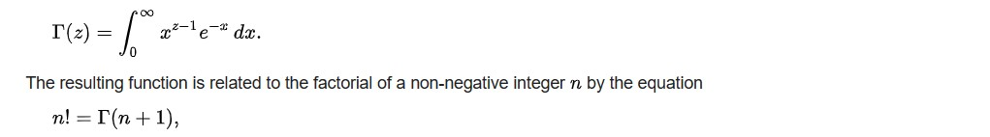

$$For any real number n,$$

$$n!$$

$$is equivalent to$$

$$Γ\left(n+1\right)$$

$$and$$

$$\int_{0}^{∞}{x^{n}e^{-x}dx}$$

$$For nonnegative integer n,$$

$$n!$$

$$can be written as$$

$$n!=n*\left(n-1\right)*\left(n-2\right)*…*\left(1\right)$$

$$It also can be written recursively as$$

$$n!=\left\{\begin{aligned}n*\left(n-1\right)!for all n>0 \\ 1 , for n==0\end{aligned}\right.$$

Ref:

[Factorial - Wikipedia](https://en.wikipedia.org/wiki/Factorial)