Math Problem – Magic Puzzle

$$Q1:$$

$$Solve the magic puzzle.$$

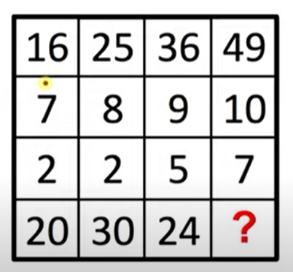

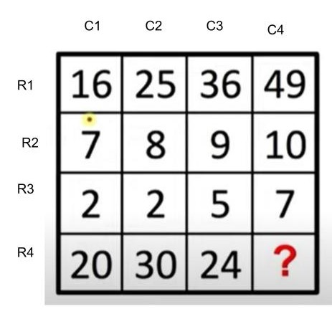

$$A1:$$

$$\sqrt{49}*\left(10-7\right)=21$$

$$method:$$

$$Recall that$$

$$a row contains horizontal elements and$$

$$a column contains vertical elements.$$

$$Shown as above figure.$$

$$Observe it and we can found the expression.$$

$$R_{4}C_{i}=\sqrt{R_{1}C_{i}}*\left(R_{2}C_{i}-R_{3}C_{i}\right)$$

$$Thus$$

$$?=R_{4}C_{4}=\sqrt{R_{1}C_{4}}*\left(R_{2}C_{4}-R_{3}C_{4}\right)=\sqrt{49}*\left(10-7\right)=21$$

Ref:

[Can you solve this Logic Puzzle in 1 Minute? | Fast & Easy Trick - YouTube](https://www.youtube.com/watch?v=KnGzXRA_1cw)



$$Q2:$$

$$Solve the magic puzzle.$$

$$A2:$$

$$\left(first ?,second ?\right)=\left(344,342\right)$$

$$There are too many ways to find patterns.$$

$$The video \left(given in the following link\right) talks about method 1$$

$$And I came up with method 2.$$

$$Let^{'}s get started.$$

$$Here, we started at index 1.$$

$$Suppose the array is called A.$$

$$method 1:$$

$$For even-indexed column,$$

$$its value is same as the value of previous index minus 2.$$

$$A\left[i\right]=A\left[i-1\right]-2$$

$$for all i=2k and i is in range$$

$$where k is a positive integer.$$

$$For odd-indexed column,$$

$$The difference between its value and$$

$$its value of previous two are 4,16,64,256,…respectively$$

$$which is a geometric sequence with ratio 4.$$

$$A\left[1\right]=4,$$

$$A\left[i\right]=A\left[i-2\right]+4^{\frac{i-1}{2}}$$

$$for all i=2k+1 and i is in range$$

$$where k is a positive integer.$$

$$Thus,$$

$$A\left[3\right]=A\left[1\right]+4^{\frac{3-1}{2}}=8$$

$$=>A\left[5\right]=A\left[3\right]+4^{\frac{5-1}{2}}=24$$

$$=>A\left[7\right]=A\left[5\right]+4^{\frac{7-1}{2}}=88$$

$$=>A\left[9\right]=A\left[7\right]+4^{\frac{9-1}{2}}=344$$

$$and$$

$$A\left[10\right]=A\left[9\right]-2=342$$

$$\left(A\left[9\right],A\left[10\right]\right)=\left(344,342\right)$$

$$method 2:$$

$$For even-indexed column,$$

$$its value is same as the value of previous index minus 2.$$

$$A\left[i\right]=A\left[i-1\right]-2$$

$$for all i=2k and i is in range$$

$$where k is a positive integer.$$

$$For odd-indexed column,$$

$$A\left[1\right]=4,$$

$$A\left[i\right]=A\left[i-1\right]*4$$

$$for all i=2k+1 and i is in range$$

$$where k is a positive integer.$$

$$Thus,$$

$$A\left[2\right]=A\left[1\right]-2=2$$

$$=> A\left[3\right]=A\left[2\right]*4=8$$

$$=>A\left[4\right]=A\left[3\right]-2=6$$

$$=>A\left[5\right]=A\left[4\right]*4=24$$

$$=>A\left[6\right]=A\left[5\right]-2=22$$

$$=>A\left[7\right]=A\left[6\right]*4=88$$

$$=>A\left[8\right]=A\left[7\right]-2=86$$

$$=>A\left[9\right]=A\left[8\right]*4=344$$

$$=>A\left[10\right]=A\left[9\right]-2=342$$

$$\left(A\left[9\right],A\left[10\right]\right)=\left(344,342\right)$$

Ref:

[Can You Solve this Logic Puzzle? | Step-by-Step Tutorial - YouTube](https://www.youtube.com/watch?v=hL1m-uhKPKg)

$$Q3:$$

$$Solve the magic puzzle.$$

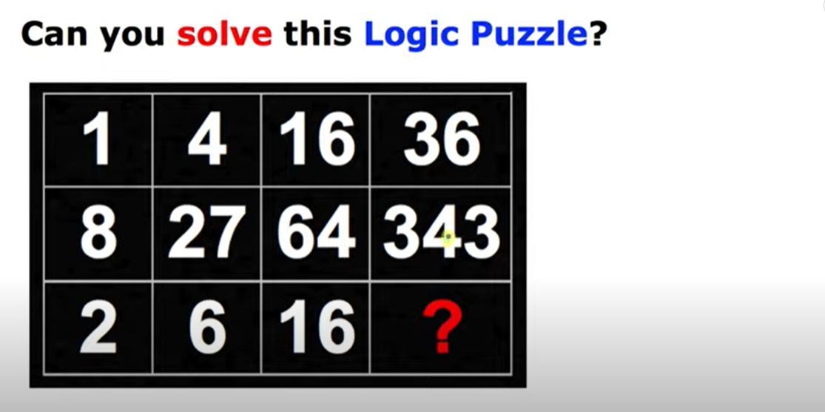

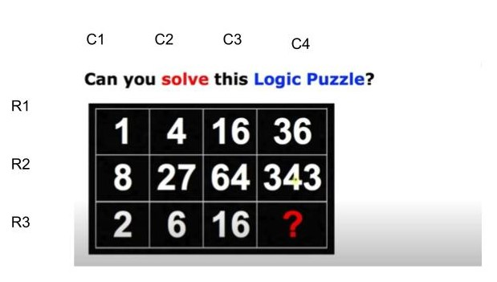

$$A3:$$

$$\sqrt{36}*\sqrt[3]{343}=42$$

$$method:$$

$$Recall that$$

$$a row contains horizontal elements and$$

$$a column contains vertical elements.$$

$$Shown as above figure.$$

$$Observe it and we can found the expression.$$

$$R_{3}C_{i}=\sqrt{R_{1}C_{i}}*\sqrt[3]{R_{2}C_{i}}$$

$$Thus,$$

$$R_{3}C_{4}=\sqrt{R_{1}C_{4}}*\sqrt[3]{R_{2}C_{4}}$$

$$=\sqrt{36}*\sqrt[3]{343}$$

$$=42$$

Ref:

[Can You Solve This Difficult Puzzle? | Brain Teaser - YouTube](https://www.youtube.com/watch?v=8mvGMLvLIRA&t=1s)



$$Q4:$$

$$Solve the magic puzzle.$$

$$A4:$$

$$\left(first ?,second ?\right)=\left(12,16\right)$$

$$method:$$

$$The value of ith index is the ith prime minus 1.$$

$$i.e. A\left[i\right]=Prime\left[i\right]-1.$$

$$where A is an array for the problem and$$

$$Prime is an array for prime numbers.$$

$$Prime=\left[2,3,5,7,11,13,17,19,…\right]$$

$$A\left[6\right]=Prime\left[6\right]-1=12 and$$

$$A\left[7\right]=Prime\left[7\right]-1=16$$

$$\left(A\left[6\right],A\left[7\right]\right)=(12,16)$$

Ref:

[Can you solve this Eureka Puzzle? - YouTube](https://www.youtube.com/watch?v=f7u6QcABGTs)

$$Q5:$$

$$Solve the magic puzzle.$$

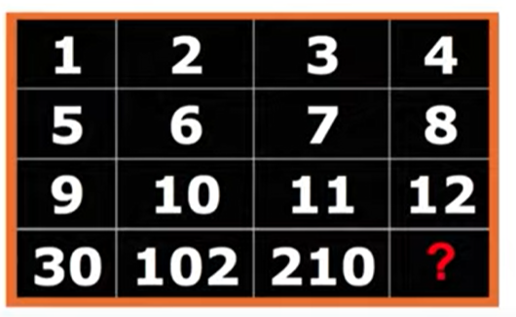

$$A5:$$

$$4*8*12-\left(4+8+12\right)=360$$

$$method:$$

$$Observe that$$

$$R_{4}C_{i}=R_{1}C_{i}*R_{2}C_{i}*R_{3}C_{i}-\left(R_{1}C_{i}+R_{2}C_{i}+R_{3}C_{i}\right)$$

$$Thus,$$

$$R_{4}C_{4}=R_{1}C_{4}*R_{2}C_{4}*R_{3}C_{4}-\left(R_{1}C_{4}+R_{2}C_{4}+R_{3}C_{4}\right)$$

$$=4*8*12-\left(4+8+12\right)=384-24=360$$

Ref:

[Can You Solve This Logic Puzzle? | Fast & Easy Explanation - YouTube](https://www.youtube.com/watch?v=K5_V2OKHphE)



$$Q6:$$

$$Solve the magic puzzle.$$

$$A6:$$

$$220*5-5=1095$$

$$method:$$

$$Observe that$$

$$A\left[1\right]=3,$$

$$A\left[i\right]=A\left[i-1\right]*\%-5 for all i is an integer, i≥2.$$

$$Thus,$$

$$A\left[5\right]=A\left[4\right]*5-5=1095$$

Ref:

[Test Your Brain | Solve this Puzzle - YouTube](https://www.youtube.com/watch?v=RY9SjRioMe0)