Math Problem – Magic Puzzle



$$Q1:$$

$$Solve the combo puzzle.$$

$$A1:$$

$$13N$$

$$method:$$

$$Let^{'}s take into two parts.$$

$$First, we focus on the number.$$

$$The sequence is$$

$$\left[3,4,6,9,x\right]$$

$$the difference of this element to next element is$$

$$\left[1,2,3,x-9\right]$$

$$which is an arithmetic sequence$$

$$\left(one-level arithmetic sequence\right).$$

$$Thus, \left(x-9\right) should be 4 which implies that$$

$$x=13.$$

$$Here the sequence$$

$$\left[3,4,6,9,x\right]$$

$$is a two-level arithmetic series\left(二階等差數列\right)$$

$$since the sequence which consists of$$

$$difference of the this element and next element.$$

$$are an arithmetic sequence.$$

$$Next, we focus on the alphabet.$$

$$The sequence is$$

$$\left[B,E,H,K,y\right]$$

$$Here, we can find that there are two missing alphabets$$

$$between this element and next element.$$

$$Thus, y should be N.$$

$$NOTE:$$

$$If we convert it into number using ASCII, then$$

$$the sequence is an arithmetic sequence.$$

$$Combine these two facts, we can conclude that$$

$$?=13N$$

Ref:

[Solve this Challenging Combination Puzzle - YouTube](https://www.youtube.com/watch?v=bxktsaH65SQ)

$$Q2:$$

$$Solve the magic puzzle.$$

$$What number should be in '?'?$$

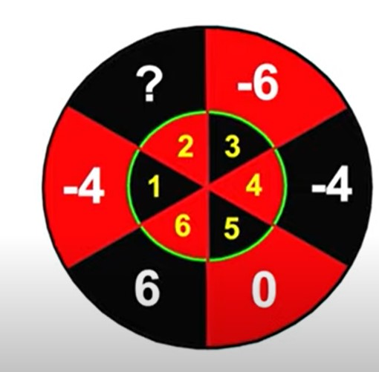

$$A2:$$

$$-6$$

$$method:$$

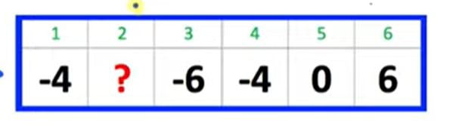

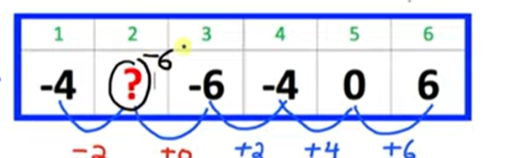

Ref:

[Can You Solve this Dartboard Logic Puzzle? | Easy Explanation - YouTube](https://www.youtube.com/watch?v=ttM2Uz3udLg)

$$Q3:$$

$$Solve the magic puzzle.$$

$$What number should be in '?'?$$

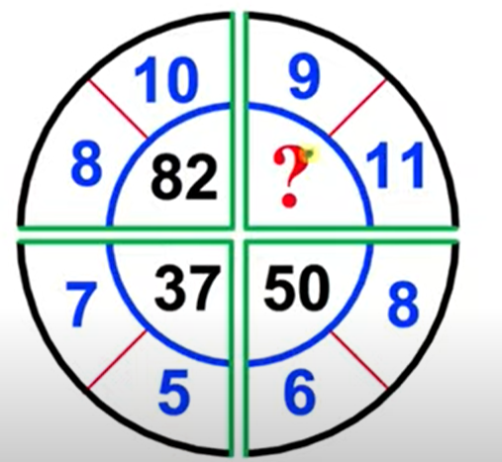

$$A3:$$

$$101$$

$$method 1:$$

$$Look at the figure. A piece is a pattern.$$

$$In each pattern, we can observe that$$

$$the internal number is the product of the other two$$

$$then plus 2.$$

$$Given the other two numbers$$

$$\left(x,y\right)$$

$$the internal number is \left(xy+2\right)$$

$$For convention, we combine them together,$$

$$making a tuple$$

$$\left(x,y,xy+2\right)$$

$$method 2:$$

$$\left(x,y,\frac{x^{2}+y^{2}}{2}\right)$$

$$Here, we found that we can get same result$$

$$in method 1 and method 2.Why?$$

$$Are they accident?or they are equivalent?$$

$$In most case, they are NOT equivalent.$$

$$i.e. xy+2 and \frac{x^{2}+y^{2}}{2} will NOT get same result.$$

$$However, if either y=x+2 or x=y+2, then$$

$$they will get same result.$$

$$To prove it, just replace y with x \left(or x with y\right).$$

$$If x=y+2, then$$

$$xy+2=\left(y+2\right)*y+2=y^{2}+2y+2$$

$$and$$

$$\frac{x^{2}+y^{2}}{2}=\frac{{\left(y+2\right)}^{2}+y^{2}}{2}=\frac{y^{2}+2y+4+y^{2}}{2}=y^{2}+2y+2$$

Ref:

[Can You Solve this Dartboard Puzzle? - YouTube](https://www.youtube.com/watch?v=9vIwW9zq7cE)

$$Q4:$$

$$Solve the magic puzzle.$$

$$What number should be in '?'?$$

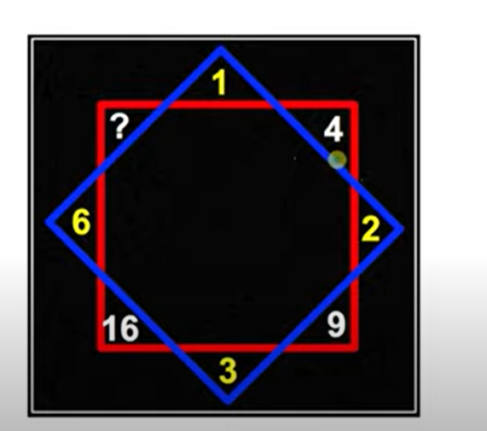

$$A4:$$

$$49$$

$$method:$$

$$\left(x,{\left(x+1\right)}^{2} \right)$$

$$Thus, the question mark should be$$

$${\left(6+1\right)}^{2}=49$$

Ref:

[Can You Solve this Octagram Puzzle? - YouTube](https://www.youtube.com/watch?v=moGRfs3p37c)

$$Q4:$$

$$Solve the magic puzzle.$$

$$What number should be in '???'?$$

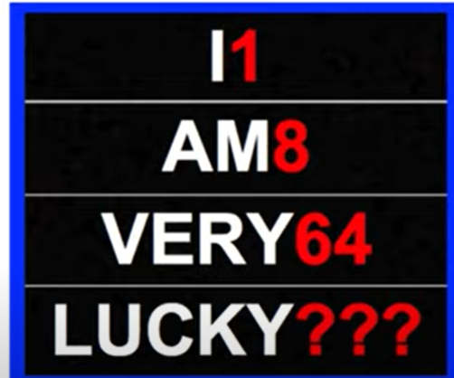

$$A5:$$

$$125$$

$$method:$$

$$number={\left(The number of digit in this word\right)}^{3}$$

$$Thus, in 4th row,$$

$$the answer=5^{3}=125.$$

Ref:

[Solve this LUCKY PUZZLE - YouTube](https://www.youtube.com/watch?v=OrP-WzZ5tk8)