Math Problem – Calculus

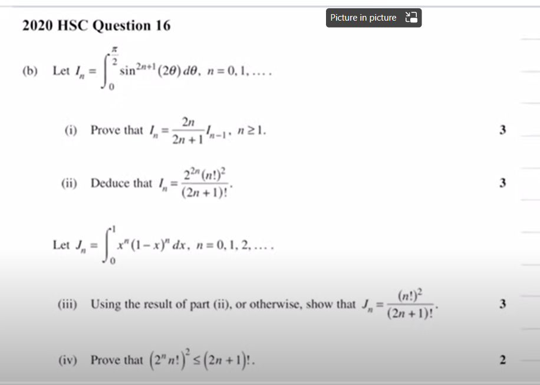

|  |  |
| --- | --- |
|  |  |
|  |  |
|  |  |

|  |  |
| --- | --- |
|  |  |
|  |  |
|  |  |

Ref:

[Recurrence Relation (4 of 6: Expressing without integrals) - YouTube](https://www.youtube.com/watch?v=tlFumJnWHYM)