Math Problem --

Evaluate an expression without calculator

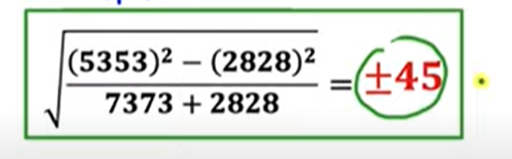





Ref:

[Solve this Puzzle | Calculators NOT Allowed | Get answer quickly by using these Tips and Tricks - YouTube](https://www.youtube.com/watch?v=wFnWAbmqz6Y)

Ref:

[Can you solve without Calculators? | Learn this Trick to solve instantly - YouTube](https://www.youtube.com/watch?v=rUiGEiRi6j0)

Ref:

[Calculators NOT Allowed | Can you Simplify Rational Expression? | Math Olympiad Training - YouTube](https://www.youtube.com/watch?v=psOR9vqbL6U)

Ref:

[Calculators NOT Allowed! | Simplify this Radical if You're a GENIUS! | - YouTube](https://www.youtube.com/watch?v=IwCxVsLZd08)