Math Problem -- Evaluate an expression without calculator

$$Q1:$$

$$Evaluate the expression without calculator.$$

$$Calculators are NOT allowed.$$

$$\sqrt{7}\sqrt{8}÷\sqrt{8}\sqrt{7}$$

$$A1:$$

$$7$$

$$P.S.$$

$$The answer may amaze you.$$

$$You may think the answer is 1.$$

$$Since you may think that$$

$$\sqrt{7}\sqrt{8}÷\sqrt{8}\sqrt{7}$$

$$=\left(\sqrt{7}\sqrt{8}\right)÷\left(\sqrt{8}\sqrt{7}\right)$$

$$=\left(\left(\sqrt{7}\right)*\left(\sqrt{8}\right)\right)÷\left(\left(\sqrt{8}\right)*\left(\sqrt{7}\right)\right)$$

$$=1$$

$$Honestly said, I think the answer is 1 at first.$$

$$Prequisite:$$

$$1.The order of basic operations.$$

$$The following figure illustrates$$

$$the order of basic operations.$$

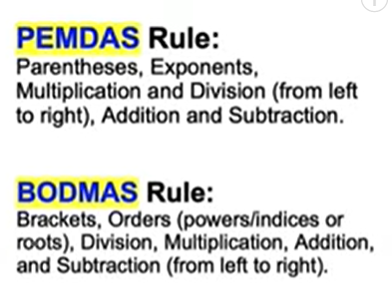

$$method:$$

$$\sqrt{7}\sqrt{8}÷\sqrt{8}\sqrt{7}$$

$$=\left(\sqrt{7}\sqrt{8}÷\sqrt{8}\right)*\left(\sqrt{7}\right)$$

$$=\left(\left(\sqrt{7}\right)*\left(\sqrt{8}\right)÷\left(\sqrt{8}\right)\right)*\left(\sqrt{7}\right)$$

$$=\left(\sqrt{7}\right)*\left(\sqrt{7}\right)$$

$$=7$$

Ref:

[Can you simplify Radical Problem? | Calculators Not Allowed | College Entrance Question - YouTube](https://www.youtube.com/watch?v=Eg6URFoBqg0)