Math Problem – Funny Puzzle

$$Q1:$$

$$Solve the funny puzzle.$$

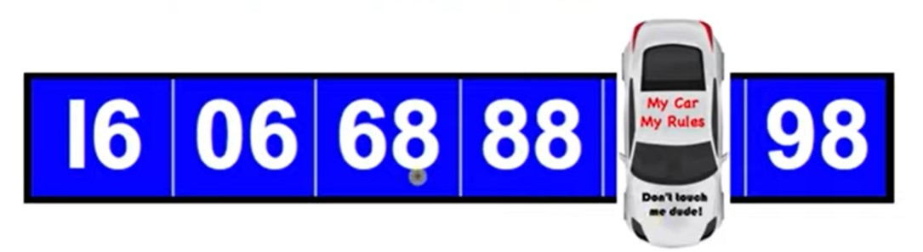

$$A1:$$

$$87$$

$$method:$$

$$It^{'}s tricky.$$

$$Flip the figure in Y axis.$$

$$Illustrated in the following figure.$$

$$I believe you can solve this problem.$$

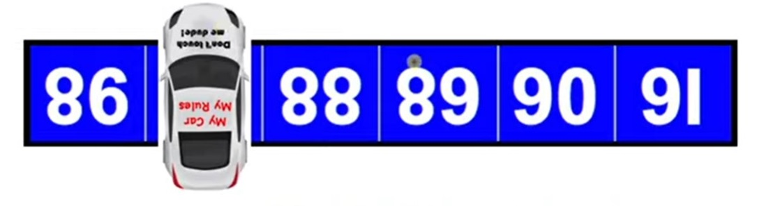

Ref:

[What Number is Hidden Underneath the Car? | Math Puzzle! - YouTube](https://www.youtube.com/watch?v=-P6JcvYbSN0)