Math Problem -- Geometry

$$Q1:$$

$$Solve the length x.$$

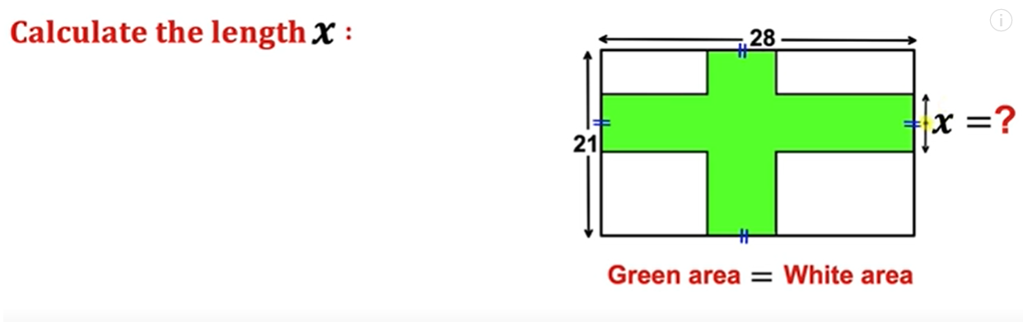

$$A1:$$

$$method:$$

$$Total area=21*28$$

$$Green area=21*28*\frac{1}{2}=294$$

$$The green area also can be represented as$$

$$21x+28x-x*x$$

$$Thus,we have the equation$$

$$21x+28x-x*x=294$$

$$=>x^{2}-49x+294=0$$

$$=>\left(x-7\right)*\left(x-42\right)=0$$

$$=>x=7 or x=42$$

$$(But x=42 is invalid$$

$$since the length of the biggest rectangle is 21)$$

Ref:

[Can you find the length x? | Green area = White area | Important Geometry skills explained - YouTube](https://www.youtube.com/watch?v=r7_w-t4QSik)