Math Problem – Logic test

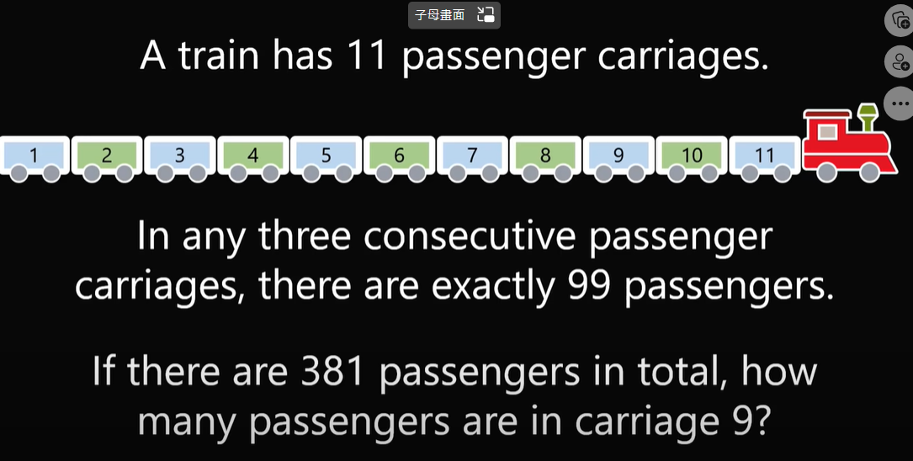





Ref:

[Logic test - how many passengers in carriage 9? - YouTube](https://www.youtube.com/watch?v=-rbozrj9poo)