Roman Number



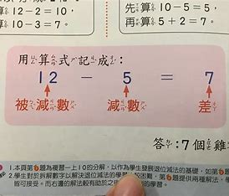

Ref:

The source of the first figure:

[Dare to Solve this Roman Numeral Math Problem | Step-by-Step Tutorial - YouTube](https://www.youtube.com/watch?v=_xOMJ91Lk6Y)

Details about roman numerals:

[Roman numerals - Wikipedia](https://en.wikipedia.org/wiki/Roman_numerals)

Roman Converter:

[Roman Numeral Converter: What is 11 in Roman Numbers? (timeanddate.com)](https://www.timeanddate.com/date/roman-calculator.html?arabic=11)