Case 1: Sales Performance Analysis
Company Background
TechSupply Co. is a regional distributor that sells electronics, office supplies, and office furniture to both retail and business customers. Management wants to better understand sales trends, customer purchasing behavior, and regional performance to improve future sales strategies.
You have been hired as a junior data analyst to explore the sales dataset and provide insights. Your task is to use Excel filtering and sorting tools to answer business questions and provide recommendations.
Dataset: use the techsupply_dataset.xlsx
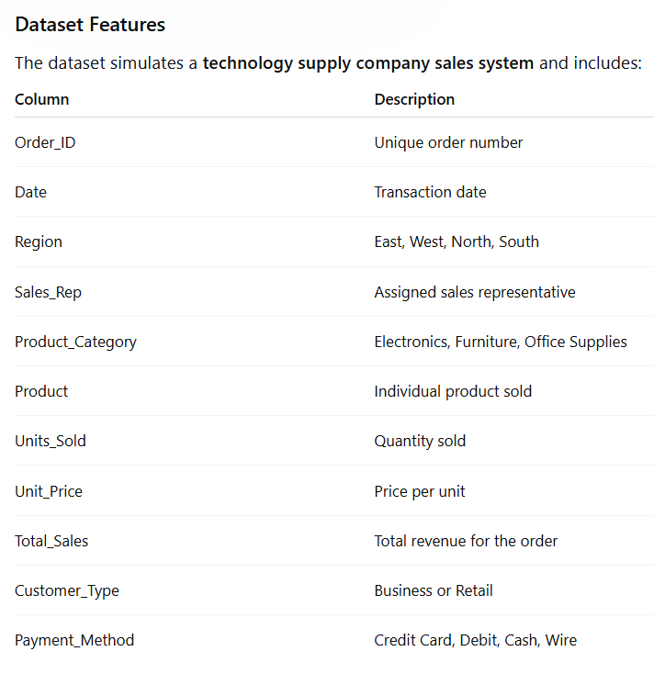

Complete the following 5 tasks.
REGIONAL PERFORMANCE ANALYSIS
Task 1: Use filters to explore sales by region.
- Filter by Region = East
- Sort Total_Sales from Largest to Smallest
Questions:
- What is the largest sale in the East region?
The largest sales in the East region is 52,950
- Which product category appears most frequently?
The category that appears most frequently is Electronics
- Which sales representative appears most often?
The sales representatives that appear most often are Johnson and Brown.
CUSTOMER BEHAVIOR ANALYSIS
Task 2: Filter by
- Customer_Type = Business
Questions
- Which product category do business customers purchase most often?
Business customers purchase office supplies more often
- What is the largest business transaction?
The largest business transaction is Order 2290
- Which sales rep handles the most business orders?
The sales reps that handled the most business orders are Lopez and Brown.
PRODUCT PERFORMANCE
Task 3: Use filters to analyze Product_Category.
Analyze each category separately:
- Electronics
- Furniture
- Office Supplies
Questions
- Which category appears to generate the highest total sales?
The category that generates the most sales is furniture.
- Which specific product appears most frequently?
The products that appear most frequently are Filing Cabinet, Notebooks, and Printer Paper.
- Which category tends to have the largest individual transactions?
The category that has the largest individual transactions is office supplies
PAYMENT PATTERN ANALYSIS
Task 4: Filter by Payment_Method
Analyze:
- Credit Card
- Debit
- Cash
- Wire
Questions
- Which payment method is used most frequently?
Credit card is the payment method used most frequently.
- Do business customers prefer a specific payment type?
Business customers seem to prefer debit payments.
- Which payment type is associated with larger purchases?
Wire appears to be the payment type associated with larger purchases.
TOP SALES REPRESENTATIVES
Task 5: Sort by:
- Sales_Rep
- Total_Sales(Largset > Smallest)
Questions
- Which sales rep appears to handle high-value transactions?
Singh appears to be handling the high-value transactions.
- Which rep appears most frequently in the dataset?
Brown appears the most frequent in the dataset.
- Which region do they appear to sell in most often?
They appear to be selling the most in the east.
ANALYST RECOMMENDATION
Imagine you are presenting your findings to management.
Answer the following:
- Which region appears to be the strongest market?
The region that appears to be the strongest market is the east.
- Which product category should the company promote more?
Furniture is the category that the company should promote more.
- Are business customers or retail customers more valuable?
Retail customers are more valuable because they generate higher sales.
- What two recommendations would you give the sales manager?
Two recommendations I would give are increasing supply of electronics in the eastern region and promoting Brown to a lead position.

Bonus
Build
- Bar Chart – Sales by Product Category
- Pie Chart – Customer Type Distribution
- Column Chart – Sales by Region
What story does the data tell?

