## Lightsheet preparation

1. Ensure **lens adapter** is on the lens.  
   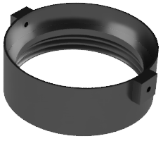  
   Double check that the **set screws** are **facing** the **sides or front/back**.
2. Install **dipping cap** on threaded **cylinder** and tighten **set screw**.  
   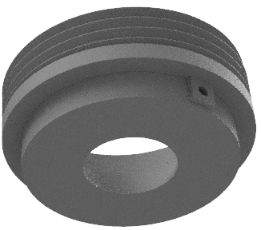
3. **Screw assembly** all the way into the adapter.
4. Turn ON the **laser**.
5. Turn ON the **motors**.
6. Turn ON the **camera**.
7. Open **ImSpector** and import your **template**.

## Stage preparation

1. Fill cuvette with **oil** until the **plastic guide**.
2. **Install cuvette** in the lightsheet cavity.
3. Install **metal plate** and tightenthe **side** **screw**.
4. Place the **Tank** on the metal plate and 2 posts:
   * Use the **2 thumb** **screws** on the 2 **posts**.
   * Use the **2** **screws** on the metal **plate**.

## ImSpector preparation

The first time you open the software:

1. Ensure the stage, laser, and camera are **powered ON**.
2. Open **ImSpector**.
3. Go to **File -> Open / Import -> Open Template** and **import** _________________________________.
4. Ensure **Instrument mode** is “Zoom Body”.  
   
5. Select the **liquid** (bug workaround). Go to the Measurement tab -> Sample -> Liquid. Even if your liquid is already selected (e.g. DBE), **change** it to another (e.g. Clarity) and then **change** it back to your liquid (e.g. DBE). If your liquid is not already selected, do it twice to be safe.  
   

## Sample & Imaging preparation

1. **Soak** the **mold** with the **brain** in **oil** for 10 min.
2. **Remove the previous** sample from lightsheet if necessary (see section).
3. **Install** the **mold** into the **holder**. Set the 2 set screws.
4. Move the **platform down** and to the **front** to make room. Rotate lens out of the way.
5. Place the **holder on the platform** and into the oil in the correct **orientation**. Rotate lens back to center.
6. Lightly install the **2 holder thumb screws**.
7. Check brain is **fully visible** in **Z**:
   1. Select the **488nm** laser, set its power to **7%**.  
      
   2. Turn ON **preview**. Use either left or right sheet.  
      
   3. Move the **sample up/down** to ensure you can see the **full brain**. Adjust the height of the holder otherwise.
   4. **Leave** sample in Z where **mid-brain is visible**.
8. Position lens and verify full brain is visible**:**
   1. **Lower the lens**, looking into the oil until the dipping cap is **just immersed** – you’ll see the surface **waves** at that point.
   2. Watching the **camera**, adjust the **fine focus** until mostly focused.
   3. Move the stage **up/down**, **left/right** to ensure the **full brain is visible**. Adjust position of holder if necessary.
   4. Now completely **lock** the **2 platform screws**.
9. Adjust lens until **fully focused**:
   1. Use the **right** lightsheet.
   2. While on **488nm**, adjust the lens’ **fine focus** until properly focused. Use a surface region with structure while zoomed in - for a guide.
   3. Adjust the **tube lens** for each acquired channel so it’s in focus. Use the circled button to fix the focus.
      1. **488 nm** should be at **zero**.
      2. All the **other channels** adjust as necessary. Press **“set”** after each adjustment to save.

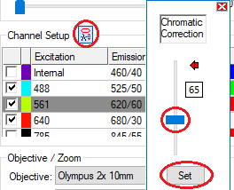

1. Verify that the **left lightsheet** is also focused:
   1. Check that the **left sheet** is **focused** and of similar strength (same order of **magnitude**).
   2. Using a cell channel (e.g. 561, 640) verify you see the **same cells** for both lightsheets.
   3. If there are issues, do the left **lightsheet alignment section** or contact the staff.



1. Set **Z**-range:  
   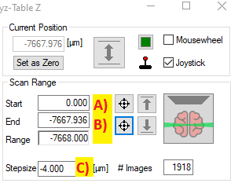  
   If you hit the **end of range** of the motors during either step, redo a-b.
   1. Move stage **DOWN** until just past the **top** of the brain. Set the **start** position there and press “Set as Zero”.
   2. Move stage **UP** until just past the **bottom** of the brain. Set the **end** position there.
   3. Set the **step-size** to ___________.
2. Set the **X, Y** range.  
   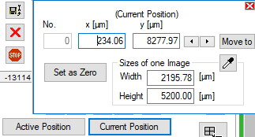
   1. **Zoom out** fully with the icon
   2. Move the stage to the **(left, right),** and **(bottom, top)** of the brain and note their **X, Y** coordinates from the “**Current Position**” window, respectively.  
        
      If you hit the **end of range** of the motors, start again.
3. Set **parameters**.
   1. Set **exposure** to ___________.
   2. Set **sheet NA** to ___________.
   3. Set **sheet width** to ___________%.
   4. Set **laser power** to:  
        
      405 nm: ____________.  
      488 nm: ____________.  
      561 nm: ____________.  
      640 nm: ____________.  
      785 nm: ____________.
   5. **Camera ROI** top-right, bottom-left coordinates should be:  
      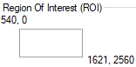  
      ____________________________  
      ____________________________.
   6. **Measurement** mode:  
      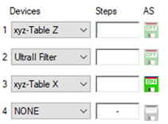
      1. **Mode** is “Multicolor Multiposition acquisition”.
      2. **Devices** order is: Table Z, Filter, Table X, NONE.
      3. **Autosave** should only be set for the last device – “Table X”.
   7. **Objective** and **zoom** should be:  
      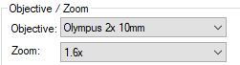  
      Objective: _______________________.  
      Zoom: __________________________.

## Sample removal

To remove the sample from the lightsheet:

1. Remove the **2 holder thumb screws**.
2. Move the **platform down** and to the **front** to make room. Center it in Y.
3. Rotate **lens** out of the way making sure there’s a drip tray under the lens.
4. Remove the **holder** and loosen the 2 set screws to remove the sample.

## Aligning left lightsheet

If the left lightsheet is not in **focus**, or different cells are visible in the left and right lightsheets, then the left sheet is aligned to a different Z-plane than the right sheet. To fix it, you’ll move the left lightsheet until the cells or other features are the same as with the right lightsheet.

1. Install the **sample**. Using the right lightsheet ensure it’s properly **focused** for all channels and set the lightsheet settings as above, except the laser **power** for all the channels should be low, e.g. 7%.
2. Pick the channels with the most features (such as cells – 561/640) and using **preview** and with the **right** laser, acquire an image with those features. It should be well focused and look such as:  
   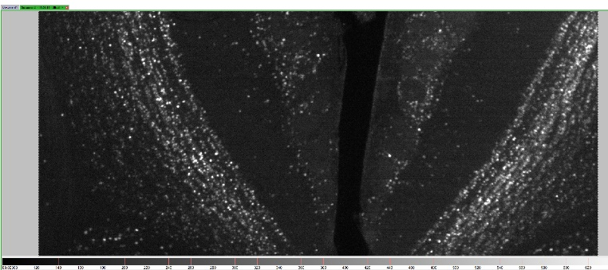
3. We’ll make a **copy** of the image so we can align to it: Right click on the title bar of the acquired image and select “**New Stack Window**”, this will split the window and open a blank image on the right.  
   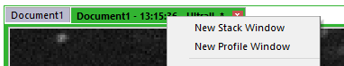
4. Right click **our** image and select “Manage Data -> **Copy** Stack”. Or do “ctrl-c”.  
   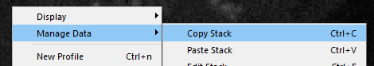
5. **Paste** the stack into the **blank** image by right clicking in it and selecting “Manage Data -> **Paste** Stack” or hitting “ctrl-v”. You should now see our image on the right as well.
6. Select the left laser and hit **preview**. You should now see the out of focus/wrong image on the **left**.  
   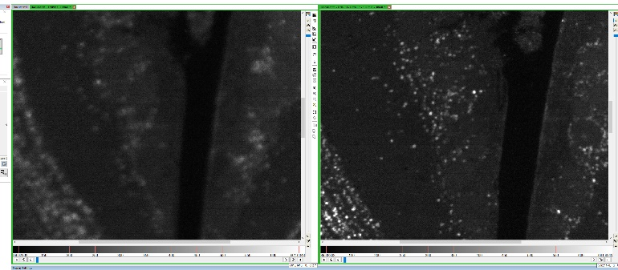
7. With the lightsheet in **preview**, use a 2mm screwdriver to adjust the left lightsheet **screw** highlighted until the left image looks like the right – with the same features/cells visible. The screw is very sensitive so be **gentle**.  
   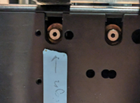
8. If necessary, also verify that the **z-projection** of the cells are circular (see section). It’s recommended at least weekly.

## Z-Projection verification

Even if the structures and cells in the images look perfectly in focus, it is possible that when looking at the cells projection in **Z** they will be smeared out. This can happen when the camera focuses correctly on the sheet in the z-direction, but the center of the lightsheet is not appropriately aligned with the center of the camera’s FOV in the x-direction (sheet-motor calibration).

These steps show how to visualize the cells in the z-direction to verify the **horizontal calibration** is correct. If it is incorrect, you’ll need to use an alignment tool to fix this. Please contact the staff for help.

1. Set up the **sample** as you would for a normal acquisition, ensuring it’s fully **focused** for all channels, and set the laser **power** low to e.g. 7%.
2. Using a channel with **cells**, **preview** and move the sample in Z until cells are clearly visible.
3. Set the z-range around this plane so as to capture a few **cells** in the **z-axis**. Such as 200um, at 4um z-step.
4. Set up the recording as if you would a normal sample and:
   1. Enable your **cell channel** and channel **488** (otherwise z-projection won’t work).
   2. Disable **autosave**.
   3. Clear all the **tiles** so a z-stack around only the current camera view is captured.  
      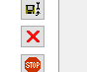
5. Press the **record** button and capture the z-stacks for the selected channels.
6. Select the cells channel, and as described in “Aligning left lightsheet” create a new stack window, copy the channel and paste it there so the channel is **duplicated**.
7. In the **duplicate** window, using the selection tool   
     
   draw a **rectangle** that is very thin in Y and long in X - just enough to contain a single cell in the y-direction.  
   
8. Using the “Analysis and Processing -> StackTools -> Crop” menu **crop** the stack to that rectangle  
   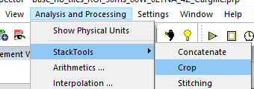
9. This should have created a new image. Select that image, fix the **contrast**, and using the **projection** window set the projection to “**Front**” and the mode to “**Maximum**”.  
   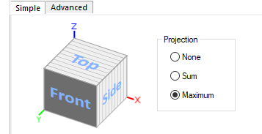
10. The **images** should now look like this.  
    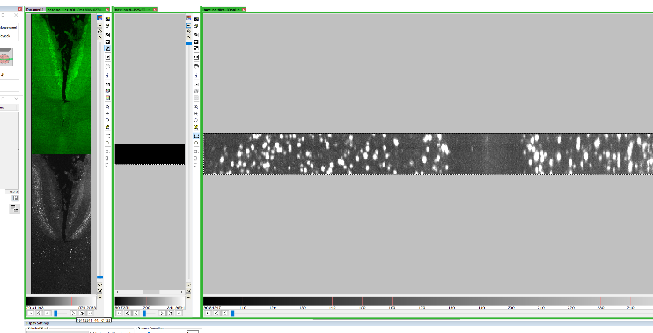
11. If the cells look approximately **circular** then the calibration is correct. Close the two newly created image tabs and you can continue to image.