Supplementary Materials
Computational evidence for a distributed AT-based regulatory mechanism enabling de novo gene birth in Pandoravirus salinus
Edward Bradford

Supplementary Table S1
Table S1. Codon usage comparison between annotated and ORFan genes: RSCU, GC3, GC12, ENC, and CAI with statistical tests.
Metric | Annotated_n | Annotated_mean | Annotated_sd | ORFan_n | ORFan_mean | ORFan_sd | Difference
GC content | 528 | 0.6502 | 0.0321 | 902 | 0.6428 | 0.0427 | +0.0074
GC3 (wobble position) | 528 | 0.7497 | 0.0574 | 902 | 0.7343 | 0.0774 | +0.0155
GC12 (constrained positions) | 528 | 0.6021 | 0.0337 | 902 | 0.5998 | 0.0428 | +0.0023
ENC (effective number of codons) | 528 | 44.9559 | 4.9847 | 902 | 45.9831 | 6.3753 | -1.0272
CAI (codon adaptation index) | 528 | 0.7913 | 0.0273 | 902 | 0.7837 | 0.0337 | +0.0075

Supplementary Table S2
Table S2. ESM-2 structural family assignments for 170 representative proteins, including tier, compositional cluster, and nearest-neighbor similarity.
Gene_ID | Structural_family | Confidence | Product | GC_content | Gene_length_bp | Start_pos | End_pos | Strand | Notes
1082 | structural_cluster_1 | 0.524 | hypothetical protein | 0.5236 | 552 | 34572 | 35123 | - | tier=A, cluster_size=53
1122 | structural_cluster_1 | 0.546 | hypothetical protein | 0.5465 | 333 | 102904 | 103236 | + | tier=A, cluster_size=53
1131 | structural_cluster_1 | 0.551 | hypothetical protein | 0.5511 | 372 | 113160 | 113531 | - | tier=A, cluster_size=53
1140 | structural_cluster_1 | 0.539 | hypothetical protein | 0.5386 | 531 | 131036 | 131566 | + | tier=A, cluster_size=53
1188 | structural_cluster_1 | 0.532 | hypothetical protein | 0.5318 | 393 | 209222 | 209614 | - | tier=A, cluster_size=53
1254 | structural_cluster_1 | 0.545 | hypothetical protein | 0.5450 | 1044 | 320553 | 321596 | + | tier=A, cluster_size=53
1325 | structural_cluster_1 | 0.536 | hypothetical protein | 0.5360 | 375 | 464920 | 465294 | - | tier=A, cluster_size=53
1328 | structural_cluster_1 | 0.525 | hypothetical protein | 0.5246 | 852 | 468298 | 469149 | + | tier=A, cluster_size=53
1329 | structural_cluster_1 | 0.558 | hypothetical protein | 0.5585 | 684 | 469447 | 470130 | + | tier=A, cluster_size=53
1338 | structural_cluster_1 | 0.564 | hypothetical protein | 0.5638 | 447 | 494215 | 494661 | + | tier=A, cluster_size=53
1356 | structural_cluster_1 | 0.521 | hypothetical protein | 0.5206 | 315 | 527479 | 527793 | - | tier=A, cluster_size=53
1394 | structural_cluster_1 | 0.522 | hypothetical protein | 0.5220 | 387 | 594682 | 595068 | - | tier=A, cluster_size=53
1407 | structural_cluster_1 | 0.542 | hypothetical protein | 0.5425 | 153 | 614585 | 614737 | - | tier=A, cluster_size=53
1448 | structural_cluster_1 | 0.524 | hypothetical protein | 0.5245 | 387 | 694291 | 694677 | + | tier=A, cluster_size=53
1478 | structural_cluster_1 | 0.559 | hypothetical protein | 0.5590 | 288 | 748176 | 748463 | + | tier=A, cluster_size=53
1520 | structural_cluster_1 | 0.497 | hypothetical protein | 0.4970 | 330 | 823500 | 823829 | - | tier=A, cluster_size=53
1551 | structural_cluster_1 | 0.556 | hypothetical protein | 0.5556 | 243 | 876417 | 876659 | - | tier=A, cluster_size=53
1635 | structural_cluster_1 | 0.550 | hypothetical protein | 0.5505 | 327 | 1018138 | 1018464 | + | tier=A, cluster_size=53
1726 | structural_cluster_1 | 0.534 | hypothetical protein | 0.5342 | 234 | 1160705 | 1160938 | + | tier=A, cluster_size=53
1773 | structural_cluster_1 | 0.551 | hypothetical protein | 0.5514 | 321 | 1253057 | 1253377 | - | tier=A, cluster_size=53
1800 | structural_cluster_1 | 0.562 | hypothetical protein | 0.5616 | 276 | 1304665 | 1304940 | + | tier=A, cluster_size=53
2002 | structural_cluster_1 | 0.564 | hypothetical protein | 0.5637 | 408 | 1655327 | 1655734 | + | tier=A, cluster_size=53
2278 | structural_cluster_1 | 0.543 | hypothetical protein | 0.5433 | 543 | 2125529 | 2126071 | + | tier=A, cluster_size=53
2281 | structural_cluster_1 | 0.541 | hypothetical protein | 0.5407 | 246 | 2130320 | 2130565 | + | tier=A, cluster_size=53
2334 | structural_cluster_1 | 0.557 | hypothetical protein | 0.5570 | 237 | 2216131 | 2216367 | + | tier=A, cluster_size=53
2341 | structural_cluster_1 | 0.592 | hypothetical protein | 0.5915 | 306 | 2229638 | 2229943 | + | tier=C, cluster_size=53
2362 | structural_cluster_1 | 0.548 | hypothetical protein | 0.5478 | 345 | 2266329 | 2266673 | + | tier=A, cluster_size=53
2365 | structural_cluster_1 | 0.530 | hypothetical protein | 0.5302 | 315 | 2270179 | 2270493 | + | tier=A, cluster_size=53
2373 | structural_cluster_1 | 0.524 | hypothetical protein | 0.5245 | 204 | 2281789 | 2281992 | - | tier=A, cluster_size=53
2401 | structural_cluster_1 | 0.604 | hypothetical protein | 0.6044 | 225 | 2325113 | 2325337 | + | tier=C, cluster_size=53
2425 | structural_cluster_1 | 0.546 | hypothetical protein | 0.5464 | 366 | 2363321 | 2363686 | + | tier=A, cluster_size=53
2465 | structural_cluster_1 | 0.533 | hypothetical protein | 0.5330 | 651 | 2436910 | 2437560 | - | tier=A, cluster_size=53
2470 | structural_cluster_1 | 0.565 | hypothetical protein | 0.5651 | 384 | 2442902 | 2443285 | + | tier=A, cluster_size=53
2473 | structural_cluster_1 | 0.545 | hypothetical protein | 0.5446 | 336 | 2445291 | 2445626 | + | tier=A, cluster_size=53
2475 | structural_cluster_1 | 0.519 | hypothetical protein | 0.5190 | 237 | 2447673 | 2447909 | - | tier=A, cluster_size=53
2477 | structural_cluster_1 | 0.488 | hypothetical protein | 0.4883 | 213 | 2449201 | 2449413 | - | tier=A, cluster_size=53
2478 | structural_cluster_1 | 0.543 | hypothetical protein | 0.5427 | 960 | 2449497 | 2450456 | - | tier=A, cluster_size=53
2479 | structural_cluster_1 | 0.544 | hypothetical protein | 0.5440 | 579 | 2451085 | 2451663 | - | tier=A, cluster_size=53
2481 | structural_cluster_1 | 0.536 | hypothetical protein | 0.5365 | 192 | 2453815 | 2454006 | - | tier=A, cluster_size=53
2483 | structural_cluster_1 | 0.514 | hypothetical protein | 0.5142 | 387 | 2455673 | 2456059 | - | tier=A, cluster_size=53
2492 | structural_cluster_1 | 0.567 | hypothetical protein | 0.5669 | 381 | 2469070 | 2469450 | + | tier=A, cluster_size=53
1173 | structural_cluster_10 | 0.606 | hypothetical protein | 0.6056 | 715 | 186765 | 187479 | - | tier=C, cluster_size=5
1516 | structural_cluster_10 | 0.566 | hypothetical protein | 0.5657 | 198 | 817589 | 817786 | - | tier=A, cluster_size=5
1945 | structural_cluster_10 | 0.678 | hypothetical protein | 0.6782 | 348 | 1545443 | 1545790 | + | tier=C, cluster_size=5
2121 | structural_cluster_10 | 0.581 | hypothetical protein | 0.5809 | 303 | 1857627 | 1857929 | + | tier=C, cluster_size=5
2487 | structural_cluster_10 | 0.458 | hypothetical protein | 0.4583 | 168 | 2459134 | 2459301 | + | tier=A, cluster_size=5
1186 | structural_cluster_11 | 0.673 | hypothetical protein | 0.6728 | 651 | 206557 | 207207 | + | tier=C, cluster_size=10
1211 | structural_cluster_11 | 0.727 | hypothetical protein | 0.7268 | 981 | 245592 | 246572 | + | tier=C, cluster_size=10
1284 | structural_cluster_11 | 0.693 | hypothetical protein | 0.6933 | 1653 | 380606 | 382258 | - | tier=C, cluster_size=10
1314 | structural_cluster_11 | 0.673 | hypothetical protein | 0.6734 | 1044 | 441428 | 442471 | + | tier=C, cluster_size=10
1317 | structural_cluster_11 | 0.630 | hypothetical protein | 0.6300 | 600 | 447603 | 448202 | - | tier=C, cluster_size=10
1384 | structural_cluster_11 | 0.682 | hypothetical protein | 0.6818 | 2445 | 578439 | 580883 | + | tier=C, cluster_size=10
1415 | structural_cluster_11 | 0.678 | hypothetical protein | 0.6778 | 717 | 628822 | 629538 | - | tier=C, cluster_size=10
1477 | structural_cluster_11 | 0.728 | hypothetical protein | 0.7278 | 900 | 746560 | 747459 | - | tier=C, cluster_size=10
1482 | structural_cluster_11 | 0.703 | hypothetical protein | 0.7030 | 2172 | 753904 | 756075 | + | tier=C, cluster_size=10
1570 | structural_cluster_11 | 0.682 | hypothetical protein | 0.6823 | 702 | 910229 | 910930 | + | tier=C, cluster_size=10
1081 | structural_cluster_12 | 0.614 | hypothetical protein | 0.6140 | 987 | 33485 | 34471 | - | tier=C, cluster_size=24
1129 | structural_cluster_12 | 0.548 | hypothetical protein | 0.5482 | 228 | 111192 | 111419 | + | tier=A, cluster_size=24
1171 | structural_cluster_12 | 0.671 | hypothetical protein | 0.6706 | 1524 | 182489 | 184012 | + | tier=C, cluster_size=24
1200 | structural_cluster_12 | 0.704 | hypothetical protein | 0.7037 | 486 | 226134 | 226619 | - | tier=C, cluster_size=24
1210 | structural_cluster_12 | 0.688 | hypothetical protein | 0.6884 | 1335 | 243754 | 245088 | + | tier=C, cluster_size=24
1216 | structural_cluster_12 | 0.608 | hypothetical protein | 0.6077 | 915 | 256613 | 257527 | - | tier=C, cluster_size=24
1220 | structural_cluster_12 | 0.645 | hypothetical protein | 0.6452 | 699 | 263923 | 264621 | + | tier=C, cluster_size=24
1367 | structural_cluster_12 | 0.691 | hypothetical protein | 0.6912 | 651 | 545339 | 545989 | + | tier=C, cluster_size=24
1408 | structural_cluster_12 | 0.700 | hypothetical protein | 0.7002 | 3462 | 615056 | 618517 | - | tier=C, cluster_size=24
1463 | structural_cluster_12 | 0.701 | hypothetical protein | 0.7014 | 1209 | 722030 | 723238 | + | tier=C, cluster_size=24
1507 | structural_cluster_12 | 0.672 | hypothetical protein | 0.6723 | 1584 | 803347 | 804930 | + | tier=C, cluster_size=24
1544 | structural_cluster_12 | 0.731 | hypothetical protein | 0.7313 | 3048 | 863336 | 866383 | - | tier=B, cluster_size=24
1675 | structural_cluster_12 | 0.650 | hypothetical protein | 0.6501 | 1389 | 1076826 | 1078214 | - | tier=C, cluster_size=24
1737 | structural_cluster_12 | 0.718 | hypothetical protein | 0.7179 | 507 | 1184184 | 1184690 | + | tier=C, cluster_size=24
1793 | structural_cluster_12 | 0.621 | hypothetical protein | 0.6206 | 1497 | 1293151 | 1294647 | + | tier=C, cluster_size=24
1891 | structural_cluster_12 | 0.612 | hypothetical protein | 0.6118 | 1149 | 1447224 | 1448372 | - | tier=C, cluster_size=24
1949 | structural_cluster_12 | 0.701 | hypothetical protein | 0.7010 | 612 | 1557848 | 1558459 | + | tier=C, cluster_size=24
2095 | structural_cluster_12 | 0.591 | hypothetical protein | 0.5913 | 504 | 1815330 | 1815833 | - | tier=C, cluster_size=24
2145 | structural_cluster_12 | 0.677 | hypothetical protein | 0.6771 | 1344 | 1896578 | 1897921 | + | tier=C, cluster_size=24
2244 | structural_cluster_12 | 0.626 | hypothetical protein | 0.6262 | 915 | 2065533 | 2066447 | + | tier=C, cluster_size=24
2251 | structural_cluster_12 | 0.682 | hypothetical protein | 0.6815 | 1482 | 2080899 | 2082380 | + | tier=B, cluster_size=24
2328 | structural_cluster_12 | 0.692 | hypothetical protein | 0.6917 | 918 | 2205779 | 2206696 | - | tier=C, cluster_size=24
2403 | structural_cluster_12 | 0.623 | hypothetical protein | 0.6227 | 1092 | 2326612 | 2327703 | - | tier=C, cluster_size=24
2484 | structural_cluster_12 | 0.686 | hypothetical protein | 0.6856 | 264 | 2456478 | 2456741 | - | tier=C, cluster_size=24
1107 | structural_cluster_3 | 0.639 | hypothetical protein | 0.6386 | 1392 | 74035 | 75426 | + | tier=C, cluster_size=2
1113 | structural_cluster_5 | 0.651 | hypothetical protein | 0.6507 | 942 | 85168 | 86109 | + | tier=C, cluster_size=9
1454 | structural_cluster_5 | 0.510 | hypothetical protein | 0.5104 | 288 | 708218 | 708505 | + | tier=A, cluster_size=9
1642 | structural_cluster_5 | 0.588 | hypothetical protein | 0.5878 | 621 | 1026727 | 1027347 | - | tier=C, cluster_size=9
1647 | structural_cluster_5 | 0.618 | hypothetical protein | 0.6185 | 540 | 1034087 | 1034626 | + | tier=C, cluster_size=9
1876 | structural_cluster_5 | 0.545 | hypothetical protein | 0.5450 | 411 | 1419235 | 1419645 | - | tier=A, cluster_size=9
2264 | structural_cluster_5 | 0.595 | hypothetical protein | 0.5952 | 294 | 2101492 | 2101785 | + | tier=C, cluster_size=9
2322 | structural_cluster_5 | 0.577 | hypothetical protein | 0.5769 | 234 | 2196339 | 2196572 | + | tier=C, cluster_size=9
2400 | structural_cluster_5 | 0.604 | hypothetical protein | 0.6042 | 240 | 2323872 | 2324111 | + | tier=C, cluster_size=9
1238 | structural_cluster_6 | 0.576 | hypothetical protein | 0.5761 | 276 | 292761 | 293036 | + | tier=C, cluster_size=4
2074 | structural_cluster_6 | 0.561 | hypothetical protein | 0.5614 | 285 | 1777968 | 1778252 | + | tier=A, cluster_size=4
2258 | structural_cluster_6 | 0.540 | hypothetical protein | 0.5402 | 709 | 2092298 | 2093006 | - | tier=A, cluster_size=4
2457 | structural_cluster_6 | 0.644 | hypothetical protein | 0.6440 | 663 | 2421860 | 2422522 | + | tier=C, cluster_size=4
1133 | structural_cluster_8 | 0.662 | hypothetical protein | 0.6616 | 1188 | 116789 | 117976 | - | tier=C, cluster_size=38
1157 | structural_cluster_8 | 0.690 | hypothetical protein | 0.6901 | 726 | 157805 | 158530 | - | tier=B, cluster_size=38
1308 | structural_cluster_8 | 0.645 | hypothetical protein | 0.6448 | 2787 | 423898 | 426684 | - | tier=C, cluster_size=38
1459 | structural_cluster_8 | 0.652 | hypothetical protein | 0.6515 | 264 | 714788 | 715051 | + | tier=C, cluster_size=38
1460 | structural_cluster_8 | 0.740 | Nucleoporin FG2 superfamily incomplete domain | 0.7404 | 2088 | 715840 | 717927 | - | tier=B, cluster_size=38
1501 | structural_cluster_8 | 0.692 | hypothetical protein | 0.6925 | 696 | 792579 | 793274 | - | tier=C, cluster_size=38
1585 | structural_cluster_8 | 0.654 | hypothetical protein | 0.6541 | 1668 | 938544 | 940211 | + | tier=C, cluster_size=38
1615 | structural_cluster_8 | 0.622 | hypothetical protein | 0.6223 | 1149 | 988696 | 989844 | - | tier=C, cluster_size=38
1632 | structural_cluster_8 | 0.650 | ankyrin repeat domain | 0.6501 | 1266 | 1013066 | 1014331 | - | tier=B, cluster_size=38
1661 | structural_cluster_8 | 0.627 | hypothetical protein | 0.6267 | 1176 | 1057119 | 1058294 | + | tier=C, cluster_size=38
1770 | structural_cluster_8 | 0.679 | serine-threonine kinase | 0.6786 | 5439 | 1244600 | 1250038 | + | tier=B, cluster_size=38
1779 | structural_cluster_8 | 0.650 | Dihydrofolate reductase incomplete domain | 0.6504 | 3567 | 1259681 | 1263247 | - | tier=B, cluster_size=38
1781 | structural_cluster_8 | 0.669 | hypothetical protein | 0.6689 | 912 | 1269247 | 1270158 | - | tier=C, cluster_size=38
1810 | structural_cluster_8 | 0.636 | hypothetical protein | 0.6355 | 609 | 1321715 | 1322323 | - | tier=C, cluster_size=38
1885 | structural_cluster_8 | 0.560 | Ubiquitin | 0.5605 | 2917 | 1431566 | 1434482 | + | tier=A, cluster_size=38
1958 | structural_cluster_8 | 0.661 | hypothetical protein | 0.6611 | 1676 | 1570847 | 1572522 | + | tier=C, cluster_size=38
1966 | structural_cluster_8 | 0.663 | ankyrin repeat domain | 0.6629 | 1587 | 1586661 | 1588247 | - | tier=B, cluster_size=38
1971 | structural_cluster_8 | 0.641 | hypothetical protein | 0.6412 | 2238 | 1595992 | 1598229 | - | tier=C, cluster_size=38
1997 | structural_cluster_8 | 0.635 | hypothetical protein | 0.6352 | 603 | 1648271 | 1648873 | + | tier=C, cluster_size=38
2028 | structural_cluster_8 | 0.630 | ankyrin repeat domain | 0.6295 | 2232 | 1702376 | 1704607 | + | tier=B, cluster_size=38
2033 | structural_cluster_8 | 0.626 | hypothetical protein | 0.6260 | 861 | 1712679 | 1713539 | - | tier=C, cluster_size=38
2034 | structural_cluster_8 | 0.620 | ankyrin repeat domain | 0.6204 | 1233 | 1713922 | 1715154 | - | tier=B, cluster_size=38
2043 | structural_cluster_8 | 0.559 | UBCc superfamily incomplete domain | 0.5587 | 528 | 1730907 | 1731434 | + | tier=A, cluster_size=38
2060 | structural_cluster_8 | 0.615 | hypothetical protein | 0.6152 | 1302 | 1757520 | 1758821 | - | tier=C, cluster_size=38
2064 | structural_cluster_8 | 0.626 | hypothetical protein | 0.6261 | 1380 | 1764364 | 1765743 | + | tier=C, cluster_size=38
2099 | structural_cluster_8 | 0.555 | hypothetical protein | 0.5546 | 1291 | 1822122 | 1823412 | + | tier=A, cluster_size=38
2135 | structural_cluster_8 | 0.584 | hypothetical protein | 0.5841 | 678 | 1879410 | 1880087 | - | tier=C, cluster_size=38
2149 | structural_cluster_8 | 0.659 | hypothetical protein | 0.6588 | 1911 | 1904717 | 1906627 | - | tier=C, cluster_size=38
2156 | structural_cluster_8 | 0.657 | ankyrin repeat domain | 0.6573 | 1824 | 1916831 | 1918654 | + | tier=B, cluster_size=38
2170 | structural_cluster_8 | 0.692 | Fascin-like incomplete domain | 0.6920 | 1422 | 1940682 | 1942103 | + | tier=B, cluster_size=38
2198 | structural_cluster_8 | 0.700 | hypothetical protein | 0.6999 | 723 | 1994604 | 1995326 | + | tier=C, cluster_size=38
2220 | structural_cluster_8 | 0.650 | hypothetical protein | 0.6499 | 1948 | 2031028 | 2032975 | - | tier=C, cluster_size=38
2223 | structural_cluster_8 | 0.552 | S-phase kinase-associated protein 1 | 0.5517 | 687 | 2035314 | 2036000 | + | tier=A, cluster_size=38
2238 | structural_cluster_8 | 0.662 | hypothetical protein | 0.6617 | 999 | 2054071 | 2055069 | - | tier=C, cluster_size=38
2249 | structural_cluster_8 | 0.650 | hypothetical protein | 0.6505 | 1173 | 2077105 | 2078277 | - | tier=C, cluster_size=38
2295 | structural_cluster_8 | 0.689 | hypothetical protein | 0.6889 | 495 | 2151287 | 2151781 | + | tier=C, cluster_size=38
2296 | structural_cluster_8 | 0.679 | hypothetical protein | 0.6786 | 585 | 2152084 | 2152668 | + | tier=C, cluster_size=38
1105 | structural_cluster_9 | 0.716 | hypothetical protein | 0.7165 | 642 | 70710 | 71351 | - | tier=C, cluster_size=22
1110 | structural_cluster_9 | 0.686 | hypothetical protein | 0.6859 | 3438 | 78087 | 81524 | - | tier=C, cluster_size=22
1185 | structural_cluster_9 | 0.721 | hypothetical protein | 0.7207 | 999 | 205227 | 206225 | + | tier=C, cluster_size=22
1222 | structural_cluster_9 | 0.670 | hypothetical protein | 0.6703 | 831 | 266577 | 267407 | - | tier=C, cluster_size=22
1258 | structural_cluster_9 | 0.653 | hypothetical protein | 0.6532 | 2886 | 328292 | 331177 | - | tier=C, cluster_size=22
1374 | structural_cluster_9 | 0.665 | hypothetical protein | 0.6646 | 1419 | 559644 | 561062 | + | tier=B, cluster_size=22
1391 | structural_cluster_9 | 0.653 | hypothetical protein | 0.6527 | 1365 | 588641 | 590005 | - | tier=C, cluster_size=22
1398 | structural_cluster_9 | 0.652 | hypothetical protein | 0.6521 | 1995 | 599278 | 601272 | - | tier=C, cluster_size=22
1402 | structural_cluster_9 | 0.662 | hypothetical protein | 0.6625 | 951 | 605950 | 606900 | - | tier=C, cluster_size=22
1432 | structural_cluster_9 | 0.696 | hypothetical protein | 0.6965 | 1140 | 667381 | 668520 | - | tier=C, cluster_size=22
1575 | structural_cluster_9 | 0.716 | hypothetical protein | 0.7158 | 2730 | 916460 | 919189 | - | tier=C, cluster_size=22
1678 | structural_cluster_9 | 0.615 | hypothetical protein | 0.6147 | 1308 | 1081728 | 1083035 | + | tier=C, cluster_size=22
1740 | structural_cluster_9 | 0.675 | hypothetical protein | 0.6746 | 1755 | 1187084 | 1188838 | - | tier=C, cluster_size=22
2093 | structural_cluster_9 | 0.592 | hypothetical protein | 0.5917 | 1129 | 1811155 | 1812283 | + | tier=C, cluster_size=22
2103 | structural_cluster_9 | 0.653 | hypothetical protein | 0.6531 | 1401 | 1828440 | 1829840 | - | tier=C, cluster_size=22
2163 | structural_cluster_9 | 0.642 | hypothetical protein | 0.6419 | 849 | 1928973 | 1929821 | - | tier=C, cluster_size=22
2168 | structural_cluster_9 | 0.634 | hypothetical protein | 0.6338 | 2127 | 1936573 | 1938699 | + | tier=C, cluster_size=22
2206 | structural_cluster_9 | 0.640 | hypothetical protein | 0.6400 | 1089 | 2007111 | 2008199 | + | tier=C, cluster_size=22
2282 | structural_cluster_9 | 0.659 | hypothetical protein | 0.6593 | 1356 | 2131572 | 2132927 | + | tier=C, cluster_size=22
2291 | structural_cluster_9 | 0.636 | hypothetical protein | 0.6364 | 1837 | 2145858 | 2147694 | - | tier=C, cluster_size=22
2435 | structural_cluster_9 | 0.682 | hypothetical protein | 0.6822 | 2130 | 2380974 | 2383103 | - | tier=C, cluster_size=22
2444 | structural_cluster_9 | 0.696 | hypothetical protein | 0.6958 | 1542 | 2397464 | 2399005 | + | tier=C, cluster_size=22
1215 | structural_singleton | 0.608 | hypothetical protein | 0.6080 | 1449 | 254476 | 255924 | + | tier=B, cluster_size=1
2185 | structural_singleton | 0.653 | hypothetical protein | 0.6527 | 429 | 1970243 | 1970671 | - | tier=C, cluster_size=1
2257 | structural_singleton | 0.522 | hypothetical protein | 0.5217 | 646 | 2091681 | 2092326 | + | tier=A, cluster_size=1

Supplementary Table S3
Table S3. Gene family detection results: all 14 compositional families with member counts, mean similarity, and spatial distribution.
Gene_ID | Family | Similarity_score | Product | GC_content | Gene_length_bp | Genomic_position_bp
1215 | family_1040 | 0.648 | hypothetical protein | 0.6080 | 1449 | 254476
2356 | family_1040 | 0.648 | hypothetical protein | 0.6934 | 897 | 2255397
2250 | family_1197 | 0.503 | hypothetical protein | 0.6710 | 1602 | 2078759
2251 | family_1197 | 0.503 | hypothetical protein | 0.6815 | 1482 | 2080899
170 | family_13 | 0.910 | tail fiber protein | 0.4140 | 2838 | 86458
302 | family_13 | 0.910 | collagen-like protein 2 | 0.3764 | 4788 | 237025
345 | family_13 | 0.910 | collagen-like protein 3 | 0.3926 | 2820 | 292697
347 | family_13 | 0.910 | tail fiber protein | 0.4051 | 2439 | 298179
803 | family_13 | 0.910 | collagen-like protein 6 | 0.3357 | 4164 | 875974
804 | family_13 | 0.910 | collagen-like protein 7 | 0.3758 | 5814 | 880269
1779 | family_1324 | 0.544 | Dihydrofolate reductase incomplete domain | 0.6504 | 3567 | 1259681
1807 | family_1324 | 0.544 | Dihydrofolate reductase incomplete domain | 0.6399 | 3513 | 1314413
1770 | family_1325 | 0.532 | serine-threonine kinase | 0.6786 | 5439 | 1244600
1948 | family_1325 | 0.532 | serine-threonine kinase | 0.6941 | 6483 | 1549807
1450 | family_1339 | 0.502 | hypothetical protein | 0.7202 | 4392 | 696982
1544 | family_1339 | 0.502 | hypothetical protein | 0.7313 | 3048 | 863336
77 | family_18 | 0.991 | holin/anti-holin | 0.4815 | 324 | 45186
78 | family_18 | 0.991 | holin/anti-holin | 0.4843 | 318 | 45192
182 | family_252 | 0.890 | transposase | 0.3229 | 573 | 100219
916 | family_252 | 0.890 | transposase | 0.3106 | 573 | 1009063
100 | family_3 | 0.910 | hypothetical protein | 0.2963 | 135 | 22736
1062 | family_3 | 0.910 | hypothetical protein | 0.2833 | 180 | 1180934
1460 | family_402 | 0.553 | Nucleoporin FG2 superfamily incomplete domain | 0.7404 | 2088 | 715840
1496 | family_402 | 0.553 | hypothetical protein | 0.6977 | 2286 | 783261
1157 | family_407 | 0.630 | hypothetical protein | 0.6901 | 726 | 157805
1776 | family_407 | 0.630 | CBM6-CBM35-CBM36 like incomplete domain | 0.6708 | 729 | 1256688
1204 | family_419 | 0.575 | Fascin-like incomplete domain | 0.6810 | 1398 | 233934
1561 | family_419 | 0.575 | Fascin-like incomplete domain | 0.6880 | 1737 | 895727
1704 | family_419 | 0.575 | Fascin-like incomplete domain | 0.6751 | 1416 | 1126238
1938 | family_419 | 0.575 | Fascin-like incomplete domain | 0.6738 | 1398 | 1529707
1943 | family_419 | 0.575 | Fascin-like protein | 0.7104 | 1236 | 1540514
1972 | family_419 | 0.575 | Fascin-like incomplete domain | 0.6830 | 1407 | 1598636
1973 | family_419 | 0.575 | Fascin-like protein | 0.7034 | 1335 | 1600745
1975 | family_419 | 0.575 | Fascin-like incomplete domain | 0.7036 | 1407 | 1605142
1976 | family_419 | 0.575 | Fascin-like incomplete domain | 0.6931 | 1401 | 1607077
2154 | family_419 | 0.575 | Fascin-like incomplete domain | 0.6910 | 1395 | 1913822
2170 | family_419 | 0.575 | Fascin-like incomplete domain | 0.6920 | 1422 | 1940682
2171 | family_419 | 0.575 | Fascin-like incomplete domain | 0.6884 | 1383 | 1942644
2028 | family_706 | 0.579 | ankyrin repeat domain | 0.6295 | 2232 | 1702376
2035 | family_706 | 0.579 | ankyrin repeat domain | 0.6298 | 2331 | 1716232
181 | family_737 | 0.906 | transposase | 0.3103 | 1563 | 98552
915 | family_737 | 0.906 | transposase | 0.3065 | 1563 | 1007396
999 | family_737 | 0.906 | transposase | 0.3131 | 1584 | 1112266
1064 | family_743 | 0.548 | ankyrin repeat domain | 0.6480 | 1179 | 1446
1066 | family_743 | 0.548 | ankyrin repeat domain | 0.6648 | 1569 | 7540
1797 | family_743 | 0.548 | ankyrin repeat domain | 0.6699 | 1221 | 1299834
2034 | family_743 | 0.548 | ankyrin repeat domain | 0.6204 | 1233 | 1713922
1065 | family_744 | 0.537 | ankyrin repeat domain | 0.6926 | 2163 | 4706
1617 | family_744 | 0.537 | ankyrin repeat domain | 0.6517 | 933 | 990936
1632 | family_744 | 0.537 | ankyrin repeat domain | 0.6501 | 1266 | 1013066
1783 | family_744 | 0.537 | ankyrin repeat domain | 0.6725 | 1536 | 1272272
1802 | family_744 | 0.537 | ankyrin repeat domain | 0.6455 | 1038 | 1305679
1854 | family_744 | 0.537 | ankyrin repeat domain | 0.6597 | 1869 | 1385658
1959 | family_744 | 0.537 | ankyrin repeat domain | 0.6635 | 1263 | 1572709
2368 | family_744 | 0.537 | ankyrin repeat domain | 0.6573 | 1278 | 2274135
1966 | family_770 | 0.504 | ankyrin repeat domain | 0.6629 | 1587 | 1586661
2083 | family_770 | 0.504 | ankyrin repeat domain | 0.6438 | 1533 | 1791397
1909 | family_772 | 0.501 | ankyrin repeat domain | 0.6648 | 1635 | 1478998
2156 | family_772 | 0.501 | ankyrin repeat domain | 0.6573 | 1824 | 1916831
1361 | family_977 | 0.542 | hypothetical protein | 0.6489 | 1236 | 534519
1374 | family_977 | 0.542 | hypothetical protein | 0.6646 | 1419 | 559644

Supplementary Table S4
Table S4. Product-level non-self BLASTp hit rates for all annotated protein categories.
Product | Total_genes | Non_self_hits | Hit_rate_pct | Top_hit_categories
ankyrin repeat domain | 130 |  | N/A
F-box domain | 92 |  | N/A
F-box incomplete domain | 26 |  | N/A
morn repeat domain | 44 |  | N/A
DNA pol3 delta2 superfamily incomplete domain | 2 |  | N/A
Leucin rich repeat domain | 1 |  | N/A
6-phospho-beta-glucosidase incomplete domain | 1 |  | N/A
BTB/POZ domain-containing protein | 3 |  | N/A
Atrophin-1 superfamily incomplete domain | 9 |  | N/A
Phosphohydrolase incomplete domain | 1 |  | N/A
BTB domain | 3 |  | N/A
AICARFT IMPCHas domain | 1 |  | N/A
HPPK domain and Pterin binding domain containing protein | 1 |  | N/A
Dihydroneopterin aldolase | 1 |  | N/A
GTP cyclohydrolase | 1 |  | N/A
glutamine amidotransferase | 1 |  | N/A
Haloacid dehydrogenase | 2 |  | N/A
Collagen | 2 |  | N/A
Complement C1q subcomponent subunit B | 3 |  | N/A
Dihydrofolate reductase | 2 |  | N/A
Von Willebrand factor type A domain | 1 |  | N/A
DNA-3-methyladenine glycosylase | 1 |  | N/A
YjgF/Yer057c/UK114 family protein | 2 |  | N/A
BTB incomplete domain | 3 |  | N/A
NR DBD like superfamily incomplete domain | 1 |  | N/A
morn repeat incomplete domain | 6 |  | N/A
Endopeptidase domain | 1 |  | N/A
Pup ligase superfamily incomplete domain | 1 |  | N/A
SPFH domain containing protein | 1 |  | N/A
Fascin-like incomplete domain | 10 |  | N/A
Fascin-like protein | 3 |  | N/A
ZipA superfamily incomplete domain | 1 |  | N/A
Histidine decarboxylase domain | 1 |  | N/A
Ubiquitin | 5 |  | N/A
Esterase FrsA incomplete domain | 1 |  | N/A
Serine/threonine protein kinase | 2 |  | N/A
Kinase VIP2 domain | 1 |  | N/A
DNA pol3 gamma3 superfamily incomplete domain | 5 |  | N/A
Glucose-methanol-choline oxidoreductase | 1 |  | N/A
Herpes BLLF1 superfamily incomplete domain | 1 |  | N/A
YncE incomplete domain | 1 |  | N/A
putative membrane transporter protein | 1 |  | N/A
TF Zn Ribbon incomplete domain | 1 |  | N/A
Retinal superfamily incomplete domain | 1 |  | N/A
Cupin | 2 |  | N/A
AAA ATPase | 1 |  | N/A
SNF2 family DNA dependent ATPase | 2 |  | N/A
LGT superfamily incomplete domain | 1 |  | N/A
PRK00708 superfamily incomplete domain | 1 |  | N/A
ExoD superfamily incomplete domain | 1 |  | N/A
Table truncated; full data (167 rows) available in the repository CSV file.

Supplementary Table S5
Table S5. E-value sensitivity analysis for annotated gene non-self hit rates across four thresholds.
E_value_threshold | Non_self_hits | Hit_rate_pct | Orphan_rate_pct
1e-50 | 50 | 9.6 | 90.4
1e-20 | 83 | 15.9 | 84.1
1e-10 | 88 | 16.9 | 83.1
1e-05 | 95 | 18.2 | 81.8

Supplementary Table S6
Table S6. Complete taxonomy of all 95 non-self BLAST hits with organism, identity, coverage, and genomic position.
Protein_ID | Product | Genomic_position_bp | Strand | Taxonomy_category | Top_hit_organism | Pct_identity | E_value | Query_coverage | In_native_zone
YP_008436418.1 | ankyrin repeat domain | 1446 | + | Giant virus | Cedratvirus kamchatka | 54.2 | 3.25e-112 | 78.1 | No
YP_008436423.1 | ankyrin repeat domain | 7540 | + | Marine algae | Micromonas pusilla CCMP1545 | 48.6 | 2.30e-120 | 83.3 | No
YP_008436426.1 | F-box domain | 12876 | - | Bacteria | Clostridia bacterium | 28.5 | 8.11e-09 | 41.8 | No
YP_008436441.1 | ankyrin repeat domain | 30576 | + | Marine algae | Scytosiphon promiscuus | 67.8 | 1.24e-31 | 60.4 | No
YP_008436573.1 | ankyrin repeat domain | 148744 | + | Giant virus | Acanthamoeba castellanii medusavirus J1 | 51.8 | 9.48e-146 | 95.8 | No
YP_008436630.1 | BTB incomplete domain | 201745 | + | Amoebozoa | Acanthamoeba castellanii str. Neff | 29.9 | 2.36e-07 | 63.7 | No
YP_008437180.2 | Acetyltransf 1 incomplete domain | 731926 | + | Giant virus | Pacmanvirus S19 | 49.6 | 3.04e-39 | 100.0 | No
YP_008437257.1 | Intein splicing superfamily domain | 793841 | - | Amoebozoa | Balamuthia mandrillaris | 83.5 | 2.88e-121 | 25.6 | No
YP_008437323.1 | Alpha/beta hydrolase | 860261 | - | Giant virus | Acanthamoeba castellanii medusavirus J1 | 60.6 | 2.61e-76 | 90.2 | No
YP_008437411.1 | ankyrin repeat domain | 932212 | - | Giant virus | Cedratvirus lausannensis | 55.6 | 5.62e-38 | 59.4 | No
YP_008437435.1 | ankyrin repeat domain | 955237 | - | Bacteria | Akkermansia sp. | 39.5 | 1.17e-12 | 82.6 | No
YP_008437437.1 | F-box domain | 955929 | + | Giant virus | Bodo saltans virus | 49.1 | 3.22e-45 | 60.5 | No
YP_008437443.1 | morn repeat domain | 960051 | - | Bacteria | Desulfobulbaceae bacterium | 38.9 | 5.63e-50 | 66.5 | No
YP_008437447.1 | ankyrin repeat domain | 963628 | + | Marine algae | Myriotrichia clavaeformis | 44.7 | 1.05e-90 | 85.7 | No
YP_008437448.1 | ankyrin repeat domain | 965211 | + | Marine algae | Micromonas pusilla CCMP1545 | 54.7 | 9.16e-77 | 70.5 | No
YP_008437470.1 | ankyrin repeat domain | 990936 | - | Marine algae | Myriotrichia clavaeformis | 55.1 | 1.32e-75 | 73.9 | No
YP_008437480.1 | ankyrin repeat domain | 1002303 | + | Giant virus | Bodo saltans virus | 39.1 | 2.97e-62 | 67.1 | No
YP_008437489.1 | ankyrin repeat domain | 1013066 | - | Marine algae | Ectocarpus fasciculatus | 52.8 | 5.63e-111 | 76.5 | No
YP_008437491.1 | ankyrin repeat domain | 1014801 | + | Marine algae | Dunaliella salina | 49.4 | 7.81e-74 | 79.1 | No
YP_008437493.1 | F-box domain | 1017150 | + | Giant virus | Bodo saltans virus | 50.9 | 8.80e-43 | 54.3 | No
YP_008437521.1 | ankyrin repeat domain | 1040791 | + | Insect | Acyrthosiphon pisum | 59.6 | 6.78e-44 | 57.1 | No
YP_008437532.1 | ankyrin repeat domain | 1049847 | + | Other eukaryote | Prymnesium parvum | 39.9 | 3.13e-76 | 80.0 | No
YP_008437543.1 | F-box domain | 1063923 | + | Insect | Acyrthosiphon pisum | 34.3 | 1.28e-35 | 86.0 | No
YP_008437545.1 | ankyrin repeat domain | 1065526 | + | Marine algae | Dunaliella salina | 43.5 | 4.10e-71 | 51.4 | No
YP_008437635.1 | Methyltransferase incomplete domain | 1151005 | + | Giant virus | Mollivirus kamchatka | 72.8 |  | 97.6 | No
YP_008437707.2 | serine-threonine kinase | 1212260 | + | Giant virus | Pithovirus sibericum | 47.1 |  | 98.1 | No
YP_008437767.2 | ankyrin repeat domain | 1272272 | + | Marine algae | Scytosiphon promiscuus | 42.5 | 1.61e-103 | 92.8 | No
YP_008437772.1 | morn repeat domain | 1280020 | + | Bacteria | Desulfobulbaceae bacterium | 40.6 | 1.63e-36 | 43.7 | No
YP_008437782.2 | ankyrin repeat domain | 1291436 | + | Marine algae | Feldmannia mitchelliae | 47.2 | 2.69e-88 | 69.4 | No
YP_008437789.1 | ankyrin repeat domain | 1299834 | + | Giant virus | Cedratvirus kamchatka | 51.1 | 3.16e-105 | 78.1 | No
YP_008437795.1 | ankyrin repeat domain | 1305679 | + | Marine algae | Scytosiphon promiscuus | 47.6 | 2.22e-79 | 82.3 | Yes
YP_008437800.1 | ankyrin repeat domain | 1312285 | + | Giant virus | Cedratvirus duvanny | 41.7 | 1.11e-79 | 70.2 | Yes
YP_008437802.1 | ankyrin repeat domain | 1318512 | - | Other eukaryote | Seminavis robusta | 41.7 | 3.17e-78 | 84.4 | Yes
YP_008437836.1 | ankyrin repeat domain | 1345828 | + | Marine algae | Micromonas pusilla CCMP1545 | 42.3 | 6.70e-17 | 40.1 | Yes
YP_008437837.1 | ankyrin repeat domain | 1346801 | + | Marine algae | Choristocarpus tenellus | 44.1 | 9.44e-34 | 88.6 | Yes
YP_008437849.2 | TLD-containing protein | 1358291 | - | Amoebozoa | Acanthamoeba castellanii str. Neff | 48.9 | 2.24e-44 | 76.2 | Yes
YP_008437879.1 | ankyrin repeat domain | 1385658 | + | Marine algae | Micromonas pusilla CCMP1545 | 45.5 | 9.26e-129 | 92.0 | Yes
YP_008437894.1 | Ubiquitin | 1398635 | + | Other virus | Choristoneura diversana nucleopolyhedrovirus | 49.5 | 7.29e-25 | 35.5 | Yes
YP_008437898.2 | Nudix hydrolase | 1401842 | - | Other eukaryote | Helianthus annuus | 26.8 | 6.36e-16 | 94.6 | Yes
YP_008437902.1 | ankyrin repeat domain | 1405208 | - | Amoebozoa | Acanthamoeba castellanii str. Neff | 41.0 | 7.61e-77 | 95.7 | Yes
YP_008437911.1 | ankyrin repeat incomplete domain | 1413116 | - | Insect | Acyrthosiphon pisum | 38.1 | 1.03e-57 | 69.0 | Yes
YP_008437923.1 | ankyrin repeat domain | 1423385 | - | Giant virus | Cedratvirus kamchatka | 37.2 | 2.04e-70 | 78.6 | Yes
YP_008437930.2 | Ubiquitin | 1431566 | + | Amoebozoa | Acanthamoeba castellanii str. Neff | 43.7 | 3.46e-166 | 99.5 | Yes
YP_008438010.1 | Alpha/beta hydrolase | 1516827 | + | Giant virus | Mollivirus shaoxing | 84.0 |  | 100.0 | Yes
YP_008438066.1 | ankyrin repeat domain | 1572709 | - | Marine algae | Desmarestia herbacea | 56.7 | 2.73e-119 | 78.1 | Yes
YP_008438076.1 | Capsular polysaccharide synthesis incomplete domain | 1580377 | - | Giant virus | Mollivirus shaoxing | 39.7 | 4.62e-46 | 61.9 | Yes
YP_008438134.1 | ankyrin repeat domain | 1635874 | - | Bacteria | Cetobacterium sp. | 45.7 | 5.45e-109 | 61.3 | Yes
YP_008438171.1 | ankyrin repeat domain | 1675447 | - | Amoebozoa | Balamuthia mandrillaris | 32.0 | 2.56e-43 | 88.2 | Yes
YP_008438181.2 | F-box incomplete domain | 1687975 | - | Marine algae | Ectocarpus siliculosus | 37.2 | 3.45e-10 | 27.8 | Yes
YP_008438183.1 | ankyrin repeat domain | 1692246 | + | Insect | Acyrthosiphon pisum | 39.8 | 1.24e-45 | 79.6 | Yes
Table truncated; full data (95 rows) available in the repository CSV file.

Supplementary Table S7
Table S7. All 9 hypothetical gene non-self hits with taxonomy, identity, and native zone membership.
Protein_ID | Genomic_position_bp | Strand | Taxonomy_category | Top_hit_organism | Pct_identity | E_value | In_native_zone
YP_008438318.2 | 1838461 | - | Amoebozoa | Acanthamoeba castellanii str. Neff | 82.4 | 1.21e-59 | Yes
YP_009430099.1 | 1657937 | - | Bacteria | Rariglobus sp. | 30.4 | 2.89e-37 | Yes
YP_009430112.1 | 1822122 | + | Amoebozoa | Acanthamoeba castellanii str. Neff | 54.0 | 1.84e-64 | Yes
YP_008437859.1 | 1370653 | + | Giant virus | Cedratvirus lena | 46.6 | 6.09e-91 | Yes
YP_008437883.1 | 1389102 | - | Giant virus | Cedratvirus plubellavi | 37.3 | 1.88e-19 | Yes
YP_008437808.1 | 1323333 | + | Giant virus | Cedratvirus Zaza IHUMI | 46.6 | 6.16e-26 | Yes
YP_008438434.1 | 1966437 | + | Giant virus | Mollivirus kamchatka | 41.0 | 8.87e-79 | Yes
YP_008437743.1 | 1250986 | + | Bacteria | Powai lake megavirus | 34.0 | 3.03e-20 | No
YP_008437273.2 | 812147 | + | Giant virus | Mollivirus kamchatka | 35.5 | 2.68e-10 | No

Supplementary Table S8
Table S8. Cross-genome compositional homogeneity: full GC, GC3, GC12, ENC, and CAI coefficient of variation comparison.
Genome | GC_mean | GC_sd | GC_CV_pct | GC_n | GC3_mean | GC3_sd | GC3_CV_pct | GC3_n | GC12_mean | GC12_sd | GC12_CV_pct | GC12_n | ENC_mean | ENC_sd | ENC_CV_pct | ENC_n | CAI_mean | CAI_sd | CAI_CV_pct | CAI_n
PhiX174 | 0.4479 | 0.0270 | 6.0 | 11 | 0.4368 | 0.0988 | 22.6 | 11 | 0.4618 | 0.0637 | 13.8 | 11 | 46.4531 | 10.1259 | 21.8 | 11 | 0.7026 | 0.0238 | 3.4 | 11
Lambda | 0.4948 | 0.0707 | 14.3 | 73 | 0.5108 | 0.1058 | 20.7 | 73 | 0.4904 | 0.0639 | 13.0 | 73 | 50.8776 | 5.9308 | 11.7 | 73 | 0.7261 | 0.0442 | 6.1 | 73
Mimivirus | 0.2879 | 0.0435 | 15.1 | 979 | 0.2024 | 0.0574 | 28.4 | 979 | 0.3320 | 0.0574 | 17.3 | 979 | 41.6458 | 5.4900 | 13.2 | 979 | 0.6574 | 0.0267 | 4.1 | 979
P. salinus | 0.6455 | 0.0393 | 6.1 | 1430 | 0.7400 | 0.0710 | 9.6 | 1430 | 0.6006 | 0.0396 | 6.6 | 1430 | 45.6038 | 5.9191 | 13.0 | 1430 | 0.7865 | 0.0317 | 4.0 | 1430

Supplementary Table S9
Table S9. Hypothesis testing matrix: evidentiary status of four genome growth models (HGT, gene duplication, mobile element expansion, de novo gene birth) across all 12 modules.
Module | Finding | HGT | Gene_duplication | Mobile_elements | De_novo_birth
2: Genome architecture | GC gap 10.7pp, lowest coding density (67.5%) | Neutral | Neutral | Neutral | Consistent (large intergenic space = substrate)
3: Null models | Poly-A/T 15x enriched; AGCT 1500-fold depleted; 88.6% effect-size noise | Neutral | Neutral | Neutral | Consistent (regulatory signals genuine, not artifacts)
4: Codon usage | ORFan GC3 diff +0.015, CAI diff +0.008; upstream cosine 0.9824 | Disfavored (no foreign signatures) | Neutral | Neutral | Consistent (compositional homogeneity)
5: Gene prediction | 347 Prodigal-only genes; true IG drops to 23.8% | Neutral | Neutral | Neutral | Consistent (unannotated proto-genes exist)
6: Evolutionary classification | GC CV 6.1% (lowest); 3 GMM clusters; no foreign outliers | Disfavored (no compositional heterogeneity) | Neutral | Neutral | Consistent (uniform composition)
7: Gene families | 96.8% singletons; 14 domain-repeat families; no tandem clustering; null d=0.06 | Neutral | Disfavored (no whole-gene duplication) | Disfavored (no expansion signal) | Consistent (singletons expected)
8: Protein structure | 9 structural families; d=1.45 vs null; 41% GC confound; proto-gene NN p=0.90 | Neutral | Neutral | Neutral | Consistent (structural continuity across tiers)
7b-c: Proto-gene continuum | T1-T5 monotonic gradient; T5 codon p=0.0005; no spatial clustering | Disfavored (no sharp boundaries) | Neutral | Neutral | Supported (gradual maturation)
9: Regulatory signals | +10.3/+9.8pp AT spikes; 82.8% intergenic; T4 p=0.14, T5 p=0.25 | Neutral | Neutral | Neutral | Supported (distributed regulatory infrastructure)
10: Transcriptomic validation | 74% strand-aware correct (p<10^-6); two-pop AT p=0.105 | Neutral | Neutral | Neutral | Supported (regulatory signals validated)
11-12: BLASTp homology | 81.8% orphan; OR=7.19 (p=7.79e-12); phylogenetic distance gradient | Disfavored (eukaryote-dominated, not multi-kingdom) | Neutral | Neutral | Supported (age-dependent homology gradient)

Supplementary Table S10
Table S10. Gene boundary AT signals across genomes: AT content, start and end delta-AT values, and poly-A/T intergenic fraction for Lambda, Mimivirus, and P. salinus.
Genome | AT_content | GC_content | Start_delta_AT_pp | End_delta_AT_pp | PolyAT_intergenic_pct
Lambda | 50.1% | 49.9% | -1.1 | +1.6 | 12-24%
Mimivirus | 72.0% | 28.0% | +1.1 | +2.1 | 16-17%
P. salinus | 38.3% | 61.7% | +10.3 | +9.8 | 82.8-83.9%

Supplementary Figure S1
Figure S1. Genome architecture: sliding-window GC profiles, gene density maps, GC skew plots, and strand maps for all four genomes in the comparison ladder.
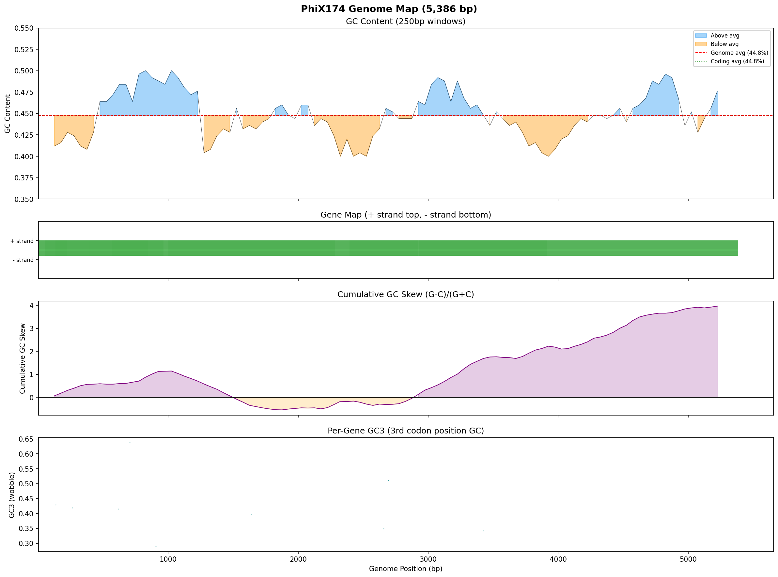
PhiX174 genome map
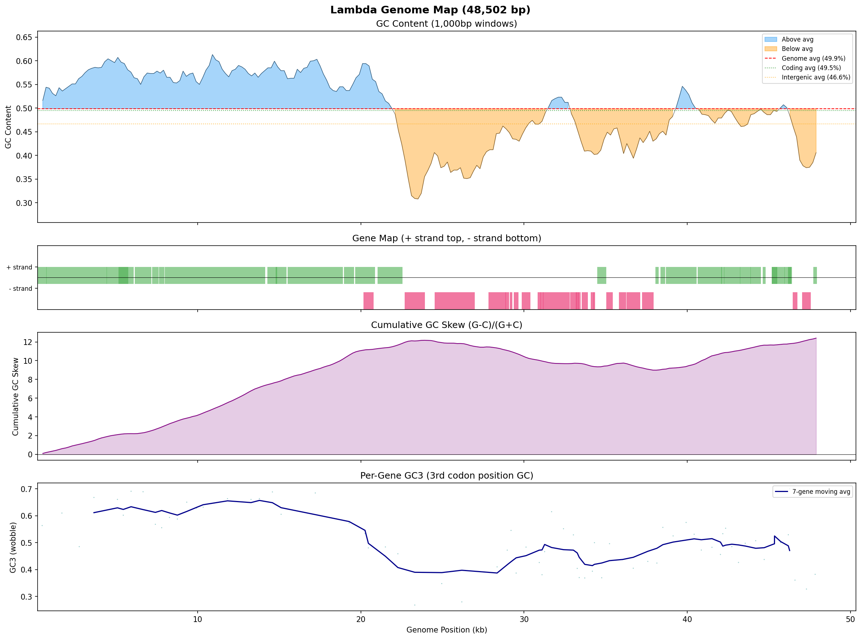
Lambda genome map
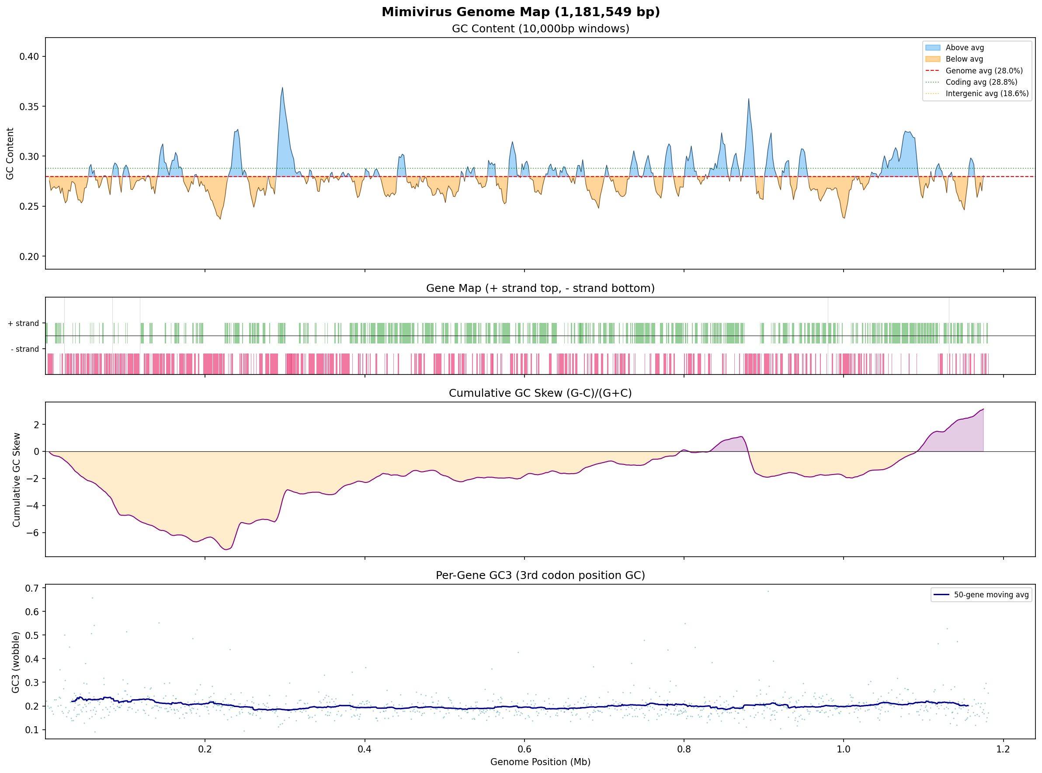
Mimivirus genome map
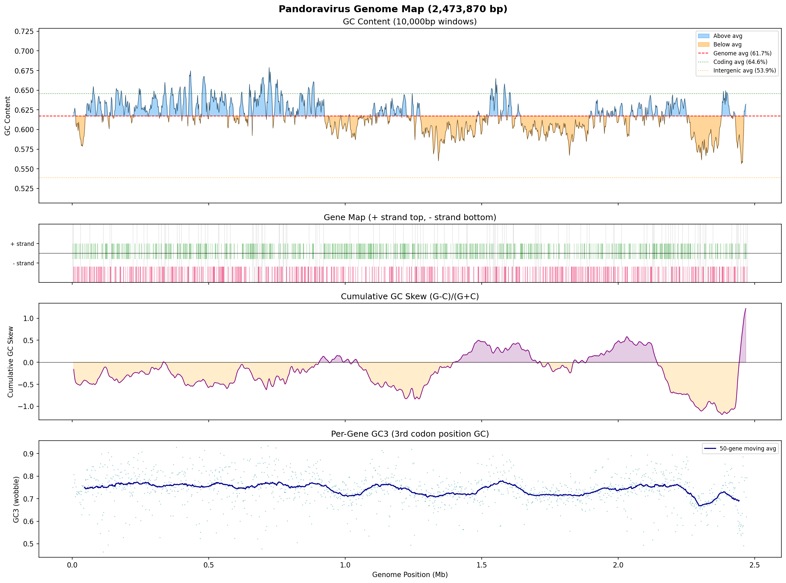
P. salinus genome map

Supplementary Figure S2
Figure S2. GMM clustering of P. salinus genes: three compositional clusters with native zone (1.3-2.0 Mb) overlay, showing cluster composition shift within the zone.
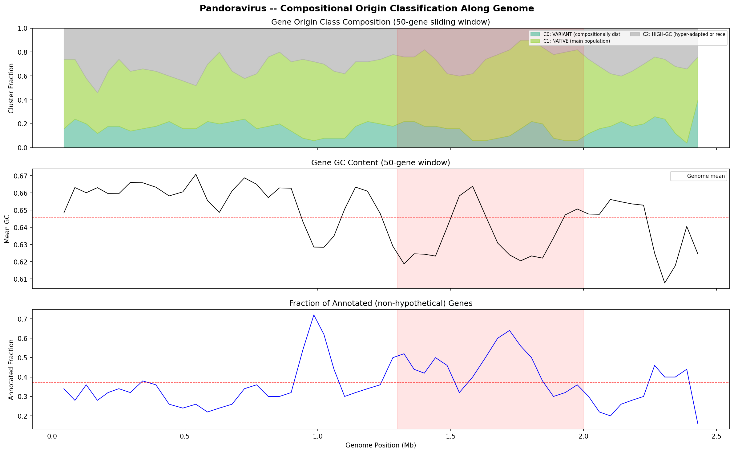
GMM clustering

Supplementary Figure S3
Figure S3. Pairwise protein 3-mer cosine similarity distributions: P. salinus vs Mimivirus, with composition-matched null model overlay.
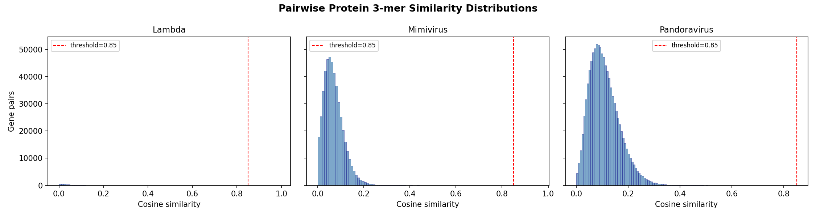
Similarity distributions
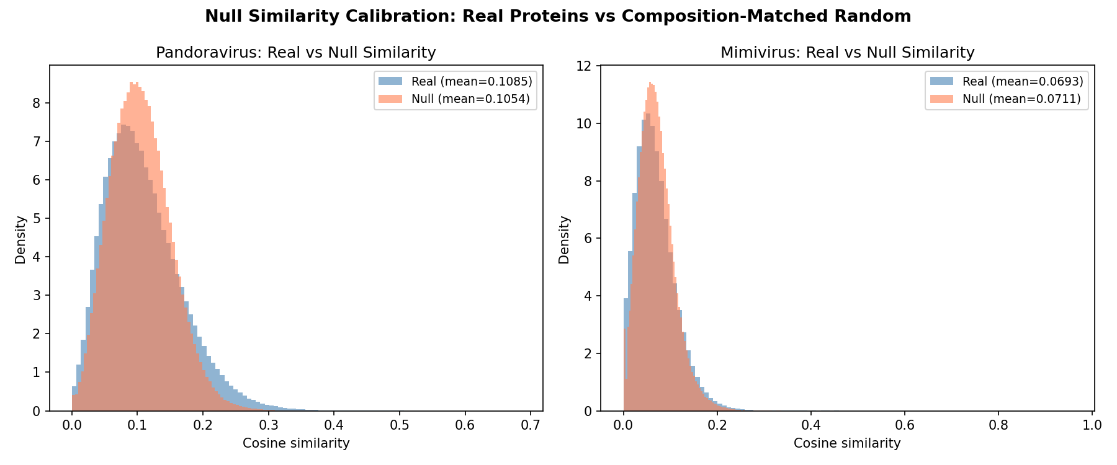
Null calibration

Supplementary Figure S4
Figure S4. ESM-2 PCA embedding space showing structural family assignments, proto-gene positions, GC content overlay, and null calibration.
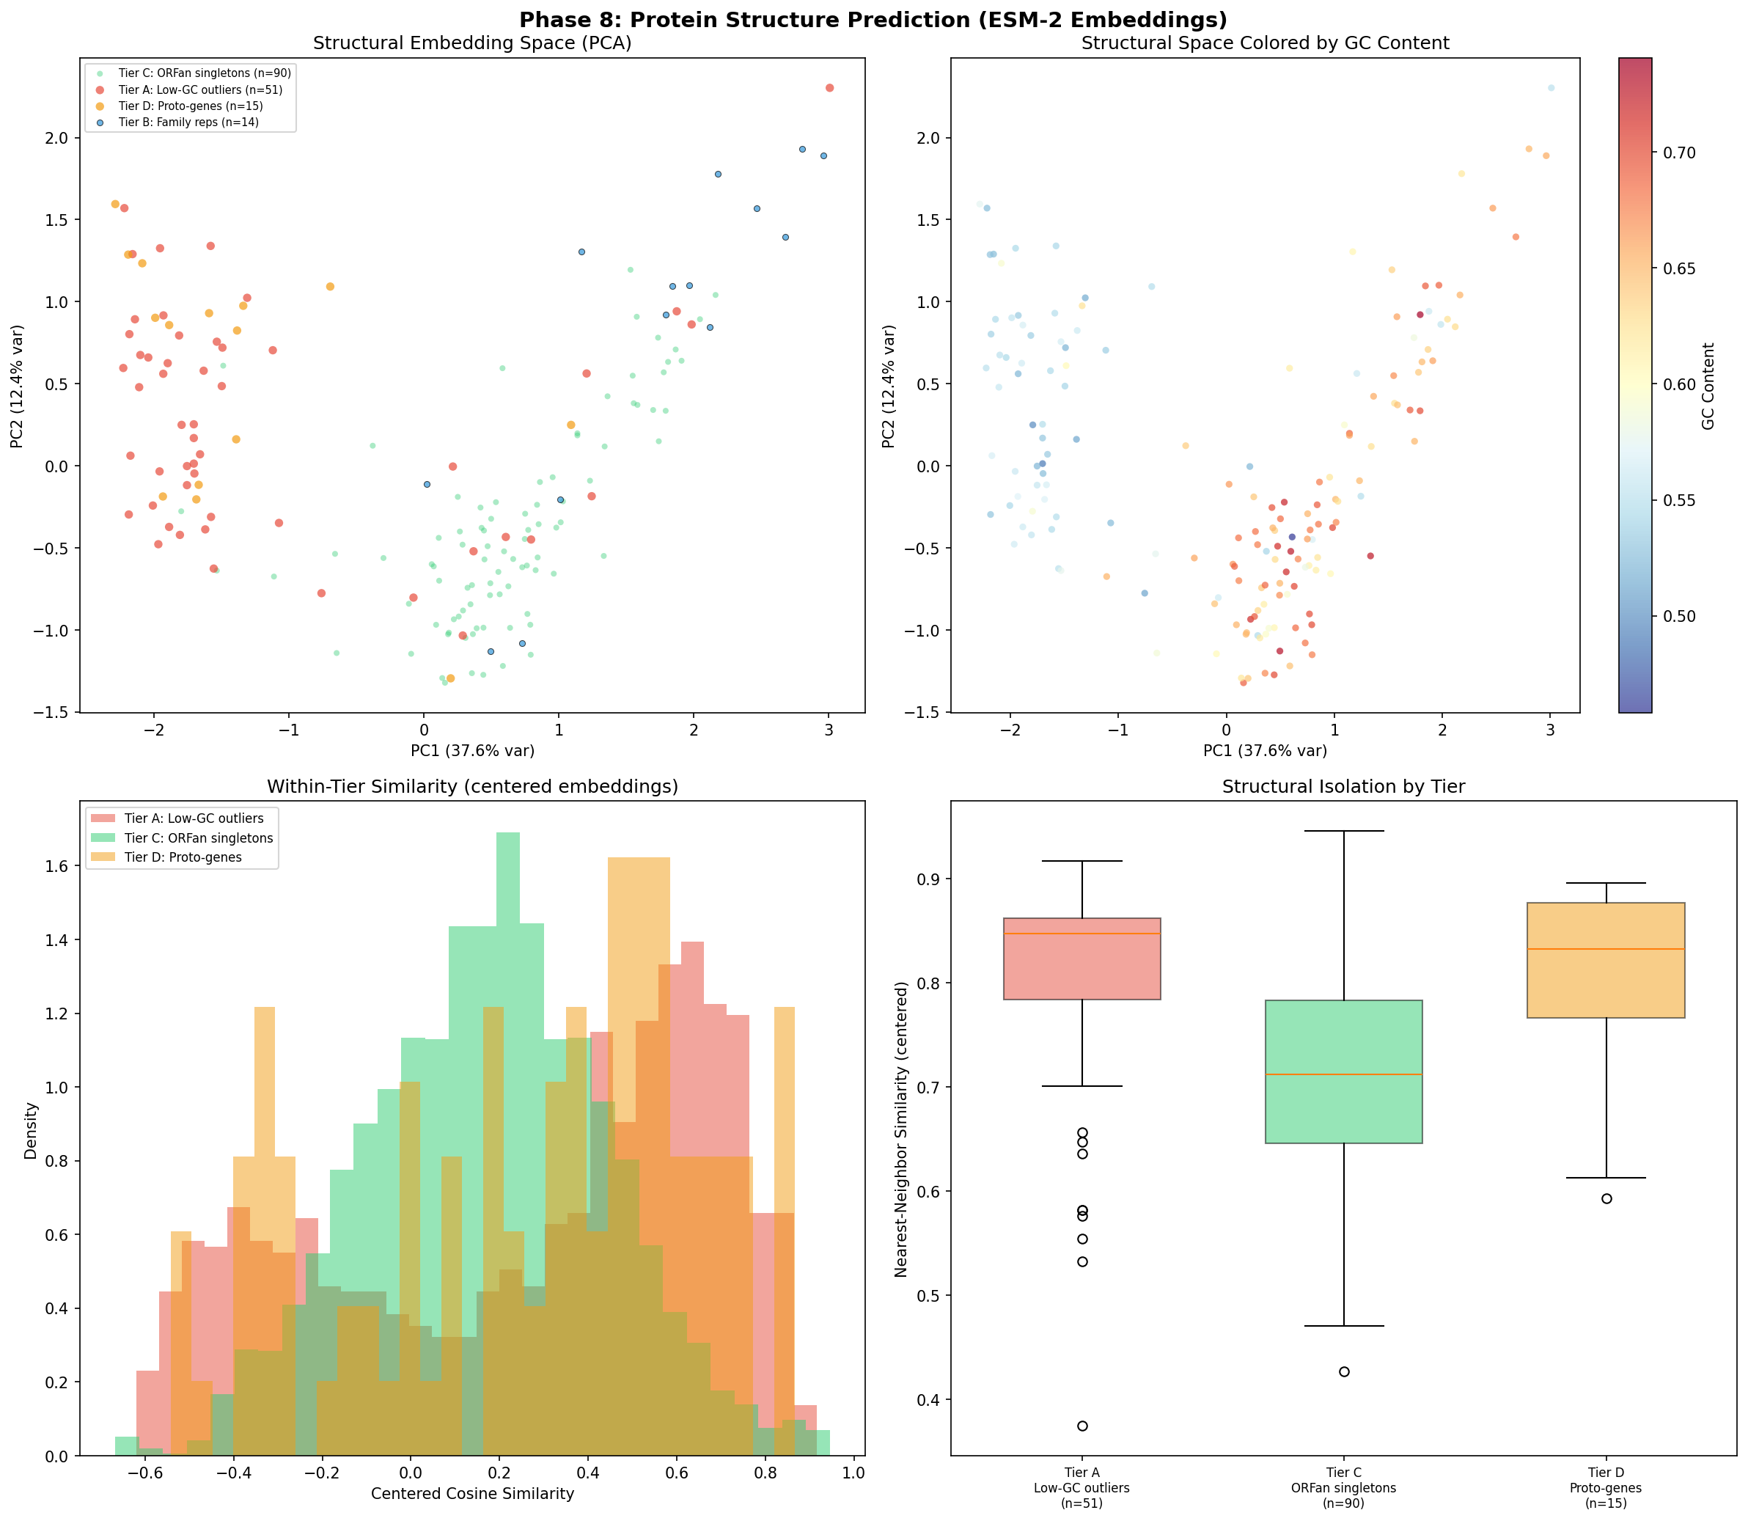
Structure prediction
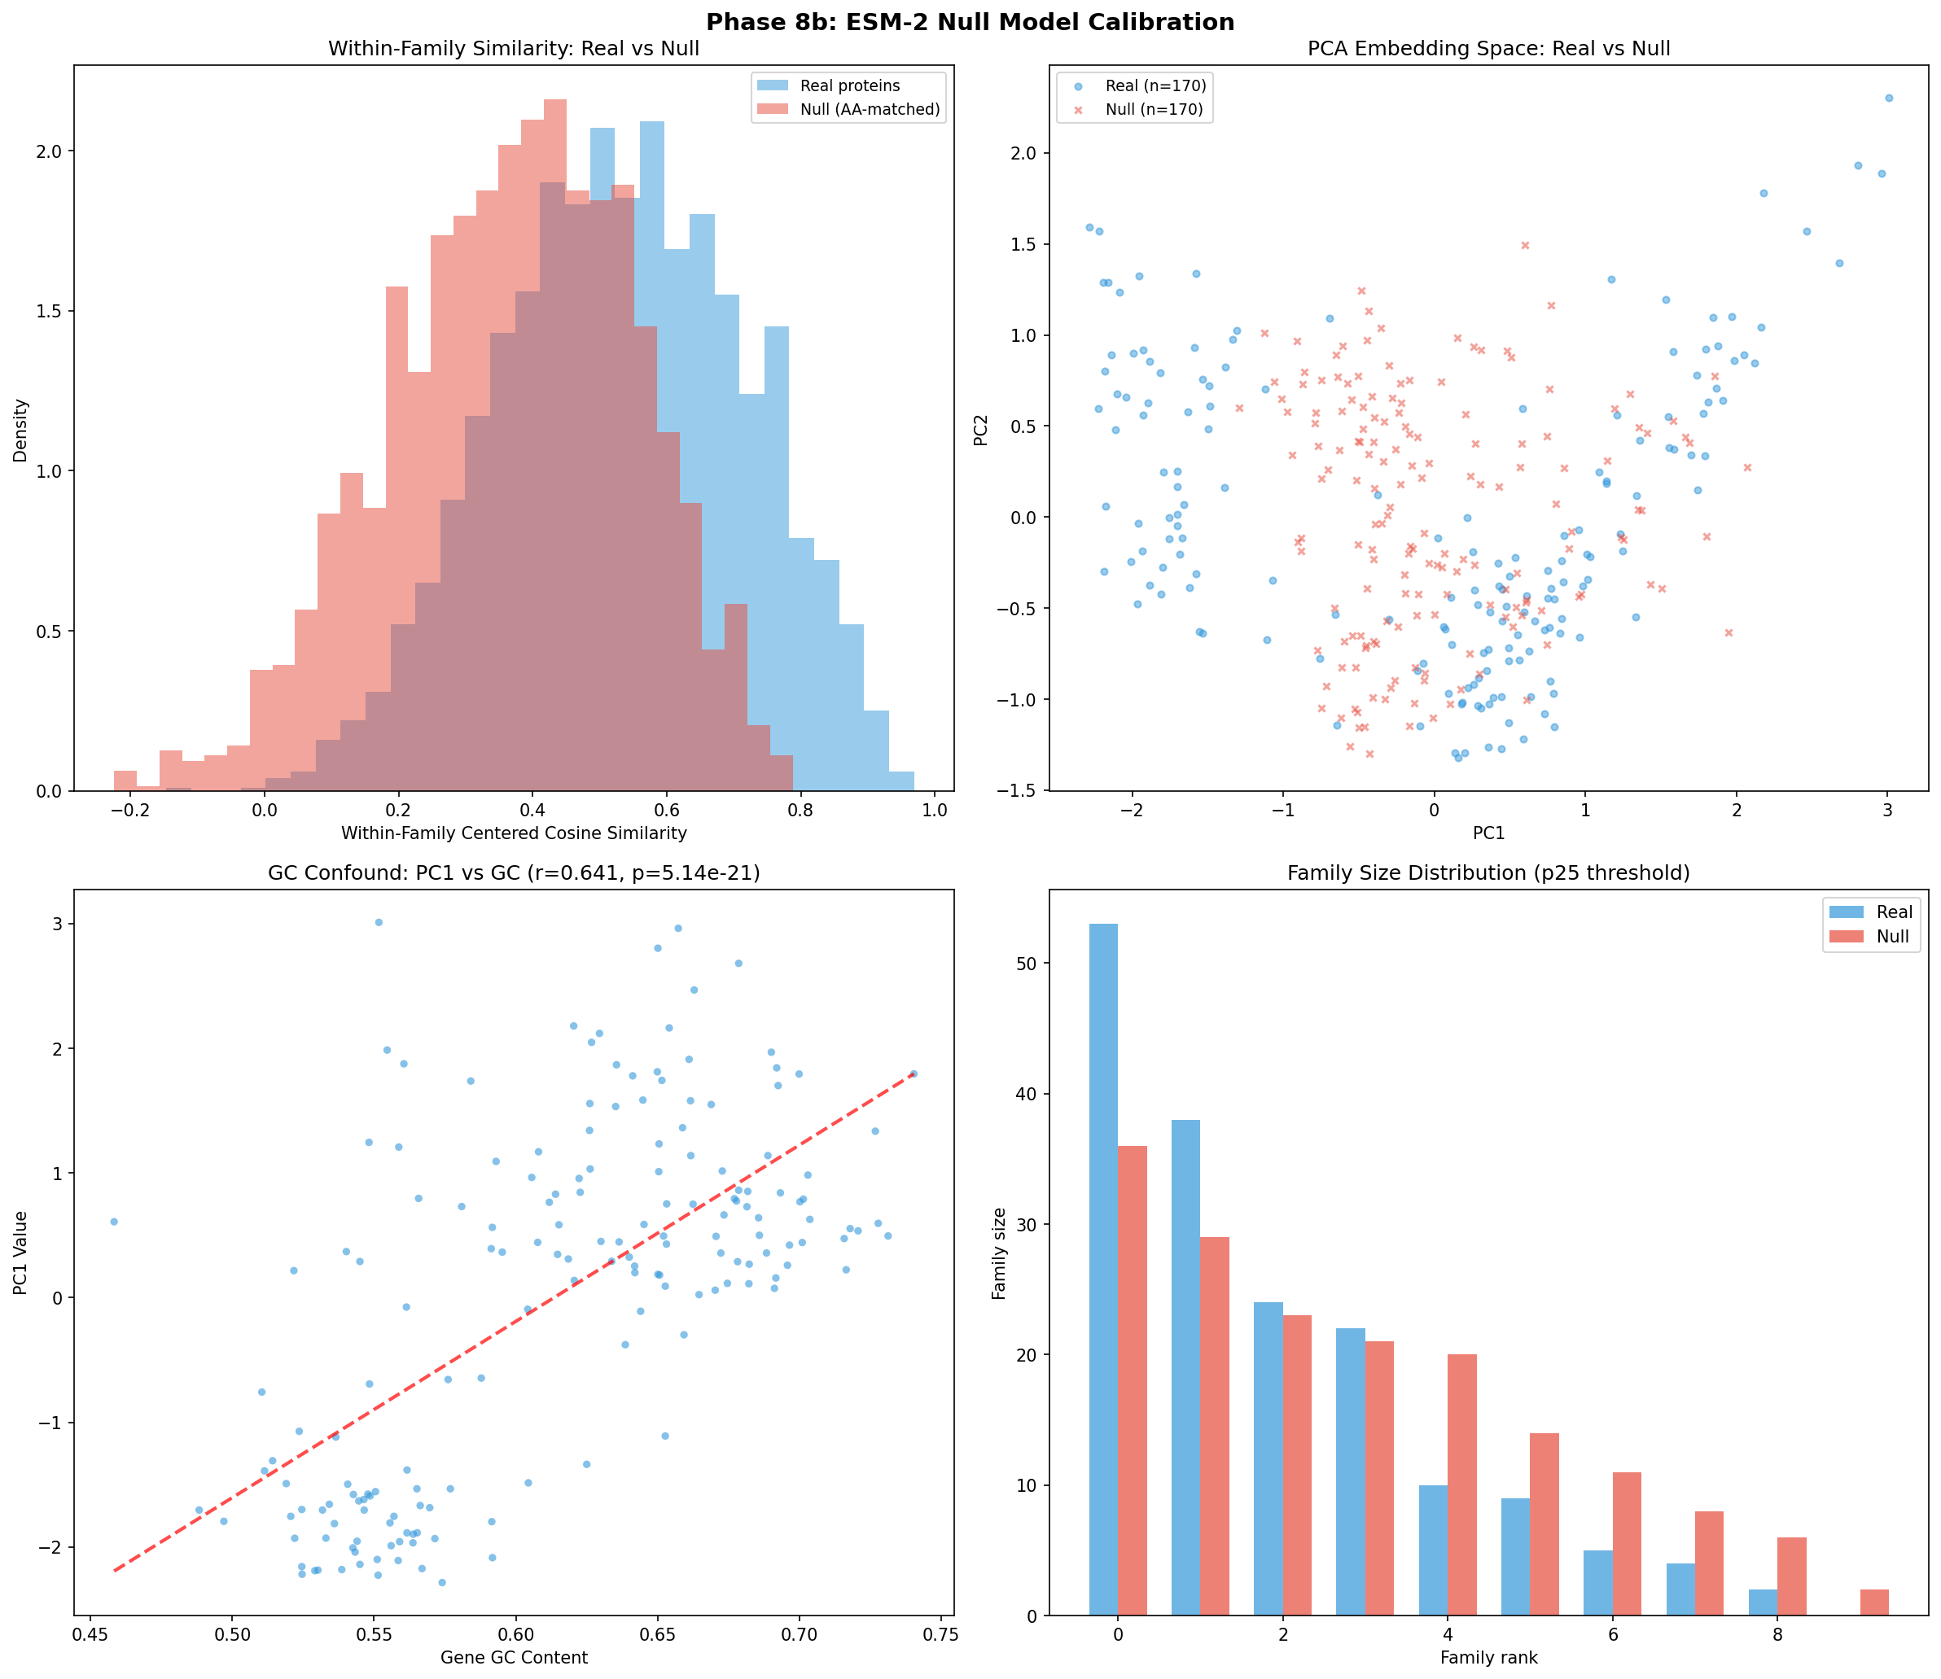
Structure null calibration

Supplementary Figure S5
Figure S5. Full 7-panel Module 11 BLASTp analysis figure.
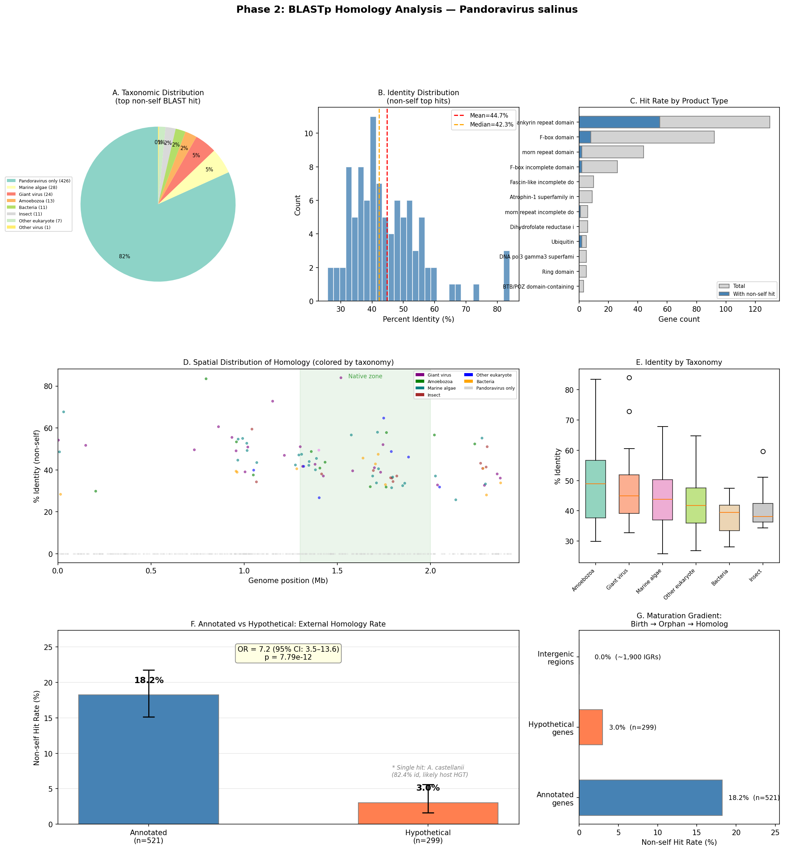
BLASTp analysis

Supplementary Figure S6
Figure S6. Module 10 corrected analysis 6-panel figure.
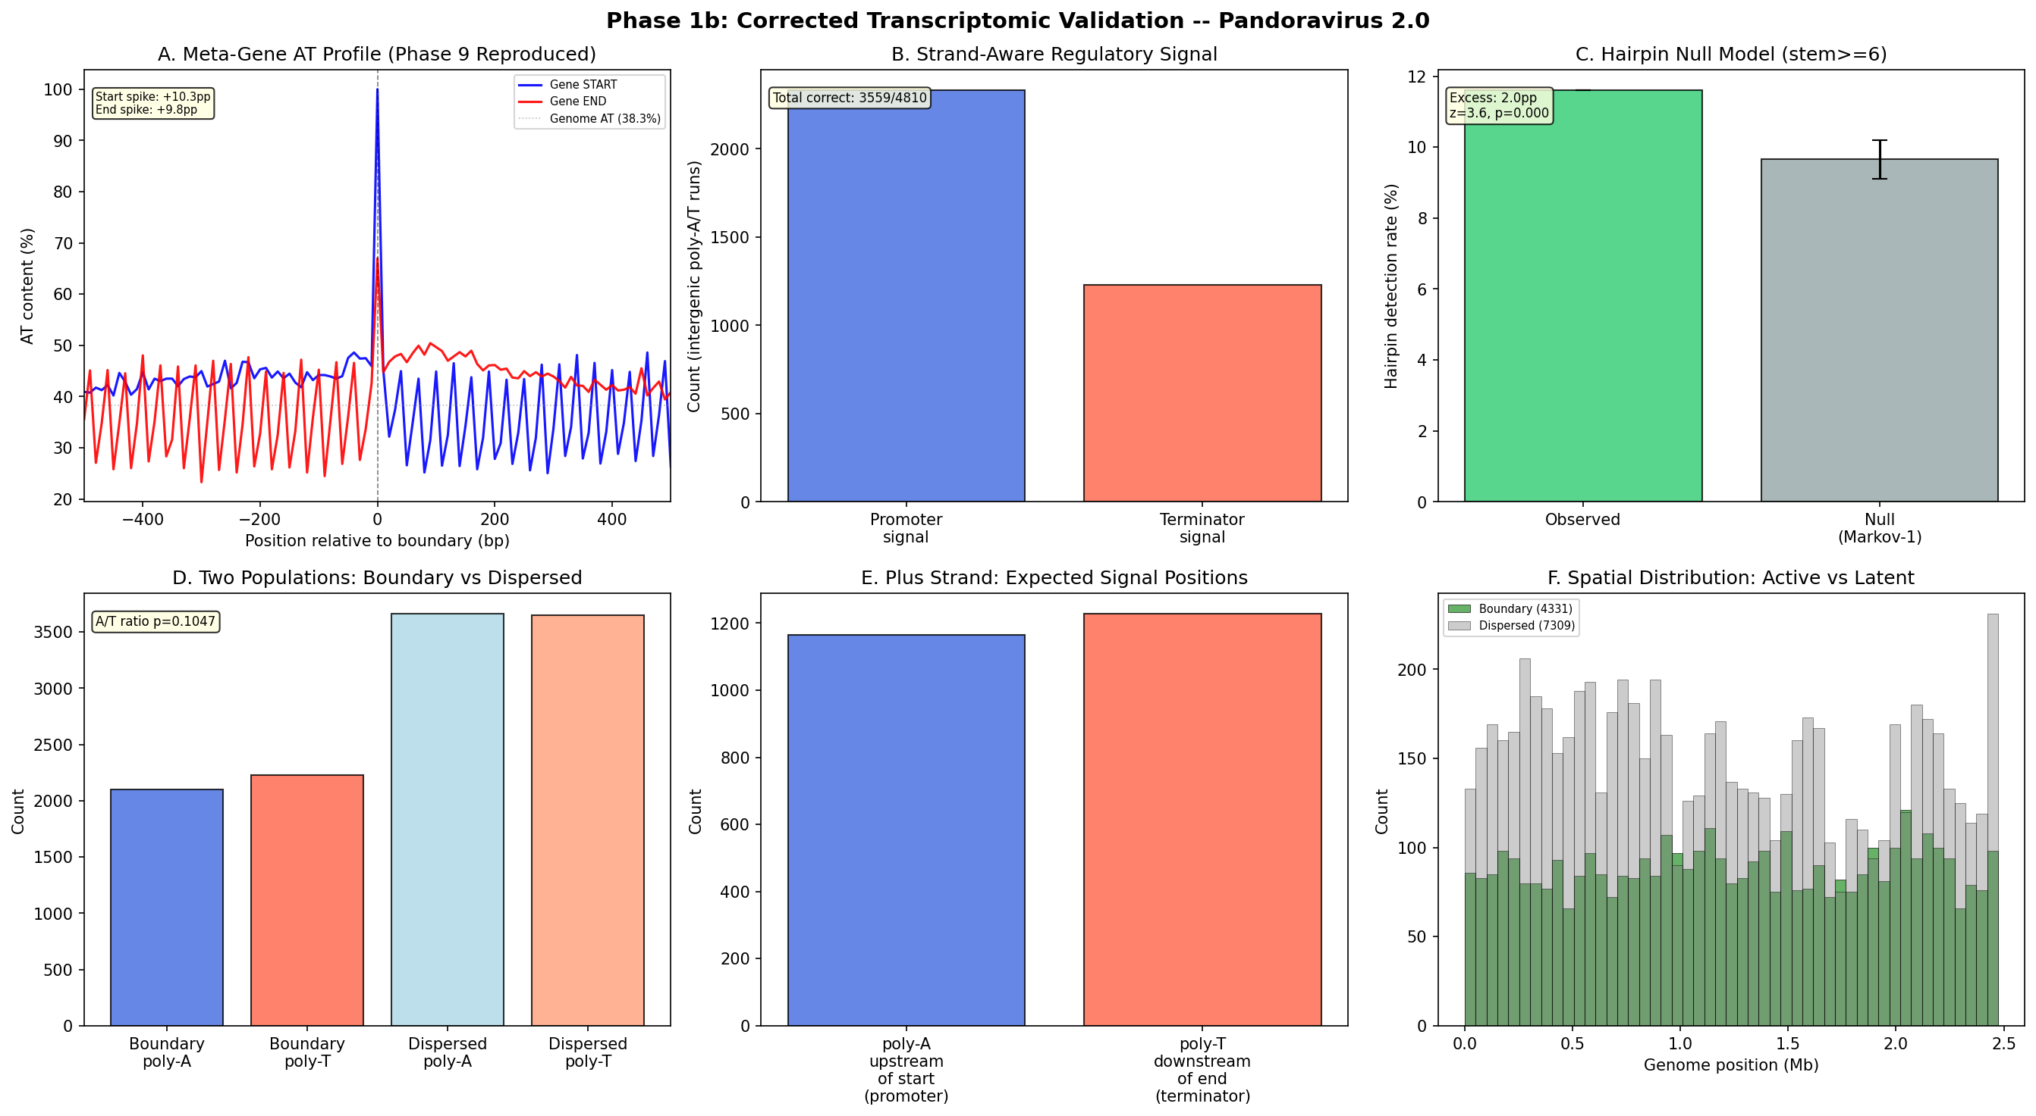
Transcriptomic validation

