**EXERCISE NO:** 2 **REGISTER NO:** 1518102073

**DATE:** 16.10.2020

**AIM:**

To print the count number x in a given list of numbers.

**PROGRAM:**

def countX(list,s):

c=0

for i in range(len(list)):

if (list[i]==x):

c+=1

return c

list=[]

x=int(input())

for i in range(x):

v=int(input())

lst.append(v)

s=int(input())

c=countX(list,s)

print(c)

**LINK:**

[**http://103.53.53.18/mod/vpl/forms/edit.php?id=230&userid=1687#**](http://103.53.53.18/mod/vpl/forms/edit.php?id=230&userid=1687#)

**OUTPUT:**

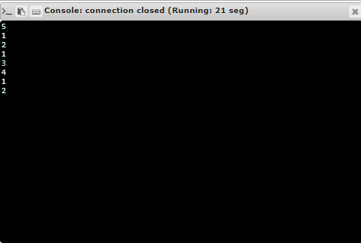

**RESULT:**

Thus, the code has been successfully executed and output is verified. ­­­­­