**EXERCISE NO:** 3 **REGISTER NO:** 1518102073

**DATE:** 16.10.2020

**AIM:**

To remove and print every second number from a list of numbers until the list becomes empty.

**PROGRAM:**

def removeThirdNo(list):

list1=[]

pos=1

s=0

for i in range(0,len(list)):

s=(pos+s)%len(list)

l=lst.pop(s)

list1.append(l)

return list1

n=int(input("Enter number of elements: "))

int_list=[]

for i in range(0,n):

e=int(input())

int_list.append(e)

p=removeThirdNo(int_list)

print(p)

**LINK:**

[http://103.53.53.18/mod/vpl/forms/edit.php?id=231&userid=1687#](http://103.53.53.18/mod/vpl/forms/edit.php?id=231&userid=1687)

**OUTPUT:**

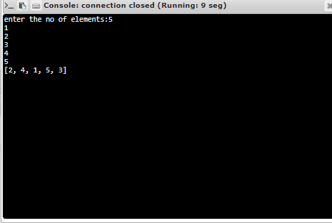

**RESULT:**

Thus, the code has been successfully executed and output is verified. ­­­­­