EXERCISE NO:14 1518102073

DATE:23/11/2020

AIM:

Write a Python class to find validity of a string of parentheses, '(', ')', '{', '}', '[' and ']. These brackets must be close in the correct order, for

example "()" and "()[]{}" are valid but "[)", "({[)]" and "{{{" are invalid.

PROGRAM:

def areBracketsBalanced(expr):

stack=[]

for c in expr:

if c in ["(","{","["]:

stack.append(c)

else:

if not stack:

return False

current_c=stack.pop()

if current_c=="(":

if c!=")":

return False

if current_c=="{":

if c!="}":

return False

if current_c=="[":

if c!="]":

return False

if stack:

return False

return True

if __name__=="__main__":

expr=input("input:")

if areBracketsBalanced(expr):

print("Output:Valid")

else:

print("Output:Invalid")

LINK:

<http://103.53.53.18/mod/vpl/forms/submissionview.php?id=327&userid=1687>

OUTPUT:

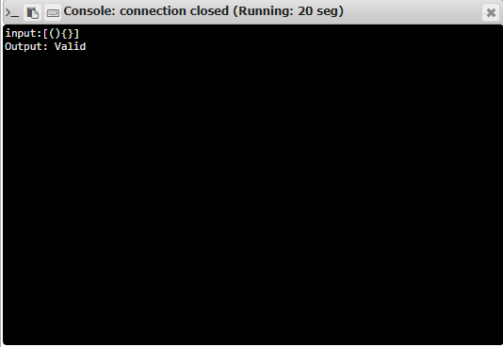

RESULT:

The output is obtained successfully.