Ideation Phase
Brainstorm & Idea Prioritization Template

Date | 1 October 2026
Team ID | SWTID-2026-5148
Project Name | Implement Client Script & UI Policy (Incident)
Maximum Marks | 4 Marks
Team: Mathangi S (Team Leader), Meena Varshini T P, Mirthika R, Muthu Priya U | Team Size: 4
Brainstorm & Idea Prioritization Template:
Brainstorming provides a free and open environment that encourages everyone within a team to participate in the creative thinking process that leads to problem solving. Prioritizing volume over value, out-of-the-box ideas are welcome and built upon, and all participants are encouraged to collaborate, helping each other develop a rich amount of creative solutions.
Use this template in your own brainstorming sessions so your team can unleash their imagination and start shaping concepts even if you're not sitting in the same room.
Reference: https://www.mural.co/templates/brainstorm-and-idea-prioritization
Step-1: Team Gathering, Collaboration and Select the Problem Statement
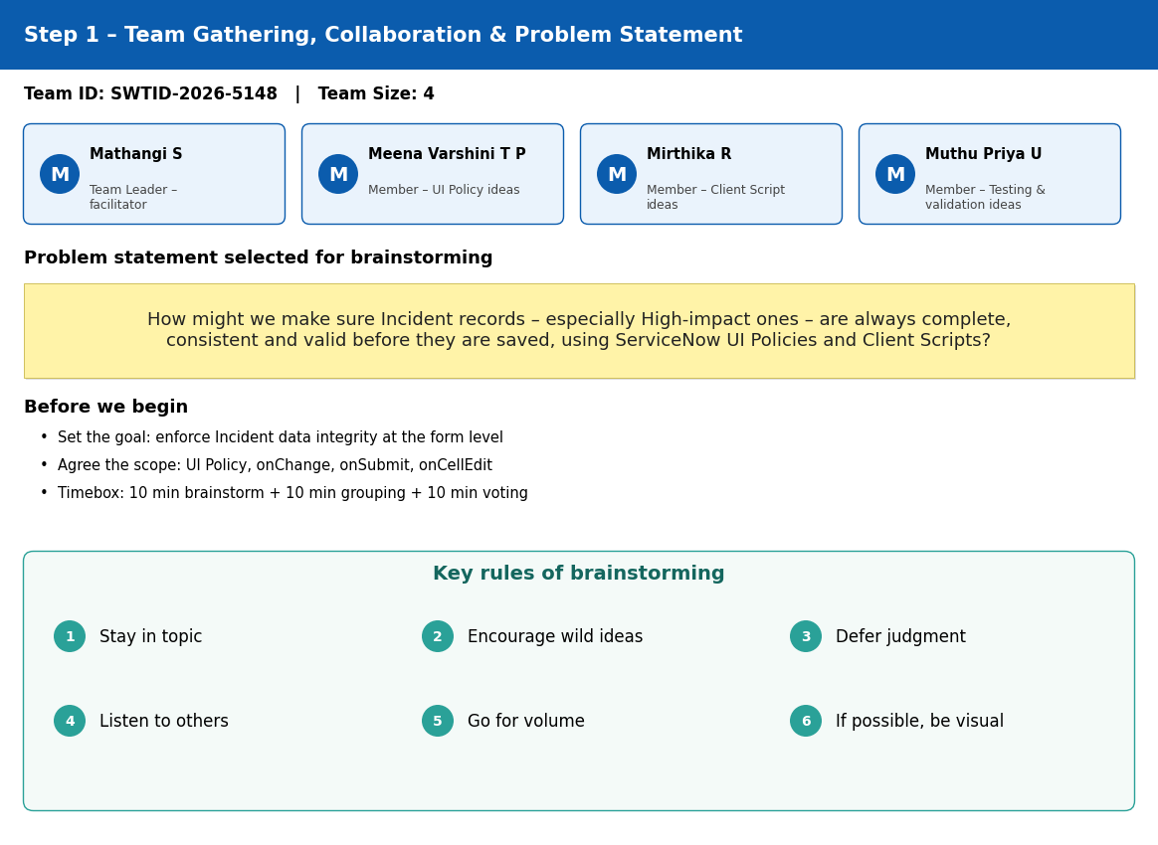

Step-2: Brainstorm, Idea Listing and Grouping
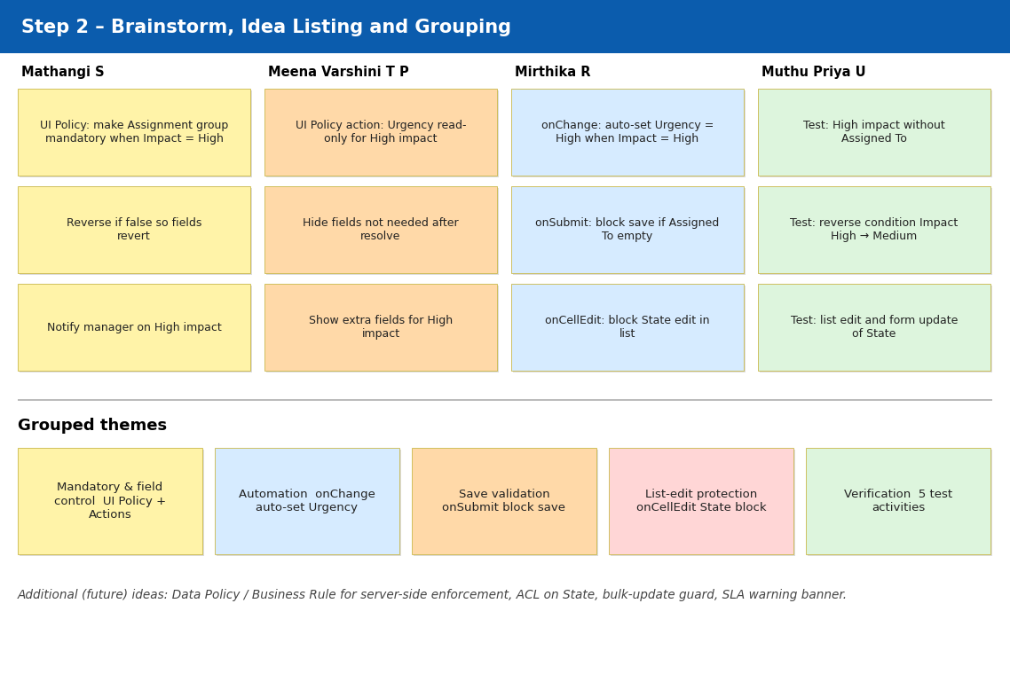

Step-3: Idea Prioritization
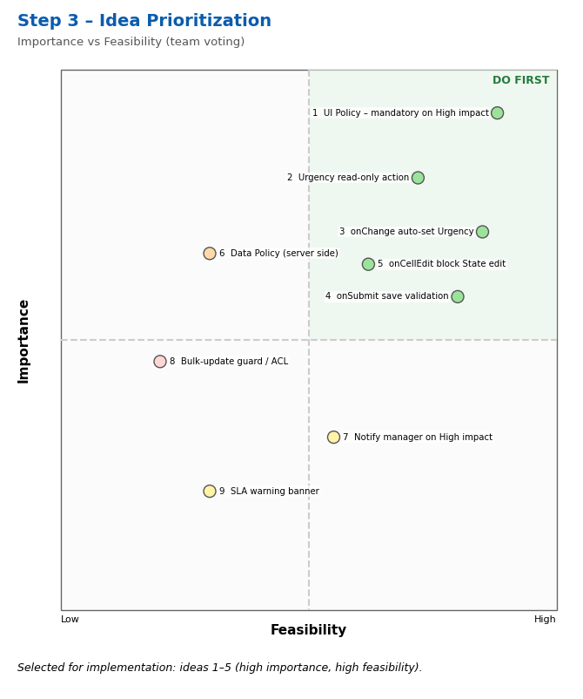
Prioritization Summary:
Idea | Importance | Feasibility | Decision
1. UI Policy – Assignment group mandatory when Impact = High (Reverse if false) | High | High | Implement
2. UI Policy Action – Urgency read-only for High impact | High | High | Implement
3. onChange Client Script – auto-set Urgency = High when Impact = High | High | High | Implement
4. onSubmit Client Script – block save if Assigned To is empty for High impact | High | High | Implement
5. onCellEdit Client Script – block State edit from list view | Medium-High | High | Implement
6. Data Policy / Business Rule for server-side enforcement | High | Medium | Future scope
7. Notify manager on High-impact incidents | Medium | Low | Future scope
8. Bulk-update guard / ACL on State | Medium-High | Low | Future scope
9. SLA warning banner on the form | Low | Low | Not selected

