Ideation Phase
Define the Problem Statements

Date | 1 October 2026
Team ID | SWTID-2026-5148
Project Name | Implement Client Script & UI Policy (Incident)
Maximum Marks | 2 Marks
Team: Mathangi S (Team Leader), Meena Varshini T P, Mirthika R, Muthu Priya U | Team Size: 4
Customer Problem Statement Template:
Create a problem statement to understand your customer's point of view. The Customer Problem Statement template helps you focus on what matters to create experiences people will love.
A well-articulated customer problem statement allows you and your team to find the ideal solution for the challenges your customers face. Throughout the process, you’ll also be able to empathize with your customers, which helps you better understand how they perceive your product or service.

Reference: https://miro.com/templates/customer-problem-statement/
Problem Statement PS-1 (illustrated):
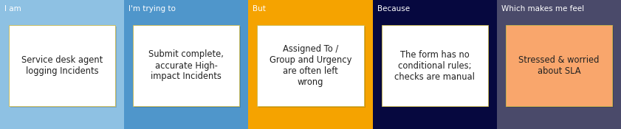
Problem Statement (PS) | I am (Customer) | I’m trying to | But | Because | Which makes me feel
PS-1 | a service desk agent who logs and triages Incidents in ServiceNow | submit complete and accurate Incident records, especially High-impact ones | Assigned To / Assignment group and Urgency are often left blank or inconsistent when the record is saved | the Incident form has no conditional rules and depends on users manually remembering to check fields | stressed and worried about SLA breaches and wrong routing
PS-2 | an ITSM manager responsible for Incident reports and SLA compliance | rely on accurate Incident data to track priority, routing and resolution | High-impact incidents are saved with a low or mismatched Urgency and incomplete assignment details | Urgency is entered manually and is not tied to Impact by any automatic rule | concerned and unable to trust reports
PS-3 | a ServiceNow administrator who owns data quality on the Incident table | make sure users cannot bypass form validations | users can change the State field directly from the list view, skipping the form-level rules | list editing is not covered by form UI Policies or onSubmit scripts | worried and not in control of data integrity

