Ideation Phase
Empathize & Discover

Date | 1 October 2026
Team ID | SWTID-2026-5148
Project Name | Implement Client Script & UI Policy (Incident)
Maximum Marks | 4 Marks
Team: Mathangi S (Team Leader), Meena Varshini T P, Mirthika R, Muthu Priya U | Team Size: 4
Empathy Map Canvas:
An empathy map is a simple, easy-to-digest visual that captures knowledge about a user’s behaviours and attitudes.

It is a useful tool to helps teams better understand their users.
Creating an effective solution requires understanding the true problem and the person who is experiencing it. The exercise of creating the map helps participants consider things from the user’s perspective along with his or her goals and challenges.
Empathy Map 1 – Service Desk Agent:
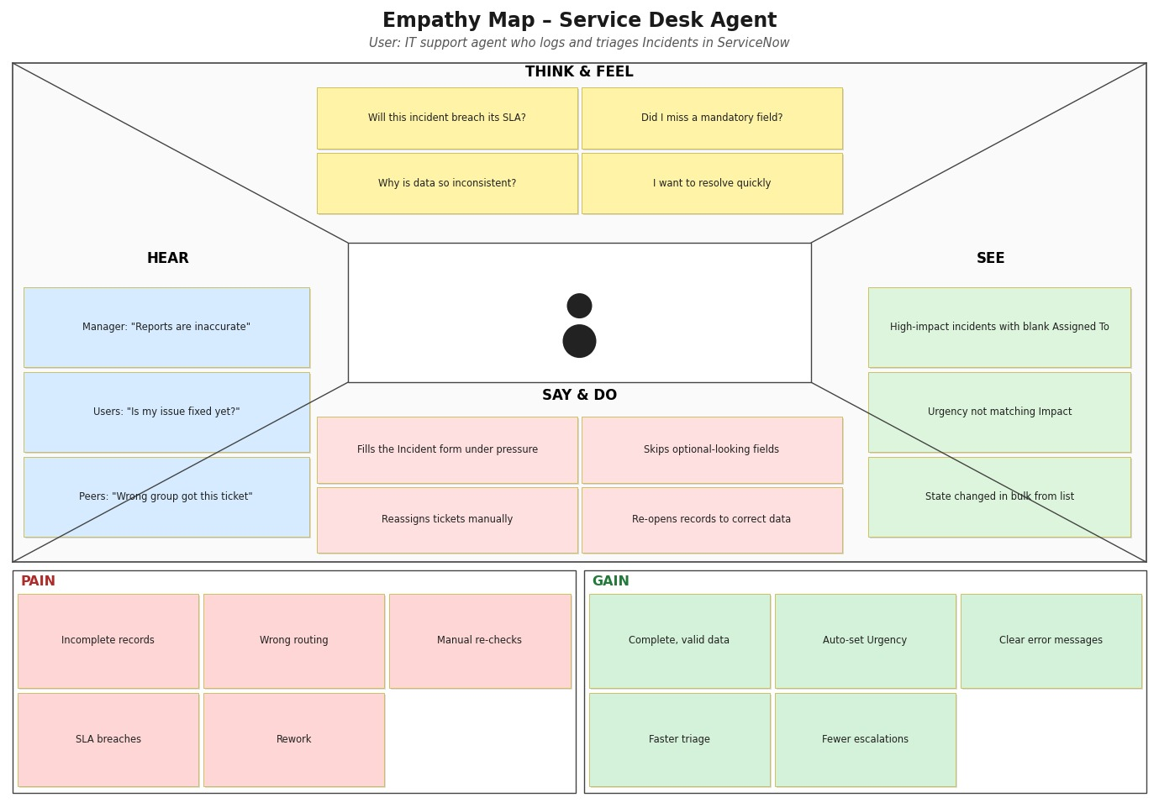

Reference: https://www.mural.co/templates/empathy-map-canvas

Empathy Map 2 – ITSM Manager / Process Owner:
