OUTBREAK RESPONSE LOGISTICS GAME

CONCEPTUAL MODEL

1. Problem Focus
Seasonal outbreaks in South Asia consistently create treatment delays because many patients bypass nearby primary health centres (PHCs) and overcrowded private hospitals.
This leads to:
- Long waiting times → time inefficiency
- High out-of-pocket expenses → cost inefficiency
Core investigation question:
How do patient decisions and Medical Officer (MO) resource allocations jointly influence
Time-to-Treatment (ATT) and Cost per Patient Episode (ACPE)?
2. System Boundary
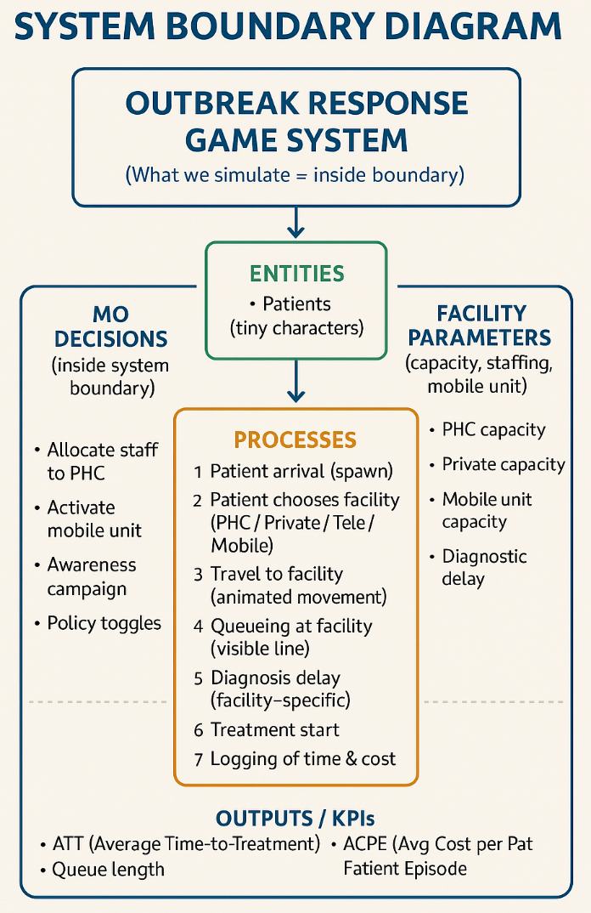
Inside the simulation
- Patient arrival, travel paths, waiting/queueing behaviour, diagnosis delay, treatment start
- PHC capacity (staff units, service rate)
- Private hospital capacity
- Mobile unit deployment
- Awareness campaigns shifting patient preference toward PHC
- MO decisions: staffing adjustments, mobile unit activation
- Real-time KPI logging + Pareto frontier generation

Outside the simulation
- Medicine inventory and supply-chain logistics
- Long-term clinical outcomes
- Epidemic transmission modelling
- Insurance and financial reimbursement systems

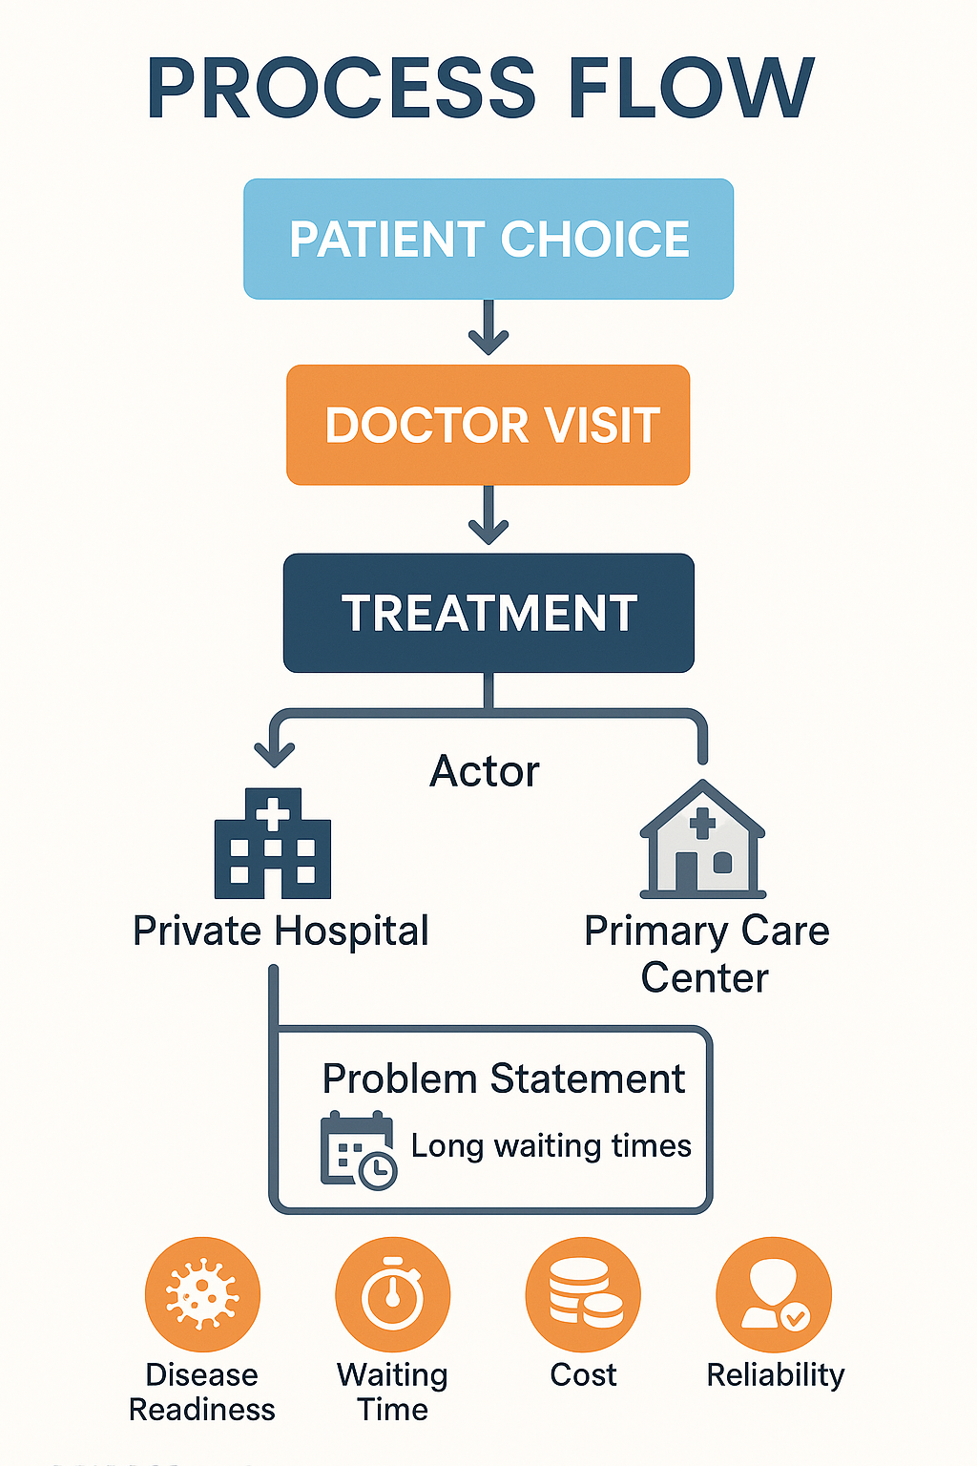
3. Main Processes
- Patient appears on map (arrival event)
- Patient selects care option (PHC / Private / Telemedicine / Mobile Unit)
- Travel animation to selected facility
- Queue formation at facility (visible tiny-characters)
- Facility-specific diagnosis delay
- Treatment start event (time recorded)
- KPI update: ATT, ACPE, queue lengths
- MO can modify system conditions (staffing, awareness, mobile unit)
- Next patient enters → loop continues for N patients

4. Actors & Resources

Actors
- Patients
- Medical Officer (MO)
- PHC staff
- Private hospital staff

Resources
- PHC facility
- Private hospital
- Mobile medical unit

Queues
- PHC queue
- Private hospital queue
5. Inputs
- Patient arrival rate (stochastic / Poisson-like)
- PHC & private hospital service rates
- Travel distance and travel time function
- Diagnosis delay parameters per facility
MO actions:
- Increase/decrease PHC staff
- Toggle mobile unit
- Trigger awareness campaigns

6. Outputs
- ATT — Average Time-to-Treatment
- ACPE — Average Cost per Patient Episode
- Queue lengths at PHC and private hospital
- PHC utilization rate
- Pareto frontier mapping the Time–Cost tradeoff
7. Level of Abstraction
A medium-level simulation:
- Individual patients represented as discrete moving entities
- Facilities treated as capacity-limited service stations
- Queues and delays simulated explicitly and visually
8. Performance Indicators (KPIs)
Primary KPIs
- ATT — Average Time-to-Treatment
- ACPE — Average Cost per Patient Episode
Optional / Secondary KPIs
- PHC Utilization %
- Queue length per facility
9. Expected Behaviours & Results
PHC-oriented choices
→ Lower ACPE, slightly higher ATT unless staffing is improved
Private-oriented choices
→ Higher ACPE, potentially lower ATT early on, rising later due to congestion
Increasing PHC staff (MO action)
→ ATT ↓, ACPE ↓, PHC utilization ↑
Awareness campaigns
→ More patients use PHC → cheaper care → Pareto shift toward efficiency
Mobile unit activation
→ Travel time ↓ → ATT ↓
→ Operational cost ↑ → ACPE ↑
End-of-scenario outcome
→ A Pareto frontier showing the system’s best achievable Time–Cost tradeoff

