Sepsis Early Prediction Using Time-Series LSTM
1. Neural Network Design and Performance
We implemented a custom LSTM-based neural network to predict sepsis onset 2h, 4h, and 6h in advance using patient-level laboratory time series.
Architecture Design
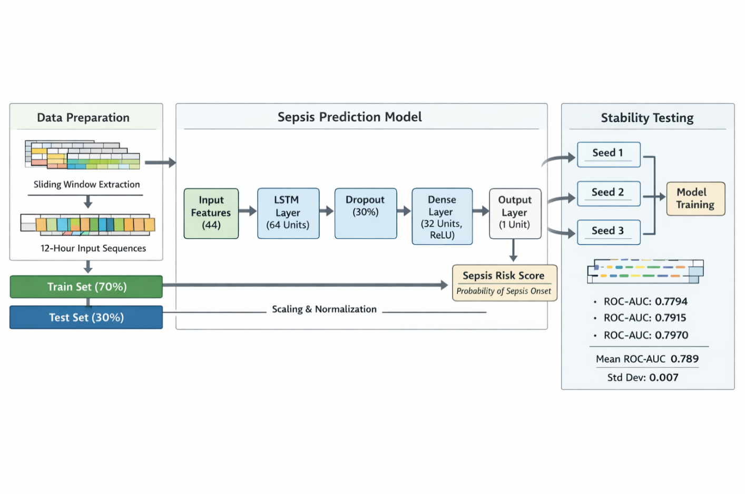Input Layer
- Input shape: (batch_size, 12 timesteps, 44 features)
- 12 timesteps correspond to 6 hours of historical laboratory measurements.
- Features include laboratory and physiological markers (excluding identifiers and labels).
Core Model
- Single-layer LSTM (hidden size = 64)
- Dropout (0.3) after LSTM output
- Fully connected layer (64 → 32)
- ReLU activation
- Final linear layer (32 → 1)
Output
- Single logit (BCEWithLogitsLoss)
- Sigmoid applied for probability estimation
Initialization
- Xavier uniform initialization for input-hidden weights
- Orthogonal initialization for hidden-hidden weights
These initialization strategies stabilize gradient flow and are well-suited for recurrent networks.
Performance (ROC-AUC)
Horizon | ROC-AUC
2h | 0.749
4h | 0.735
6h | 0.736
Performance is highest at 2h, indicating stronger discriminative signals closer to sepsis onset.
Minimal Feature Subset
Permutation importance analysis revealed that no small subset of features could approximate full-model performance.
For 4h prediction:
- Top 3 features → AUC ≈ 0.626 (Δ ≈ 0.11)
- Top 5 features → AUC ≈ 0.615 (Δ ≈ 0.12)
This indicates:
- Early sepsis detection relies on distributed multi-system signals.
- Prediction is not compressible to a minimal laboratory triad.
- Feature requirements differ across horizons.

2. Custom Architecture Compliance
No pretrained models were used.
All models were implemented from scratch using PyTorch, including:
- Custom LSTM layer definition
- Custom training loop
- Manual early stopping logic
- Manual permutation importance
Utilities such as DataLoader and StandardScaler were used appropriately, but no external model architectures were reused.
3. Training Strategy and Justification
Data Splitting
- Patient-level split (80/20)
- Prevents leakage across time windows
Class Imbalance Handling
- Severe imbalance handled using pos_weight in BCEWithLogitsLoss
- Ensures minority class influence during gradient updates
Optimization
- Adam optimizer (lr = 1e-3)
- Batch size = 256 (reduced to 512 for fast subset experiments)
- Max 20 epochs
- Early stopping (patience = 5)
Early stopping was tuned on ROC-AUC to optimize discrimination rather than raw accuracy.
Why This Strategy?
Sepsis prediction is a highly imbalanced, event-onset problem.
Optimizing ROC-AUC prioritizes ranking ability over raw classification threshold performance.
The LSTM architecture enables:
- Temporal dependency learning
- Multi-feature interaction modeling
- Sequence-level representation extraction

4. Error Metrics and Justification
We evaluated:
- ROC-AUC (primary metric)
- PR-AUC
- Confusion matrices
- Threshold analysis
Why ROC-AUC?
Sepsis onset is rare.
Accuracy is misleading in imbalanced datasets.
ROC-AUC measures discriminative ranking ability independent of threshold.
This is appropriate for early-warning systems.
PR-AUC was additionally considered due to imbalance sensitivity.
5. Feature Importance Analysis
Permutation importance was used to assess feature contribution by measuring ROC-AUC drop after feature shuffling.
Why Permutation Importance?
- Model-agnostic
- Directly tied to predictive performance
- Suitable for nonlinear LSTM architectures
- Avoids gradient-based interpretability bias
Key Findings
Across horizons:
- 6h: Metabolic and oxygenation markers (lactate, hemoglobin, sodium) dominate.
- 4h: Respiratory and inflammatory markers (respiratory_minute_volume, leukocytes, temperature) peak.
- 2h: Lactate and hemodynamic instability markers become strongest.
This suggests dynamic physiological evolution:
- Early metabolic imbalance
- Mid-stage respiratory and inflammatory escalation
- Late-stage acute hypoperfusion and organ dysfunction
Structural Observation
timestep showed strong importance across horizons, indicating temporal proximity carries predictive signal.
However, it represents structural time indexing rather than physiological measurement and should be interpreted cautiously in real-world deployment contexts.
Overall Conclusion
The LSTM-based time-series model successfully captures temporal physiological progression toward sepsis onset.
Key insights:
- Discrimination improves closer to onset (2h).
- Prediction relies on distributed, multi-system laboratory interaction.
- Feature importance shifts dynamically across time horizons.
- No minimal small feature set adequately replaces the full model.
This supports the hypothesis that early sepsis detection requires integrative modeling of evolving physiological instability rather than reliance on isolated biomarkers.
For further context : https://github.com/mathangi18/Sepsis_Early_Prediction.git

