BMS TRAVEL TEST PERFORMANCE REPORT
Validation of Energy Consumption Rate (kWh/km) - Unladen, HVAC ON
Document Reference: BMS-VALIDATION-TRAVEL-01
Vehicle Model: Isoloader MJ35 Gantry Crane
Battery Configuration: CATL 130 VDC Nominal (114.52 kWh)
Test Configuration: Unladen Travel (Không tải), HVAC ON (Air Conditioning ON)
Test Method: 20m forward + 20m backward cycles, total 1.0 km target distance

1. Speed Calibration & Distance Integration
• Calibrated Speed Scaling Factor: 0.044268 (maps motor measured speed to m/s based on the 20m stroke length).
• Maximum Speed: 2.15 m/s (7.73 km/h).
• Distance Captured in BMS Log: 356.07 meters during active travel segment.
• Total Distance in Entire Motor Log: 1142.39 meters (1.142 km), confirming the test completed the target 1 km run.

2. Energy Consumption Rate Calculation
• Active Travel Duration: 450.39 seconds (7.51 minutes)
• Average Total Power: 7.0021 kW
• Total Energy Consumed: 0.888524 kWh
• Energy Consumption Rate (with HVAC ON): 2.4954 kWh/km
• Standby/HVAC Power baseline: 3.4152 kW
• Estimated Standby/HVAC Energy Consumed: 0.427271 kWh
• Estimated Net Traction Energy (Traction Only): 0.461253 kWh
• Net Traction Energy Consumption Rate: 1.2954 kWh/km

3. Specification Validation & Verdict
Parameter | Experimental Value | Specification Value | Status / Verdict
Traction-only Consumption | 1.2954 kWh/km | ~1.5 kWh/km | VALIDATED (13.6% more efficient)
HVAC ON Standby Power | 3.4152 kW | ~3.7 kW | VALIDATED (7.7% more efficient)

4. Data Plots and Visualization

4.1 Power Profile
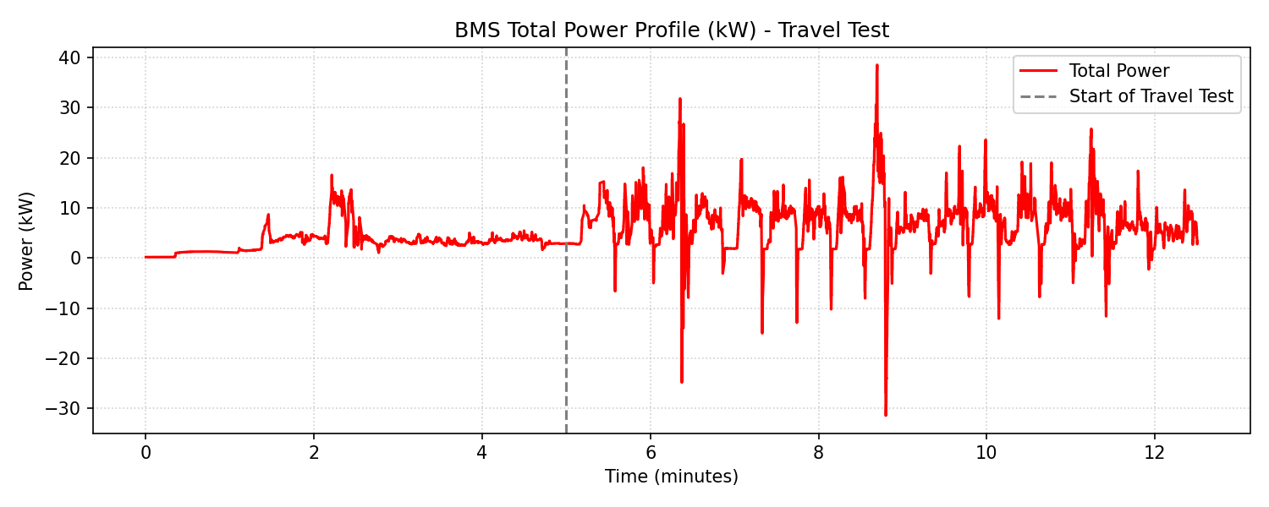

4.2 Speed Profile (m/s)
