BMS OPERATION LADEN TRAVEL TEST REPORT - TRY 2
Validation of Energy Consumption Rate (20T Load) - HVAC ON - Try 2
Document Reference: BMS-REPORT-LOAD-HVAC-ON-TRY2
Vehicle Model: Isoloader MJ35 Gantry Crane
Battery Configuration: CATL 130 VDC Nominal (114.52 kWh)
Test Configuration: Laden Travel (Có tải 20 tấn), HVAC ON (Lần 2)
Test Method: 25m forward + 25m backward cycles, total 40 times (target 1.0 km)

1. Executive Summary
• Average Combined Power (with HVAC ON): 7.8766 kW
• Total Distance Traveled: 1012.81 m (1.0128 km)
• Total Energy Consumed: 2.9862 kWh
• Energy Consumption Rate (with HVAC ON): 2.9485 kWh/km
• Net Traction-only Energy Consumption Rate: 2.3420 kWh/km
• Maximum Vehicle Speed: 4.94 km/h (3.07 mile/h)
• Projected Runtime (80% Battery Capacity): 11.63 Hours (11 giờ 37 phút)

2. Motor Balance & Anomaly Analysis
Parameter | Drive A (transA) | Drive B (transB) | Drive C (transC) | Drive D (transD)
Average Current (A) | 29.91 A | 39.87 A | 57.78 A | 36.63 A
Maximum Current (A) | 140.00 A | 130.00 A | 128.00 A | 136.00 A
Mean Absolute Torque (Nm) | 12.02 Nm | 15.16 Nm | 25.24 Nm | 13.94 Nm
Mean Motor Temp (°C) | 50.4 °C | 50.4 °C | 56.7 °C | 47.6 °C
Maximum Motor Temp (°C) | 54.0 °C | 54.0 °C | 64.0 °C | 51.0 °C

3. Data Plots and Visualization

3.1 Power Profile
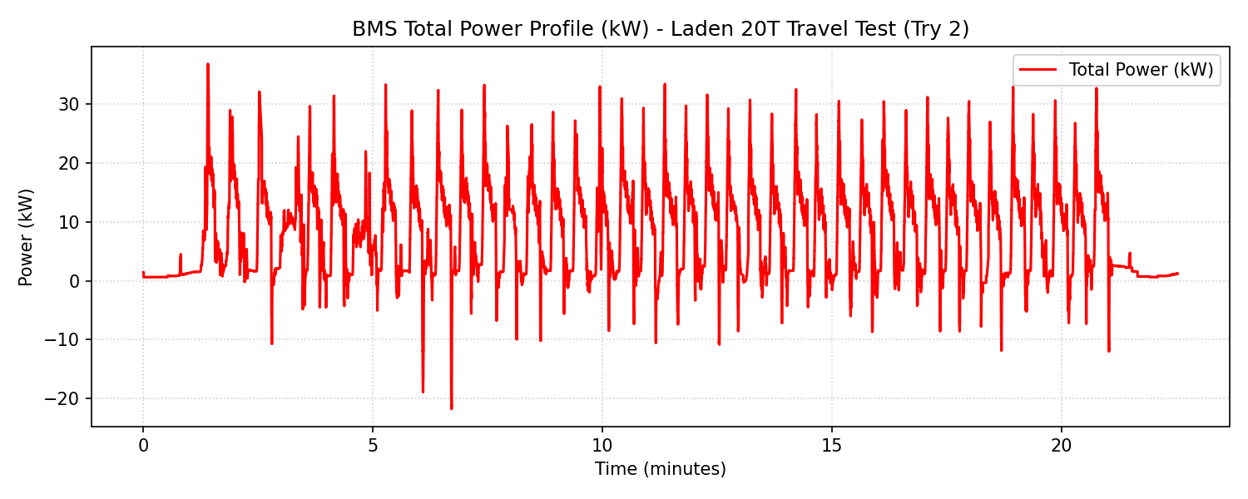

3.2 Calibrated Travel Speed
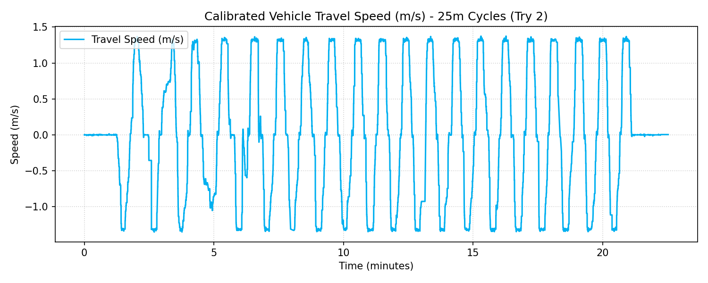

3.3 Motor Currents Comparison
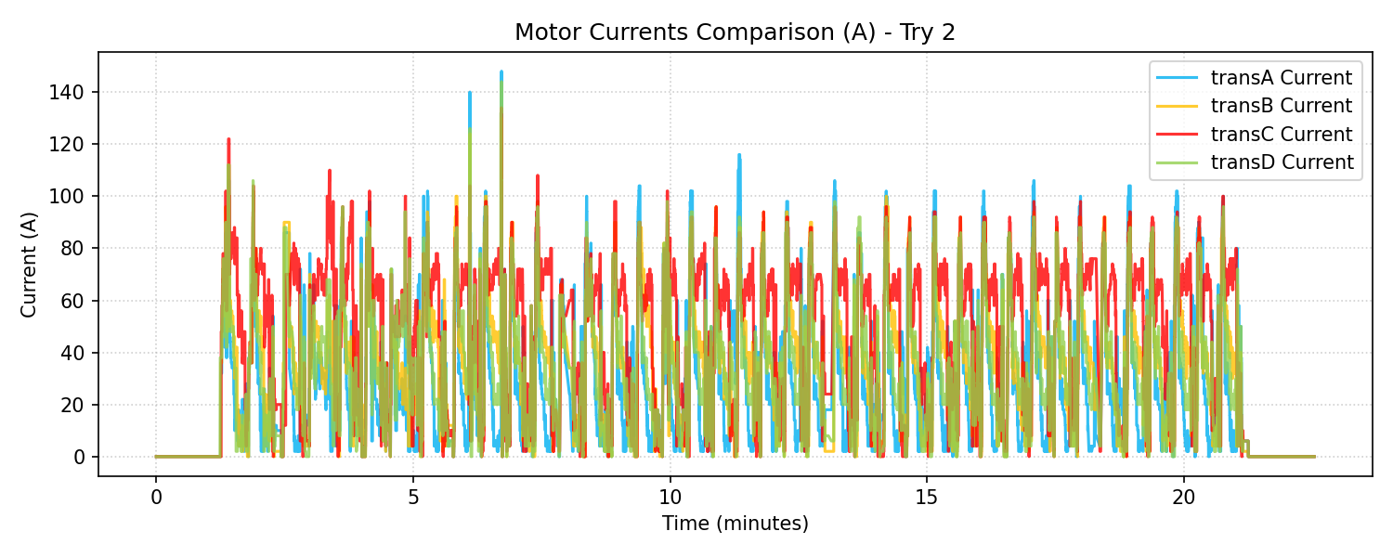

3.4 Motor Temperatures Comparison
