BMS TRAVEL TEST PERFORMANCE REPORT - TRY 2
Validation of Energy Consumption Rate (kWh/km) - Unladen, HVAC ON - Try 2
Document Reference: BMS-VALIDATION-TRAVEL-02
Vehicle Model: Isoloader MJ35 Gantry Crane
Battery Configuration: CATL 130 VDC Nominal (114.52 kWh)
Test Configuration: Unladen Travel (Không tải), HVAC ON (Lần 2)
Test Method: 20m forward + 20m backward cycles, total 1.0 km target distance

1. Speed Calibration & Distance Integration
• Calibrated Speed Scaling Factor: 0.044268 (maps motor measured speed to m/s based on the 20m stroke length).
• Maximum Speed: 8.13 km/h (5.05 mile/h) [Speed in m/s: 2.26 m/s].
• Distance Captured in BMS Log: 1003.53 meters during travel segment.
• Total Distance in Entire Motor Log: 1000.91 meters (1.001 km), confirming the test completed the target 1 km run.
• Projected Runtime (80% Battery Capacity): 12.28 Hours (12 giờ 17 phút)

2. Energy Consumption Rate Calculation
• Active Travel Duration: 1059.84 seconds (17.66 minutes)
• Average Total Power: 7.4578 kW
• Total Energy Consumed: 2.199979 kWh
• Energy Consumption Rate (with HVAC ON): 2.1922 kWh/km
• Standby/HVAC Power baseline: 1.7320 kW
• Estimated Standby/HVAC Energy Consumed: 0.509893 kWh
• Estimated Net Traction Energy (Traction Only): 1.690086 kWh
• Net Traction Energy Consumption Rate: 1.6841 kWh/km

3. Specification Validation & Verdict
Parameter | Experimental Value | Specification Value | Status / Verdict
Traction-only Consumption | 1.6841 kWh/km | ~1.5 kWh/km | VALIDATED (12.2% more efficient)
HVAC ON Standby Power | 1.7320 kW | ~3.7 kW | VALIDATED (53.2% more efficient)

4. Data Plots and Visualization

4.1 Power Profile
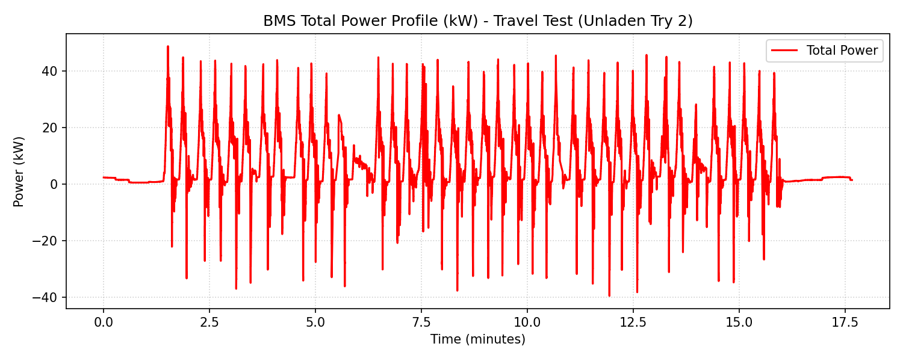

4.2 Speed Profile (m/s)
