BMS OPERATION LADEN TRAVEL TEST REPORT
Validation of Energy Consumption Rate (20T Load) - HVAC ON
Document Reference: BMS-REPORT-LOAD-HVAC-ON
Vehicle Model: Isoloader MJ35 Gantry Crane
Battery Configuration: CATL 130 VDC Nominal (114.52 kWh)
Test Configuration: Laden Travel (Có tải 20 tấn), HVAC ON
Test Method: 25m forward + 25m backward cycles, total 40 times (target 1.0 km)

1. Executive Summary
• Average Combined Power (with HVAC ON): 8.5211 kW
• Total Distance Traveled: 993.61 m (0.9936 km)
• Total Energy Consumed: 2.9513 kWh
• Energy Consumption Rate (with HVAC ON): 2.9703 kWh/km
• Net Traction-only Energy Consumption Rate: 2.3239 kWh/km

2. Motor Balance & Anomaly Analysis
Parameter | Drive A (transA) | Drive B (transB) | Drive C (transC) | Drive D (transD)
Average Current (A) | 30.95 A | 37.16 A | 67.45 A | 35.73 A
Maximum Current (A) | 132.00 A | 108.00 A | 116.00 A | 112.00 A
Mean Absolute Torque (Nm) | 13.65 Nm | 15.22 Nm | 29.76 Nm | 14.19 Nm
Mean Motor Temp (°C) | 43.7 °C | 43.2 °C | 50.5 °C | 40.8 °C
Maximum Motor Temp (°C) | 48.0 °C | 48.0 °C | 59.0 °C | 45.0 °C

3. Data Plots and Visualization

3.1 Power Profile
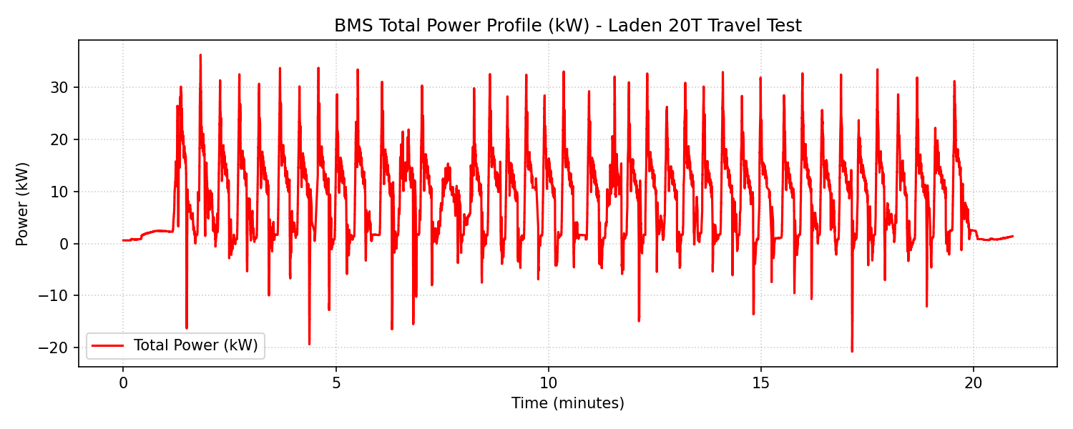

3.2 Calibrated Travel Speed
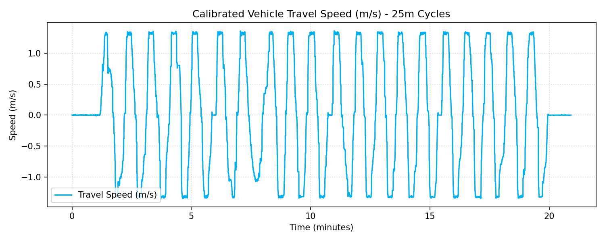

3.3 Motor Currents Comparison
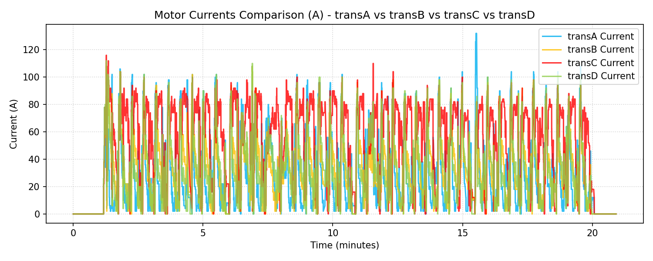

3.4 Motor Temperatures Comparison
