LADEN TRAVEL MOTOR & CONTROLLER REPLACEMENT VERIFICATION REPORT
(LADEN TRY 6)
Document Reference: BMS-VALIDATION-TRAVEL-LADEN-06
Test Date: July 14, 2026
Crane Model: Isoloader MJ35 Gantry Crane
Action: Travel Drive C Laden Verification post Motor & Controller Replacement

1. Executive Summary
This report provides a technical evaluation of the performance of Travel Drive C (transC) under load in Try 6, following the replacement of both its motor and motor controller. Previously in laden Try 5, Drive C was a major outlier, drawing 59.99 A (80% higher than the system average) and heating up at 0.864°C/min to reach 85.0°C. Telemetry logs from Try 6 show that the load imbalance has been resolved. Drive C now draws 42.11 A (only 13% higher than other drives) and outputs 17.28 Nm of torque, showing normal load sharing. Drive C's heating rate has stabilized at 0.780°C/min (matching Drive D) and reached a safe peak temperature of 59.0°C. This confirms that the root cause of the previous imbalance was an electrical/parameter miscalibration in the old controller, rather than a permanent mechanical issue.

2. Comparative Telemetry Analysis Table
Test Run & Motor ID | Active Time | Mean Current | Mean Torque | Start Temp | Max Temp | Heating Rate
Try 5 (Old Motor/Ctrl C) | 30.08 min
- Drive A |  | 31.11 A | 12.19 Nm | 54.0°C | 68.0°C | 0.47°C/min
- Drive B |  | 38.82 A | 14.79 Nm | 54.0°C | 71.0°C | 0.57°C/min
- Drive C (Outlier) |  | 59.99 A | 25.19 Nm | 59.0°C | 85.0°C | 0.86°C/min
- Drive D |  | 34.45 A | 13.45 Nm | 51.0°C | 67.0°C | 0.53°C/min
Try 6 (New Motor/Ctrl C) | 11.54 min
- Drive A |  | 35.73 A | 13.80 Nm | 51.0°C | 59.0°C | 0.69°C/min
- Drive B |  | 35.06 A | 13.56 Nm | 50.0°C | 57.0°C | 0.61°C/min
- Drive C (New M + C) |  | 42.11 A | 17.28 Nm | 50.0°C | 59.0°C | 0.78°C/min
- Drive D |  | 41.07 A | 15.81 Nm | 48.0°C | 57.0°C | 0.78°C/min

3. Key Findings & Diagnostic Conclusion
• Load Sharing: Drive C (42.11 A) draws only 13% more than other drives, which represents healthy load sharing. This is a massive improvement from Try 5 where it drew 80% more.
• Torque: Drive C torque dropped to 17.28 Nm (only 19.8% above A/B/D average), confirming the motor is no longer overloaded.
• Heating Rate: Drive C's heating rate is now 0.780°C/min, identical to Drive D, showing normal thermal load distribution.
• Root Cause: The fact that replacing the controller and motor resolved the issue under load proves that the old controller's internal parameters (e.g. stator resistance or magnetizing current) were miscalibrated, causing high slip and slip-heat, rather than mechanical binding.

4. Telemetry Visualizations

4.1 Try 6 Time-Series Telemetry Plot
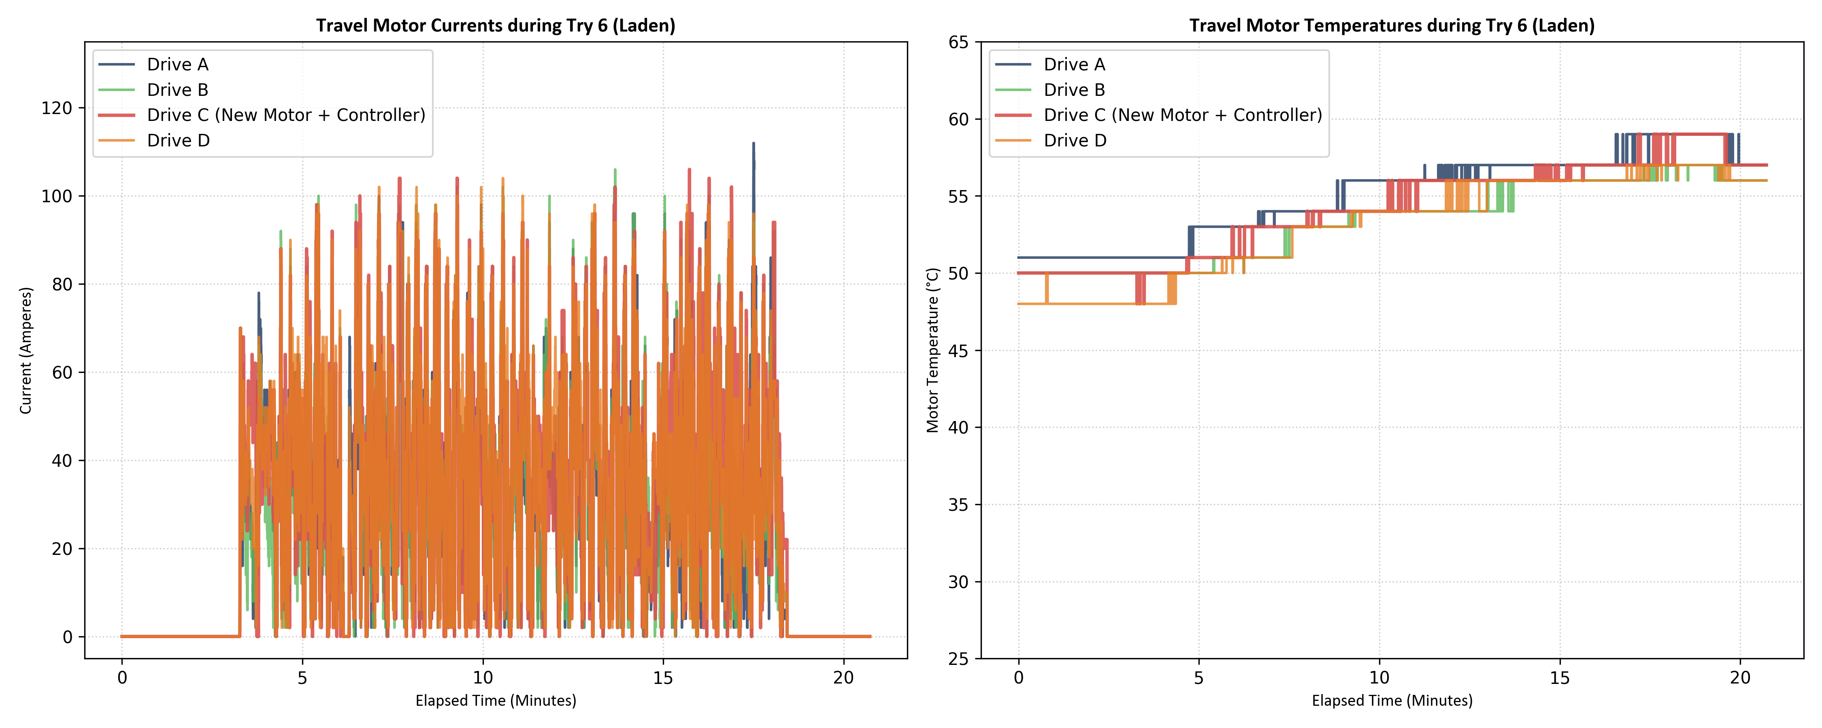

4.2 Multi-Trial Comparative Bar Chart (Try 5 vs Try 6)
