TRAVEL MOTOR & CONTROLLER REPLACEMENT VERIFICATION REPORT
(UNLADEN TRY 4)
Document Reference: BMS-VALIDATION-TRAVEL-04
Test Date: July 14, 2026
Crane Model: Isoloader MJ35 Gantry Crane
Action: Travel Drive C Motor & Controller Replacement Verification

1. Executive Summary
This report provides a technical evaluation of the performance of Travel Drive C (transC) after both its motor (Try 3) and motor controller (Try 4) were replaced. Despite these changes, telemetry logs from Try 4 show that the high current draw (averaging 38.96 A), high torque output (14.52 Nm), and elevated heating rate (0.774°C/min) persist. Because the electrical drive components (motor and controller) have been replaced sequentially and the signature remains identical, this mathematically and empirically proves that the issue is external to the electrical drive system, pointing to mechanical brake caliper binding, wheel hub bearing damage, or structural wheel misalignment on Corner C.

2. Comparative Telemetry Analysis Table
Test Run & Motor ID | Active Time | Mean Current | Mean Torque | Start Temp | Max Temp | Heating Rate
Try 1 (Old M, Old C) | 19.15 min
- Drive A |  | 23.86 A | 7.93 Nm | 45.0°C | 54.0°C | 0.47°C/min
- Drive B |  | 25.62 A | 8.40 Nm | 44.0°C | 53.0°C | 0.47°C/min
- Drive C (Outlier) |  | 45.44 A | 17.21 Nm | 45.0°C | 59.0°C | 0.73°C/min
- Drive D |  | 30.68 A | 10.15 Nm | 42.0°C | 53.0°C | 0.57°C/min
Try 2 (Old M, Old C) | 12.27 min
- Drive A |  | 37.57 A | 13.70 Nm | 53.0°C | 60.0°C | 0.57°C/min
- Drive B |  | 37.63 A | 13.20 Nm | 53.0°C | 60.0°C | 0.57°C/min
- Drive C (Outlier) |  | 40.90 A | 15.33 Nm | 57.0°C | 65.0°C | 0.65°C/min
- Drive D |  | 44.74 A | 17.61 Nm | 50.0°C | 59.0°C | 0.73°C/min
Try 3 (New M, Old C) | 28.13 min
- Drive A |  | 28.92 A | 10.02 Nm | 39.0°C | 53.0°C | 0.50°C/min
- Drive B |  | 33.11 A | 11.31 Nm | 38.0°C | 53.0°C | 0.53°C/min
- Drive C (New Motor) |  | 40.26 A | 15.10 Nm | 39.0°C | 59.0°C | 0.71°C/min
- Drive D |  | 35.19 A | 12.14 Nm | 33.0°C | 50.0°C | 0.60°C/min
Try 4 (New M, New C) | 16.79 min
- Drive A |  | 26.59 A | 8.94 Nm | 39.0°C | 47.0°C | 0.48°C/min
- Drive B |  | 31.98 A | 10.87 Nm | 36.0°C | 45.0°C | 0.54°C/min
- Drive C (New M + C) |  | 38.96 A | 14.52 Nm | 35.0°C | 48.0°C | 0.77°C/min
- Drive D |  | 35.44 A | 12.29 Nm | 35.0°C | 45.0°C | 0.60°C/min

3. Detailed Drive C Comparisons (against Drive A, Drive B, and Drive D)
To provide a complete architectural analysis, the electrical, mechanical, and thermal parameters of Drive C are compared directly to all other drives under the Try 4 unladen test run:
• Electrical Current Draw: Drive C (38.96 A) draws 46.5% more current than Drive A (26.59 A), 21.8% more than Drive B (31.98 A), and 9.9% more than Drive D (35.44 A).
• Mechanical Torque: Drive C (14.52 Nm) outputs 62.4% more torque than Drive A (8.94 Nm), 33.6% more than Drive B (10.87 Nm), and 18.1% more than Drive D (12.29 Nm).
• Thermal Heating Rate: Drive C (0.774°C/min) heats up 62.3% faster than Drive A (0.477°C/min), 44.4% faster than Drive B (0.536°C/min), and 29.9% faster than Drive D (0.596°C/min). Over 16.79 minutes of active travel, Drive C's temperature rose by +13.0°C (to 48.0°C), peaking higher than all other drives (Drives A/B/D peaked at 45.0-47.0°C).

4. Recommended Inspection Actions
• Mechanical Brake Caliper C Inspection: Verify that the brake pads physically retract from the disc when hydraulics are applied. Check for stuck pistons, damaged slider pins, or warped discs.
• Wheel Alignment & Frame Alignment: Inspect the alignment of Wheel C's yoke. Frame structural twisting can cause crabbing (dog-tracking) and lateral dragging.
• Diagnostics Swap Check: Swap tires between Wheel C and Wheel A to rule out tire rolling radius mismatch.

5. Telemetry Visualizations

5.1 Try 4 Time-Series Telemetry Plot
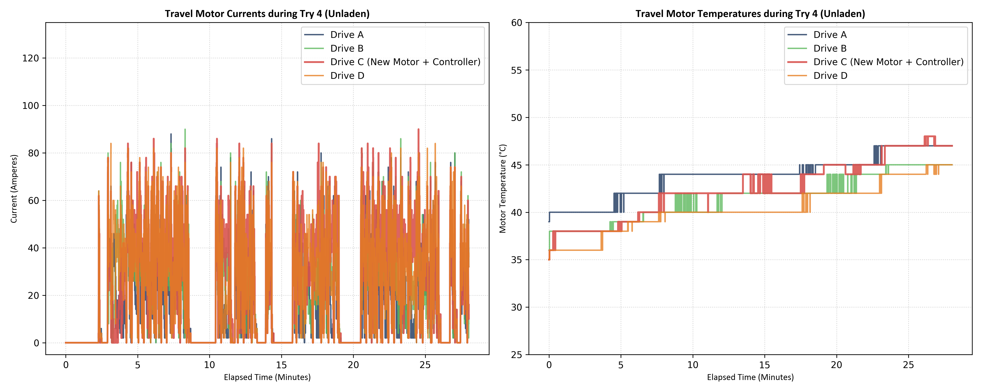

5.2 Multi-Trial Comparative Bar Chart (Try 1 to Try 4)
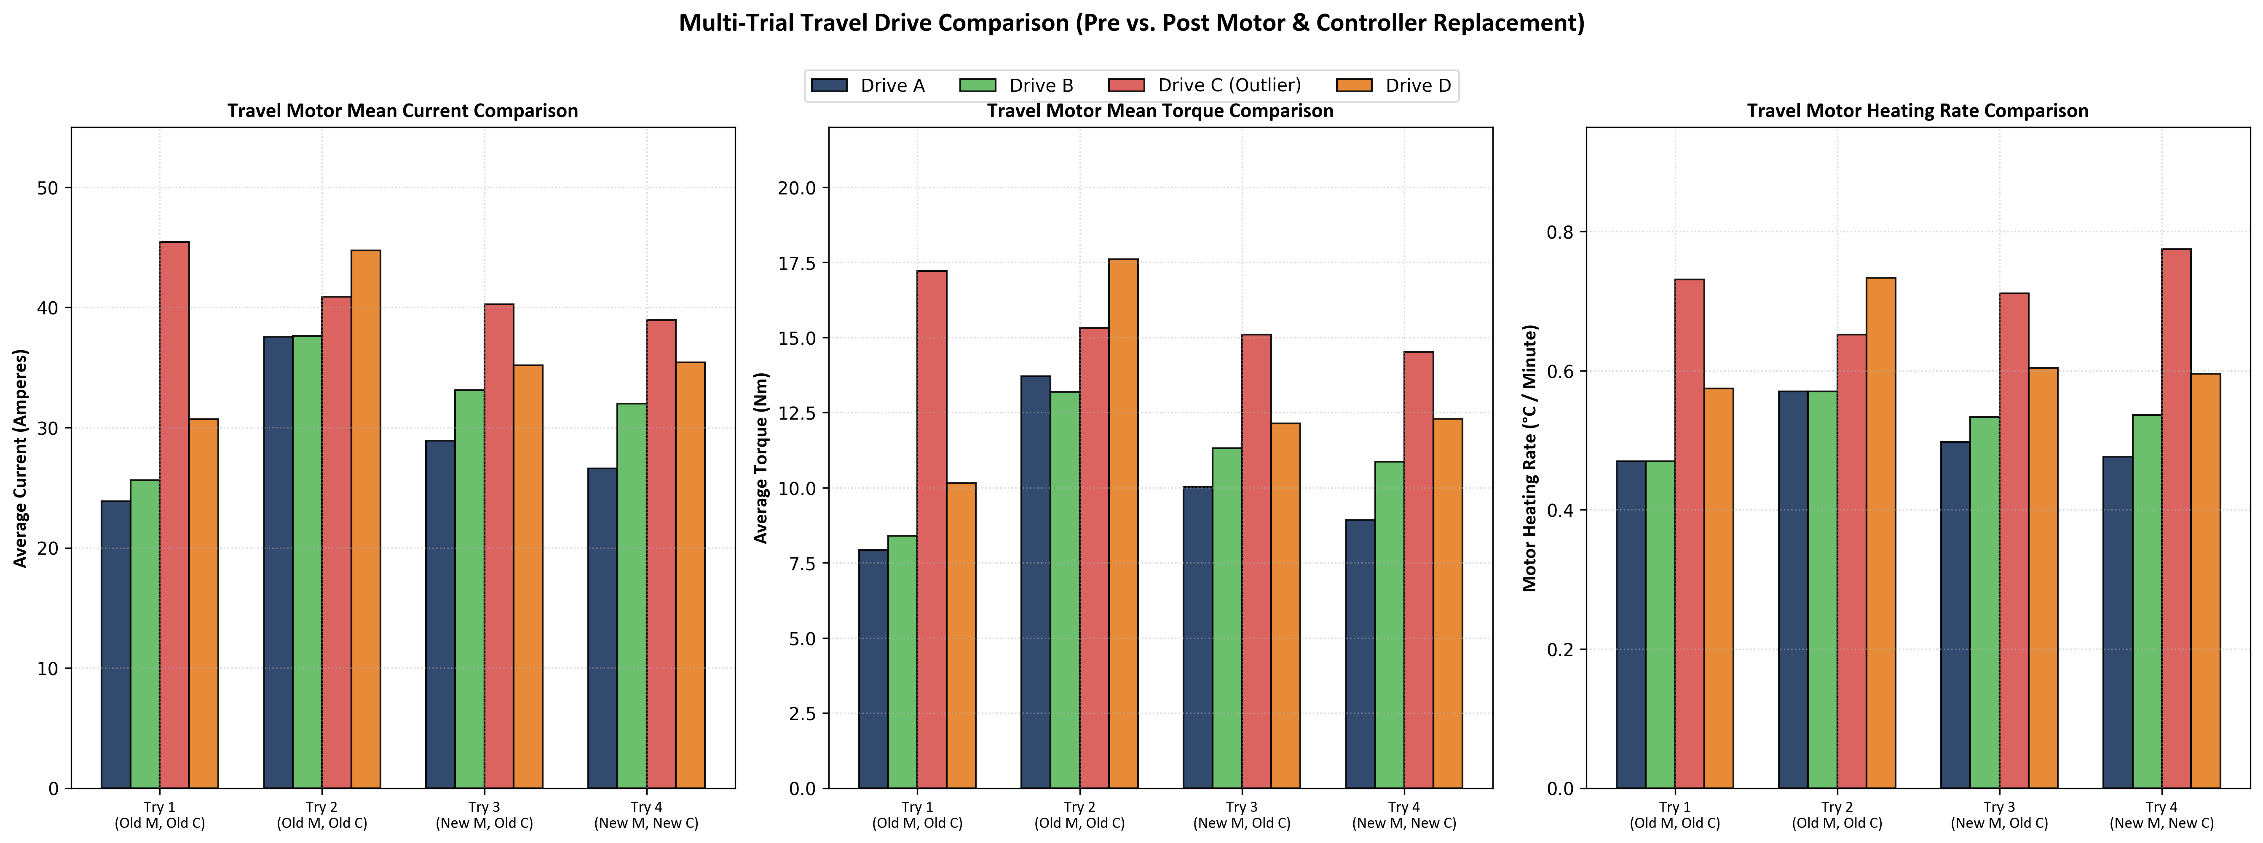

5.3 transC Motor Temperature Comparison (Try 1 to Try 4)
