BMS WINCH PERFORMANCE TEST REPORT
Validation of energy consumed, regenerated and motor temperatures under 20T load
Document Reference: BMS-VALIDATION-WINCH-01
Vehicle Model: Isoloader MJ35 Gantry Crane
Battery Configuration: CATL 130 VDC Nominal (114.52 kWh)
Test Configuration: Winch/Hoist Lifting (Nâng hạ tời 20 tấn), HVAC ON
Test Method: 5 continuous raise + lower cycles, lift height 4200 mm

1. Executive Energy Summary
• Total Energy Discharged (Gross): 1.6332 kWh
• Total Energy Regenerated: 0.7787 kWh
• Net Energy Consumed: 0.8545 kWh
• Regeneration Percentage: 47.68%
• Gross Energy Consumed per Cycle: 0.3266 kWh
• Regenerated Energy per Cycle: 0.1557 kWh
• Net Energy Consumed per Cycle: 0.1709 kWh
• 80% SOC Cycle Capacity (Gross, no regen benefit): 280.5 Cycles (lượt lên xuống)
• 80% SOC Cycle Capacity (Net, with regen benefit): 536.1 Cycles (lượt lên xuống)

2. Motor Balance & Temperature Analysis (Active Lifting)
Parameter | Winch A (WinchA) | Winch B (WinchB) | Winch C (WinchC) | Winch D (WinchD)
Average Current (A) | 75.71 A | 56.56 A | 73.97 A | 73.57 A
Maximum Current (A) | 98.00 A | 80.00 A | 94.00 A | 96.00 A
Mean Absolute Torque (Nm) | 33.59 Nm | 23.51 Nm | 33.09 Nm | 32.90 Nm
Mean Motor Temp (°C) | 59.4 °C | 0.0 °C | 58.9 °C | 52.2 °C
Maximum Motor Temp (°C) | 70.0 °C | 0.0 °C | 68.0 °C | 59.0 °C

3. Data Plots and Visualization

3.1 Power Profile
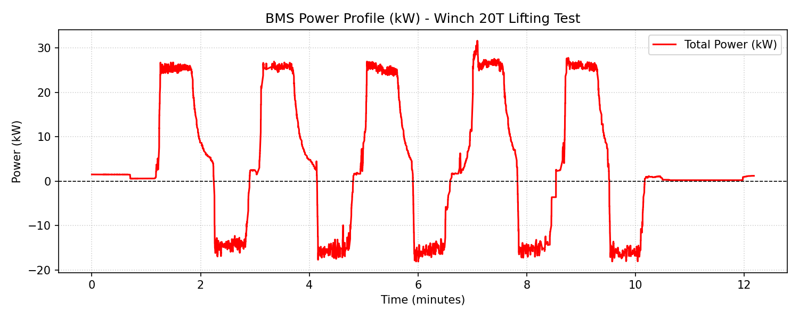

3.2 Winch Drum Angular Position
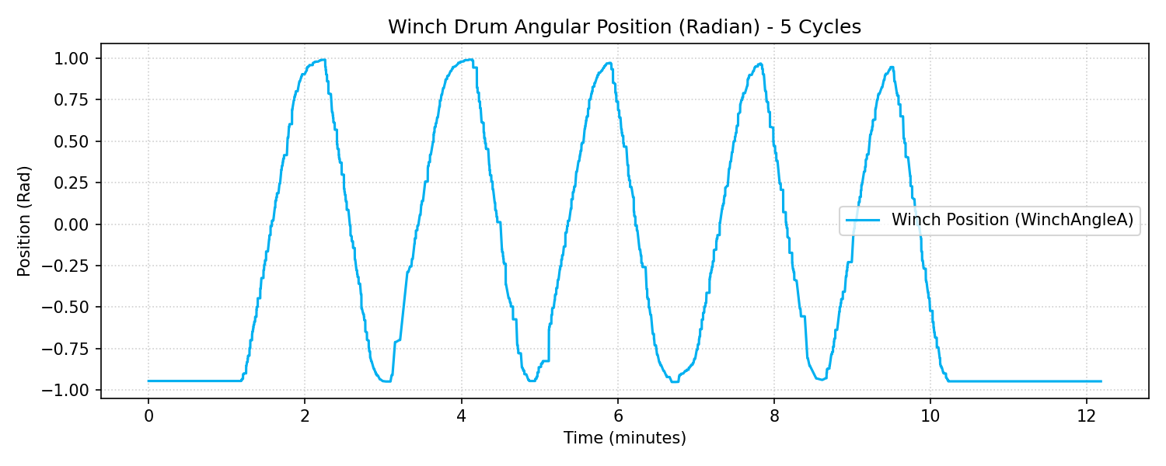

3.3 Winch Motor Currents Comparison
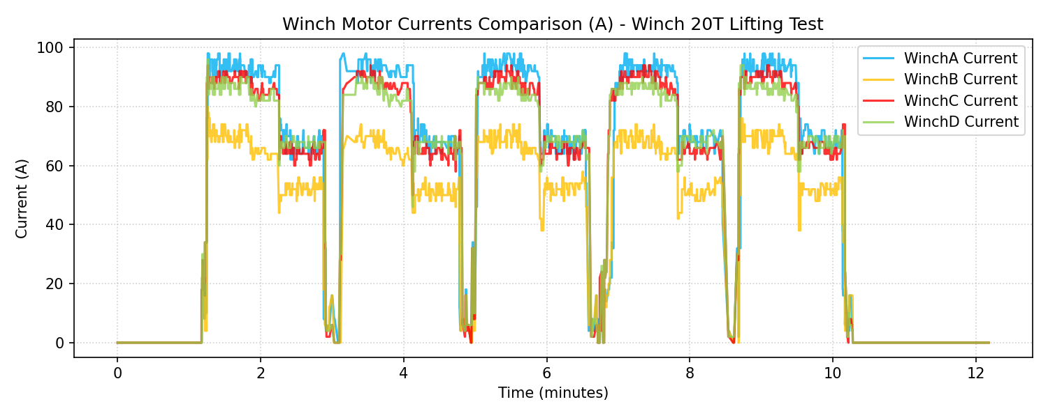

3.4 Winch Motor Temperatures Comparison (Excluding WinchB)
