BMS BATTERY PERFORMANCE REPORT
Case Study: Preparing State - HVAC OFF
Document Reference: BMS-REPORT-TC-01
Vehicle Model: Isoloader MJ35 Gantry Crane
Battery Configuration: CATL 130 VDC Nominal (114.52 kWh)
System State: Preparing (Init Stage 5)
HVAC System Status: OFF
Test Duration: 3599.96 s (60.00 mins)

1. Executive Summary
• Average Total Power: 0.3297 kW
• Total Energy Consumed during Test: 0.3297 kWh
• Projected Continuous Runtime (100% to 10% SOC): 312.64 Hours
• Test Verdict: PASS. The battery packs operate within normal parameters.

2. Statistical Analysis
Metric | Pack A (BMSA) | Pack B (BMSB) | Combined Total
Voltage (Min) | 127.8 V | 127.8 V | -
Voltage (Max) | 127.9 V | 127.9 V | -
Voltage (Average) | 127.89 V | 127.90 V | -
Current (Min) | 0.800 A | 0.800 A | -
Current (Max) | 4.500 A | 4.600 A | -
Current (Average) | 1.253 A | 1.325 A | -
Power (Min) | 0.102 kW | 0.102 kW | 0.205 kW
Power (Max) | 0.576 kW | 0.588 kW | 1.164 kW
Power (Average) | 0.160 kW | 0.169 kW | 0.330 kW

3. Data Plots and Visualization

3.1 Pack Voltages over Time
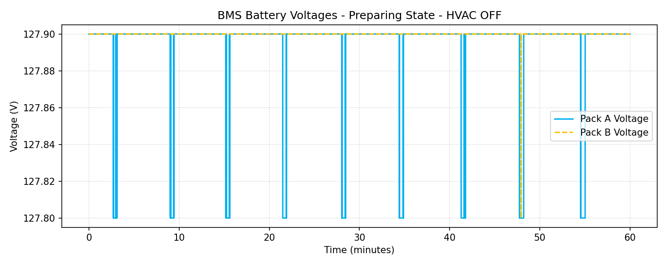

3.2 Pack Currents over Time
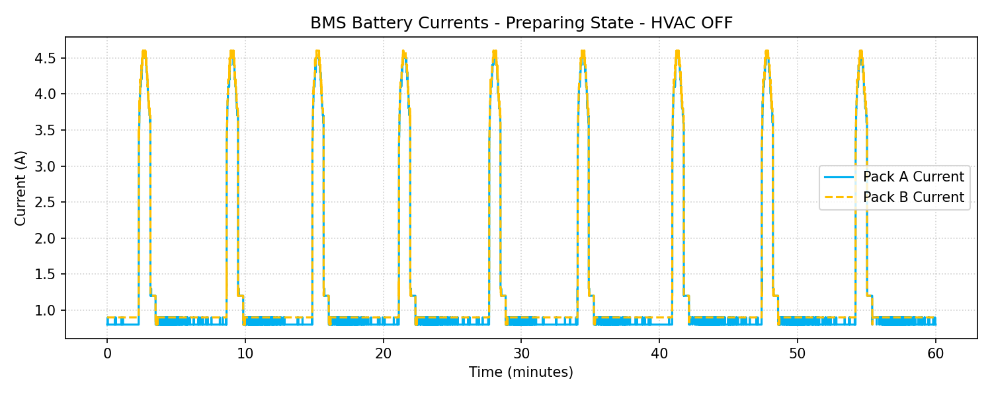

3.3 Power Consumption (kW)
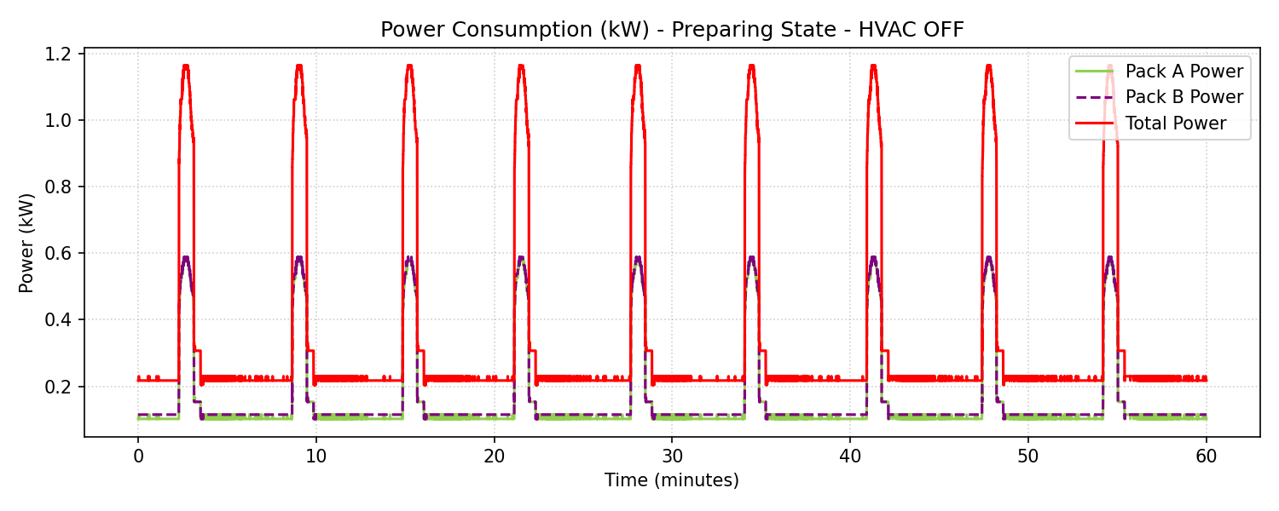

3.4 Load Profile Distribution
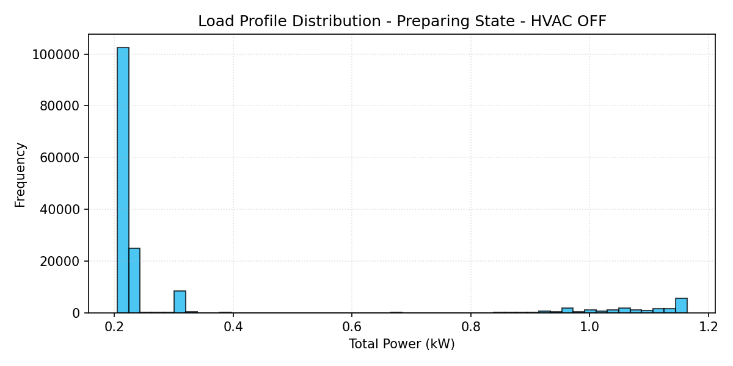

3.5 State of Charge (SOC) Profile
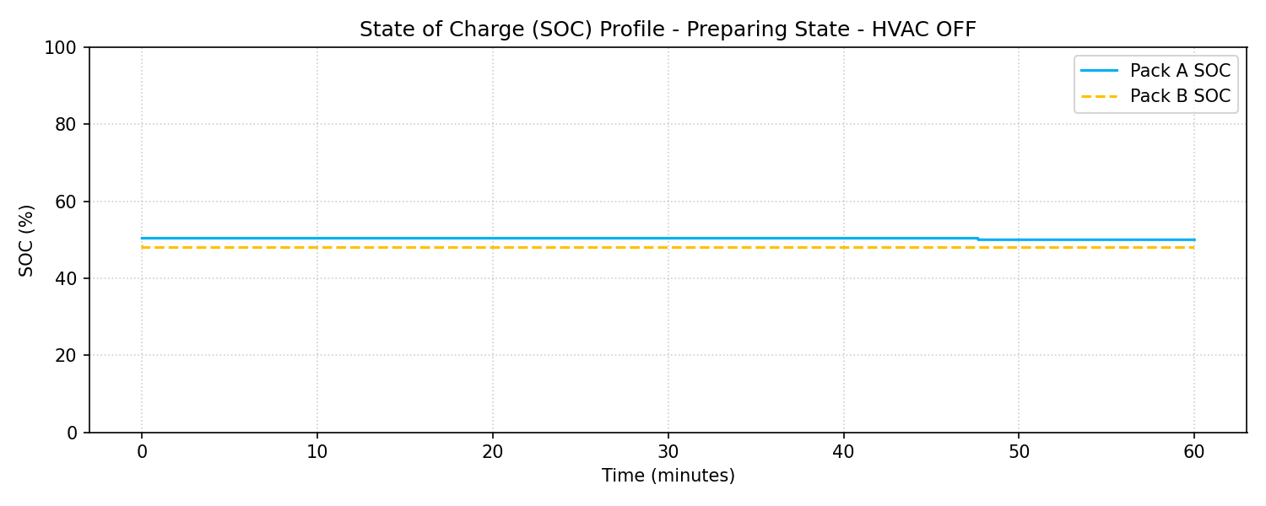

4. Engineering Recommendations
1. Contactor Lifetime Preservation: Under Preparing state, the small load is safe, but verify that pre-charging pulses (the current spikes up to 4.5A) do not cause contactor degradation over time.
2. HVAC Impact: The air conditioning consumes about ~3.37 kW constantly. This represents a significant load during standby (representing about 91% of standby power). Operators should be trained to turn OFF the HVAC when the crane is parked in preparing state for long periods to conserve battery energy.
3. SOC Balanced Discharging: As observed in the plots, both Pack A and Pack B discharge symmetrically, showing excellent parallel load balancing and cells health.

