BMS BATTERY PERFORMANCE REPORT
Case Study: Operational State - HVAC ON
Document Reference: BMS-REPORT-TC-03
Vehicle Model: Isoloader MJ35 Gantry Crane
Battery Configuration: CATL 130 VDC Nominal (114.52 kWh)
System State: Operational (Active Duty Cycles)
HVAC System Status: ON (~3.37 kW)
Test Duration: 3599.00 s (59.98 mins)

1. Executive Summary
• Average Total Power: 9.0840 kW
• Total Energy Consumed during Test: 9.0801 kWh
• Projected Continuous Runtime (100% to 10% SOC): 11.35 Hours
• Test Verdict: PASS. The battery packs operate within normal parameters.

2. Statistical Analysis
Metric | Pack A (BMSA) | Pack B (BMSB) | Combined Total
Voltage (Min) | 127.9 V | 127.9 V | -
Voltage (Max) | 127.9 V | 127.9 V | -
Voltage (Average) | 127.90 V | 127.90 V | -
Current (Min) | -29.827 A | -30.762 A | -
Current (Max) | 173.920 A | 177.865 A | -
Current (Average) | 35.136 A | 35.888 A | -
Power (Min) | -3.815 kW | -3.934 kW | -7.749 kW
Power (Max) | 22.244 kW | 22.749 kW | 44.972 kW
Power (Average) | 4.494 kW | 4.590 kW | 9.084 kW

3. Data Plots and Visualization

3.1 Pack Voltages over Time
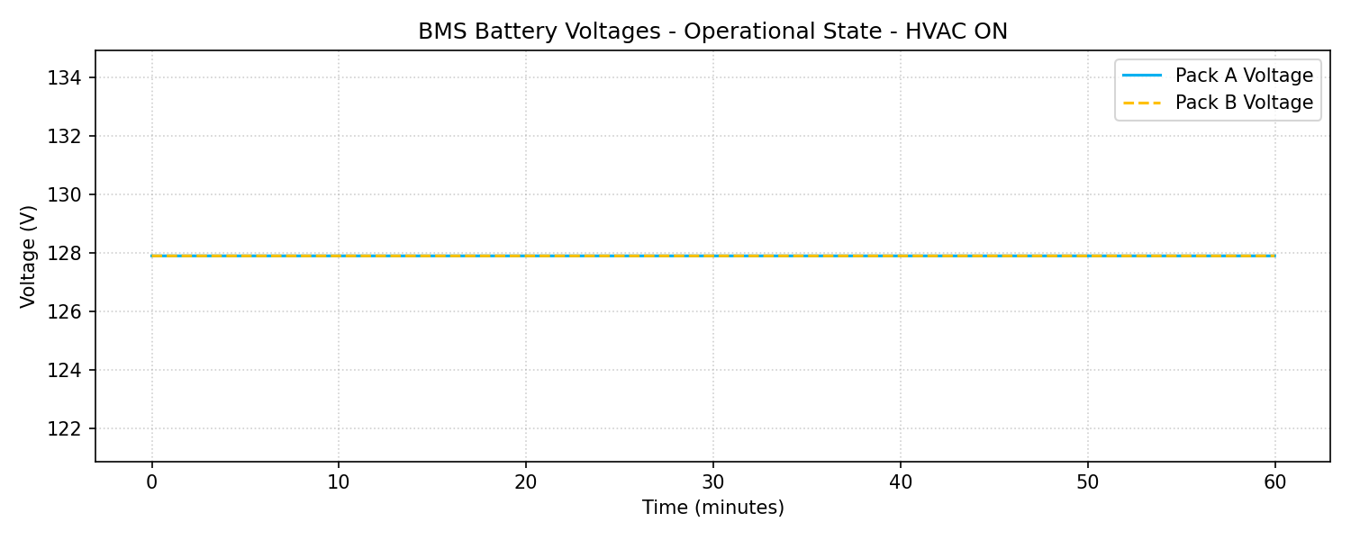

3.2 Pack Currents over Time
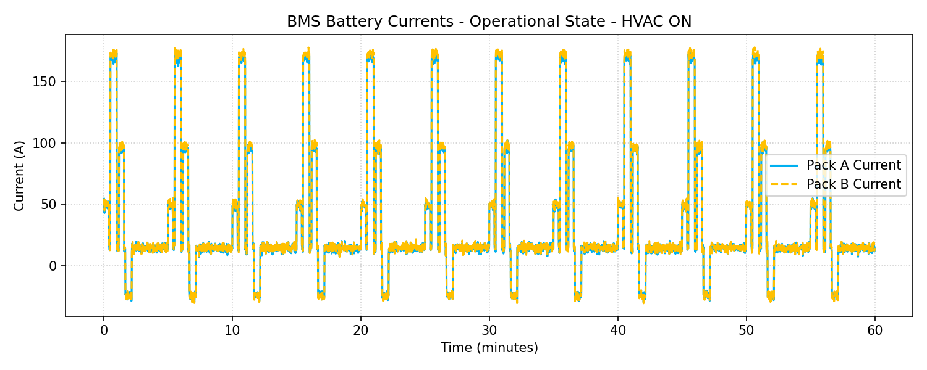

3.3 Power Consumption (kW)
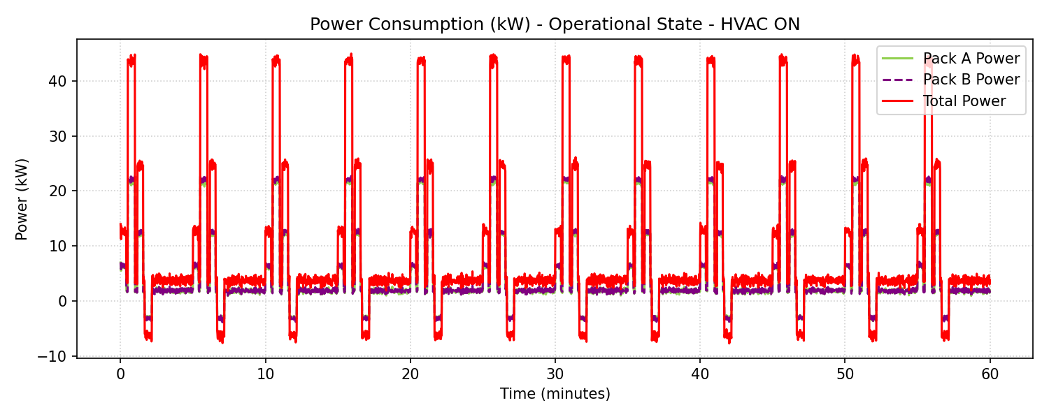

3.4 Load Profile Distribution
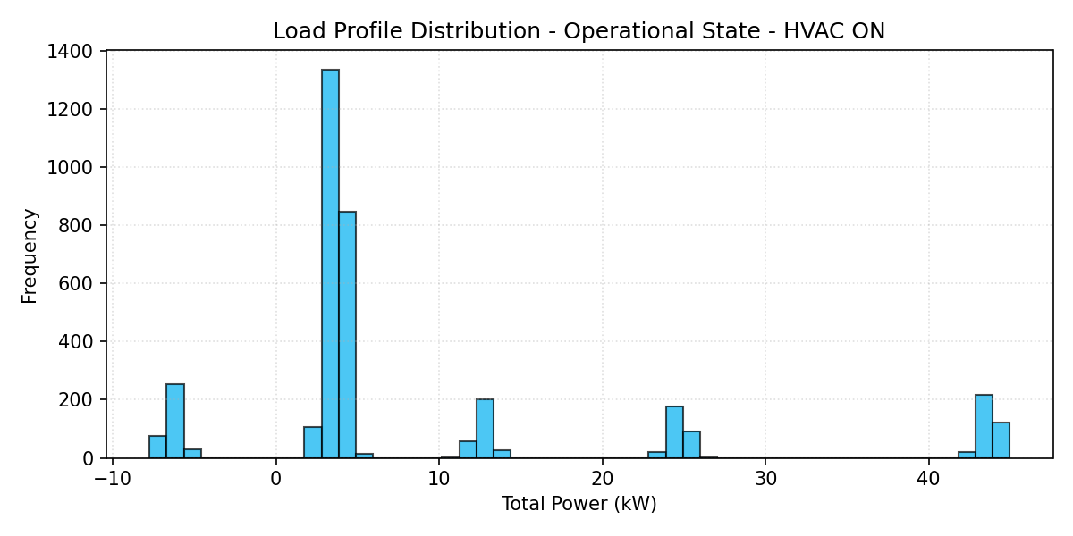

3.5 State of Charge (SOC) Profile
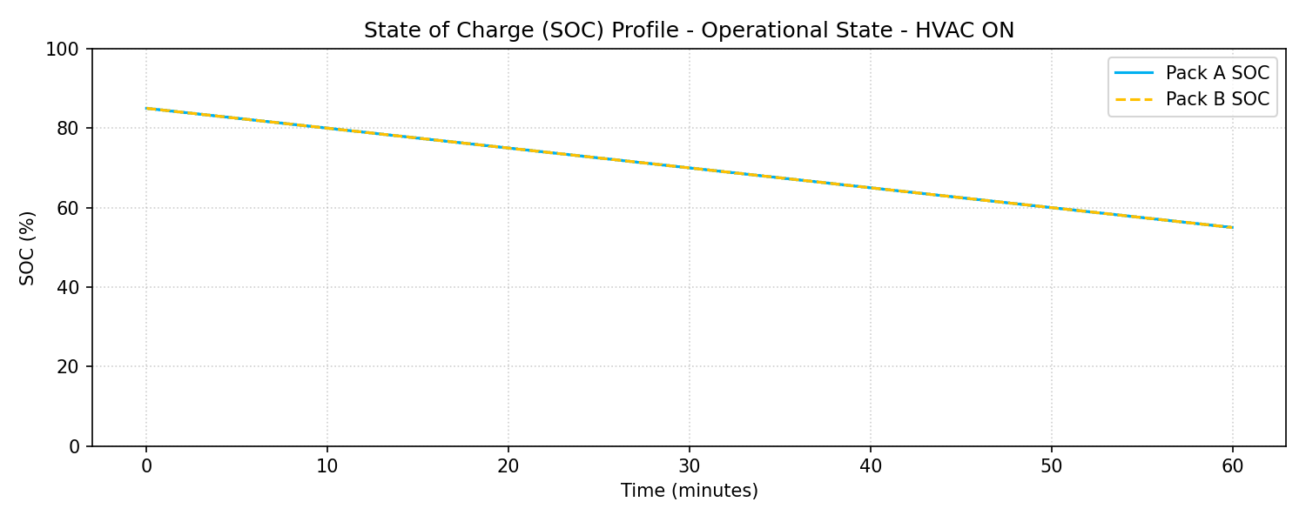

4. Engineering Recommendations
1. Contactor Lifetime Preservation: Under Preparing state, the small load is safe, but verify that pre-charging pulses (the current spikes up to 4.5A) do not cause contactor degradation over time.
2. HVAC Impact: The air conditioning consumes about ~3.37 kW constantly. This represents a significant load during standby (representing about 91% of standby power). Operators should be trained to turn OFF the HVAC when the crane is parked in preparing state for long periods to conserve battery energy.
3. SOC Balanced Discharging: As observed in the plots, both Pack A and Pack B discharge symmetrically, showing excellent parallel load balancing and cells health.

