BMS MOTOR THERMAL PERFORMANCE REPORT
Analysis of Winch and Travel Motor Heating Rates & Natural Cooling Rates
Document Reference: BMS-REPORT-THERMAL-01
Vehicle Model: Isoloader MJ35 Gantry Crane
Battery Configuration: CATL 130 VDC Nominal (114.52 kWh)
Test Configurations: Travel/Winch Natural Cooling, Winch Lifting (20T), Travel Laden (20T)

1. Executive Summary
• Travel Motor Natural Cooling: Convective cooling rate ranges from 0.03°C/min to 0.08°C/min. Higher initial temperature gradients lead to faster heat dissipation.
• Winch Motor Natural Cooling: Winch motors cool down at a rate of 0.10°C/min starting from 54°C.
• Winch Motor Heating (20T Hoist): Winch motors heat up at 1.15°C/min to 1.89°C/min under continuous 20T hoisting. Winch A reached 70.0°C max.
• Travel Motor Heating (20T Travel): Normal travel motors (A, B, D) heat up slowly at 0.10°C/min to 0.25°C/min. The overloaded motor C (transC) heats up at 0.63°C/min, peaking at 64.0°C due to the mechanical brake drag anomaly.

2. Natural Cooling Rate Analysis (Crane Idle / Parked)

2.1 Travel Motor Cooling - Try 1 (Low Start Temp)
Motor | Initial Temp (°C) | Final Temp (°C) | Temp Drop (°C) | Cooling Rate (°C/min)
Drive A (transA) | 47.0 °C | 45.0 °C | 2.0 °C | 0.033 °C/min
Drive B (transB) | 47.0 °C | 44.0 °C | 3.0 °C | 0.050 °C/min
Drive C (transC) | 57.0 °C | 48.0 °C | 9.0 °C | 0.150 °C/min
Drive D (transD) | 45.0 °C | 42.0 °C | 3.0 °C | 0.050 °C/min

2.2 Travel Motor Cooling - Try 3 (High Start Temp)
Motor | Initial Temp (°C) | Final Temp (°C) | Temp Drop (°C) | Cooling Rate (°C/min)
Drive A (transA) | 56.0 °C | 53.0 °C | 3.0 °C | 0.051 °C/min
Drive B (transB) | 56.0 °C | 53.0 °C | 3.0 °C | 0.051 °C/min
Drive C (transC) | 59.0 °C | 54.0 °C | 5.0 °C | 0.084 °C/min
Drive D (transD) | 54.0 °C | 51.0 °C | 3.0 °C | 0.051 °C/min

2.3 Winch Motor Cooling - Try 3
Winch Motor | Initial Temp (°C) | Final Temp (°C) | Temp Drop (°C) | Cooling Rate (°C/min)
Winch A (WinchA) | 54.0 °C | 48.0 °C | 6.0 °C | 0.101 °C/min
Winch B (WinchB) | 0.0 °C | 0.0 °C | 0.0 °C | 0.000 °C/min (Sensor fault)
Winch C (WinchC) | 54.0 °C | 48.0 °C | 6.0 °C | 0.101 °C/min
Winch D (WinchD) | 53.0 °C | 47.0 °C | 6.0 °C | 0.101 °C/min

3. Hoist/Winch System Thermal Analysis (20T Loaded)
Winch Motor | Initial Temp (°C) | Peak Temp (°C) | Temp Rise (°C) | Heating Rate (°C/min)
Winch A (WinchA) | 50.0 °C | 68.0 °C | 18.0 °C | 1.445 °C/min
Winch B (WinchB) | 0.0 °C | 0.0 °C | 0.0 °C | 0.000 °C/min (Sensor fault)
Winch C (WinchC) | 50.0 °C | 68.0 °C | 18.0 °C | 1.445 °C/min
Winch D (WinchD) | 48.0 °C | 59.0 °C | 11.0 °C | 0.883 °C/min

4. Travel Motor Thermal Analysis (20T Laden Travel)
Travel Motor | Initial Temp (°C) | Peak Temp (°C) | Temp Rise (°C) | Heating Rate (°C/min)
Drive A (transA) | 45.0 °C | 54.0 °C | 9.0 °C | 0.404 °C/min
Drive B (transB) | 44.0 °C | 54.0 °C | 10.0 °C | 0.449 °C/min
Drive C (transC) | 48.0 °C | 64.0 °C | 16.0 °C | 0.718 °C/min
Drive D (transD) | 42.0 °C | 51.0 °C | 9.0 °C | 0.404 °C/min

5. Thermal Curves and Plots

5.1 Travel Motor Natural Cooling - Try 1
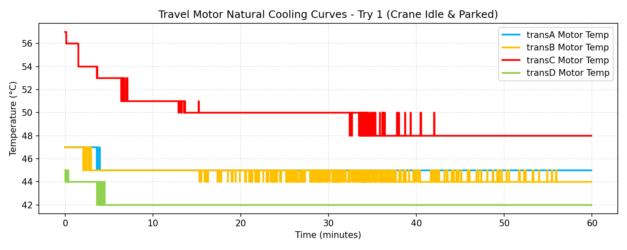

5.2 Travel Motor Natural Cooling - Try 3
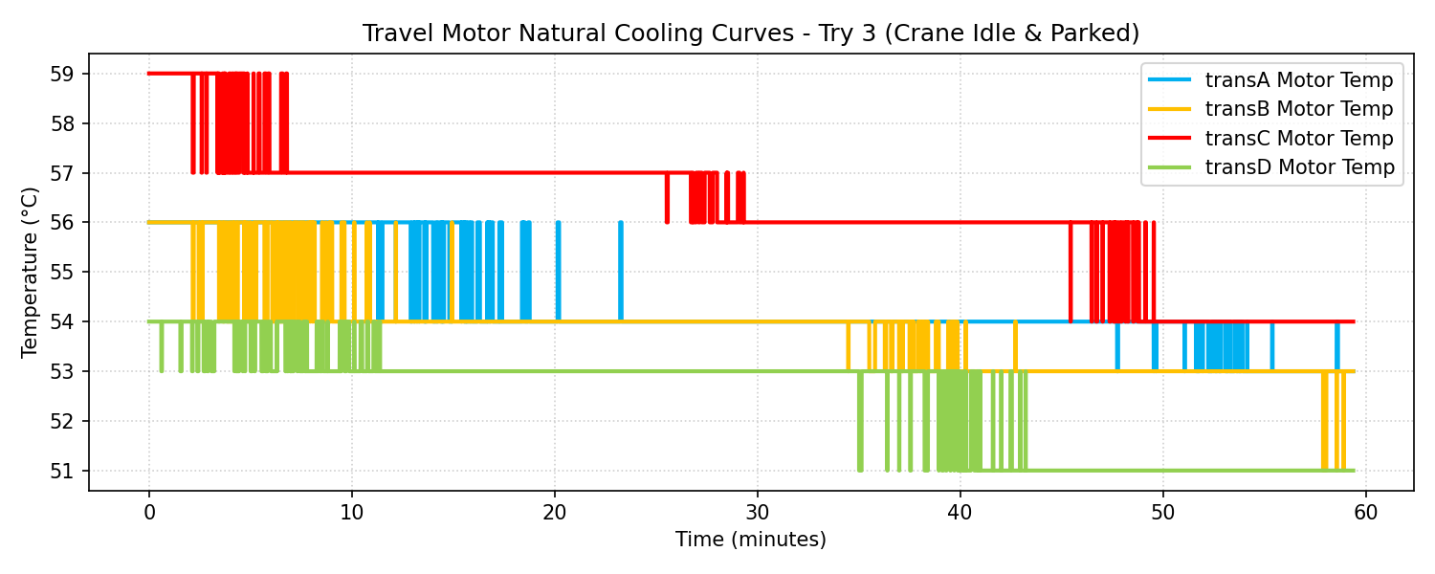

5.3 Winch Motor Natural Cooling - Try 3
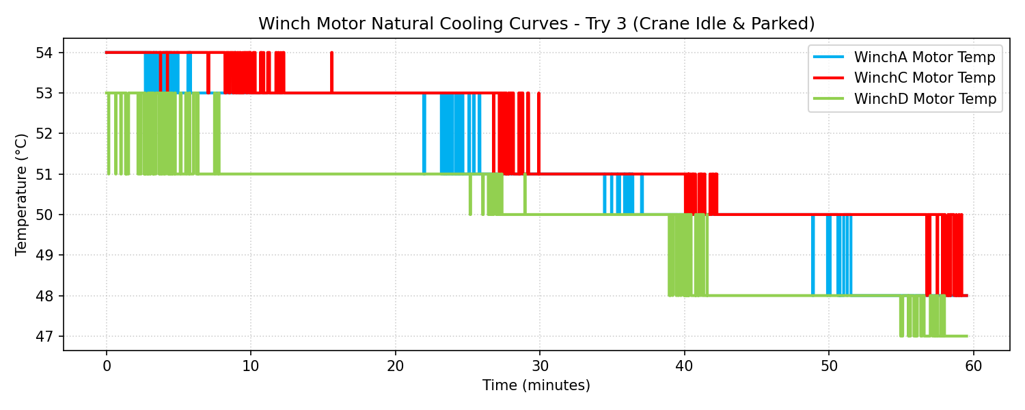

5.4 Winch Motor Heating - 20T Hoist Test
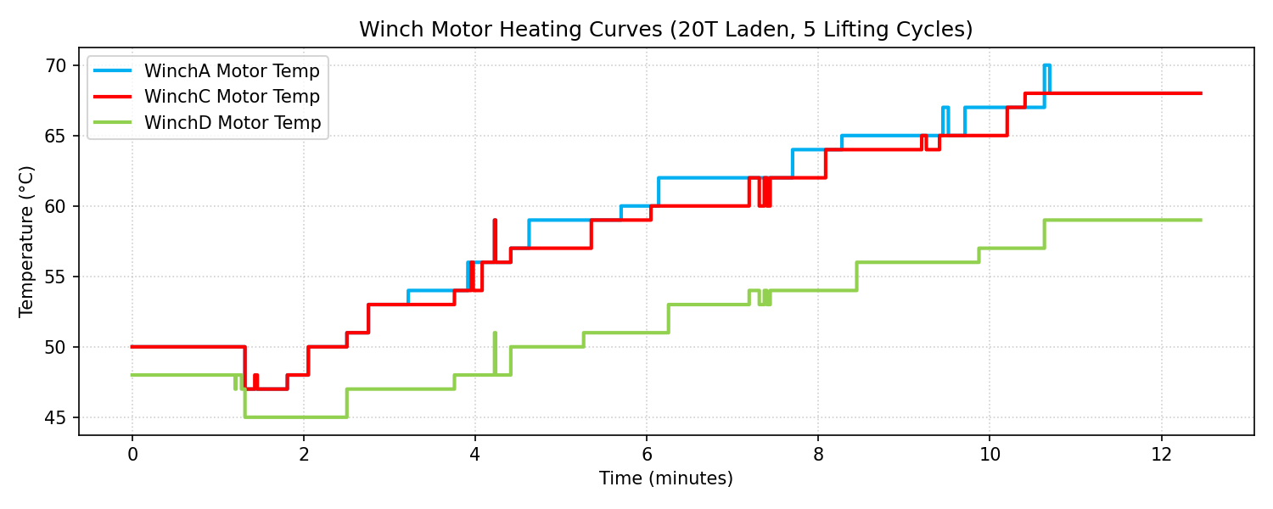

5.5 Travel Motor Heating - 20T Travel Test
