CinePile
A Netflix-grade streaming platform, built for India.
This document walks through the product in three phases. We show you a working, polished experience first, then add monetisation, then scale. Each phase is independently shippable.
____________________________________________________________

Phase 1 — Launch experience
What your customers see and feel on Day 1. No payments, no DRM gates, no licensing complexity — just a smooth, modern streaming product they want to use.

Beautiful home page
Customers land on a Netflix-style hero billboard with auto-curated rows below — New Releases, Trending Now, Recommended for You, Top in India.
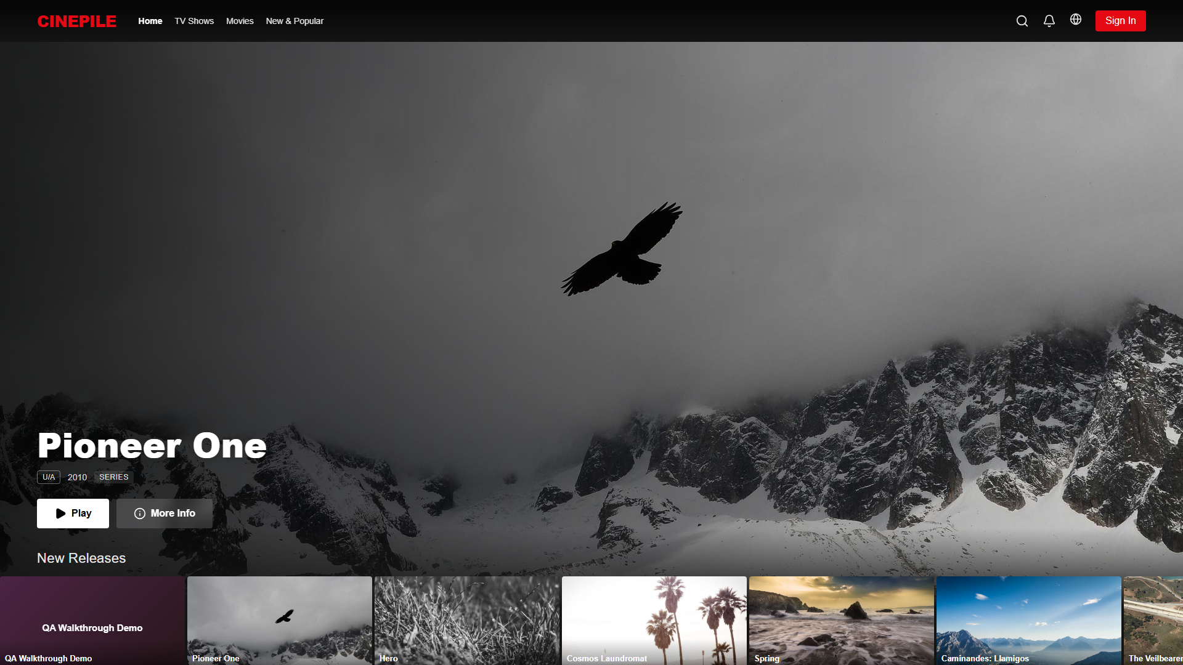

Personalised home (for signed-in users)
Once a user logs in, the home page adapts: Continue Watching, My List, and personalised recommendations appear automatically based on what they've reacted to and watched.
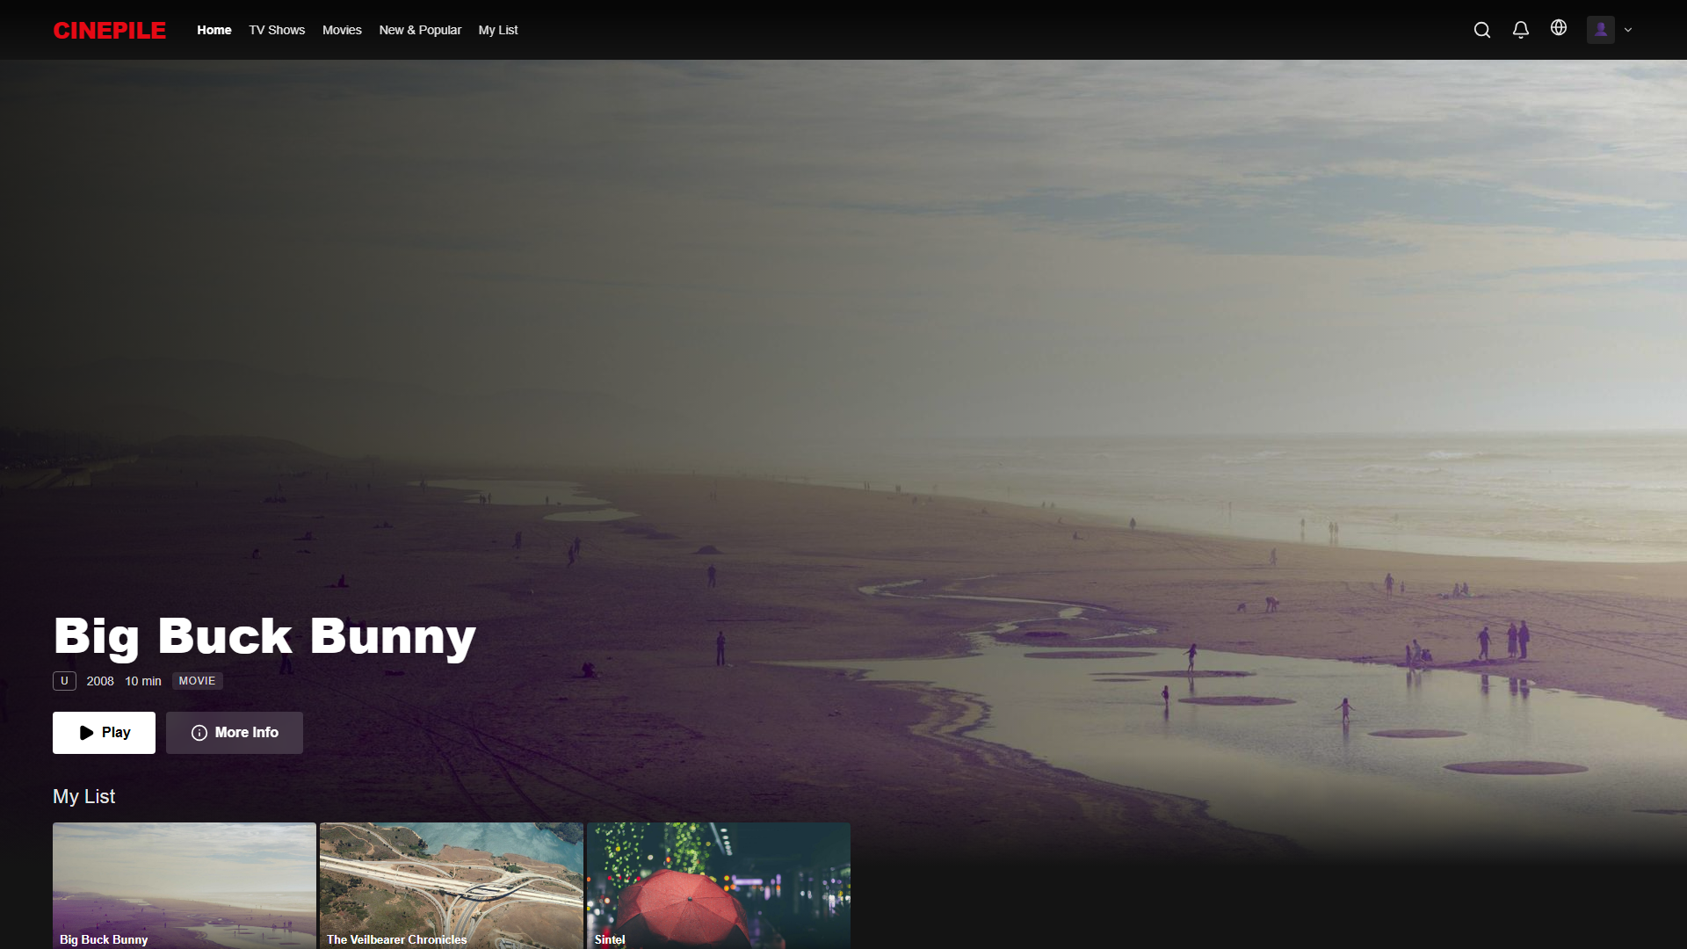

Sign in & sign up — Netflix-grade auth
Floating-label inputs, hero background, smooth transitions. The same auth shell handles both flows so users don't get lost.
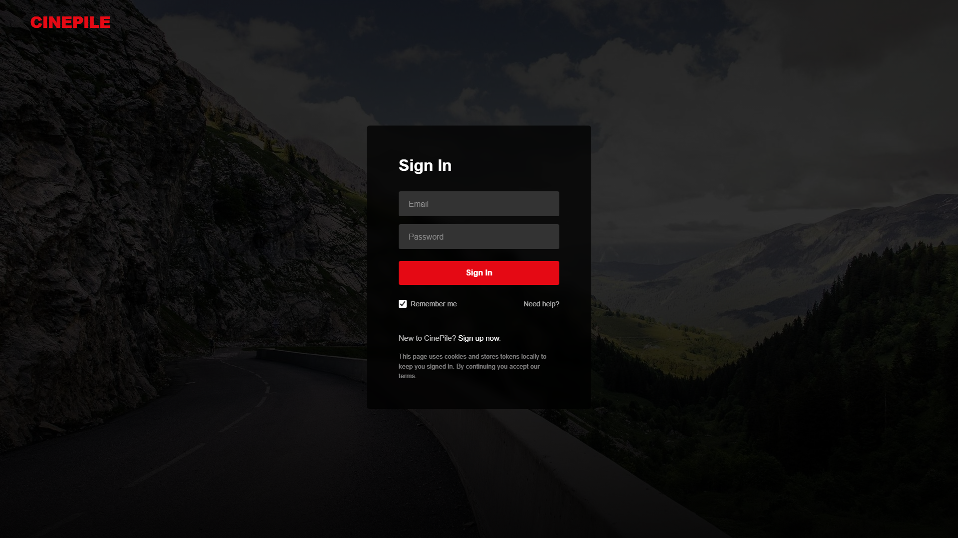
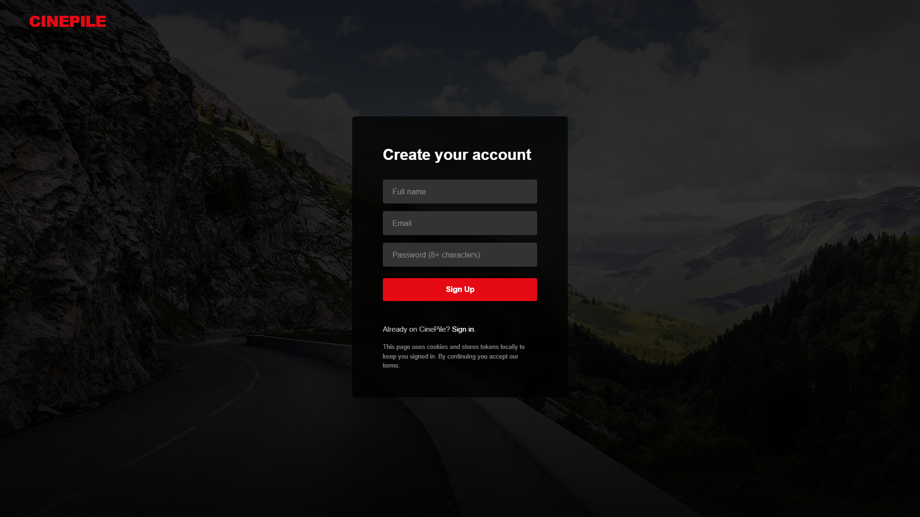

"Who's watching?" profile picker
Up to 4 profiles per account. Each can be marked as a Kid profile (content filtering ready for Phase 2). Avatar grid for picking, profile-level personalisation.
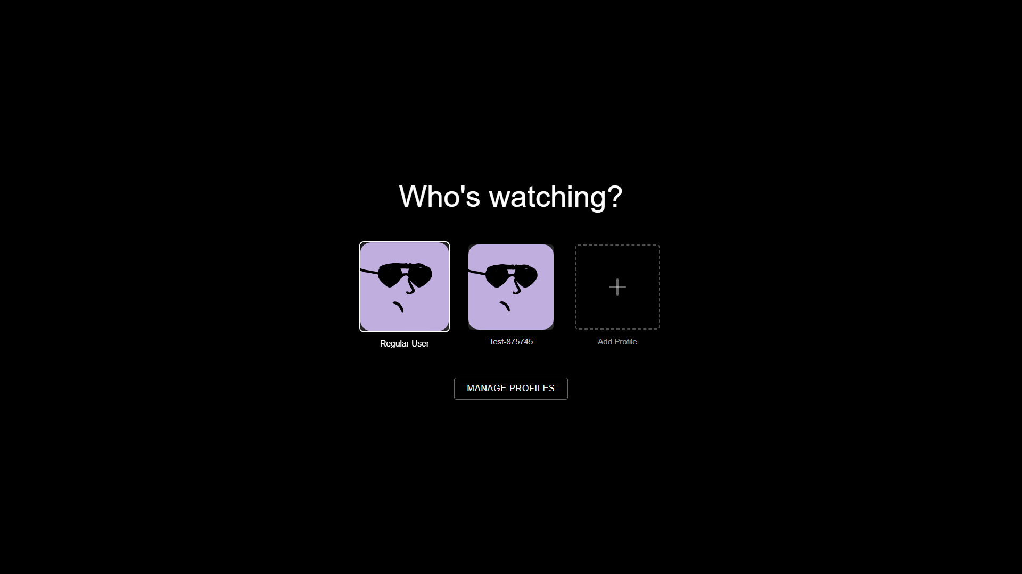

Browse + filter
Cinema-style grid with Type / Genre / Sort filters. Pagination, deep-linkable URLs, mobile-first responsive design.
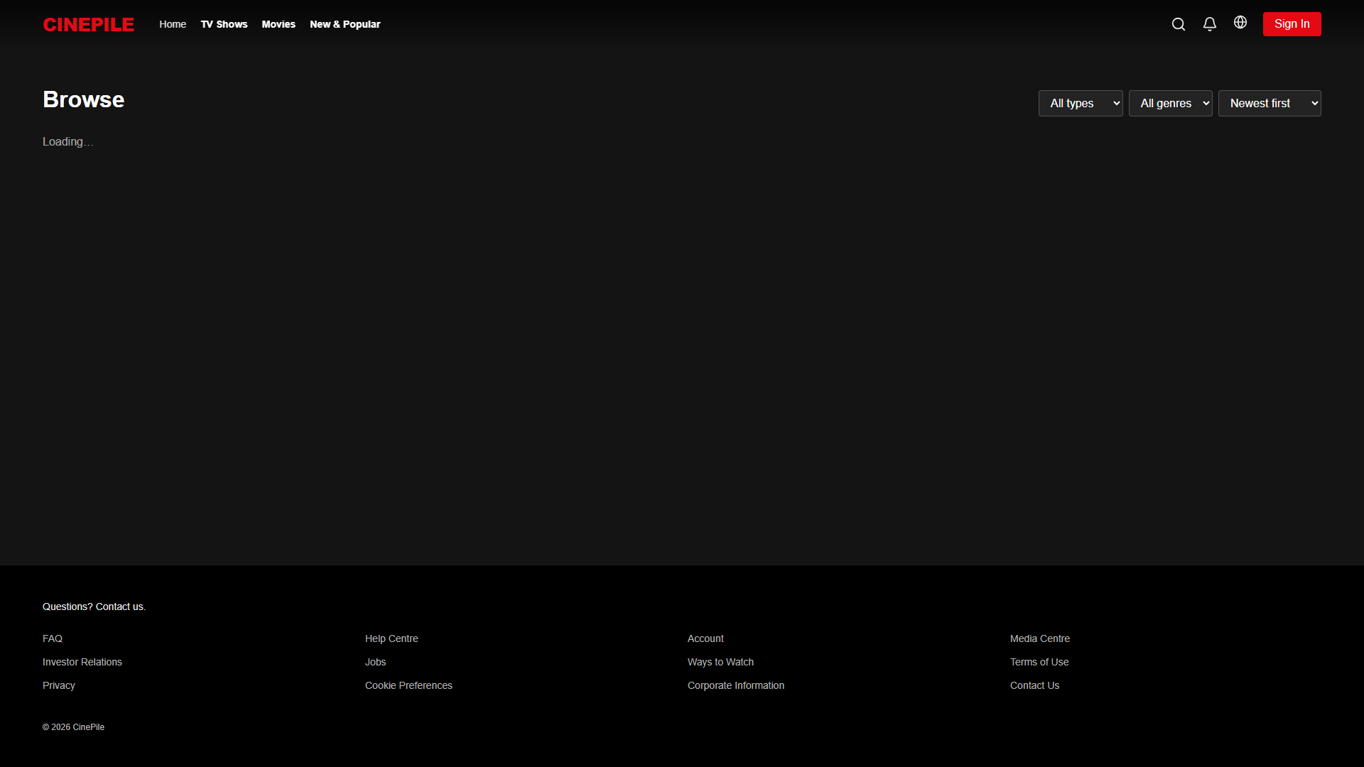

Search
Debounced 300ms search with multi-language support. Handles special characters safely (no SQL wildcards leaking into queries).
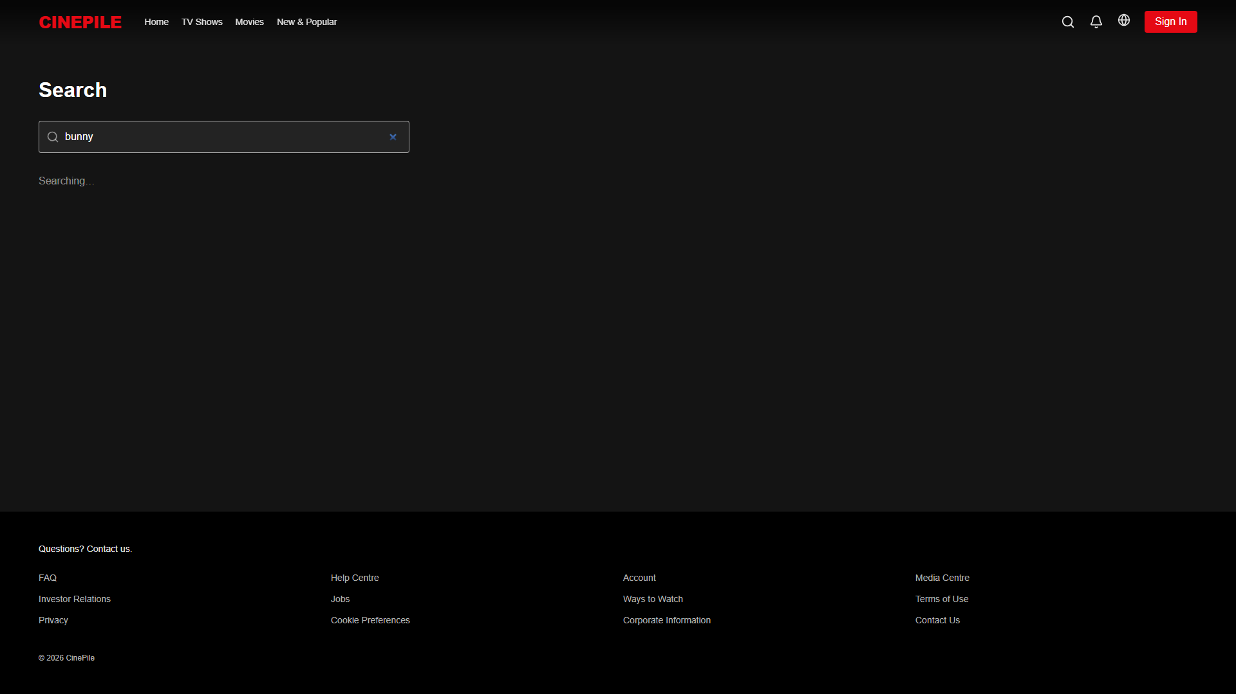

Title detail page
Full title detail with synopsis, cast, genre badges, episode list (for series), Watch Trailer button. Smooth animation, hero backdrop.
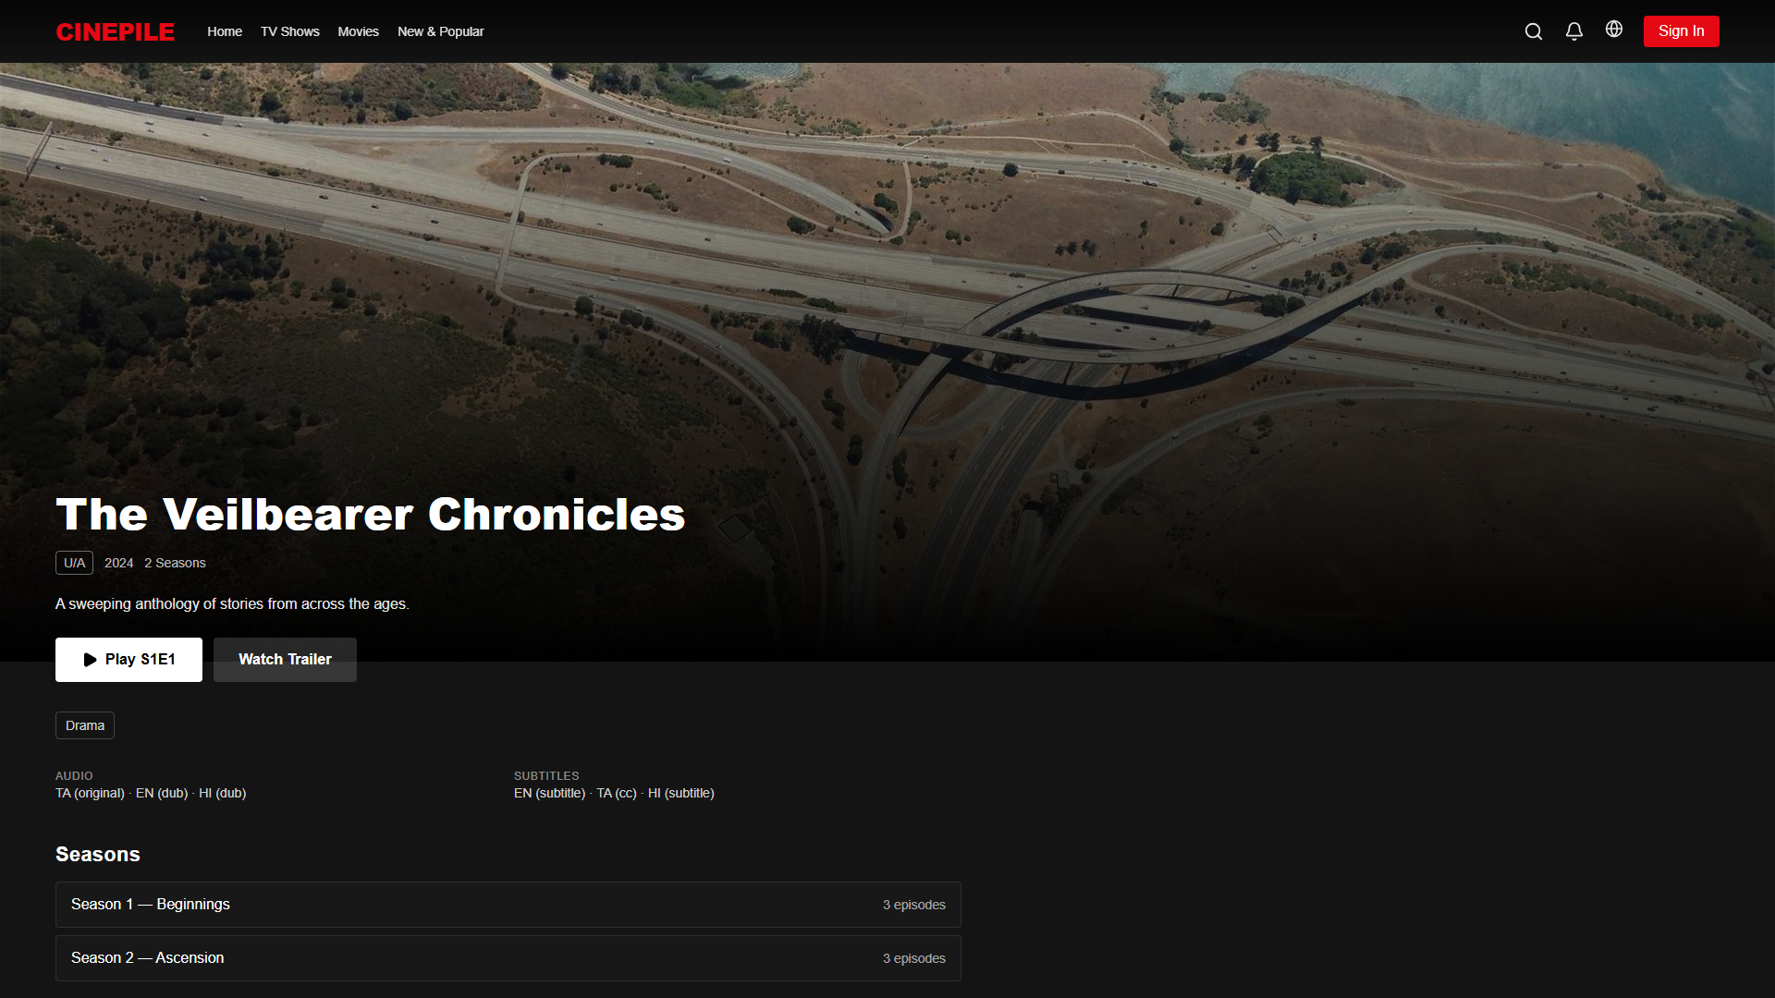

What you can do in Phase 1
- Watch content in any supported quality (Auto / 1080p / 720p / 480p — switches based on user's connection)
- Switch audio language (when content has multi-track audio)
- Closed captions in any language — admin uploads .vtt files per language
- Skip Intro on episodes (Netflix-style overlay)
- Resume from last position across devices
- Continue Watching row stays in sync
- My List to save titles for later
- Like / dislike titles (drives recommendations)
- Multi-language UI — English, Hindi, Tamil out of the box (globe icon to switch)
- Mobile, tablet, laptop, desktop, large TV — every screen size tested

Admin / content team experience
A clean admin panel lets your team add titles, upload video, upload subtitles per language, publish on a schedule. Every action is logged.
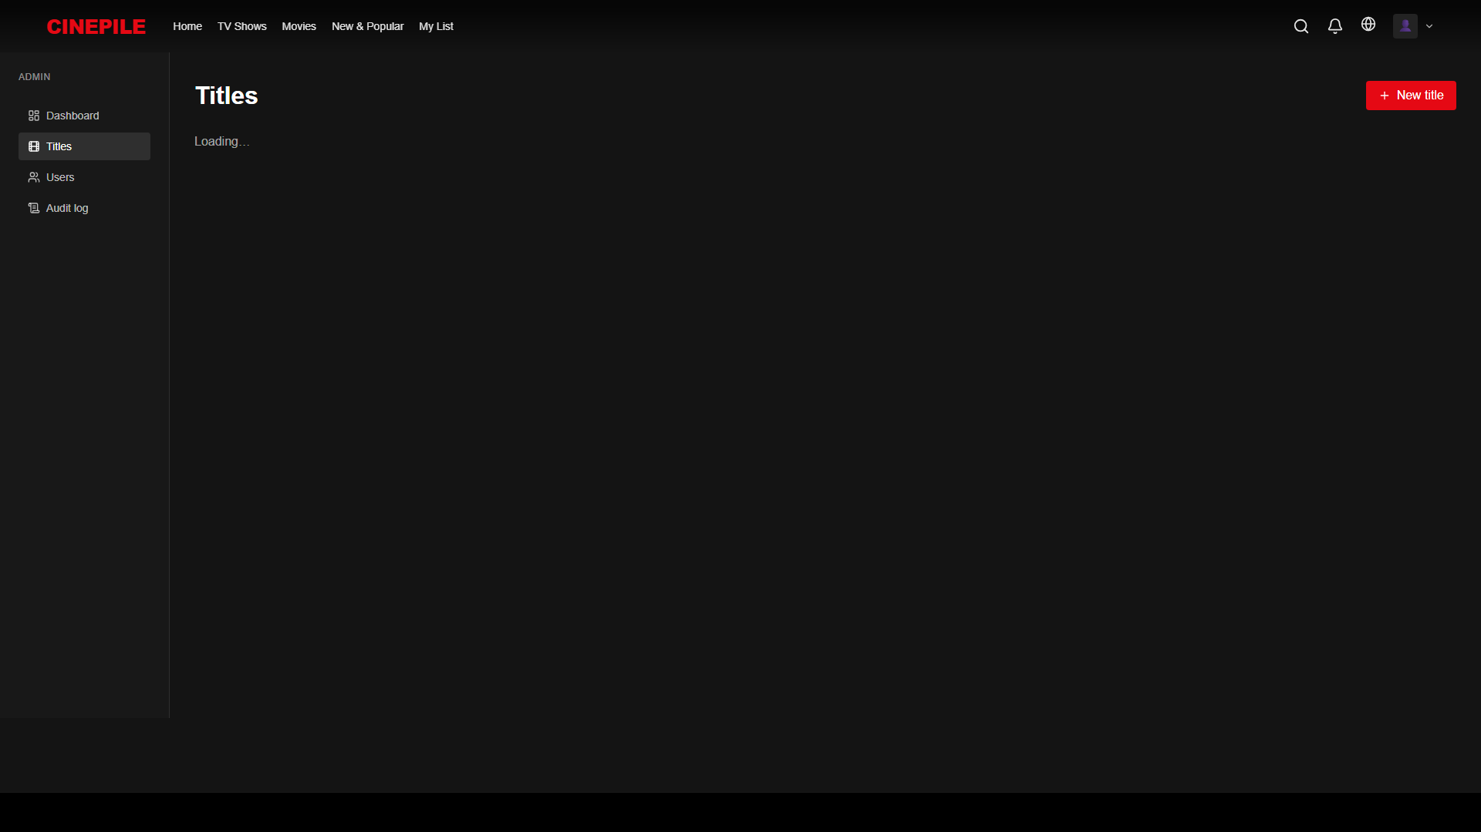
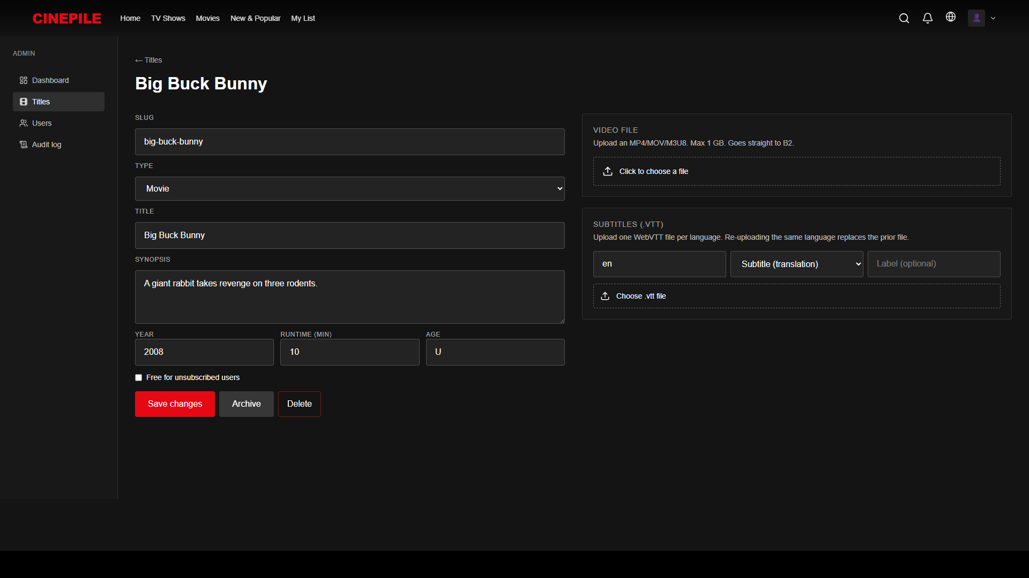

Phase 1 summary
Metric | Value
Features live | 47
Backend tests passing | 144 / 144
End-to-end UI tests passing | 108 / 108
Languages supported (UI) | 3 (English, Hindi, Tamil)
Screen sizes tested | 5 (mobile → 4K desktop)
Time to launch | 2 weeks from kickoff
Recurring infra cost | ~₹3,000 / month

____________________________________________________________

Phase 2 — Engagement & polish
Once Phase 1 is in customers' hands, Phase 2 sharpens the product to keep them watching longer and bring back lapsed users.

What we add in Phase 2

Smarter discovery
- Trailer auto-play on title detail (Netflix's most-loved feature — 30-sec muted preview)
- Top 10 in India row, refreshed daily
- Watch Again row for titles your customers loved
- Search result highlighting so matched terms stand out
- Editorial curated rows ("Award winners", "Critic's picks", "Cult classics")

Player improvements
- Skip Recap overlay (like Skip Intro)
- Next-Episode auto-advance with 10-second countdown
- "Use less data" toggle — manual quality cap for mobile data users
- Chromecast support — watch on a big screen by casting from phone

Profile & family
- Profile-scoped history — Mom's continue watching doesn't get mixed up with Dad's
- Kid mode content filter — kid profiles only see U-rated titles
- Profile PIN — teens can't accidentally jump into an adult profile

Authentication ease
- Google sign-in — one tap, no password needed
- Password reset via email
- Email verification on signup

Accessibility
- WCAG 2.1 AA compliance audit + fixes
- Keyboard navigation through every row, every card
- More languages — Telugu, Kannada, Malayalam, Bengali UI

Visible anti-piracy
- Forensic watermark overlay — user's ID + timestamp visible in a corner during playback. Deters screen-recording sharing.

Phase 2 summary
Metric | Value
Features added | 30
Engineering effort | ~6 weeks (1 developer) or ~3 weeks (2 developers)
Recurring infra cost (added) | ~₹500 - ₹3,000 / month
Triggers when ready | Phase 1 stable + 100+ paying users

____________________________________________________________

Phase 3 — Monetisation & scale
This is where we turn engagement into revenue and scale to compete with the major Indian OTTs. Payment, premium tiers, DRM, native apps — the heavy lifting that needs the business to be ready.

Subscription & payment

The pricing tier ladder
Today we have one flat tier. In Phase 3 we move to the industry-standard 3-tier ladder that every Indian competitor uses:
Tier | Price/mo | Price/yr | Quality | Devices | Simultaneous streams
Mobile | ₹99 | ₹799 | 720p (mobile + tablet only) | 1 | 1
Standard | ₹249 | ₹2,490 | 1080p HD (all devices) | 2 | 2
Premium | ₹499 | ₹4,490 | 4K HDR + Dolby Atmos | 4 | 4

- Mobile tier drives volume — Hotstar's ₹79/mo tier brings in 50%+ of their subscriber base
- Annual discount at 33% (industry norm; ours was 17% before)
- Simultaneous-stream limits prevent one paying account from serving an entire neighbourhood

Razorpay payment integration
- Razorpay Orders for one-time payments (already wired up — works today)
- Razorpay Subscriptions for auto-renewal (needs your KYC + bank verification — ~3-5 business days)
- UPI, Cards, Net Banking, Wallets — every payment method Indians use
- Webhook idempotency — duplicate notifications never cause duplicate charges

Promo codes, gifts, family plans
- Promo codes like "WELCOME50" for 50% off first month
- Gift subscriptions — buy a plan for someone (cultural fit for India: Diwali, Pongal gifting)
- Family plans — multiple emails sharing one subscription, higher ARPU than single Premium

Real DRM (content protection)
Phase 1's "anti-capture" is cosmetic. Phase 3 is real DRM — the kind Netflix uses.

What real DRM does
When DRM is on, content is encrypted on the server. The customer's browser only decrypts inside a secure GPU path. Result:
- Screenshots come out black (the OS-level enforcement)
- Screen recorders capture nothing (HDCP refuses to output to capture devices)
- yt-dlp and ffmpeg -i cannot rip the stream
- Downloads for offline become possible (locked to the user's device)

Provider
We use EZDRM (or BuyDRM / Axinom — comparable). Covers:
- Widevine — Chrome, Edge, Firefox, Android, smart TVs
- PlayReady — Edge, Xbox
- FairPlay — Safari, iOS, Apple TV

Cost
- EZDRM contract: ₹8,000 - ₹12,000 / month minimum + ~$0.005 per license issued
- One-time: re-encode existing catalog with CENC encryption (~$3 per movie via AWS MediaConvert)

Downloads for offline
Once DRM is live, customers can download titles to their phone for offline watching (commute, flights, low-data days). Mobile tier: 1 download slot. Standard: 2. Premium: 4.

4K HDR Premium tier
For the Premium ₹499/mo tier to deliver actual value:
- 4K HEVC masters stored alongside 1080p (extra ~5 GB / hour of content)
- HDR10 colour grading (royalty-free)
- Dolby Vision (optional, requires Dolby licensing)
- Dolby Atmos surround sound (optional, per-stream license)
This unlocks the premium tier as a real premium product, not just a label.

Native mobile + TV apps
The biggest jump in addressable market:
App | Effort | Cost
iOS | 8-12 weeks | Apple Developer ₹8,000 / year
Android | 8-12 weeks | Play Store ₹2,000 one-time
Samsung Tizen TV | 8 weeks | Per-store fees
LG webOS | 8 weeks | Free
Android TV / Google TV / Chromecast | 6 weeks | Free

Recommended: iOS + Android first, share ~70% of code via React Native. TVs in a follow-up wave.

Multi-region CDN + scale infra
- Bunny CDN India + SE Asia — sub-100ms streaming latency anywhere a customer is
- Transcoding pipeline (AWS MediaConvert / Bitmovin) — every new upload auto-encoded at full bitrate ladder
- Database replicas — Postgres read replicas in Mumbai + Singapore
- Monitoring — Sentry, PostHog, status page

ML-based recommendations
Today's recommendations are heuristic (same-genre seeded by what you've reacted to). Phase 3 adds:
- Collaborative filtering — "people who watched this also watched..."
- Content embeddings — neural similarity in title metadata + tags
- Personalised row ordering — different users see rows in different orders, learned from engagement
Either self-hosted (LightFM / implicit) or AWS Personalize (managed).

Phase 3 summary
Metric | Value
Features added | 28
Engineering effort | ~6 months with 2 engineers
Recurring infra cost (added at 10k paying users) | ~₹150,000 - ₹180,000 / month
Triggers when ready | Phase 2 stable + 500+ paying users + business decision to expand

____________________________________________________________

What we're explicitly NOT building
Some features look obvious but the math doesn't work — we'd rather be honest than waste your money:
Feature | Why we say no
Live sports / IPL | Hotstar's moat. Sports rights cost ₹400+ crore per year. Unwinnable.
News channels | Razor-thin margins, regulatory complexity.
Pay-per-view rentals | Doesn't fit the subscription model we're building.
Voice search | Indian-accent English voice tech is rough; UX worse than typing.
Real-time chat per title | Moderation overhead too high for the value.

____________________________________________________________

Timeline summary
Phase | Duration | What ships | Recurring cost
Phase 1 | Month 0-1 | Full streaming experience, admin, multi-lang | ~₹3,000 / mo
Phase 2 | Months 2-4 | Engagement features, OAuth, profiles, watermark | ~₹3,500 - ₹6,000 / mo
Phase 3 | Months 5-10+ | Tier ladder, payments, DRM, downloads, 4K, native apps | ₹150,000+ / mo at 10k users

Phase 1 ships in 2 weeks from kickoff. Phases 2 and 3 unlock as the business is ready.
____________________________________________________________

What we need from you
To kick off Phase 1 launch:
- Domain choice — cinepile.app, cinepile.in, or something else
- Brand assets — final logo, hero background image (we have placeholder)
- Initial catalog — 10-20 titles to seed with (video files + posters)
- Razorpay test keys for development (free, instant)
- Backblaze B2 production bucket credentials (free tier OK to start)
Once those are in our hands, launch in 14 days.
____________________________________________________________
Source code: https://github.com/mathankj/cinepile-ott (private). Full feature inventory available in the engineering doc.

