BEST DENTAL SCIENCE COLLEGE
DEPARTMENT OF PUBLIC HEALTH DENTISTRY
CAMP REPORT – CAMP REPORT – HIGH COURT MADURAI
DATE: DATE: 15.10.2025

Department of Public Health Dentistry, BEST DENTAL SCIENCE COLLEGE, Madurai in association with adf and with dfdasd conducted a dental screening and treatment camp at CAMP REPORT – HIGH COURT MADURAI on 15thOctober2025. .
Dr R. Palanivel Pandian organised this program. The Camp started at 10:30 AM and ended at 6:00 PM. . A team of dentists including 1 staff member, 1 postgraduate member and 8 interns member provided oral health care to the people.
A total of 165 people attended the dental camp and 64 people were treated along with oral health education and oral hygiene instructions.

PHOTOS
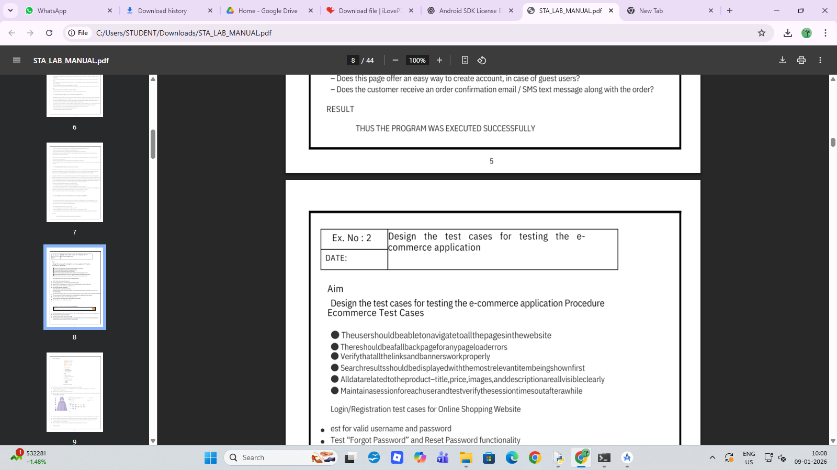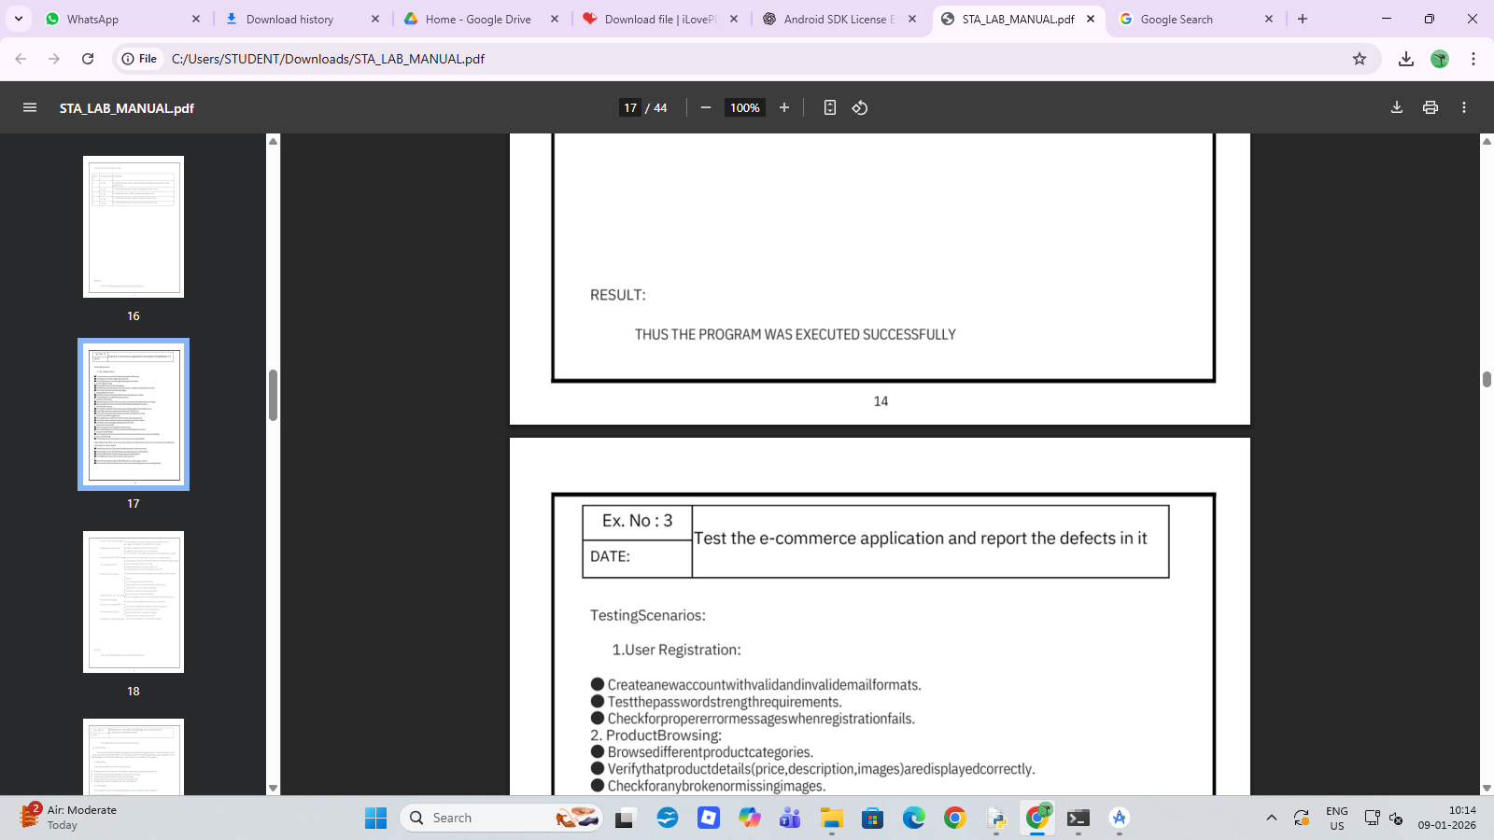

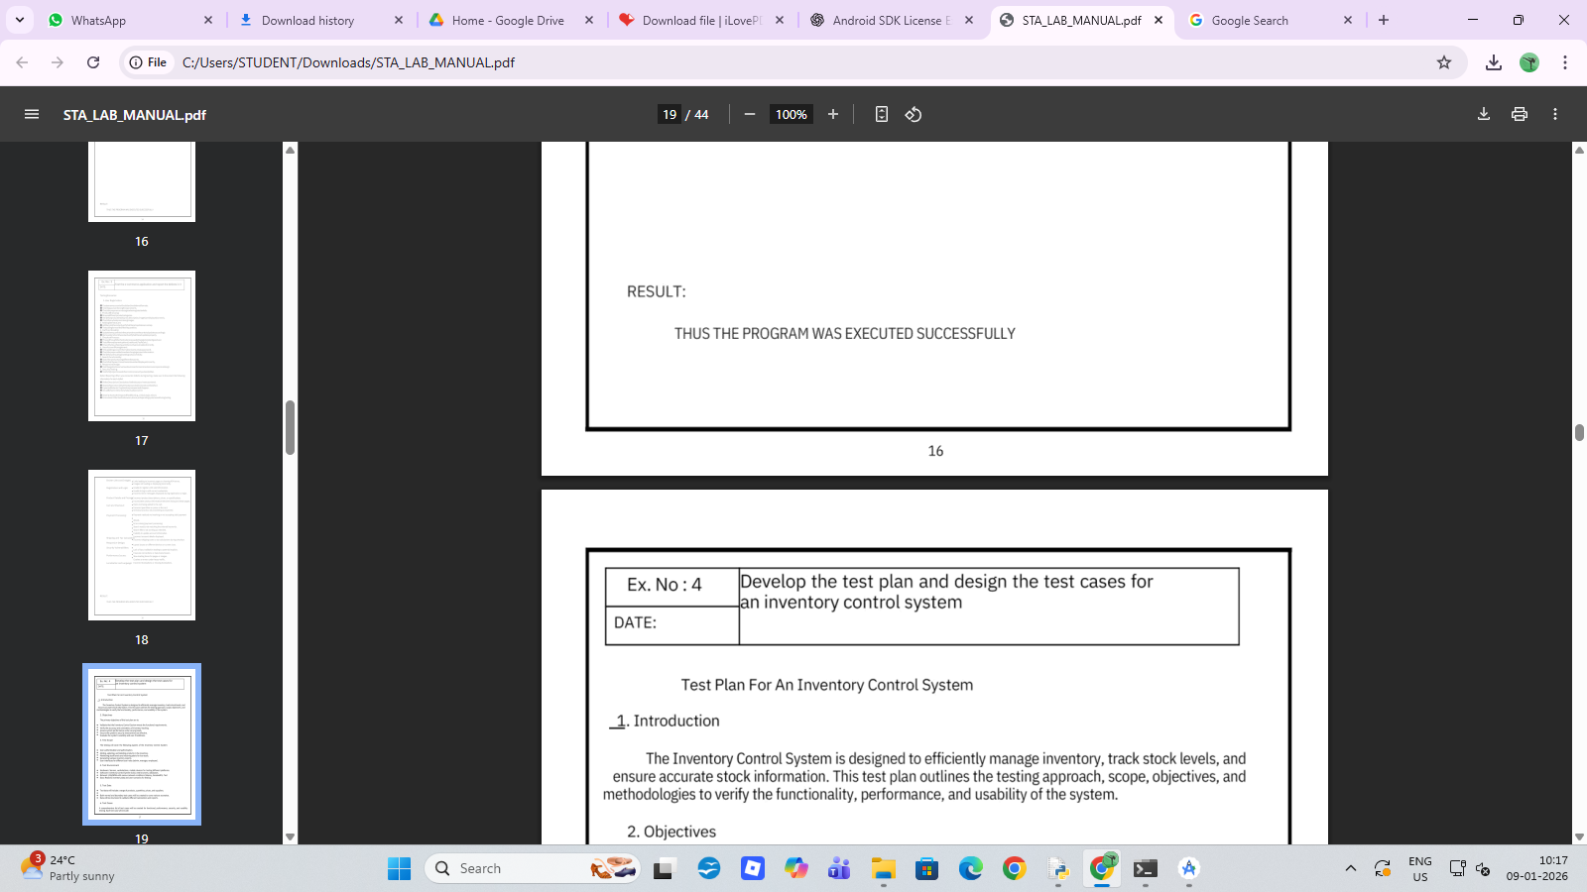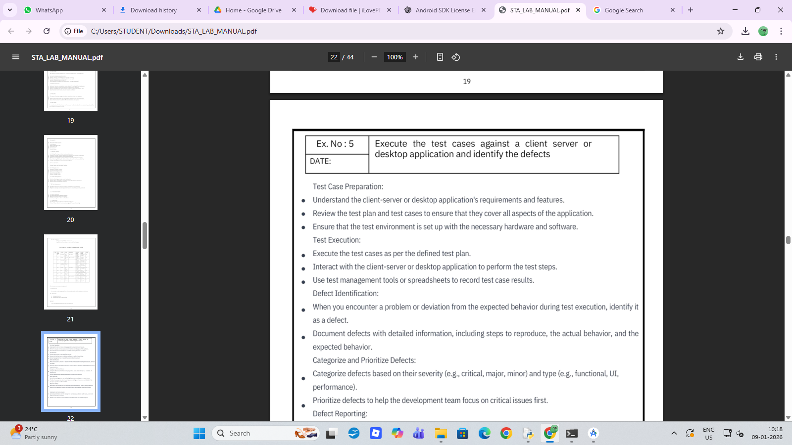

CAMP STATISTICS
Gender | No of Patients
Male | 101
Female | 64

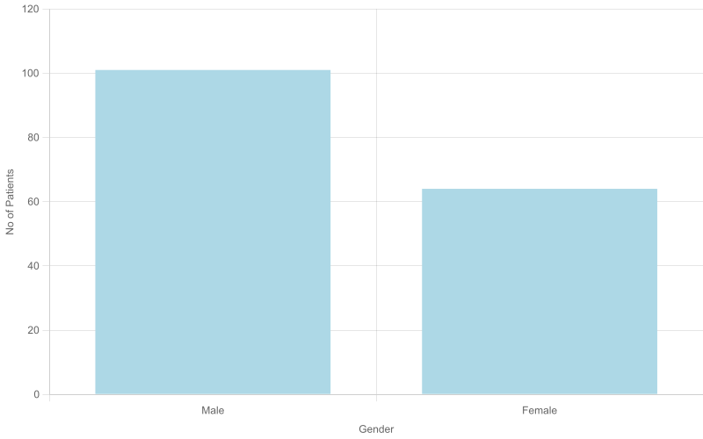

SCREENING STATISTICS
Diagnosis | No of Patients
Dental Caries | 70
Gingivitis | 29
Missing | 0

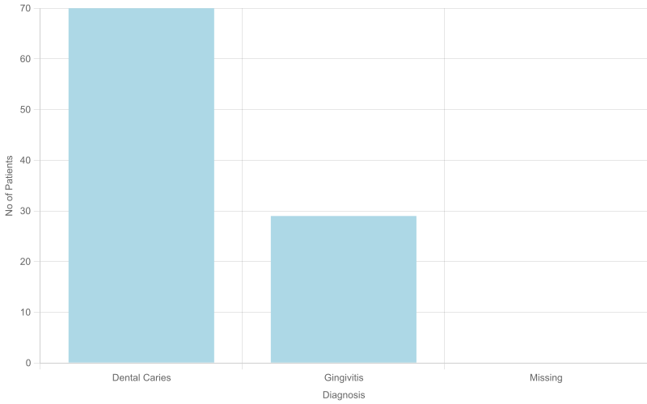

TREATMENT STATISTICS
Treatment | No of Patients
Scaling | 64

