Ball games began to gradually resemble modern football in the 19th century. The birthplace of football is England, where football became increasingly popular, particularly among students attending public schools during the Victorian era. The first football club was created in 1840 in Cambridge when seven students decided to merge the different football rules that each school used into one common rule set. This rule set was published as the “Cambridge Rules” and established principles that are considered the foundation of the modern game (Searby, 1997). The constant need for a universal code for football to be established led to the creation of the Football Association (FA) in October 1863 and in November 1863 the then secretary of the FA announced the first 23 laws that had been provisionally agreed by the association and were later collated to 14 laws that constituted the Association’s code. The establishment of this code, that embraced the “Cambridge Rules”, by the FA led to the enlargement of the FA as more and more clubs started to join the association. During this period clubs were based upon organizations such as schools, private clubs, and military with exclusively amateur players representing them (Harvey, 2013). In the subsequent decades, as more clubs began to recruit professional footballers, it became necessary for them to have a fixed schedule and a steady income to grow. Consequently, in 1888 “The Football League” was created as a professional competition with an established set of rules. In the first season of the Football League 12 teams participated, with the creation of the League being an immediate financial success (Fletcher, 2013). However, the transition to professional football necessitated changes to the way the clubs operated, meaning the restructuring of football clubs from non-profit organizations run by board elected members to limited liability companies with the goal of increasing their income. Originally, clubs focused primarily on sports development neglecting financial profit, however, as clubs began to sign contracts with their best players and matches started to be more competitive having players under contract came at a high cost, forcing the clubs to restructure their operating model. This change guaranteed at least a satisfactory level of profit for the clubs of the Football League and allowed the rapid development of the League and of professional football in general in the following decades (Taylor, 2013).
This monumental drop was largely a result of the 5-year withdrawal of English clubs from European competitions that was imposed to them by the then Prime Minister of England Margaret Thatcher following the Hesley tragedy in 1985. Following the withdrawal,
- Searby, P., 1997. A History of the University of Cambridge. Cambridge: Cambridge University Press (History of the University of Cambridge).
- Fletcher, P., 2013. One letter, two meetings and 12 teams–the birth of the league football. Retrieved February, 26, p.2013.
- Taylor, M., 2013. The association game: A history of British football. Routledge.
- Harvey, A., 2013. Football: The first hundred years: The untold story. Routledge.

Data preprocessing is a necessary procedure to guarantee the validity and reliability of data analysis results. Due to faults in data collection, transmission, and storage, many datasets may contain outliers and missing values. For more reliable analysis of the dataset a data preprocessing step can be applied to remove outliers and fill in missing values. Furthermore, the majority of data mining algorithms have specific requirements for the input data, for instance, they can only process categorical or numerical data. In such a case, standard data preprocessing ought to be performed to guarantee the compatibility between data and algorithms.
Data preprocessing generally involves five main tasks (Luengo et al., 2020):
- Data Cleaning: Data cleaning seeks to improve the quality of the data by removing outliers and imputation of missing values.
- Data Reduction: Typically, data are kept in two dimensional tables with building variables represented by columns and observations obtained at a particular time step represented by rows. Data reduction is used to decrease the dimensions of data and consequently, reduce the associated computational costs.
- Data Scaling: The goal of data scaling is to convert the original data into comparable ranges for predictive modeling.
- Data Transformation: Data transformation aims at organizing the original data into formats that are suitable for multiple data mining algorithms, e.g., transforming numerical data to categorical data and vice versa.
- Data Partitioning: The main objective of data partitioning is to separate the entire dataset into separate groups based on specific characteristics. This process is expected to improve the reliability and sensitivity of the analysis (Fan et al, 2021).
The two new calculated columns are copied into a new excel sheet.
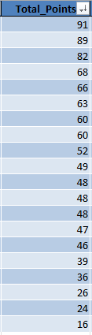
- 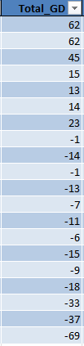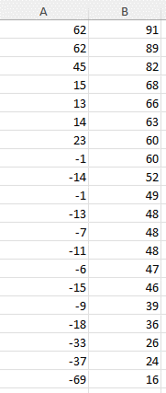
For the analysis of this sheet the Python programming language will be utilized. In particular, the data of the excel sheet will be accessed and extracted through the xlrd Python library, the columns will be organized in an array format through the numpy Python library, the two arrays, X (Total goal difference) and Y (Total points), will be visualized in a scatterplot through the matplotlib Python plotting library with each data point plotted as a dot on the graph, and they will be fitted into a linear regression model through the LinearRegression model class of the sklearn (scikit-learn) Python library. The total goal difference in this relationship is the independent variable (X) and the total points is the dependent variable (Y).
The average of home and away points for all teams, calculated in both graphs, is at 30.35 for the home points and at 22.55 for the away points. Therefore, the teams accumulated on average 7.80 more points when competing at their home field. 19/20 teams accumulated more points at home with Burnley being the one outlier, Liverpool secured the most home points and Manchester City the most away points. The team with the largest difference between home and away points was Newcastle United with the fourth best 40 points secured at home and a below average 20 points accumulated away from home.
The third comparison involves the home/away Goals For and Goals Against metrics for each team. The three scatter plots and bar charts that will be used have the same structure as the previous ones. In this case, however, the (X) axis represents the goals for and the (Y) axis represents the goals against and the four categories are: Good Offense-Good Defense, Good Offense-Bad Defense, Bad Offense-Good-Defense, Bad Offense-Bad Defense. Teams performing above average in the Goals For metric are considered to have a good offense and teams performing below average in the Goals Against metric are considered to have a good defense. The scatter plots and bar charts:
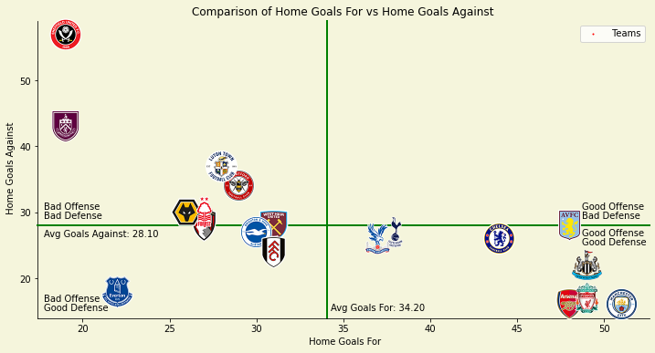
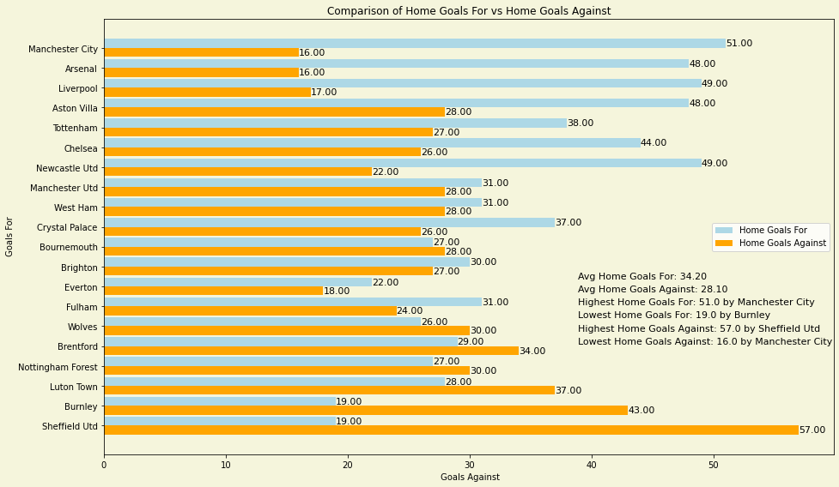
The average home Goals For are 34.20 and the average home Goals Against are 28.10 with the average home Goals Difference being 6.10.
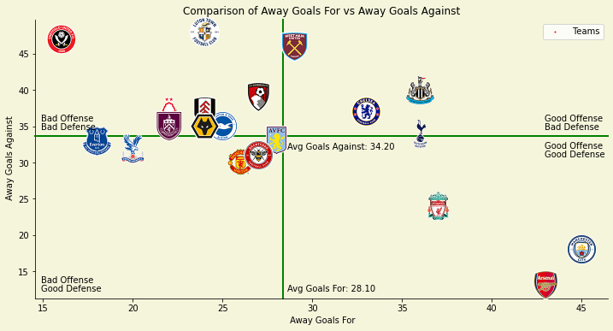
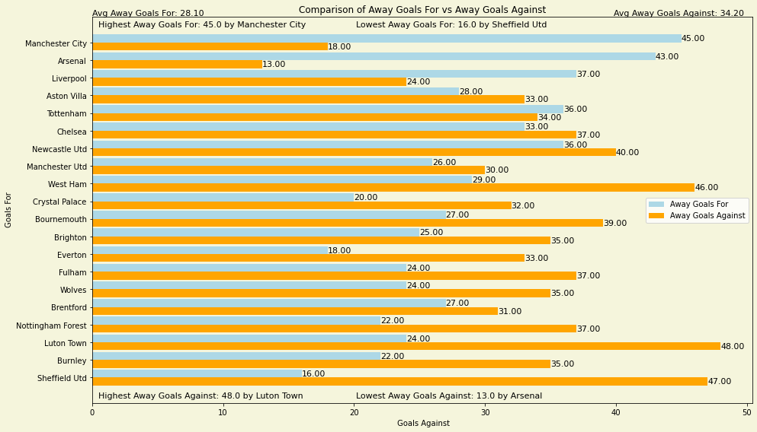
The average away Goals For are 28.10 and the average away Goals Against are 34.20 with the average away Goals Difference being -6.10. The scatter plot and bar chart of the home/away Goal Differences that combines the home and away Goals:
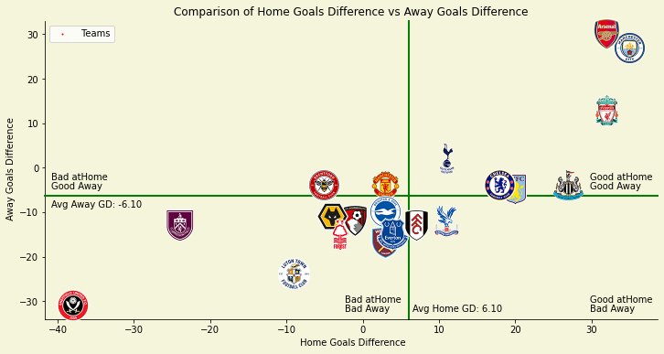
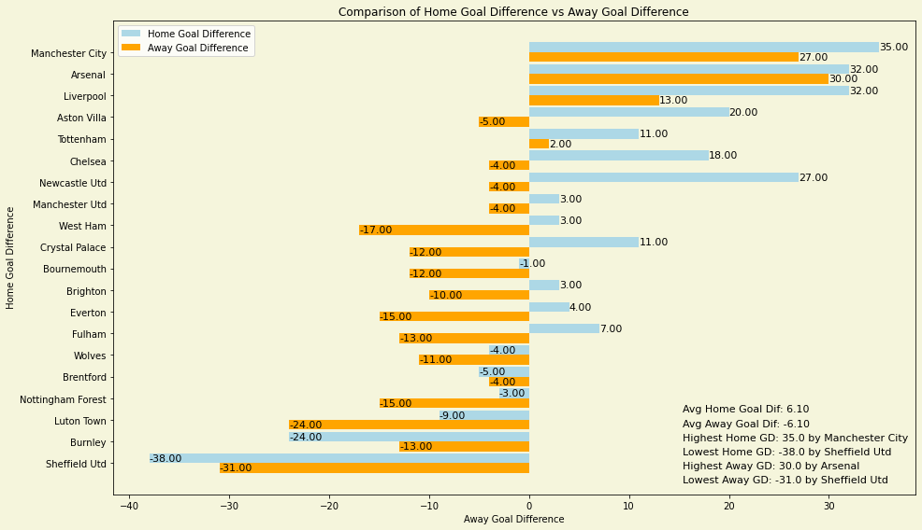
The average home Goal Difference being 6.10 and the average away Goal Difference being -6.10 indicates that teams generate, a staggering 12.20 more Goal Difference on average when competing at their home field. Additionally, according to the metric, Manchester City was the best home team with Arsenal being the best team away from home, Newcastle United had the biggest difference between home and away performance with the fourth best 27.00 Goal Difference at home and a slightly above average -4.00 away from home, moreover, 17/20 teams performed better at home than way with Brentford, Sheffield United, and Burnley being the three outliers.
Since our dataset includes separate data for home and away matches for each team in order to for the total points and total goal difference to be compared, they have to be calculated first. The calculation for the total points = home points + away points and for total goal difference = home goal difference + away goal difference.
Following the same process, the total expected goals difference must be calculated (home xGD + away xGD). The metrics must be calculated: xGF = Home xGF + Away xGF and xGA = Home xGA + xGA.
, that were calculated previously (Question 1).
(xGF/90) with Expected Goals Against per match (xGA/90) and Total Points per Matches Played with Expected Goal Difference per match (xGD/90)
In recent years, football has seen the development of numerous, innovative, ubiquitous metrics that are utilized by the analytics departments of many clubs. These metrics can have an impact on several of the clubs’ daily operations, from assessing overall team performance to making financial decisions regarding player transfers. The leading metric of this scientific movement is the expected goals metric, which enables analysts to gauge the likelihood of a particular shot resulting in a goal. Essentially, the expected goals metric gives a probability to every shot that a team takes during a match between 0 and 1, with 0 denoting no chance of the shot resulting in a goal and 1 denoting a certain goal. The utilization of this metric is considered a superior way of dealing with randomness in football than a conventional goal-based metric since a shot is a far more frequent occurrence than a goal (Brechot and Flepp, 2020). Generating a probability value that indicates the likelihood of a shot resulting in a goal, can assist in providing analysts with an unbiased evaluation of what occurred in a match, particularly how many goals each team “should have” scored based on the chances they created (Tippett, 2019). Developing strategies that can enable clubs to more accurately predict future events and thereby obtain an edge over opposition clubs can prove to be very financially advantageous. This advantage, given to analysts by the expected goals metric, can assist the decision-making process at both the business and sports levels of football. The metric has the ability to not only aid football clubs in financial situations like contract negotiations and player acquisitions, but is also able, through tactical analysis of team and player performance, to help to improve their on-field results. This is the real power of expected goals or xG. Since its creation, the use of the xG metric has proliferated in the world of football. The metric, as well as other related metrics such as post-shot expected goals and expected assists, is used by most elite football clubs and numerous betting companies, helping them in developing or acquiring players and refining betting odds modelling for gambling websites (Brechot and Flepp, 2020).
Examining correlation between predictors or between predictors and a target variable is a key aspect of Exploratory Data Analysis (EDA) in various modelling projects. Two variables (e.g. X and Y) are positively correlated when high X values correspond to high Y values, and low X values correspond to low Y values. However, if high Y values correspond to low X values, and vice versa, the variables are negatively correlated. The metric that measures the extent of correlation between two variables that are on the same scale, is the Pearson’s correlation coefficient, which ranges from -1 to +1, with -1 indicating perfect negative correlation, 0 indicating no correlation, and +1 indicating perfect positive correlation. In essence, correlation is a way of measuring the way in which two variables are related (Bruce et.al., 2020). The most common method for visualizing the relationship between two measured data variables is the scatterplot. Every point on the graph is a record, with the x-axis representing one variable and the y-axis representing another (Freedman et.al., 2007).
Simple linear regression provides a model of the relationship between the magnitude of one variable and that of a second, for instance, as X increases, Y decreases or as X increases, Y also increases. The difference with correlation is that regression quantifies the nature of the relationship, while correlation assesses the degree of association between two variables. Simple linear regression predicts how much Y will change when X changes by a specific amount. While according to the correlation coefficient, the variables X and Y are interchangeable, regress aims at predicting the Y variable from X using a linear relationship (i.e., a line):
Y = b₀ + b₁ * X
The symbol b₀ represents the intercept (or constant), and the symbol b₁ represents the slope for X. The slope shows how much each unit change in the independent variable X affects the dependent variable Y and the intercept represents the predicted value of Y when X is equal to zero (Bruce et.al., 2020). Despite only b₁ typically being referred to as coefficient in general use, both b₁ and b₀ appear as coefficients in R output. The X variable is described by the term predictor or independent variable while the Y variable is referred to as the dependent variable because it is dependent on X. (Montgomery et al., 2021). Despite the lack of a concerted standard of a suitable performance metric in regression analysis the coefficient of determination (R-squared or R²) is one of the most well established and preferred metrics. R² quantifies how much the dependent variable is determined by the independent variables, in terms of proportion of variance (Chicco et al., 2021).

3. Compare the Teams’ Performances Throughout the Whole 2023-2024 Premier League Season.
The first comparison involves the Total Expected Goals For (xGF) and Total Expected Goals Against (xGA) metrics for each team. The scatter plot and bar chart, that have the same structure as the in the previous Expected Goals comparisons:
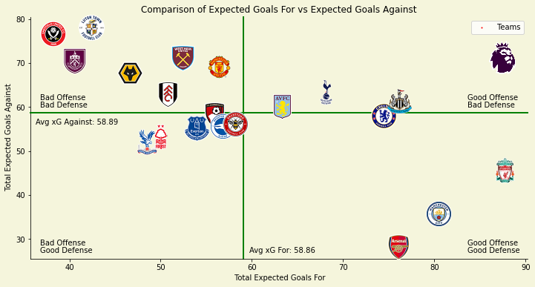
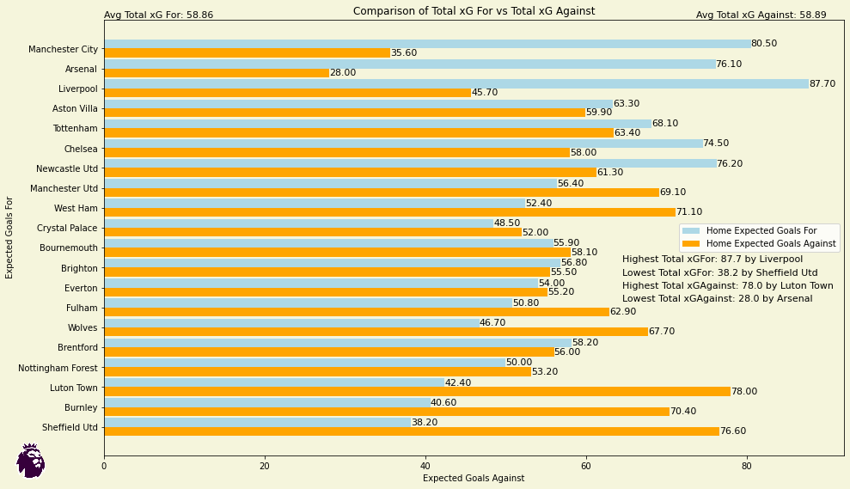
Based on the xG metric Liverpool was the best offensive team with an impressive 87.7 xGF and Sheffield United the worst with 38.2 xGF. Arsenal was the best defensive team with only 28.0 xGA and Luton Town the worst with 78.0 xGA.
The second comparison involves the Total Points and Expected Goal Difference (xGD) metrics for each team. The bar chart:
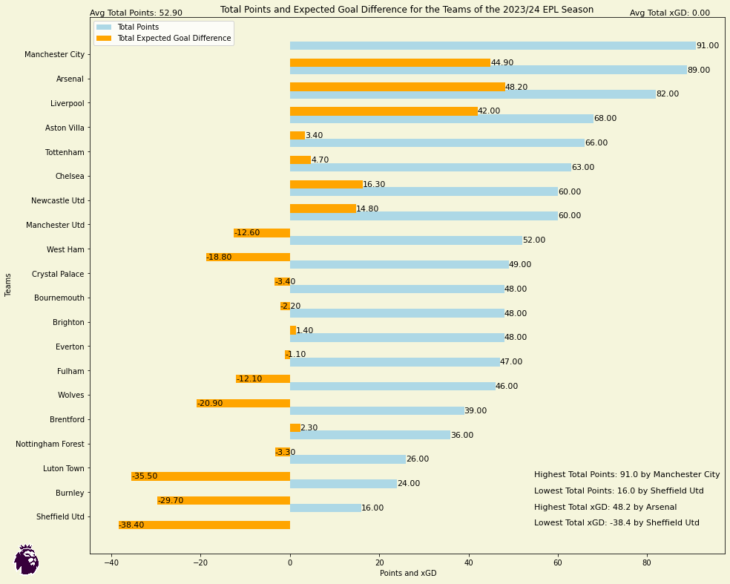
The xGD is a metric often utilized for assessing a team’s overall performance (Mulazimoglu et al., 2024). Despite its high predictive capability for the points accumulated by each team based on its performance, however, teams can often accumulate more points than a better performing team or vice versa. This comparison, therefore, allows us to examine which teams accumulated more points than their performance suggested or vice versa. For example, xGD suggests that the best performing team was Arsenal despite finishing with the second most points behind Manchester City. It is crucial for teams to have further metrics to assess their performance rather than just the number of Points they have accumulated.
The final comparisons involve the Expected Goals For per match (xGF/90) with Expected Goals Against per match (xGA/90) and Total Points per Matches Played with Expected Goal Difference per match (xGD/90) metrics for each team. The bar charts:
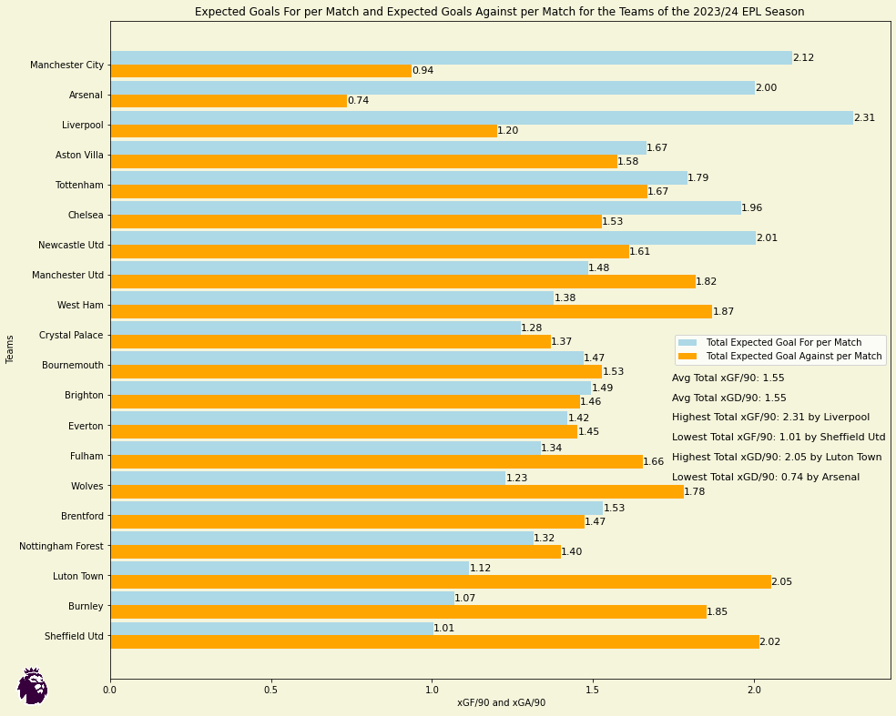

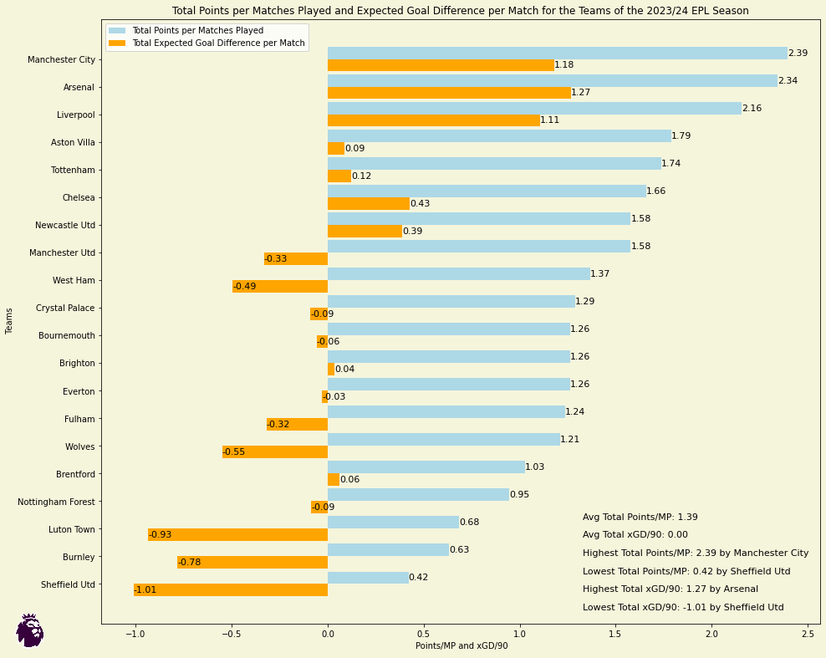
These metrics in our case do not provide any additional insight when compared to the previous bar charts since all the teams have competed in the same number of matches. However, these metrics that are adjusted to the matches played can prove to be extremely useful in comparisons where the teams have not played the same number of matches. For example, these metrics can be used to compare a team’s performance in the current 2024-2025 season of the EPL, that has not concluded yet, with its performance in the previous 2023-2024 season.

