Title:
“Football Analytics: An Analysis Based on the 2023-24 EPL Season.”

Program: MSc Data Analytics & Technologies
Course: Data Analysis and Visualization (DAT7301)
Supervisors: Dr. Diareme Kyvele Constantina, Dr. Kyriaki Saiti, Mr. Apostolos Mouzakitis (PhDc)
Student Name: Matthaios Chatzimichail
Student ID: 2434173
Word Count: 3944 Words
Date of Submission: 25/1/2025

Contents
Introduction 3
The English Premier League (EPL) 3
Aims of the Analysis 5
Data Presentation 5
Data Pre-processing 6
Analysis Questions 7
A. Examining the Correlation Between Total Goal Difference and Total Expected Goal Difference. 7
B. Hypotheses: There Is a Correlation Between the Total Points Accumulated by Each Team and Their Total Goal Difference and Total Expected Goal Difference. 12
C. Examining the Significance of the “Home Advantage” for the Teams of the 2023-2024 Premier League season. 17
Conclusions 27
Reflection 28
References 29

Introduction
Big data and sports analytics have become important tools in professional football and can increase the competitiveness of professional football clubs. Football analytics have changed and will continue to change the strategies of professional football clubs and their stakeholders (Herberger and Litke, 2021). This report consists of a presentation of the English Premier League (EPL) and an analysis based on the performance statistics of the teams that competed in the 2023-2024 season of the EPL.

The English Premier League (EPL)
In the second half of the 20th century English football experienced a sudden fall from the level it had reached up to this point. The English first division fell in the European power rankings from the first place in the 84/85 season to the 21st place in the 90/91 season. English football clubs were struggling to attract top players and modernize their facilities. In order for the clubs to get back to their feet and develop, funds were required that led to a conflict regarding the distribution of the revenues generated from television rights. The big clubs especially believed that the equal share of money between the clubs, that was the distribution standard of the league up to this point, was unfair as the most profit was made thanks to the most popular clubs (Taylor, 2013). For the purpose of resolving this conflict the English Football Association (FA) decided on the creation of a new breakaway league to represent the first division of English football, namely the FA Premier League. The Premier League was established as a limited company working out of an office at the FA. This structure allowed the league to independently negotiate its own sponsorship and broadcast deals. The main objective of the Premier League was to significantly increase the top clubs’ turnover and capitalize from the game’s commercial character (Elliott, 2017). The League granted the clubs more privileges with each club getting one vote with a majority of votes being required for a decision regarding the League to be made. The start of the Premier League was set on August 1992 with 22 teams participating and the entirety of the tv rights revenue going straight to the clubs (Watanabe, 2021). The league swiftly became a dominant force in world football due to a number of key factors, including improved stadium facilities, global appeal, and television rights. 32 years after its formation the Premier League has become a truly global product with dedicated fans all around the world, with the League being broadcasted in 212 territories worldwide and experiencing a significant increase in revenue from overseas broadcasters in recent years. In the 2022/23 season Premier League clubs made £3.2 billion in broadcast revenue while their total revenue reaching an all-time high of £6.1 billion which has been projected to rise to close to 7 billion by the end of the current 2024/25 season. This immense economic prominence that the Premier League has achieved can be largely attributed to the significant commercial and broadcast interest that the league has developed worldwide (Deloitte, 2024). Moreover, the Premier League has greatly and extensively benefited the English economy by supporting more than 100,000 jobs, generating close to £8 billion in GVA, and providing a direct tax contribution in excess of £4 billion annually (Ernst and Young, 2022). Additionally, the League has immensely influenced global football culture and British popular culture while also leading the way when it comes to implementing new technologies such as Goal-line technology and VAR (Shah, 2024).
The current structure of the Premier League consists of 20 clubs/teams with each team playing each other twice (home and away) adding up to 38 games for every team each season. The team with the most points at the end of the season is crowned champion, and the three bottom teams are relegated to the second division each year. The three relegated teams are being replaced each year by the top three teams of the second division (Ramchandani et al., 2018).

Aims of the Analysis

Data Presentation
The dataset that was selected for this analysis is comprised of one csv file that contains performance data for the 20 teams that competed in the English Premier League’s 2023-2024 season. The excel file comprises 20 rows, one for each club, and 27 columns of performance statistics divided into Home and Away match statistics for each club. In the 2023-2024 season each team competed in a total of 38 matches, 19 matches in their home field and 19 on an opponent field. The columns of the dataset consist of the name of each team and the amount of Home/Away:
- Matches Played/MP
- Wins (Each granting 3 points)
- Draws (Each granting 1 point)
- Loses (Each granting 0 points)
- Goals Scored (GF)
- Goals Conceded (GA)
- Goal Difference/GD (Goals Scored – Goals Conceded)
- Points Accumulated/Pts
- Points Per Match (Points Accumulated / Matches Played)
- Expected Goals For/xGF
- Expected Goals Against/xGA
- Expected Goal Difference/xGD (Expected Goals For – Expected Goals Against)
- Expected Goal Difference per 90 minutes (Expected Goal Difference / Matches Played) for each team.

Data Pre-processing
Data preprocessing is a necessary procedure to guarantee the validity and reliability of data analysis results (Luengo et al., 2020). Data preprocessing generally involves five main tasks: Data Cleaning, Data Reduction, Data Scaling, Data Transformation, Data Partitioning (Fan et al, 2021). In the case of this project, no data preprocessing task was applied except the calculation of some additional columns:
- Total MP = Home MP + Away MP
- Total Points = Home Points + Away Points
- Total xGD = Home xGD + Away xGD
- Total GD = Home GD + Away GD
The selected dataset was already preprocessed as the majority of the datasets that are available on the Kaggle website, that the dataset was harvested from. Kaggle is an online community and competition platform for data scientists. In a web-based data science environment, the platform lets users locate and publish datasets and develop models. The link for the dataset:
https://www.kaggle.com/code/plavak10/epl-23-24-home-away-xg-xga/input

Analysis Questions

A. Examining the Correlation Between Total Goal Difference and Total Expected Goal Difference.
“Two variables (e.g. X and Y) are positively correlated when high X values correspond to high Y values, and low X values correspond to low Y values”. However, if high Y values correspond to low X values, and vice versa, the variables are negatively correlated. The metric that measures the extent of correlation between two variables that are on the same scale, is the Pearson’s correlation coefficient, which ranges from -1 to +1, with -1 indicating perfect negative correlation, 0 indicating no correlation, and +1 indicating perfect positive correlation. In essence, “correlation is a way of measuring the way in which two variables are related” (Bruce et.al., 2020). The most common method for visualizing the relationship between two measured data variables is the scatterplot. “Every point on the graph is a record, with the x-axis representing one variable and the y-axis representing another” (Freedman et.al., 2007).
Simple linear regression provides a model of the relationship between the magnitude of one variable and that of a second, for instance, as X increases, Y decreases or as X increases, Y also increases. The difference with correlation is that “regression quantifies the nature of the relationship, while correlation assesses the degree of association between two variables”. Simple linear regression predicts how much Y will change when X changes by a specific amount. While according to the correlation coefficient, the variables X and Y are interchangeable, regress aims at predicting the Y variable from X using a linear relationship (i.e., a line):
Y = b₀ + b₁ * X
The symbol b₀ represents the intercept (or constant), and the symbol b₁ represents the slope for X. “The slope shows how much each unit change in the independent variable X affects the dependent variable Y and the intercept represents the predicted value of Y when X is equal to zero” (Bruce et.al., 2020). The X variable is described by the term predictor or independent variable while the Y variable is referred to as the dependent variable because it is dependent on X. (Montgomery et al., 2021). Despite the lack of a concerted standard of a suitable performance metric in regression analysis the coefficient of determination (R-squared or R²) is one of the most well established and preferred metrics. R² quantifies how much the dependent variable is determined by the independent variables, in terms of proportion of variance (Chicco et al., 2021).
In the case of this project, regression will be utilized to reveal a supposed linear relationship between predictor variables and an outcome variable and determine if a predictor variable is a good predictor of the outcome variable. The aim is to understand and explain a relationship using the data that the regression will fit to. The relationship to be examined is that between the Total Goal Difference (GD = Goals Scored – Goals Conceded) and the Total Expected Goal Difference (xGD = Expected Goals For – Expected Goals Against) of the teams throughout the 2023-2024 season of the EPL. According to (Mulazimoglu et al., 2024) xGD is a metric often utilized to assess a team’s overall performance. The examination of this relationship will help us understand whether the Expected Goals metric offers a valuable way of predicting the actual Goals that a team will score and concede throughout a season.

The Expected Goals metric enables analysts to gauge the likelihood of a particular shot resulting in a goal. Essentially, “the expected goals metric gives a probability to every shot that a team takes during a match between 0 and 1, with 0 denoting no chance of the shot resulting in a goal and 1 denoting a certain goal”. The utilization of this metric is considered a superior way of dealing with randomness in football than a conventional goal-based metric since a shot is a far more frequent occurrence than a goal (Brechot and Flepp, 2020). Generating a probability value that indicates the likelihood of a shot resulting in a goal, can assist in providing analysts with an unbiased evaluation of what occurred in a match, particularly how many goals each team “should have” scored based on the chances they created (Tippett, 2019). This advantage, given to analysts by the expected goals metric, can assist the decision-making process at both the business and sports levels of football. The metric, as well as other related metrics such as post-shot expected goals and expected assists, is used by most elite football clubs and has the ability to not only aid them in financial situations like contract negotiations and player acquisitions, but is also able, through tactical analysis of team and player performance, to help to improve their on-field results.
Therefore, the xGD in this relationship is the independent variable (X) and the GD is the dependent variable (Y). The scatter plot of the GD and xGD variables with the Linear Regression line, with the dots being replaced with the team’s logos:
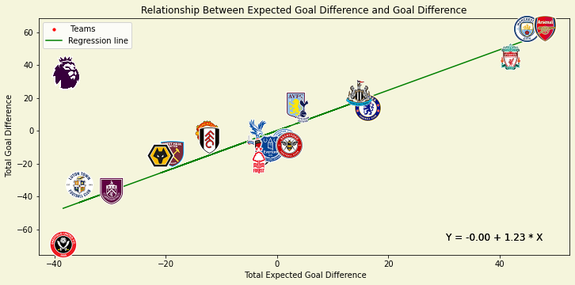
The Correlation coefficient of the relationship is measured at 0.9461 indicating a very strong positive linear relationship and a strong correlation between the Total Expected Goal Difference and the Total Goal Difference, with the positive value suggesting that as X increases, Y increases as well.
The coefficient of determination (R²) is measured at 0.8950, suggesting that predicting the Total Goal Difference based on the Total Expected Goal Difference with this model is very effective. This result indicates that the model has high predictive capability and fits the data well.
The slope (b₁) was measured at 1.23 representing the amount that the Total Goal Difference is expected to increase for every unit increase in the Total Expected Goal Difference. The positive slope number indicates a positive correlation between the variables as an increase in Expected Goal Difference suggests an increase of the Total Goal Difference.
The intercept (b₀) was measured at 0 representing the Goal Difference that a team would have with an Expected Goal Difference of 0.
The equation of the regression line was calculated as:
Y = -0.00 + 1.23 * X
Therefore, given an example Total Expected Goal Difference of 20, the model would predict the number of Total Goal Difference to be 24.62.
The results of the model indicate that there is a strong correlation between the metrics and that the Expected Goal Difference (xGD) metric can be utilized by teams or by individual analysts to predict the Goal Difference of a team (The goals that a team would score and concede) in addition to evaluating their overall performance throughout a season.

B. Hypotheses: There Is a Correlation Between the Total Points Accumulated by Each Team and Their Total Goal Difference and Total Expected Goal Difference.
“A hypothesis is a specific conjecture regarding a property of a population of interest”. There are various approaches for examining whether a hypothesis is plausible or not. In the case of this project the P-value approach will be utilized. In the p-value approach, “the p-value is computed on the basis of a test statistic and is compared with the significance level”. If the p-value is smaller than the significance level, the null hypothesis is rejected (Park, 2015).
The relationship that will be examined for the first hypothesis is that between the Total Points that each team accumulated throughout the 38 matches of the 2023-2024 season of the EPL and the Total Goal Difference (GD) of each team. In this relationship the p-value (0.000) is lower than the significance level (0.05). Therefore, the null hypothesis, which is that the GD does not affect the Total Points, is rejected and our hypothesis is not rejected as the relationship between the two variables is statistically significant.
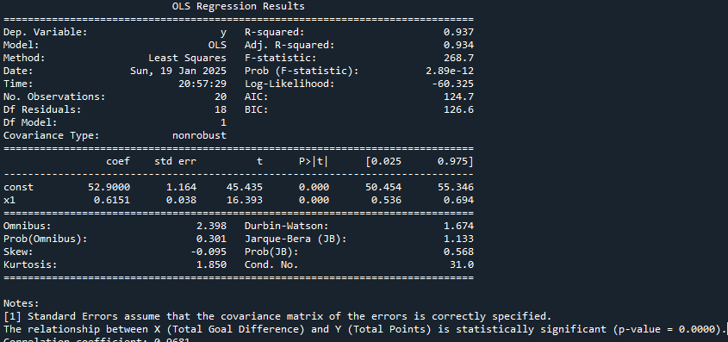
Since our hypothesis is not rejected the correlation between the variables will be examined. The GD in this relationship is the independent variable (X) and the Total Points is the dependent variable (Y). The scatter plot of these two variables with the Linear Regression line, with the dots being replaced with the team’s logos:
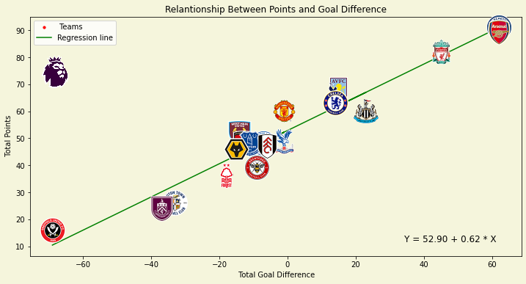
The Correlation coefficient of the relationship is measured at 0.9681 indicating a very strong positive linear relationship and a strong correlation between the Total Goal Difference and Total Points, with the positive value suggesting that as X increases, Y increases as well.
The coefficient of determination (R²) is measured at 0.9372 suggesting that predicting the Total Points based on the Total Goal Difference with this model is very effective. This result indicates that the model has high predictive capability and fits the data well.
The slope (b₁) was measured at 0.62 representing the amount that the Total Points are expected to increase for every unit increase in the Total Goal Difference. The positive slope number indicates a positive correlation between the variables as an increase in Goal Difference suggests an increase of the Total Points.
The intercept (b₀) was measured at 52.90 representing the number of Points that a team would accumulate with a Goal Difference of 0.
The equation of the regression line was calculated as:
Y = 52.90 + 0.62 * X
Therefore, given an example Total Goal Difference of 20, the model would predict the number of Total Points to be 65.20.
The relationship that will be examined for the second hypothesis is that between the Total Points and the Total Expected Goal Difference (xGD) of each team. In this relationship the p-value (0.000) is lower than the significance level (0.05). Therefore, the null hypothesis, which is that the xGD does not affect the Total Points, is rejected and our hypothesis is not rejected as the relationship between the two variables is statistically significant.
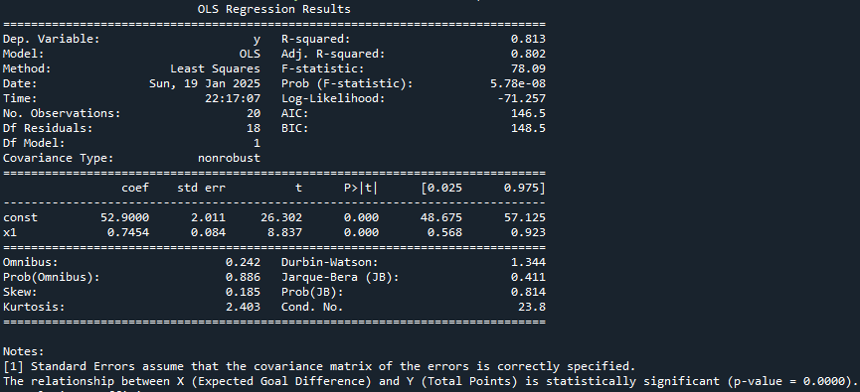
Since our hypothesis is not rejected the correlation between the variables will be examined. The xGD in this relationship is the independent variable (X) and the Total Points is the dependent variable (Y). The scatter plot of these two variables with the Linear Regression line, with the dots being replaced with the team’s logos:
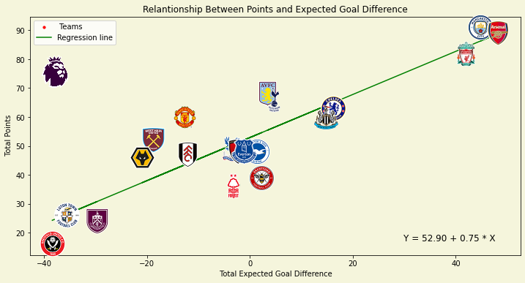
The Correlation coefficient of the relationship is measured at 0.9051 indicating a very strong positive linear relationship and a strong correlation between the Total Expected Goal Difference and Total Points, with the positive value suggesting that as X increases, Y increases as well.
The coefficient of determination (R²) is measured at 0.8127 suggesting that predicting the Total Points based on the Total Expected Goal Difference with this model is still quite effective, although less effective than our previous model. This result indicates that this model fits the data quite well and has reasonably good predictive capability.
The slope (b₁) was measured at 0.75 representing the amount that the Total Points are expected to increase for every unit increase in the Total Expected Goal Difference. Compared to the previous model (with a 0.62 slope) the slope of this model indicates that the relationship between Expected Goal Difference and Points is stronger than the previously examined relationship.
The intercept (b₀) was measured at 52.90 representing the number of Points that a team would accumulate with a Goal Difference of 0.
The equation of the regression line was calculated as:
Y = 52.90 + 0.75 * X
Therefore, given an example Total Expected Goal Difference of 20, the model would predict the number of Total Points to be 67.90.
In conclusion, both hypotheses are not rejected and, according to the models, there is a strong positive correlation between the Total Points that a team accumulates with both their Total Goal and Expected Goal Differences. Since accumulating points is of the outmost importance for the teams and is synonymous with a team’s success, it would be beneficial for them to focus on maximizing their goal and expected goal differences in order to acquire more points and ultimately be more successful throughout a season. Additionally, individual analysts can more accurately forecast a team’s success by examining these metrics.

C. Examining the Significance of the “Home Advantage” for the Teams of the 2023-2024 Premier League season.
Home advantage is a well-established concept in professional sports, including football, and refers to the phenomenon of teams performing better playing at their home field compared to their performance when competing in an opponent’s field (Peeters and van Ours, 2021). In order to assess the significance of home advantage a handful of the performance statistics of the teams of the 2023-2024 Premier League Season at their home field versus their performance statistics at an away field will be compared. The first comparison that will be made is between the Home and Away Points that each team accumulated throughout the 2023-2024 EPL season. A scatter plot is utilized to visualize the relationship between the Home Points on the (X) axis and the Away Points on the (Y) axis, with each data point represented by a team’s logo. The scatter plot contains two spines that are positioned at the average value number of each axis, setting a benchmark for comparison by splitting the graph into four parts/categories. The four categories are: Good at home-Good away, Good at home-Bad away, Bad at home-Good away, Bad at home-Bad away. Teams that have accumulated a number of Points above the average are considered to be good at Home/Away and teams that have accumulated a number of Points below the average are considered to be bad at Home/Away. The scatter plot, in addition to providing insights into the Home and Away performance of each team, allows for a comparison between each team:
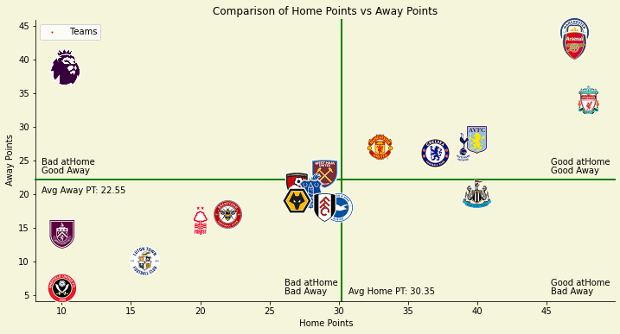
The second chart is a bar chart with the light blue bars representing the Home Points and the orange bars representing the Away Points of each team:
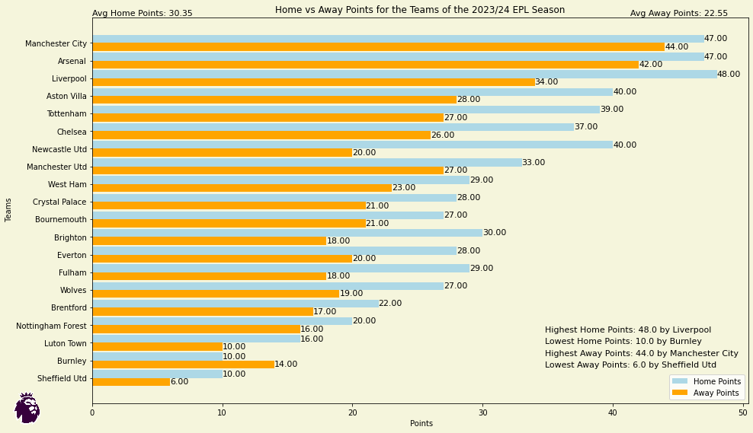
The average of Home and Away Points for all teams, calculated in both graphs, is 30.35 for the Home Points and at 22.55 for the Away Points. Therefore, the teams accumulated on average 7.80 more Points when competing at their home field. 19/20 teams accumulated more Points at Home with Burnley being the one outlier, Liverpool secured the most Home Points and Manchester City the most Away Points. The team with the largest difference between Home and Away Points was Newcastle United with the fourth best 40 points secured at home and a below average 20 points accumulated away from home.
The second comparison involves the Home/Away Expected Goals For (xGF) and Expected Goals Against (xGA) in addition to the Home/Away Expected Goal Difference (xGD = xGF - xGA) metrics for each team. The two scatter plots and bar charts that will be used have the same structure as the previous ones. In this case, however, the (X) axis represents the Expected Goals For and the (Y) axis represents the Expected Goals Against and the four categories are: Good Offense-Good Defense, Good Offense-Bad Defense, Bad Offense-Good-Defense, Bad Offense-Bad Defense. Teams performing above average in the Expected Goals For metric are considered to have a good offense and teams performing below average in the Expected Goals Against metric are considered to have a good defense. The scatter plots that allow for a comparison between each team in addition to providing insights into the Home and Away performance of each team, and bar charts:
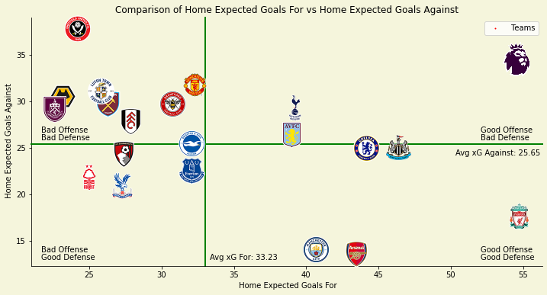
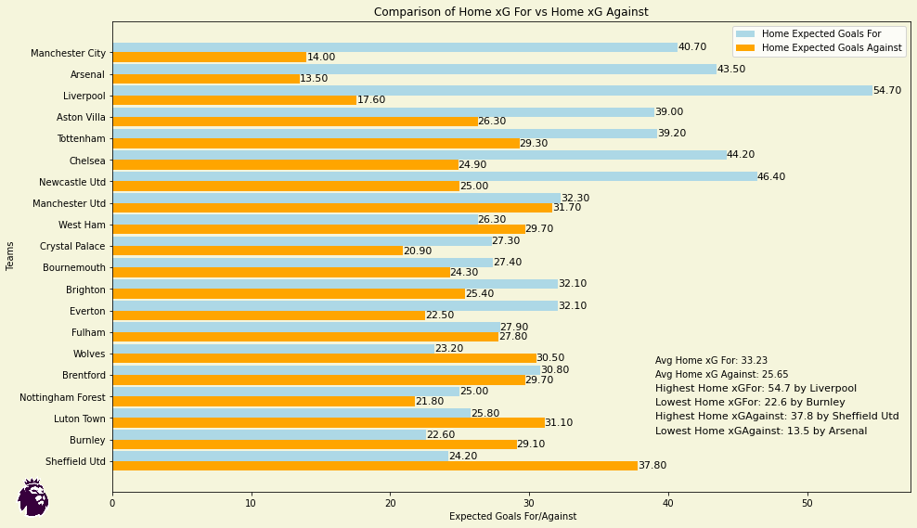
The average home Expected Goals For are 33.23 and the average home Expected Goals Against are 25.65 with the average home Expected Goals Difference being 7.58.
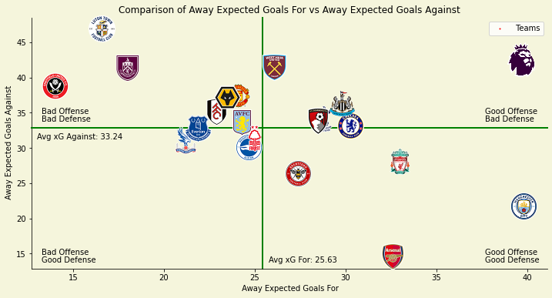
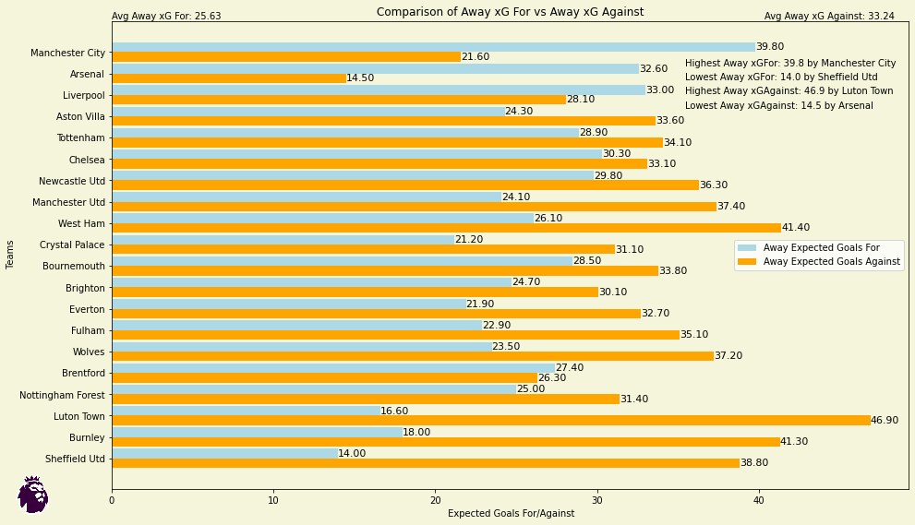
The average away Expected Goals For are 25.63 and the average away Expected Goals Against are 33.24 with the average away Expected Goals Difference being -7.61. The comparison of these two sets of graphs indicates an overall significantly better performance of the teams when competing in their home field. Regarding individual teams, Liverpool’s Expected Goals Home and Away numbers are significantly different as they are significantly better at Home. Arsenal is the best defensive team both at Home and Away with Luton Town, Burnley, West Ham, Newcastle, Liverpool, Crystal Palace, and Everton having the worst Away defensive performances compared to their Home performances. Brentford is the only team that has a higher Home xGA number than Away xGA.
The third comparison involves the Home/Away Expected Goal Difference (xGD = xGF - xGA) metrics for each team. The scatter plot of the Home/Away Expected Goal Differences (xGD) that combine the Home and Away Expected Goals with the (X) axis representing the Home Expected Goal Difference and the (Y) axis representing the Away Expected Goal Difference and the bar chart:
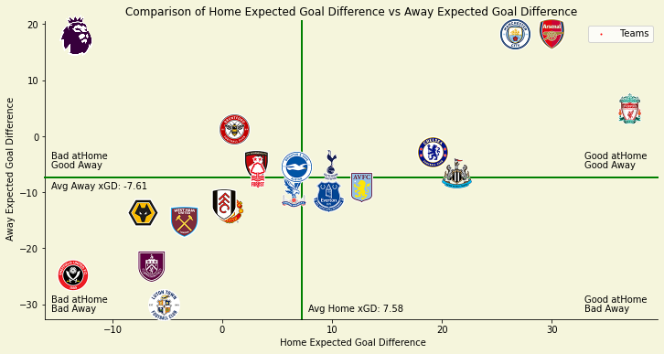
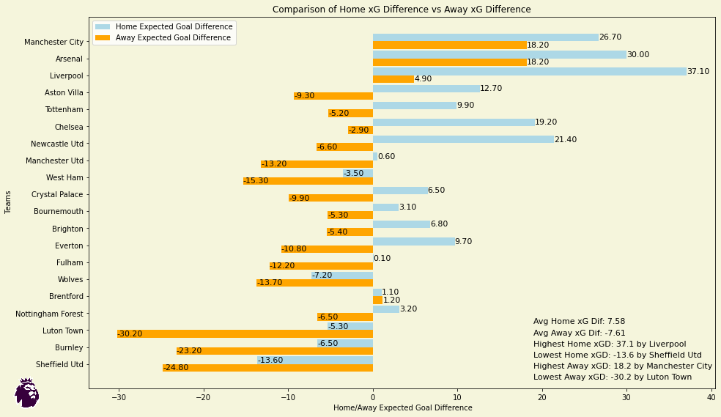
The average Home Expected Goal Difference being 7.58 and the average Away Expected Goal Difference being -7.61 indicates that teams generate a staggering 15.19 more Expected Goal Difference on average when competing at their home field. Additionally, according to the metric, Liverpool was by far the best home team while being the third best team away from home having the biggest difference between their home and away performances with the best 37.10 xGD at home and a below average 4.90 away from home, Manchester City was the best away team along with Arsenal at 18.20 xGD and, 19/20 teams performed better at home than way with Brentford being the only outlier.
The final comparison involves the Home/Away Results for each team. The two bar charts and pie charts include the Home/Away Wins, Draws, and Loses for each team. In the bar charts, the (X) axis represents the Results and the (Y) axis represents the teams. The pie charts summarize the overall performance of the teams displaying the proportion of wins, draws, and losses. The charts:
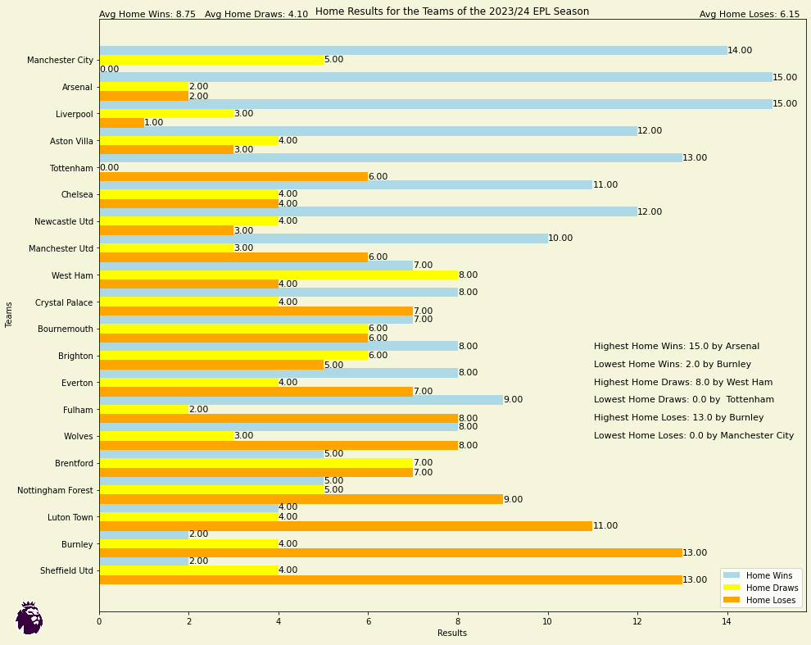
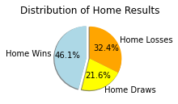
The average Home Wins for all the teams are at 8.75, Home Draws at 4.10, and Home Loses at 6.15. The proportion of Home Wins at 46.1%, Home Draws at 21.6%, and Home Loses at 32.4%. Arsenal alongside Liverpool had the most wins with 15.0 while Manchester City managed to stay undefeated on their home field.
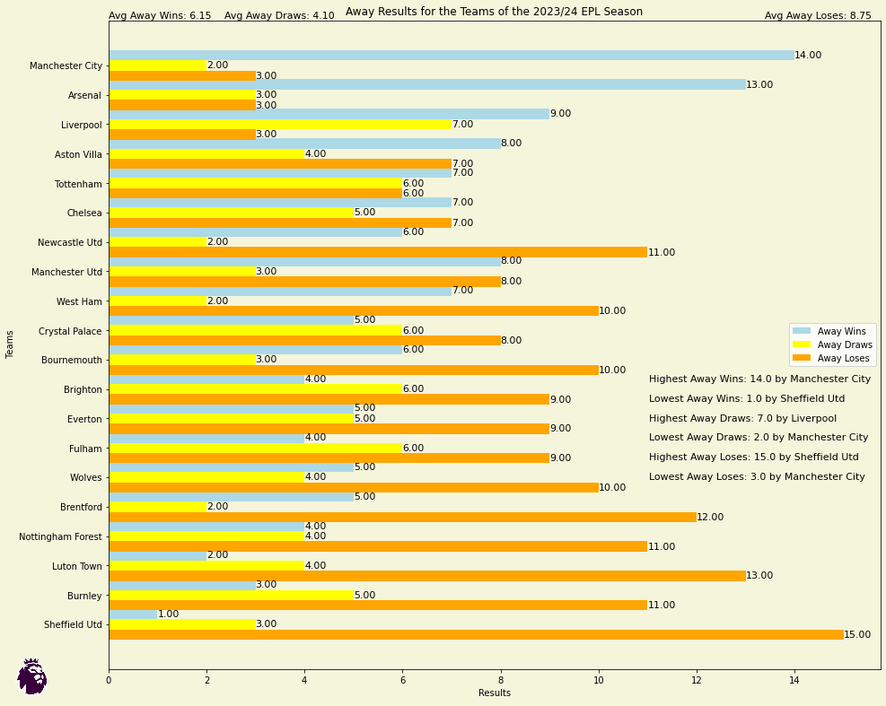
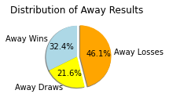
The average Away Wins for all the teams are at 6.15, Away Draws at 4.10, and Away Loses at 8.75. The proportion of Away Wins at 32.4%, Away Draws at 21.6%, and Away Loses at 46.1%. Manchester City are the best overall away team with the most wins, 14.0, and the lowest 3.0 loses. Both the averages and result’s proportions indicate a much better overall performance of the teams at home compared to away performance.
In conclusion, all the comparisons indicate that teams perform significantly better overall when competing in their home field. Home Advantage, therefore, for the teams of the Premier League, seems to be extremely significant when it comes to their overall performance. As a result, the teams may prepare and adjust their tactics differently for home matches where they are likely to have an advantage and for away matches where they are likely to have a disadvantage.

Conclusions
The implementation of data analytics can ultimately help football clubs obtain a competitive edge over their rivals. In the case of this project, analysis of their performance data can provide clubs with useful insights regarding the areas they need to improve, enabling them to adjust or optimize their match tactics and improve player development (Thakkar and Shah, 2021). In conclusion, this analysis based on the 2023-2024 season of the Premier League can provide clubs and individuals with an overview of the clubs’ performance in addition to important insights about the metrics that are best related to said performance.

Reflection
The development of this project enhanced my personal knowledge and experience in managing and handling a dataset, utilizing the Python language and the built-in functions of its libraries to develop various graphs, and perform general data visualization processes. Regarding the dataset and its analysis, in future projects the analysis could extend to a larger dataset (containing data from multiple seasons of the EPL or from different Leagues and possibly more statistics for each team) and incorporate more advanced analytical techniques. This expansion could provide deeper insights into long-term trends and comparisons between the teams across different seasons and Leagues.

References
- Brechot, M. and Flepp, R., 2020. Dealing with randomness in match outcomes: how to rethink performance evaluation in European club football using expected goals. Journal of Sports Economics, 21(4), pp.335-362.
- Bruce, P., Bruce, A. & Gedeck, P. 2020, Practical Statistics for Data Scientists: 50+ Essential Concepts Using R and Python, 2;Second;2nd; edn, O'Reilly Media, Incorporated, Sebastopol.
- Chicco, D., Warrens, M.J. and Jurman, G., 2021. The coefficient of determination R-squared is more informative than SMAPE, MAE, MAPE, MSE and RMSE in regression analysis evaluation. Peerj computer science, 7, p.e623.
- Deloitte., 2024. Annual Review of Football Finance.
- Elliott, R. ed., 2017. The English Premier League: a socio-cultural analysis. Taylor & Francis.
- Ernst and Young., 2022. Premier League: Economic and social impact. Ernst & Young LLP.
- Fan, C., Chen, M., Wang, X., Wang, J. and Huang, B., 2021. A review on data preprocessing techniques toward efficient and reliable knowledge discovery from building operational data. Frontiers in energy research, 9, p.652801.
- Freedman, D., Pisani, R. and Purves, R., 2007. Statistics. International student ed. Pisani, R. Purves, 4th edn. WW Norton & Company, New York.
- Herberger, T.A. and Litke, C., 2021. The impact of big data and sports analytics on professional football: A systematic literature review. Digitalization, digital transformation and sustainability in the global economy: risks and opportunities, pp.147-171.
- Luengo, J., García-Gil, D., Ramírez-Gallego, S., García, S. and Herrera, F., 2020. Big data preprocessing. Cham: Springer.
- Montgomery, D.C., Peck, E.A. and Vining, G.G., 2021. Introduction to linear regression analysis. John Wiley & Sons.
- Mulazimoglu, O., Tokul, E., Can, S. and Eyuboglu, A., 2024. Examining the Superiority of Professional Football Teams with the Contribution of Expected Goal (xG) Value. RBFF-Revista Brasileira de Futsal e Futebol, 16(64), pp.67-75.
- Park, H.M., 2015. Hypothesis testing and statistical power of a test.
- Peeters, T. and van Ours, J.C., 2021. Seasonal home advantage in English professional football; 1974–2018. De Economist, 169(1), pp.107-126.
- Ramchandani, G., Plumley, D., Boyes, S. and Wilson, R., 2018. A longitudinal and comparative analysis of competitive balance in five European football leagues. Team Performance Management: An International Journal, 24(5/6), pp.265-282.
- Shah, V., 2024. Determinants Of Success: A Comprehensive Review Of Factors Affecting Team Rankings In The English Premier League.
- Taylor, M., 2013. The association game: A history of British football. Routledge.
- Thakkar, P. and Shah, M., 2021. An assessment of football through the lens of data science. Annals of Data Science, pp.1-14.
- Tippett, J., 2019. The expected goals philosophy: A game-changing way of analysing football. wydawca nieznany.
- Watanabe, N.M., 2021. International sport finance. In Financial management in the sport industry (pp. 589-630). Routledge.

