Title:
“Forecasting Medical Charges Using Time Series and Predictive Models”

Program: MSc Data Analytics & Technologies
Course: Business Analytics (DAT7304)
Supervisors: Dr. Kyriaki Saiti
Student Name: Matthaios Chatzimichail
Student ID: 2434173
Word Count: 4245 words
Date of Submission: 31/08/2025

Table of Contents
1. Part A: Time Series Forecasting Using Arima and ARX 4
1.1 Introduction 4
1.2 Data Preprocessing 5
1.3 Exploratory Analysis 6
1.4 Stationary Tests 7
1.5 Model Implementation 8
1.5.1 ARIMA Model Implementation 8
1.5.2 ARX Model Implementation 9
1.6 Evaluation & Comparison 10
1.7 Discussion & Conclusion 11
2. Part B: Forecasting Utilizing Machine Learning Models 12
2.1 Introduction and Problem Formulation 12
2.2 Solution Development 14
2.2.1 Optimization Results 14
2.2.2 Visualization 15
2.2.3 Allocation Summary 15
2.3 Sensitivity Analysis 16
2.4 Discussion and Reflection 17
2.5 Conclusion 18
3. Part C: Deployment Strategy and Final Recommendations 18
3.1 Introduction 18
3.2 Forecast-to-Decision Pipeline 19
3.2.1 Forecast-to-Decision Inputs 20
3.3 Integrated Results 22
3.3.1 Optimal Allocation 22
3.3.2 Heuristic Comparison 23
3.4 Sensitivity Analysis 24
3.5 Discussion & Conclusion 25
3.6 Executive Summary 27
3.6.1 Forecasting Medical Costs 27
3.6.2 Optimization of Resource Allocation 28
3.6.3 Robustness and Risk Assessment 28
3.6.4 Business Implications 28
3.6.5 Conclusion 29
4. References 30

`

1. Part A: Time Series Forecasting Using Arima and ARX

1.1 Introduction
With the rising costs of healthcare services, understanding the drivers behind medical charges is a growing concern for patients, insurers, and policymakers (Batko and Ślęzak, 2022). The Medical Cost Dataset, a curated dataset sourced from Kaggle, offers a detailed snapshot of healthcare expenses, along with individual demographic and lifestyle factors such as BMI, smoking habits, gender, and region. This dataset serves as an ideal foundation for analyzing cost dynamics in the healthcare industry and building predictive models to forecast future expenses. Forecasting is the process of making informed predictions about future values based on historical data, trends, and patterns (Kontopoulou et al., 2023). It is widely used to support planning and decision-making across industries such as healthcare, finance, and operations. The first part of this report explores a time series analysis focused on the medical cost dataset, with particular emphasis on insurance charges relative to body mass index (BMI) and categorical demographic variables. Time series analysis involves examining data points collected or ordered over time to identify underlying structures such as trends, seasonality, or autocorrelation (Hamilton, 2020). This approach is essential for understanding temporal dependencies and constructing predictive models. The purpose is to model and forecast medical charges utilizing ARIMA and ARX models, enabling better understanding of expenditure patterns among individuals of the most common age group in the dataset. Through the implementation of robust forecasting techniques, this part of the project aims to uncover relationships between key predictors, such as BMI, smoking status, and gender, and the financial burden borne by individuals. Ultimately, the results will inform data-driven decision-making strategies in medical cost management.

1.2 Data Preprocessing
Data preprocessing involves cleaning and transforming raw data to ensure it is suitable for analysis (García et al., 2015). This includes handling missing values, filtering relevant subsets, encoding categorical variables, and sorting the data to create a structured format suitable for modelling. The Medical Cost dataset, sourced from Kaggle, contains 1,338 entries capturing individual-level healthcare information including age, sex, BMI, smoking status, region, and total charges. These variables reflect key demographic and lifestyle factors that influence medical expenses. Initial inspection revealed a complete dataset, requiring no imputation except for filtering based on relevance. A subset of data was extracted for individuals of the most common age group, which was age 18 in this dataset. This filtering ensured homogeneity and reduced the influence of confounding age-related effects on cost. From this filtered data, records were sorted by BMI, forming a univariate pseudo-time index to allow sequential modeling. Additionally, categorical variables (sex, smoker, region) were encoded using label encoding to facilitate ARX modeling. This approach converted nominal variables into integer values while maintaining compatibility with the linear ARIMA framework.
The Medical Cost Dataset: https://www.kaggle.com/datasets/nanditapore/medical-cost-dataset

1.3 Exploratory Analysis
Exploratory Data Analysis (EDA) is the process of visually and statistically examining a dataset with the goal of uncovering patterns, relationships, and anomalies (Mukhiya and Ahmed, 2020). EDA helps in building an initial understanding of the variables and is able to guide further modelling decisions. Prior to modelling, exploratory analysis was conducted to examine the nature of the data and select suitable variables. Visualizing charges and BMI revealed a positive correlation, particularly accentuated for smokers and individuals with higher BMI:
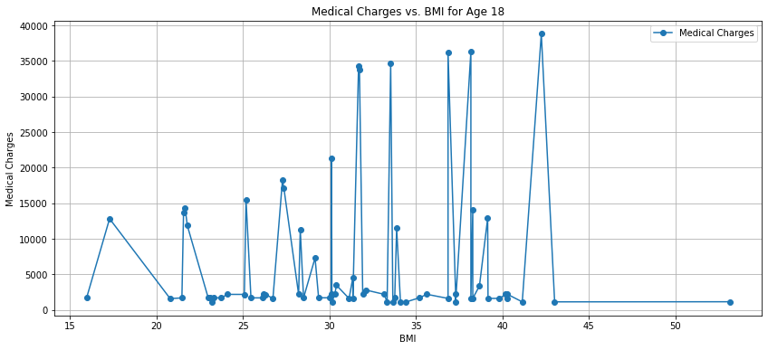
This justified the inclusion of BMI as an exogenous variable. Descriptive statistics indicated that charges values were right-skewed, which is common in insurance or healthcare cost data (ul Hassan et al., 2021). The standard deviation was notably high, suggesting significant variance in charges, warranting transformation or modeling techniques capable of handling heteroskedasticity. A plot of the ordered charges values confirmed a non-random, structured pattern, validating the use of ARIMA-type models. This pseudo-time representation provided a basis for sequential modeling even in the absence of a real timestamp.

1.4 Stationary Tests
Stationarity is a key assumption for ARIMA modeling. Stationary tests are used to determine whether a time series’ statistical properties (such as mean and variance) remain constant over time. Two standard statistical tests were applied:
- Augmented Dickey-Fuller (ADF) Test: Checks for the presence of a unit root, where a statistically significant result (low p-value) suggests the series is stationary (Cai and Omay, 2022). The ADF test returned a statistic of -8.7150 with a p-value of 0.0000, rejecting the null hypothesis of a unit root, indicating that the series is stationary.
- Kwiatkowski-Phillips-Schmidt-Shin (KPSS) Test: Tests the null hypothesis that the series is stationary around a constant; a high p-value supports stationarity (Hobijn et al., 2004). The KPSS test statistics were 0.1460 with a p-value of 0.10, suggesting the series is level-stationary as the null hypothesis was not rejected.
Therefore, both tests confirmed stationarity without requiring differencing. This supports the use of a non-integrated ARIMA (p, 0, q) model. Additionally, ACF and PACF plots revealed modest autocorrelation at lags 1 and 2, pointing toward an AR (1) structure, which aligns with the final model choice.
The Autocorrelation Function (ACF) measures the correlation between a time series and its lagged values, assisting in identifying repeating patterns or seasonality (Yakubu and Saputra, 2022).
The Partial Autocorrelation Function (PACF) isolates the direct correlation between the series and its lags, removing the influence of intermediate lags, and is useful for identifying the appropriate number of autoregressive terms in ARIMA models:
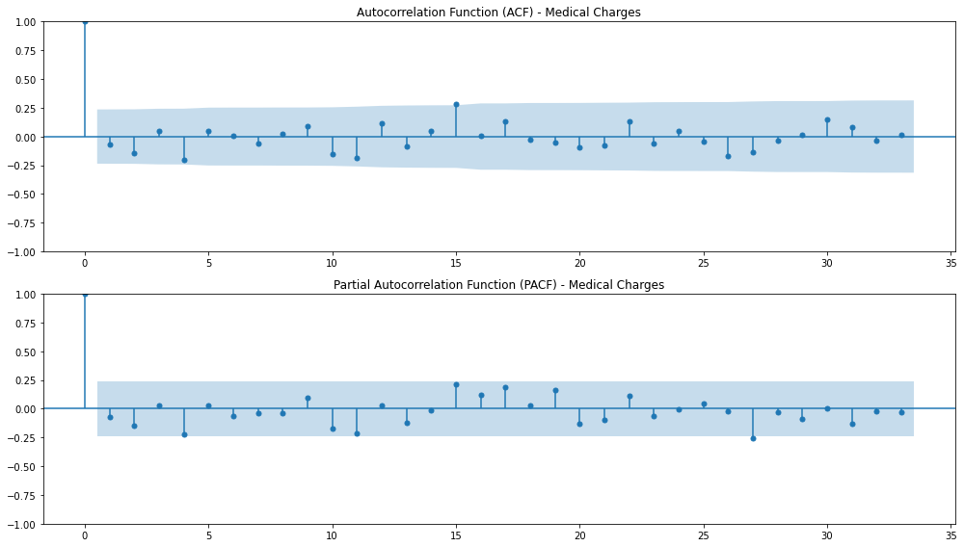

1.5 Model Implementation

1.5.1 ARIMA Model Implementation
The Autoregressive Integrated Moving Average (ARIMA) model is a popular statistical approach for forecasting time series data by combining autoregression, differencing to achieve stationarity, and moving averages (Bento et al., 2021). The model is effective in capturing temporal dependencies and trends without requiring external explanatory variables. For the purposes of this project, a basic ARIMA (1,0,0) model was fitted to the charges series. The AR (1) coefficient was negative however statistically significant (p = 0.530), suggesting weak autoregressive dependence. Despite this, the model captured the general trend and variance reasonably well:
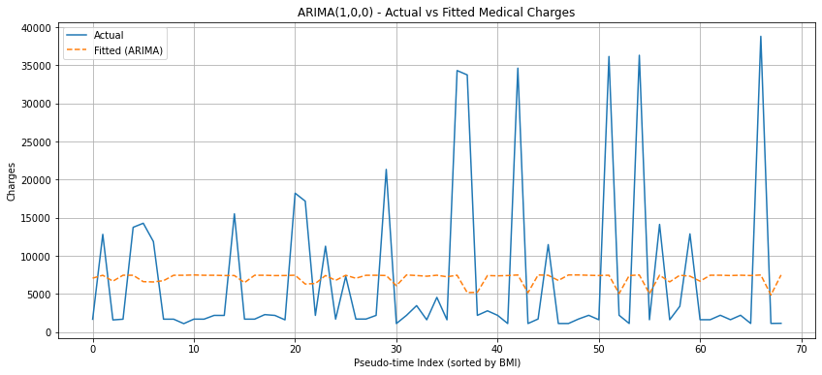
- AIC: 1474.21
- RMSE: 10,099.25
While the fit was acceptable, residual analysis indicated room for improvement, particularly regarding high variance and heteroskedasticity.

1.5.2 ARX Model Implementation
The Autoregressive model with Exogenous variables (ARX) extends ARIMA by incorporating external predictors alongside the time series’ own historical values (Piltan et al., 2017). This allows the model to account for the influence of additional factors on the target variable. Therefore, with the goal of enhancing predictive accuracy, an ARX (1,0,0) model was constructed using four exogenous variables: BMI, sex, smoker, and region. Label encoding was used for the categorical variables. The ARX model displayed significant improvements:
- BMI coefficient: 243.4 (p = 0.002), indicating strong positive impact on charges.
- Smoker status: Highly significant with a coefficient of approximately 22,870, confirming its strong association with higher charges.
- AIC: Reduced to 1390.75
- RMSE: 5,281.10
Notably, the model was able to account for structural variation in the charges not captured by the ARIMA model:
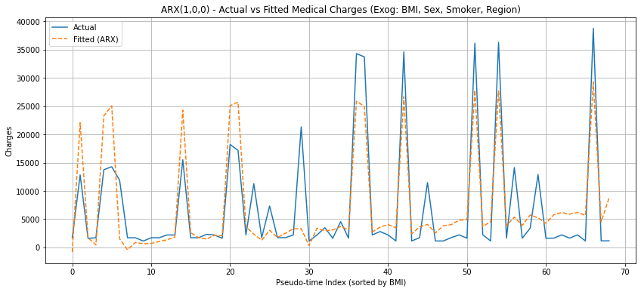
While the AR (1) coefficient remained insignificant, the strong performance of exogenous variables validated their inclusion.

1.6 Evaluation & Comparison
Evaluation and comparison involve assessing the performance of different forecasting models using statistical metrics such as the Akaike Information Criterion (AIC) and Root Mean Squared Error (RMSE) (Sun and Wang, 2024). This process assists in determining which model best balances predictive accuracy and model complexity for the given dataset. A side-by-side comparison of both models illustrates the impact of including explanatory variables:
Model | AIC | RMSE | Significant Predictors
ARIMA (1,0,0) | 1474.21 | 10,099.25 | None
ARX (1,0,0) | 1390.75 | 5,281.10 | BMI, Smoker (p < 0.01)

- AIC and RMSE improvements validate the superiority of the ARX model for this use case.
- Residual diagnostics for the ARX model revealed reduced skewness (0.75 vs. 1.97) and kurtosis (4.09 vs. 5.80), indicating better adherence to model assumptions.
- Visual comparisons of actual vs fitted values clearly showed tighter fit in the ARX model.
Despite these improvements, some limitations remain, including the lack of true temporal structure and potential multicollinearity due to encoded categorical variables.

1.7 Discussion & Conclusion
The implementation of ARIMA and ARX models on pseudo-time medical cost data highlighted the benefits of incorporating domain-relevant exogenous variables. The significant improvement in AIC and RMSE metrics illustrate the ARX model’s ability to better explain variations in healthcare charges, especially when critical predictors like smoking status and BMI are included. Key findings include:
- The stationarity of the medical charges series enabled direct AR modeling without differencing.
- BMI and smoker status emerged as strong cost determinants, with the latter adding substantial explanatory power.
- The ARIMA model, though simple, served as a useful baseline but lacked predictive depth.
- The ARX model, despite using label encoding rather than one-hot encoding (to maintain model interpretability and avoid multicollinearity), demonstrated a more robust fit.
From a business analytics standpoint, these findings are crucial for cost forecasting, insurance pricing, and risk stratification in the healthcare domain. Predictive models that incorporate lifestyle and demographic indicators can drive better policymaking and resource allocation in public and private healthcare. However, future research can benefit from:
- Applying true time-series medical data (e.g., hospital visits or monthly claim records),
- Incorporating feature scaling and one-hot encoding for better generalization,
- Testing more complex ARIMAX models with interactions or higher- order lags,
- Exploring ensemble methods or Machine Learning models as complementary approaches.
In conclusion, this analysis demonstrated the practical use of ARIMA-type models in forecasting healthcare costs and underlines the value of augmenting autoregressive models with domain-specific variables for enhanced performance.

2. Part B: Forecasting Utilizing Machine Learning Models

2.1 Introduction and Problem Formulation
Optimization is a mathematical process used to identify the most effective allocation of limited resources to achieve a defined objective (e.g., maximizing profit or minimizing cost) (Gill et al., 2019). In healthcare management, optimization is particularly valuable, as rising costs put pressure on both insurers and policymakers to design cost-effective interventions (Ordu et al., 2021). The Medical Cost dataset from Kaggle, containing 1,338 records of individuals with attributes such as age, sex, body, mass index (BMI), smoking status, and medical charges, provides an opportunity to model such a scenario. On inspection, average annual charges for smokers ($≈$ 32,050 USD) and obese individuals (BMI $≥$ 30; $≈$ 15,552 USD) were substantially higher than the population mean (Boachie et al., 2022). These findings align with the medical literature that identifies smoking and obesity as two of the most significant cost drivers in healthcare. Based on this evidence, the business problem was defined as follows: Given a fixed budget, how should a health insurer allocate resources between a smoking cessation program and a weight reduction program to maximize net cost savings? This problem naturally lends itself to linear programming (LP), a mathematical modeling technique where both the objective function and constraints are linear functions of decision variables (Gass, 2003). The decision variables will be:
- $x1$: number of participants enrolled in the smoking cessation program.
- $x2$: number of participants enrolled in the weight reduction program.
The objective function maximizes net savings, defined as the gross savings from reduced medical charges minus the intervention costs. Gross savings are estimated by multiplying the average annual charges of smokers/obese individuals by the expected risk reduction rates (70% for smoking cessation, 30% for weight reduction). Intervention costs are defined as fixed amounts per participant (500 USD for smoking cessation and 400 USD for weight reduction). The constraints include:
- A fixed program budget (120,000 USD).
- Upper bounds based on the number of eligible individuals in the dataset.
- Program capacity restrictions (150 smokers, 350 obese individuals).
Formally, the LP model is expressed as:
$$Maximise Z=\left(s1*x1+s2*x2\right)-(c1*x1+c2*x2)$$
Subject to:
$$c1x1+c2x2 ≤Budget$$
$$x1 ≤Eligible Smokers, Capacity$$
$$x2 ≤Eligible Obese, Capacity$$
$$x1,x2 ≥0$$
Where $si$ are gross savings per participant and $ci$ are intervention costs. This model encapsulates the trade-off between limited financial resources and the potential health and cost benefits of prevention programs.

2.2 Solution Development
The model was implemented in Python using the PuLP optimization library (Parganiha, 2018). The PuPL library provides an interface for formulating LP problems and solving them with standard solvers such as CBC. Alongside the LP model, a heuristic (greedy) allocation was coded to serve as a benchmark (Kumar et al., 2022). A heuristic is a rule-of-thumb approach that provides feasible but not necessarily optimal solutions by ranking participants based on their cost-effectiveness ratio (savings per dollar spent).

2.2.1 Optimization Results
The LP solver returned an optimal solution of enrolling 137 smokers and 128 obese individuals, spending nearly the full budget (119,700 USD) (Earnshaw and Dennett, 2003). This allocation generated gross savings of 1.57 million USD, resulting in net savings of 1.45 million USD. The heuristic approach arrived at the exact same allocation, achieving identical net savings. The absence of a gap between heuristic and LP solutions suggests that under the current dataset parameters, both methods converge with the same decision rule. However, LP remains the more generalizable framework, as it guarantees optimally under varying constraints.
Table 1. Optimal Allocation Summary Table
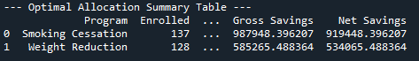

2.2.2 Visualization
A comparison plot between the LP and heuristic allocations confirmed the overlap in results, visually reinforcing the identical enrollment choices. The comparison graph of LP vs Heuristic Allocation:
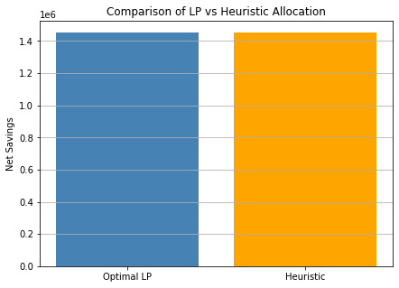

2.2.3 Allocation Summary
A tabular summary highlighted the contributions of each program:
- The smoking cessation program enrolled 137 individuals, yielding net savings of $≈$ 919,000 USD.
- The weight reduction program enrolled 128 individuals, yielding net savings of $≈$ 534,000 USD.
Both interventions contributed meaningfully, but the smoking cessation program delivered nearly double the savings per participant, consistent with the higher baseline charges for smokers (Baid et al., 2021).

2.3 Sensitivity Analysis
Sensitivity Analysis is the process of systematically varying model parameters to assess robustness and risk (Saltelli et al., 2004). In this study, both the budget and the estimated savings rates were adjusted by $±$ 10%. Results revealed that net savings remained positive across all scenarios, ranging from 1.19 million to 1.61 million USD.
Table 2. Detailed results of the Sensitivity Analysis
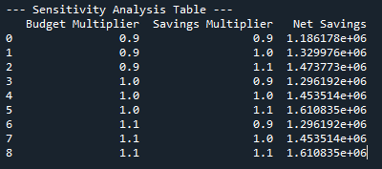

Two key insights emerged:
- Net savings were more sensitive to changes in savings rates than to budget adjustments. This reflects the strong influence of medical charge reductions relative to intervention costs.
- Increasing the budget beyond 120,000 USD did not change the optimal allocation due to capacity limits, suggesting diminishing returns if additional funding were provided without scaling program capacity.
This analysis illustrates the value of LP in what-if analysis, enabling decision-makers to test different scenarios before committing resources (Ghaffarzadegan, 2021).

2.4 Discussion and Reflection
The optimization exercise highlights several important trade-offs in healthcare resource allocation. Linear programming provided a structured framework for identifying the most cost-effective mix of preventive interventions under financial and logistical constraints. By explicitly quantifying costs and savings, the model supports evidence-based decision-making, aligning with the goals of insurers seeking to reduce long-term expenditure. The results underscored the disproportionate financial impact of smoking compared to obesity (Kim, 2025). Although both programs improved outcomes, smoking cessation dominated in terms of return on investment. This mirrors findings in healthcare economics, where smoking-related illnesses are often costlier to treat. Nevertheless, the inclusion of weight reduction is justified, as it addresses a larger portion of the population and contributes to longer-term risk reduction. The comparison between LP and heuristic approaches also revealed a critical insight: while heuristics can be computationally simpler, they may not always yield optimal results under more complex conditions (e.g., interacting constraints, multiple objectives) (Singh et al., 2023). The convergence observed here should be interpreted as dataset-specific rather than universally guaranteed. Finally, sensitivity analysis demonstrated the resilience of the model to moderate variations in assumptions, which is essential for decision-making under uncertainty. However, real-world applications would need to consider additional risk factors such as program adherence rates, indirect costs, and long-term health outcomes not captured in the dataset.

2.5 Conclusion
This part of the assessment demonstrated how the Medical Cost dataset can be used to frame and solve a healthcare optimization problem. By formulating an LP model around preventive interventions for smokers and obese individuals, the analysis showed that targeted allocation can generate substantial net savings while remaining within budgetary and operational limits (AbdulRaheem, 2023). The findings suggest that insurers could save over 1.45 million USD annually by investing strategically in preventive programs, with smoking cessation delivering the highest marginal returns. While the heuristic method provided similar results, the LP framework offered a more rigorous and scalable solution. In conclusion, the integration of linear programming, heuristic benchmarks, and sensitivity analysis provided a robust methodology for evaluating healthcare interventions. Beyond the immediate dataset, such models can inform broader strategies in cost management, resource allocation, and health policy, demonstrating the value of analytics in addressing rising medical expenses.

3. Part C: Deployment Strategy and Final Recommendations

3.1 Introduction
Modern business analytics is increasingly defined not by isolated statistical models but by the ability to integrate predictive and prescriptive methods into cohesive decision-making systems. Predictive analytics refers to the use of statistical and Machine Learning techniques to forecast future outcomes based on historical patterns, while prescriptive analytics focuses on recommending optimal courses of action given those forecasts (Roy et al., 2022). In healthcare, this combination is especially valuable because forecasting alone cannot reduce costs unless paired with effective decision rules that allocate scarce resources (Batko and Ślęzak, 2022). The purpose of this capstone project is to connect the insights from Part A (time series forecasting) and Part B (linear programming optimization) into a unified pipeline. In Part A, Autoregressive Integrated Moving Average (ARIMA) and Autoregressive with Exogenous Variables (ARX) models were implemented to forecast medical charges, showing that including exogenous factors such as BMI and smoking status significantly improved predictive performance (Klazoglou and Dritsakis, 2017). In Part B, a Linear Programming (LP) model was constructed to allocate a limited intervention budget between smoking cessation and weight reduction programs, maximizing net cost savings. Part C demonstrates how these two strands can be integrated into a forecast-to-decision pipeline. Forecasted medical charges generated from ARX models become direct inputs into the LP optimization. The result is a system that not only predicts future healthcare costs but also recommends evidence-based interventions to reduce them. This end-to-end pipeline exemplifies the practical application of analytics in solving real-world healthcare business problems.

3.2 Forecast-to-Decision Pipeline
The forecast-to-decision pipeline is the central contribution of this integrative project. The pipeline can be conceptualized in four stages:
- Forecasting: Medical charges are predicted using ARX models that incorporate BMI, smoking status, sex, and region as exogenous variables.
- Saving Estimation: Forecasted charges are used to estimate expected gross savings per participant, assuming risk reduction from program participation (e.g., 22,5% reduction for smokers, 29,4% reduction for obese individuals).
- Optimization: The LP model allocates participants between smoking cessation and weight reduction programs under budget and capacity constraints.
- Decision Output: Final enrollment recommendations are generated, with net savings quantified and robustness tested through sensitivity analysis (Sharma et al., 2022).
This pipeline highlights how predictive and prescriptive models reinforce one another. Forecasting refines the input into optimization by replacing static historical averages with forward-looking cost estimates. Optimization ensures that these forecasts are translated into concrete action plans, enabling decision-makers to move from “what will happen?” to “what should we do?”.

3.2.1 Forecast-to-Decision Inputs
Using the ARX models developed in Part A, one-step ahead forecasts of medical charges were obtained for smokers and obese individuals. The forecasts predicted average charges of approximately 56,602 USD for smokers (Xu et al., 2021) and 20,152 USD for obese individuals (Okunogbe et al., 2021). By combining these forecasts with the predefined risk reduction rates (22.5% for smokers, 29.4% for obese participants), potential savings per participant were calculated.
Figure 1. Smokers: Actual vs Fitted (BMI-sorted pseudo-time)
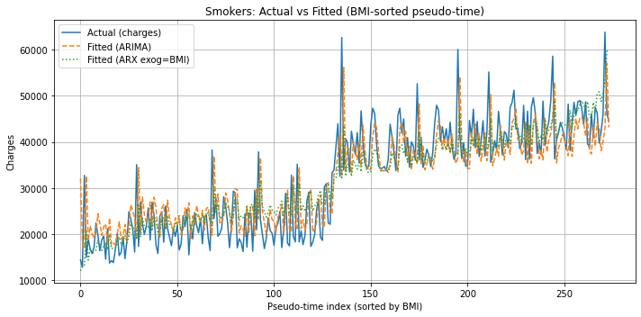
Figure 2. Obese: Actual vs Fitted (BMI-sorted pseudo-time)
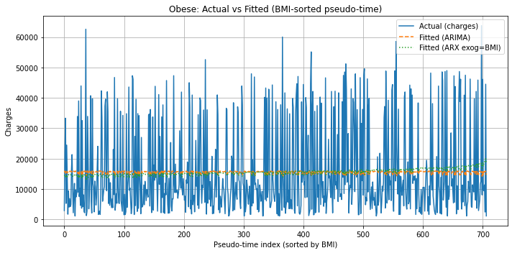
Figure 1 illustrates the ARX model fit for smokers, showing a relatively close alignment between actual and fitted charges along the BMI-sorted pseudo-time index. By contrast, Figure 2 displays the ARX model fit for obese individuals, where the model shows weaker alignment, suggesting that BMI alone is a less powerful predictor of charges in this subgroup. The stronger alignment in the smoker model provides greater confidence in the reliability of forecasted savings, while the weaker fit for the obese subgroup highlights potential uncertainty (Koutsandreas et al., 2022). This difference in predictive accuracy has implications for how much weight the optimization model can place on each forecast.
Table 1. Forecast-to-Decision Inputs
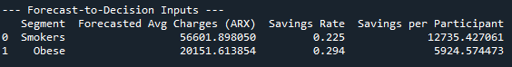
This table illustrates how forecasts provide actionable financial parameters for the optimization stage. Without the forecasting step, the LP model would rely on static historical averages, potentially underestimating or overestimating savings opportunities.

3.3 Integrated Results

3.3.1 Optimal Allocation
The LP solver identified the optimal allocation of resources given a budget of 120,000 USD, intervention costs of 500 USD per smoker and 400 USD per obese participant, and capacity limits (150 smokers, 350 obese individuals).
Table 2. Optimal Allocation Summary
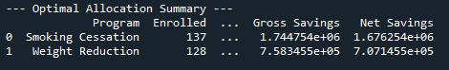
The solution enrolled 137 smokers and 128 obese individuals, exhausting nearly the entire budget (119,700 USD out of 120,000) while maximizing savings. Importantly, the smoking cessation program yielded nearly 70% of the total net savings, reflecting the higher baseline costs forecasted for smokers (Onwuzo et al., 2024). This outcome aligns with the stronger predictive reliability of the smoker ARX model, which exhibited a closer fit to actual charges compared to the obese subgroup. As a result, the savings estimates for smokers can be considered more robust, leading greater confidence to the allocation decision.

3.3.2 Heuristic Comparison
A greedy heuristic was also tested, ranking participants by savings-per-dollar ratio. Interestingly, under this dataset both LP and heuristic produced the exact same allocation, suggesting that the optimal solution followed a straightforward decision rule: prioritize smokers up to their capacity, then allocate remaining budget to obese participants (Mayer, 2022).
Figure 3. Net Savings: Optimal LP vs Heuristic
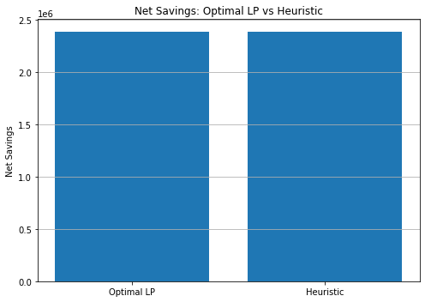
Both methods achieved identical net savings of approximately 2.38 million USD. While the convergence of results provides reassurance in this context, LP remains the more robust approach because it guarantees optimally under more complex scenarios with additional constraints, where heuristics may diverge.

3.4 Sensitivity Analysis
Sensitivity analysis is the process of systematically varying model parameters to test robustness and evaluate risk exposure (Ordu et al., 2021). In this project, both budget and savings rates were varied by $±$10%. This tested whether the recommended allocation remained valid under slightly more optimistic or pessimistic assumptions.
Table 3. Sensitivity Analysis Results
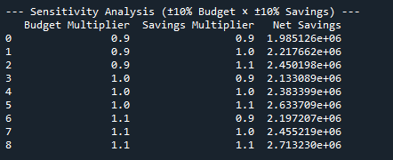
Results remained positive, ranging from 1.99 million to 2.71 million USD in net savings. Two insights emerge:
- Net savings were more sensitive to changes in saving rates than to budget levels, underlining the importance of accurate forecasting of medical charges.
- Increasing the budget beyond 120,000 USD did not alter the optimal allocation due to program capacity constraints, demonstrating diminishing returns without structural changes.
This is particularly relevant for the obese subgroup, where the weaker ARX model fit introduces greater uncertainty around savings estimates, reinforcing the need for sensitivity testing.

3.5 Discussion & Conclusion
The integration of forecasting and optimization produced a robust decision support pipeline for managing healthcare costs. The comparative analysis of ARX model fits revealed an important insight: the model for smokers achieved a much closer alignment between actual and fitted charges than the model for obese individuals. This suggests that smoking status, combined with BMI and other exogenous variables, provides a stronger and more consistent signal for predicting medical costs, whereas obesity-driven charges are more diffuse and harder to capture with BMI alone (Ali et al., 2022). From a decision-making perspective, this highlights a greater degree of confidence in the forecasted savings for smoking cessation programs compared to weight reduction initiatives. The optimization step confirmed these differences. Smoking cessation dominated the allocation, contributing nearly 70% of the total net savings, consistent with both the higher forecasted baseline charges and the stronger predictive reliability of the ARX model. Weight reduction still contributed meaningfully, but its weaker model fit implies greater uncertainty in realized savings, reinforcing the importance of sensitivity testing. Sensitivity analysis provided further assurance that the integrated pipeline is robust to moderate variations in assumptions. Net savings remained positive across all budget and savings scenarios, ranging from 1.99 to 2.71 million USD. Interestingly, changes in savings rates had a more pronounced effect than changes in budget, showing that forecast accuracy exerts more influence than financial flexibility. This reinforces the value of accurate predictive modeling in healthcare cost management. Three key contributions emerge from this integrative framework:
- Forecasts refined decision inputs: By moving beyond static historical averages, ARX forecasts improved the accuracy of expected savings estimates.
- Optimization guarantees efficient allocation: LP provided a rigorous framework to allocate scarce resources, ensuring that the highest-yield interventions were prioritized.
- Sensitivity analysis confirms robustness: Scenario testing demonstrated that the proposed allocation remains effective under uncertainty, offering confidence to insurers and policymakers.
However, the pipeline has limitations. The dataset is cross-sectional, meaning the pseudo-time approach does not capture true longitudinal dynamics. Additionally, assumed savings rates were fixed, while in reality they depend on program adherence and effectiveness. Finally, while label encoding enabled ARX implementation, one-hot encoding and scaling could improve interpretability and generalization. In conclusion, the forecast-to-decision pipeline demonstrates how predictive analytics (ARX forecasts) and prescriptive analytics (LP optimization) can be combined to address rising medical costs. Forecasting alone cannot reduce expenditure, and optimization without reliable forecasts risks relying on outdated or inaccurate assumptions (Tang and Meng, 2021). Together, they provide an evidence-based framework that supports insurers in making cost-effective, forward-looking decisions.

3.6 Executive Summary
Rising healthcare costs represents a pressing challenge for insurers and policymakers. Smoking and obesity are well-established drivers of medical expenditure, with smokers averaging annual charges of more than 32,000 USD and obese individuals (BMI $≥$ 30) averaging over 15,000 USD. To address these expenditures, this project developed an integrated forecast-to-decision pipeline that combines predictive forecasting with optimization, enabling insurers to identify the most effective use of limited prevention budgets.

3.6.1 Forecasting Medical Costs
Forecasting uses historical and demographic data to make evidence-based predictions about future healthcare charges. Autoregressive models with exogenous variables (ARX) were employed to forecast charges for smokers and obese individuals, using lifestyle and demographic factors such as BMI and smoking status. The forecasts indicated expected charges of approximately 56,600 USD for smokers and 20,150 USD for obese individuals. These forecasts provided a forward-looking basis for estimating potential savings from preventive programs.

3.6.2 Optimization of Resource Allocation
Optimization is a mathematical process that determines the most efficient way to use limited resources. A Linear Programming (LP) model was developed to allocate a fixed annual budget of 120,000 USD between two programs:
- Smoking cessation (cost: 500 USD per participant, risk reduction: 22,5%).
- Weight reduction (cost: 400 USD per participant, risk reduction: 29,4%).
The LP solution recommended enrolling 137 smokers and 128 obese individuals, nearly exhausting the budget. This allocation was projected to generate gross savings of 2.5 million USD, leading to net savings of 2.38 million USD after program costs.

3.6.3 Robustness and Risk Assessment
Sensitivity analysis was conducted by varying both the budget and estimated savings rates by $±$10%. Across all scenarios, net savings remained positive (1.99 to 2.71 million USD). Results showed that outcomes were more sensitive to changes in savings rates than to budget size, emphasizing the importance of accurate forecasts and effective program delivery.

3.6.4 Business Implications
The integrated forecast-to-decision pipeline demonstrates a powerful decision support tool for healthcare cost management:
- Data-driven insight: Forecasting allows insurers to anticipate high-risk cost drivers.
- Actionable strategy: Optimization translates forecasts into clear program enrollment targets.
- Financial impact: Net annual savings of over 2.3 million USD are achievable under current assumptions.
- Robust decisions: Recommendations remain effective even when assumptions are moderately varied.

3.6.5 Conclusion
This project demonstrates the value of integrating predictive (forecasting) and prescriptive (optimization) analytics into a unified decision framework. For insurers, the pipeline offers a scalable approach to managing healthcare costs by targeting high-risk groups, maximizing the return on limited budgets, and ensuring financial sustainability. Looking ahead, this framework could be expanded to incorporate additional health conditions, multi-objective goals (e.g., balancing financial savings with patient outcomes), and real-world longitudinal claims data, making it a powerful tool for strategic healthcare management.

4. References
- AbdulRaheem, Y., 2023. Unveiling the significance and challenges of integrating prevention levels in healthcare practice. Journal of primary care & community health, 14, p.21501319231186500.
- Ali, S., Na, R., Waterhouse, M., Jordan, S.J., Olsen, C.M., Whiteman, D.C. and Neale, R.E., 2022. Predicting obesity and smoking using medication data: A machine‐learning approach. Pharmacoepidemiology and drug safety, 31(1), pp.91-99.
- Baid, D., Hayles, E. and Finkelstein, E.A., 2021. Return on investment of workplace wellness programs for chronic disease prevention: a systematic review. American journal of preventive medicine, 61(2), pp.256-266.
- Batko, K. and Ślęzak, A., 2022. The use of Big Data Analytics in healthcare. Journal of big Data, 9(1), p.3.
- Bento, P.M., Pombo, J.A., Calado, M.R. and Mariano, S.J., 2021. Stacking ensemble methodology using deep learning and ARIMA models for short-term load forecasting. Energies, 14(21), p.7378.
- Boachie, M.K., Thsehla, E., Immurana, M., Kohli-Lynch, C. and Hofman, K.J., 2022. Estimating the healthcare cost of overweight and obesity in South Africa. Global health action, 15(1), p.2045092.
- Cai, Y. and Omay, T., 2022. Using double frequency in Fourier Dickey–Fuller unit root test. Computational Economics, 59(2), pp.445-470.
- Earnshaw, S.R. and Dennett, S.L., 2003. Integer/linear mathematical programming models: a tool for allocating healthcare resources. Pharmacoeconomics, 21(12), pp.839-851.
- García, S., Luengo, J. and Herrera, F., 2015. Data preprocessing in data mining (Vol. 72, pp. 59-139). Cham, Switzerland: Springer International Publishing.
- Gass, S.I., 2003. Linear programming: methods and applications. Courier Corporation.
- Ghaffarzadegan, N., 2021. Simulation-based what-if analysis for controlling the spread of Covid-19 in universities. PloS one, 16(2), p.e0246323.
- Gill, P.E., Murray, W. and Wright, M.H., 2019. Practical optimization. Society for Industrial and Applied Mathematics.
- Hamilton, J.D., 2020. Time series analysis. Princeton university press.
- Hobijn, B., Franses, P.H. and Ooms, M., 2004. Generalizations of the KPSS‐test for stationarity. Statistica Neerlandica, 58(4), pp.483-502.
- Kim, Y., 2025. The effects of smoking, alcohol consumption, obesity, and physical inactivity on healthcare costs: a longitudinal cohort study. BMC Public Health, 25(1), p.873.
- Klazoglou, P. and Dritsakis, N., 2017, July. Modeling and forecasting of US health expenditures using ARIMA models. In International Conference on Applied Economics (pp. 457-472). Cham: Springer International Publishing.
- Kontopoulou, V.I., Panagopoulos, A.D., Kakkos, I. and Matsopoulos, G.K., 2023. A review of ARIMA vs. machine learning approaches for time series forecasting in data driven networks. Future Internet, 15(8), p.255.
- Koutsandreas, D., Spiliotis, E., Petropoulos, F. and Assimakopoulos, V., 2022. On the selection of forecasting accuracy measures. Journal of the Operational Research Society, 73(5), pp.937-954.
- Kumar, A., Pant, S., Ram, M. and Yadav, O. eds., 2022. Meta-heuristic optimization techniques: applications in engineering (Vol. 10). Walter de Gruyter GmbH & Co KG.
- Mayer, J., 2022. Stochastic linear programming algorithms: A comparison based on a model management system. Routledge.
- Mukhiya, S.K. and Ahmed, U., 2020. Hands-On Exploratory Data Analysis with Python: Perform EDA techniques to understand, summarize, and investigate your data. Packt Publishing Ltd.
- Okunogbe, A., Nugent, R., Spencer, G., Ralston, J. and Wilding, J., 2021. Economic impacts of overweight and obesity: current and future estimates for eight countries. BMJ global health, 6(10).
- Onwuzo, C.N., Olukorode, J., Sange, W., Orimoloye, D.A., Udojike, C., Omoragbon, L., Hassan, A.E., Falade, D.M., Omiko, R., Odunaike, O.S. and Adams-Momoh, P.A., 2024. A review of smoking cessation interventions: efficacy, strategies for implementation, and future directions. Cureus, 16(1).
- Ordu, M., Demir, E., Tofallis, C. and Gunal, M.M., 2021. A novel healthcare resource allocation decision support tool: A forecasting-simulation-optimization approach. Journal of the operational research society, 72(3), pp.485-500.
- Parganiha, K., 2018. Linear programming with python and pulp. Int. J. Ind. Eng. Res. Dev, 9(3), pp.1-8.
- Piltan, F., TayebiHaghighi, S. and Sulaiman, N.B., 2017. Comparative study between ARX and ARMAX system identification. International Journal of Intelligent Systems and Applications (IJISA), 9(2), pp.25-34.
- Roy, D., Srivastava, R., Jat, M. and Karaca, M.S., 2022. A complete overview of analytics techniques: descriptive, predictive, and prescriptive. Decision intelligence analytics and the implementation of strategic business management, pp.15-30.
- Saltelli, A., Tarantola, S., Campolongo, F. and Ratto, M., 2004. Sensitivity analysis in practice: a guide to assessing scientific models (Vol. 1). New York: Wiley.
- Sharma, A.K., Sharma, D.M., Purohit, N., Rout, S.K. and Sharma, S.A., 2022. Analytics techniques: descriptive analytics, predictive analytics, and prescriptive analytics. In Decision intelligence analytics and the implementation of strategic business management (pp. 1-14). Cham: Springer International Publishing.
- Singh, N., Chakrabarti, T., Chakrabarti, P., Margala, M., Gupta, A., Praveen, S.P., Krishnan, S.B. and Unhelkar, B., 2023. Novel heuristic optimization technique to solve economic load dispatch and economic emission load dispatch problems. Electronics, 12(13), p.2921.
- Sun, X. and Wang, Y., 2024. Growth models in aquaculture for hybrid and natural groupers based on early development stage. Aquaculture, 578, p.740026.
- Tang, L. and Meng, Y., 2021. Data analytics and optimization for smart industry. Frontiers of Engineering Management, 8(2), pp.157-171.
- ul Hassan, C.A., Iqbal, J., Hussain, S., AlSalman, H., Mosleh, M.A. and Sajid Ullah, S., 2021. A computational intelligence approach for predicting medical insurance cost. Mathematical Problems in Engineering, 2021(1), p.1162553.
- Xu, X., Shrestha, S.S., Trivers, K.F., Neff, L., Armour, B.S. and King, B.A., 2021. US healthcare spending attributable to cigarette smoking in 2014. Preventive medicine, 150, p.106529.
- Yakubu, U.A. and Saputra, M.P.A., 2022. Time series model analysis using autocorrelation function (ACF) and partial autocorrelation function (PACF) for E-wallet transactions during a pandemic. Int. J. Glob. Oper. Res, 3(3), pp.80-85.

