Data Modelling and Analysis, Assessment 1.
Matthaios Chatzimichail.
In order to satisfy the scenario of the assessment we need to create 4 tables: Series, Episodes, Actors, and Dircetors. This report will demonstrate the commands, in SQL language, necessary to create the table and all the attributes they contain.
1.)Creating the tables

- Creating the “Series” table.

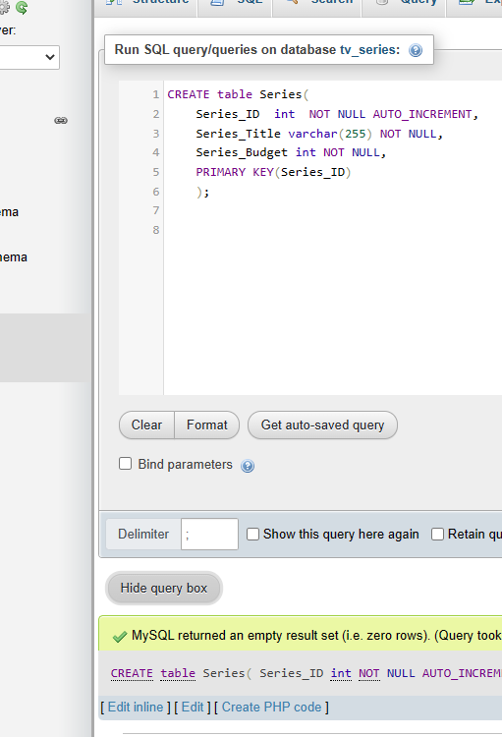

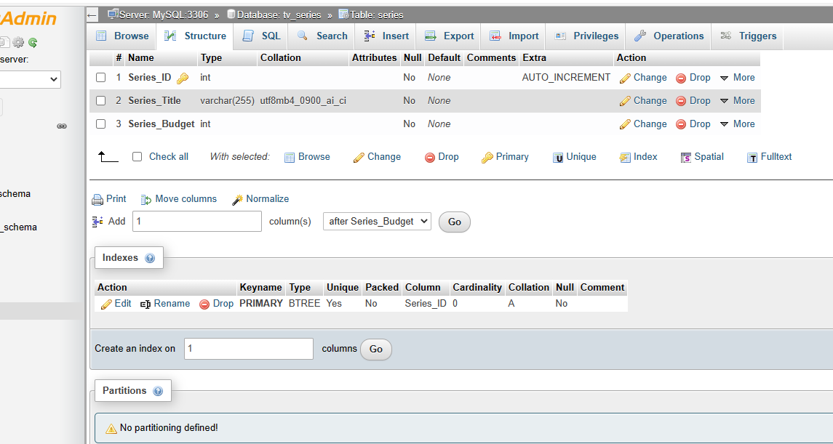

- Creating the “Episodes” table.

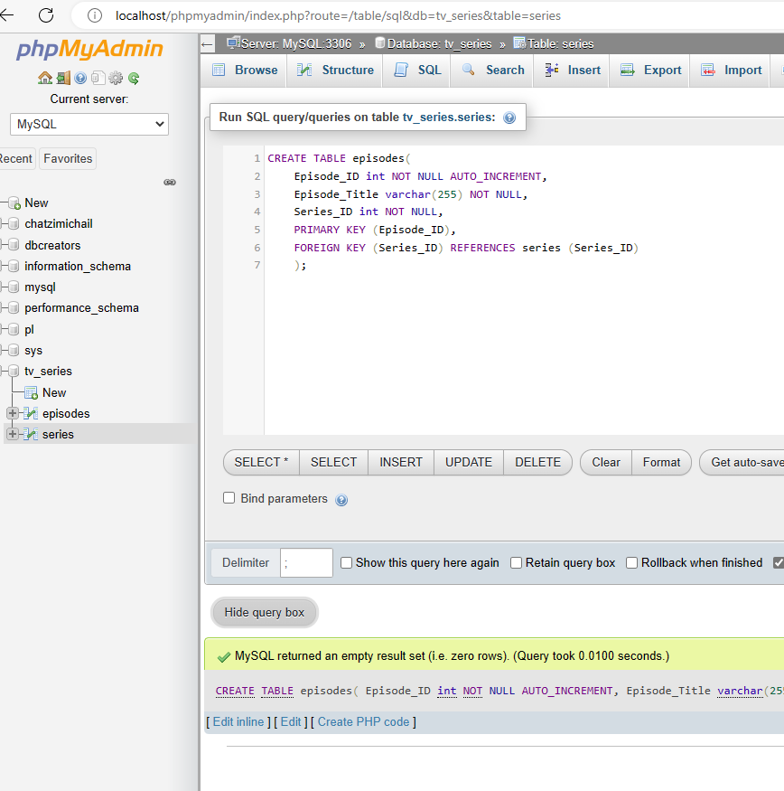

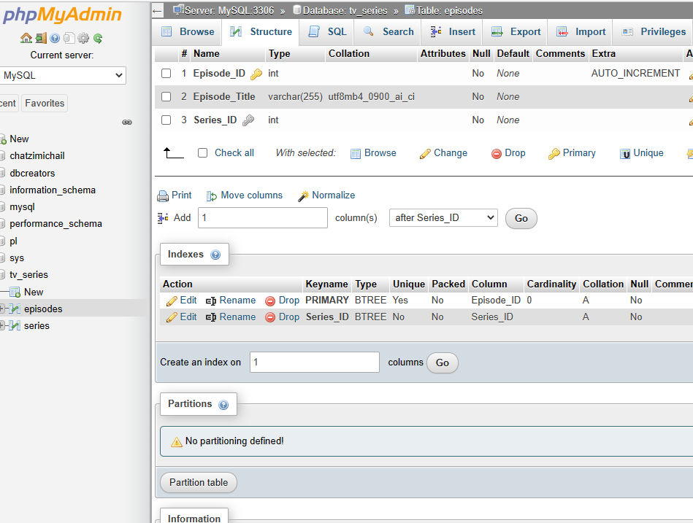

- Creating the “Actors” table.

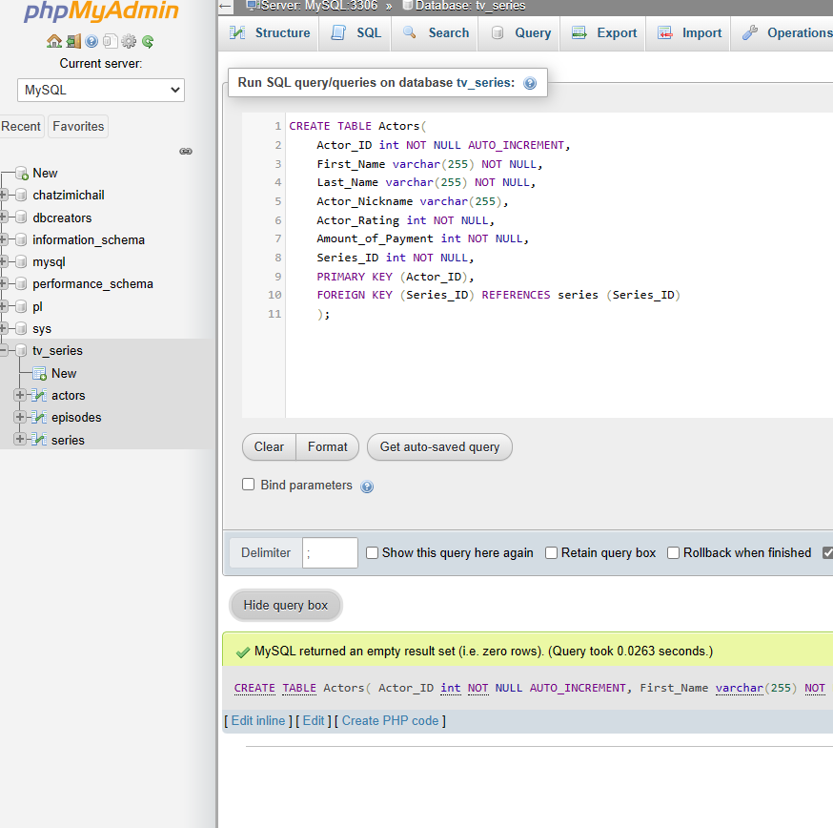
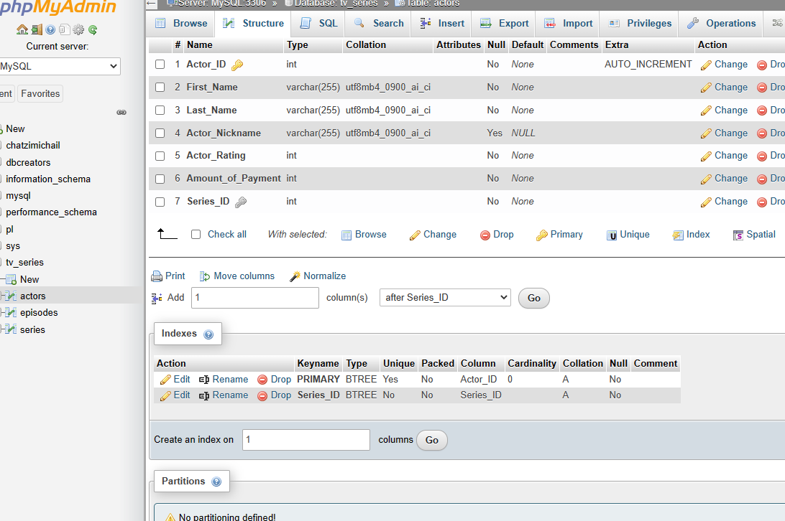

- Creating the “Directors” table.

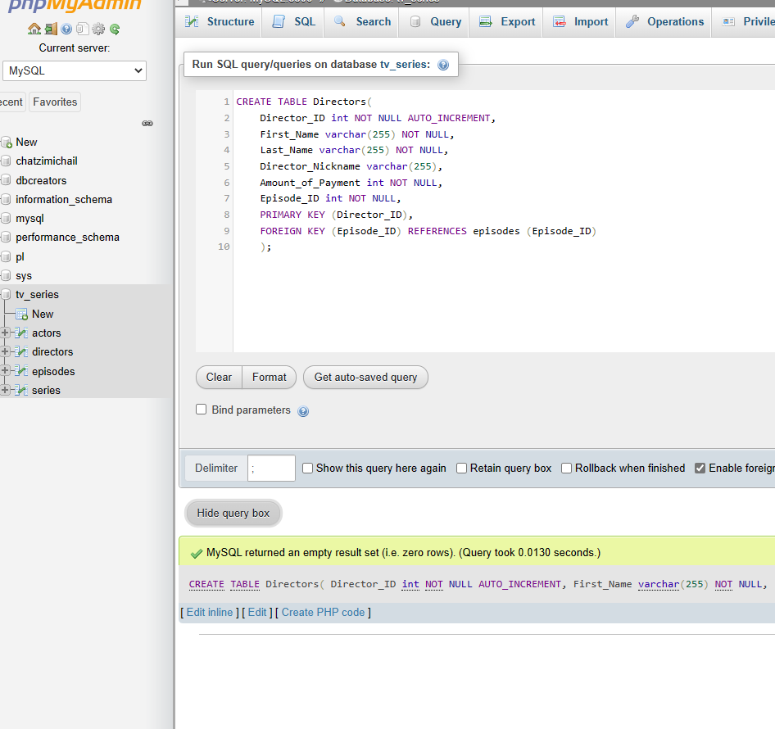

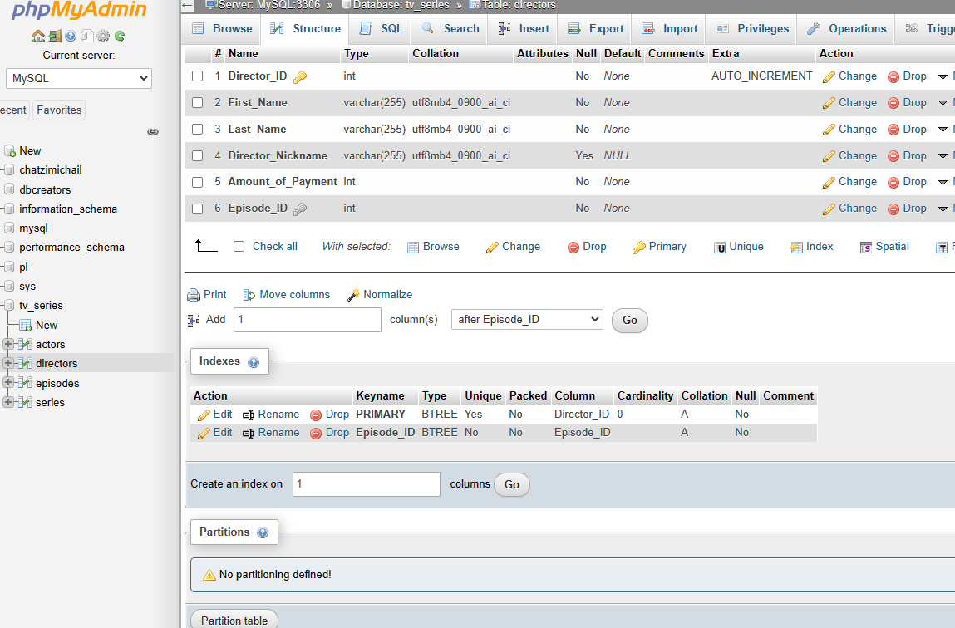

2.)Queries

- Show the Series Title and budget of the series that have a budget over 500000.

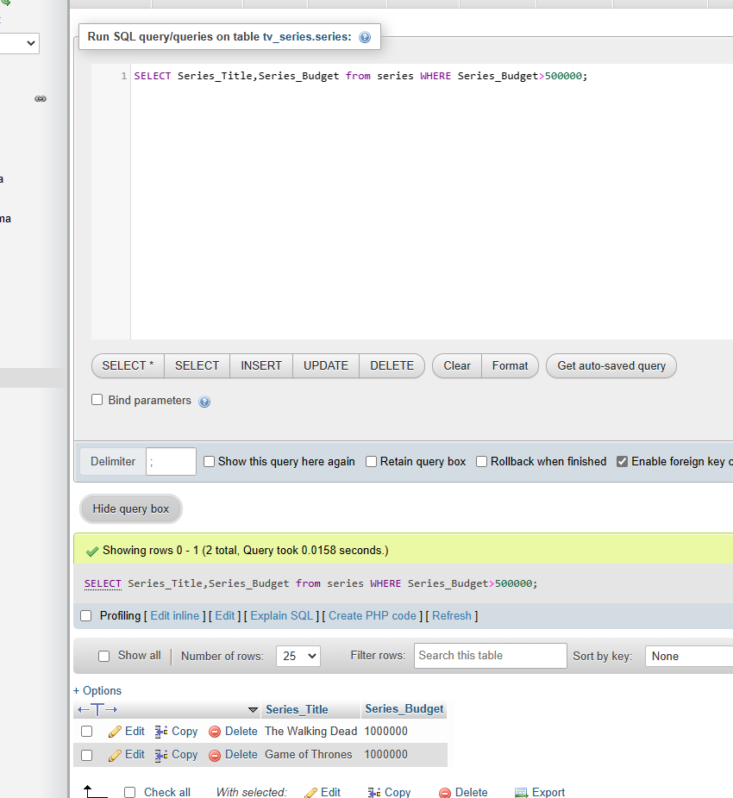
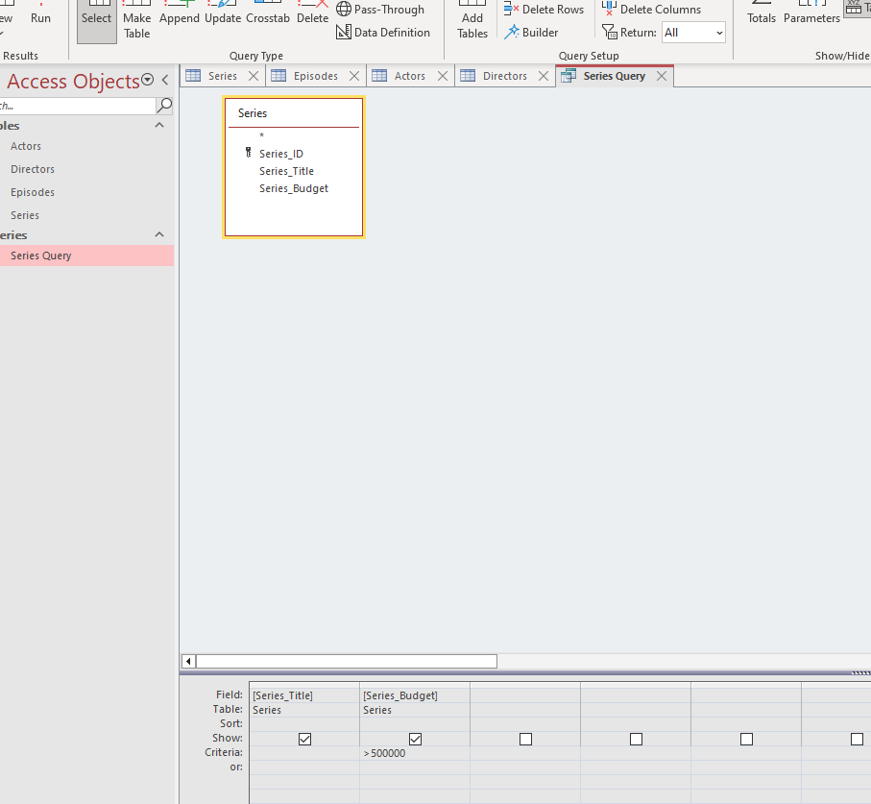

- Show all the Series and their episodes.

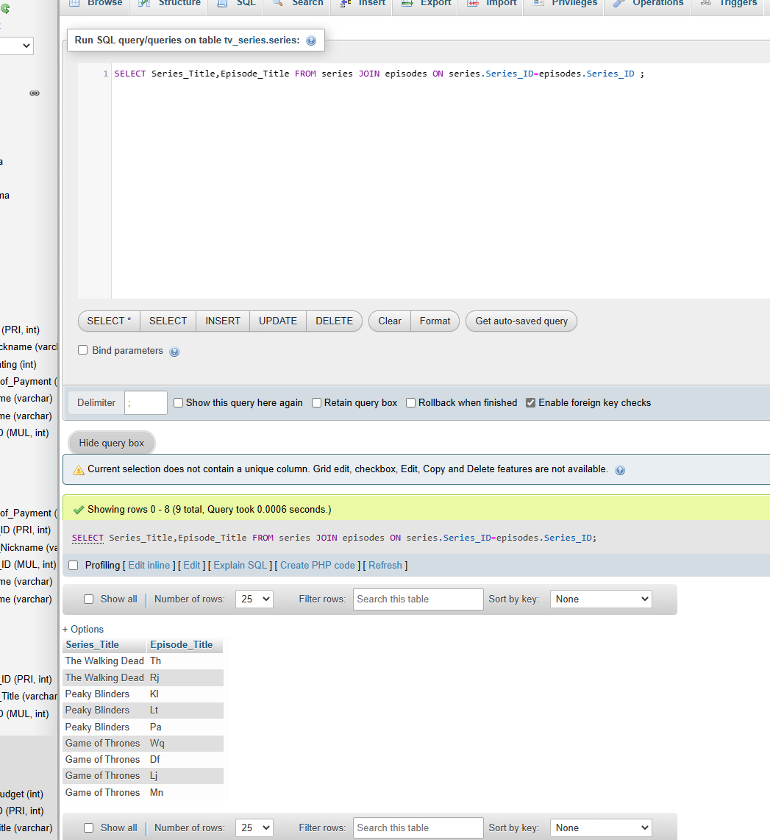

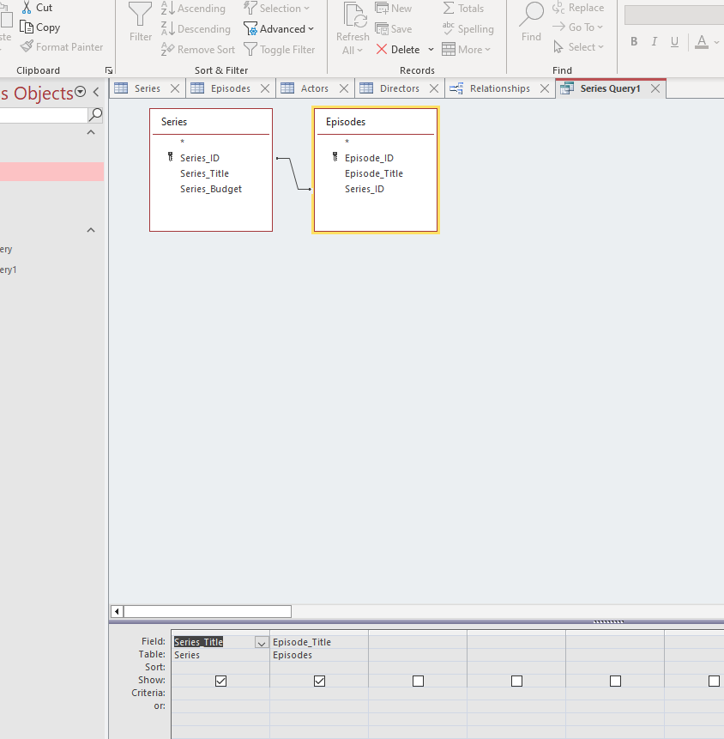

- Show all the directors and the episodes they made as well as the series that every episode belongs to.

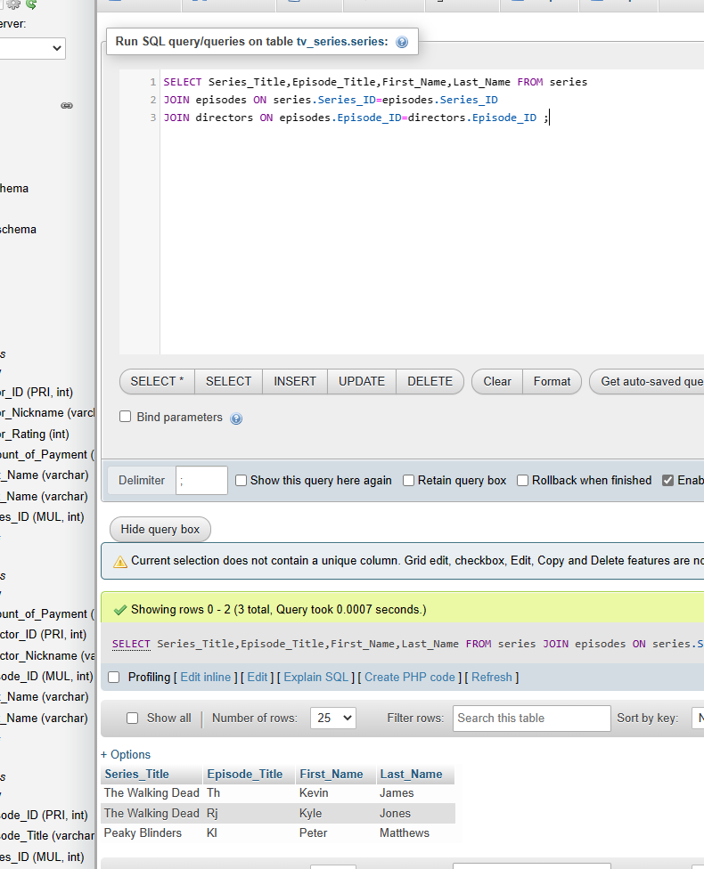

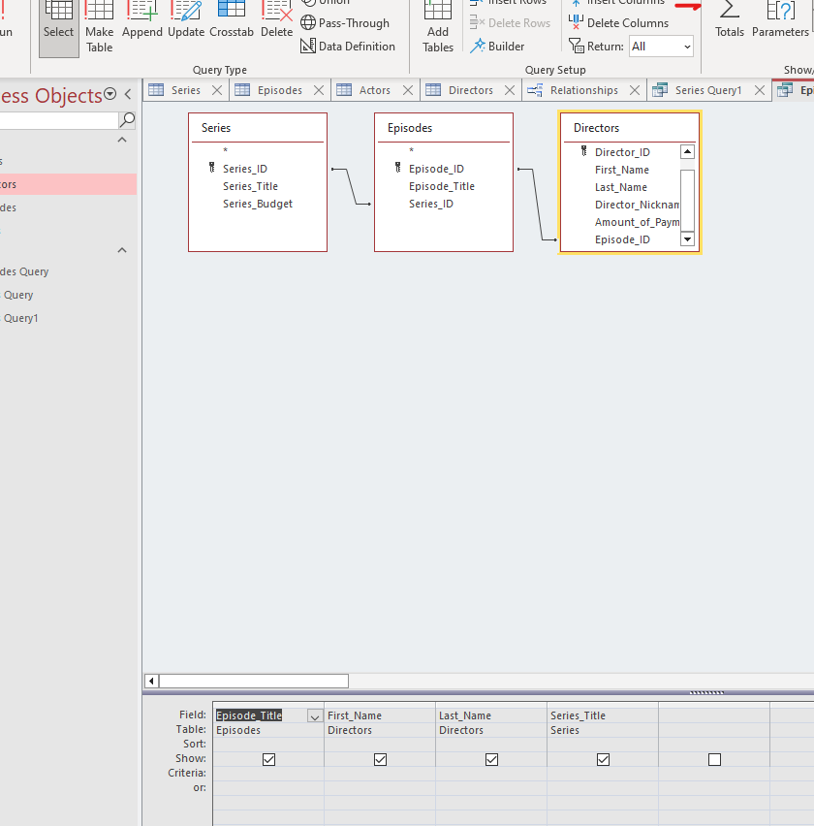

3.) Documentation
The database named ‘tv_series’ was created to store information about the aspects of multiple tv series, it consists of four tables. The first table is the ‘Series’ table containing three attributes namely :
a.) PRIMARY KEY Series_ID (int NOT NULL AUTO INCREMENT), number character, required and automated number.
b.) Series_Title (varchar(255) NOT NULL), any type of character with a limit of 255 characters and required attribute.
c.) Series_Budget(int NOT NULL), number character and required attribute.

The ‘Series_ID’ being the primary key of the table is the basic attribute of the table and it is set at AUTO INCREMENT in order to allocate to it’s value of the table an automated number, that allocation improves the organization of the database.
Next in line there is the ‘Episodes’ table which has the following attributes :
- PRIMARY KEY Episode_ID(int NOT NULL AUTO INCREMENT), number character, required and automated number.
- Episode_Title(varchar(255) NOT NULL), any type of character with a limit of 255 characters and required attribute.
- FOREIGN KEY Series_ID(int NOT NULL), number character and required attribute.

The last attribute Series_ID is a foreign key, the purpose of a foreign key is to connect two or more tables as it is the same attribute that another table has as it’s PRIMARY KEY. In this case the FOREIGN KEY connects the table Episodes ,which is a part of, with the table Series with the goal of each episode to be allocated to it’s respective series.
The third table is the Actors table consisting of the attributes below:

- PRIMARY KEY Actor_ID(int NOT NULL AUTO INCREMENT), number character, required and automated number.
- First_Name(varchar(255) NOT NULL), any type of character with a limit of 255 characters and required attribute.
- Last_Name(varchar(255) NOT NULL), any type of character with a limit of 255 characters and required attribute.
- Actor_Nickname(varchar(255)), any type of character with a limit of 255 characters.
- Actor_Rating(int NOT NULL), number character and required attribute.
- Amount_of_Payment(int NOT NULL), number character and required attribute.
- FOREIGN KEY Series_ID(int NOT NULL), number character and required attribute.

In this case the foreign key ,Series_ID, is connecting the Actor table with the Series table. In this way we associate every actor with the series they participate in.

The last table is the Directors table which consists of the following attribute:

- PRIMARY KEY Director_ID(int NOT NULL AUTO INCREMENT), number character, required and automated number.
- First_Name(varchar(255) NOT NULL), any type of character with a limit of 255 characters and required attribute.
- Last_Name(varchar(255) NOT NULL), any type of character with a limit of 255 characters and required attribute.
- Director_Nickname(varchar(255)), any type of character with a limit of 255 characters.
- Amount_of_Payment(int NOT NULL), number character and required attribute.
- FOREIGN KEY Episode_ID(int NOT NULL), number character and required attribute.

In this case the FOREIGN KEY Episode_ID connects the Directors table with the Episodes table and therefor connecting the directors with the episodes they have created.

4.)Testing
The most important for a database developer to execute after he creates a database is a proper testing process. In the database tv_series the data is logically organized and optimally stored in tables and there is no unnecessary data present. Moreover the length of each field is of the correct size and the data type of each field matches the specifications, in addition all the similar fields have the same name across tables. Additionally every necessary Primary or foreign key constraints has been created on the tables and the references for the foreign keys are optimal. Furthermore every condition is covered by the input data and the proper handling has been done for exceptions as well as the correct coding conventions have been followed. Finally the database is secure from unauthorized access, all the users have their own permissions and not every user has access to alter the database only to observe it.

