**Preparation and Maintanence of ZOHO Books for EduConnect Learning Center**

anage their donations, tEduConnect Learning Center, an educational institution, uses Zoho Books to mrack expenses, and handle grant finances. They can generate donor receipts, track expensesrelated to educational programs, and generate financial reports. Zoho Books helps them maintain financial transparency and accountabilityrelated to educational programs, and generate financial reports. Zoho Books helps them maintain financial transparency and accountability

nage their donations, tEduConnect Learning Center, an educational institution, uses Zoho Books to mrack expenses, and handle grant finances. They can generate donor receipts, track expensesrelated to educational programs, and generate financial reports.

related to educational programs, and generate financial reports. Zoho Books helps them maintain financial transparency and accountability

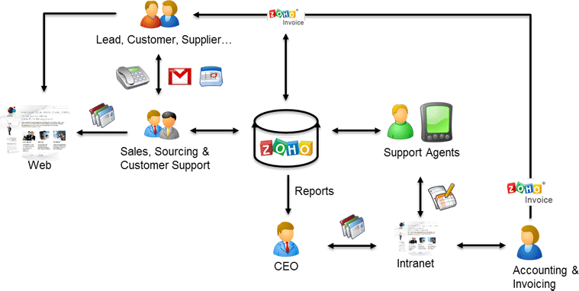

As a Center of Excellence, HealthHub Clinics offers multi-disciplinary resources and smart healthcare solutions, supported by a holistic and compassionate approach, understanding and quality care designed around your health.

1. **Problem definition & design Thinking**
   1. *Empathy map*

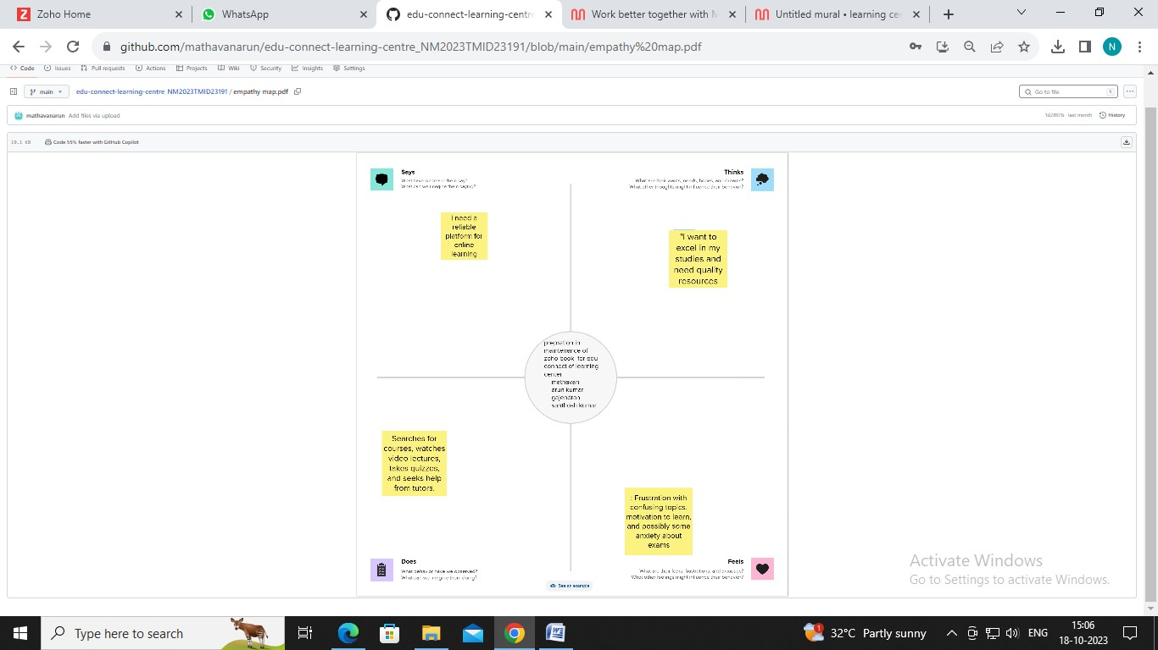

* 1. *Ideation & Brainstorming map*

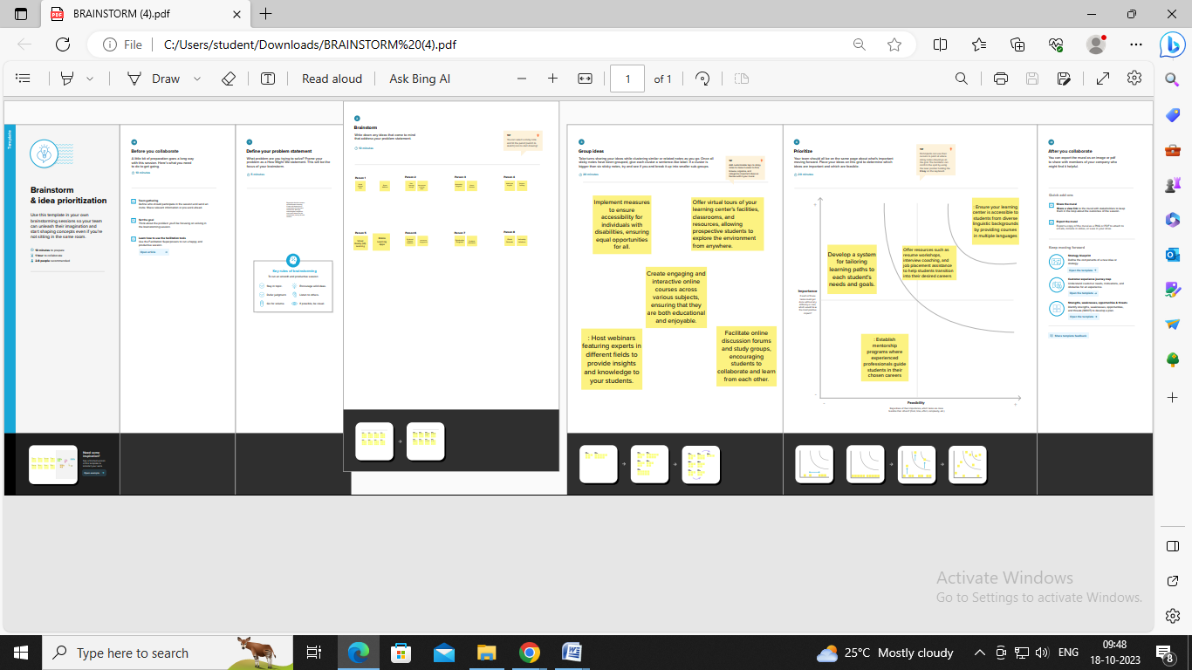

1. **Result Profit&loss**

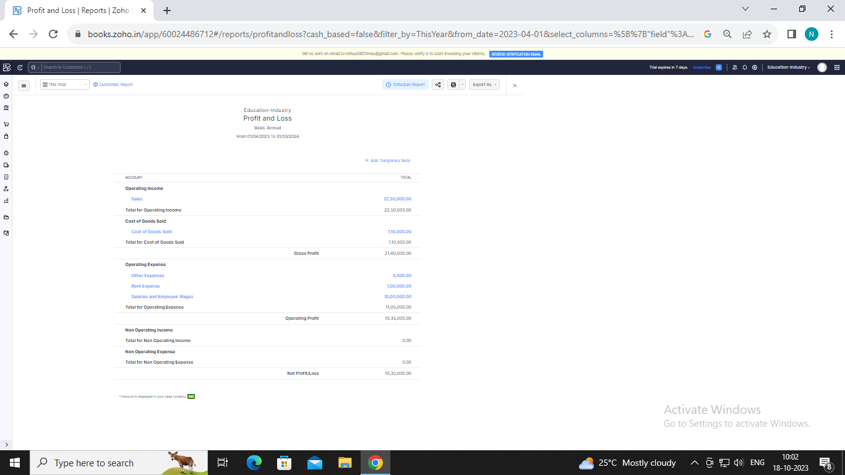

Balance sheet:

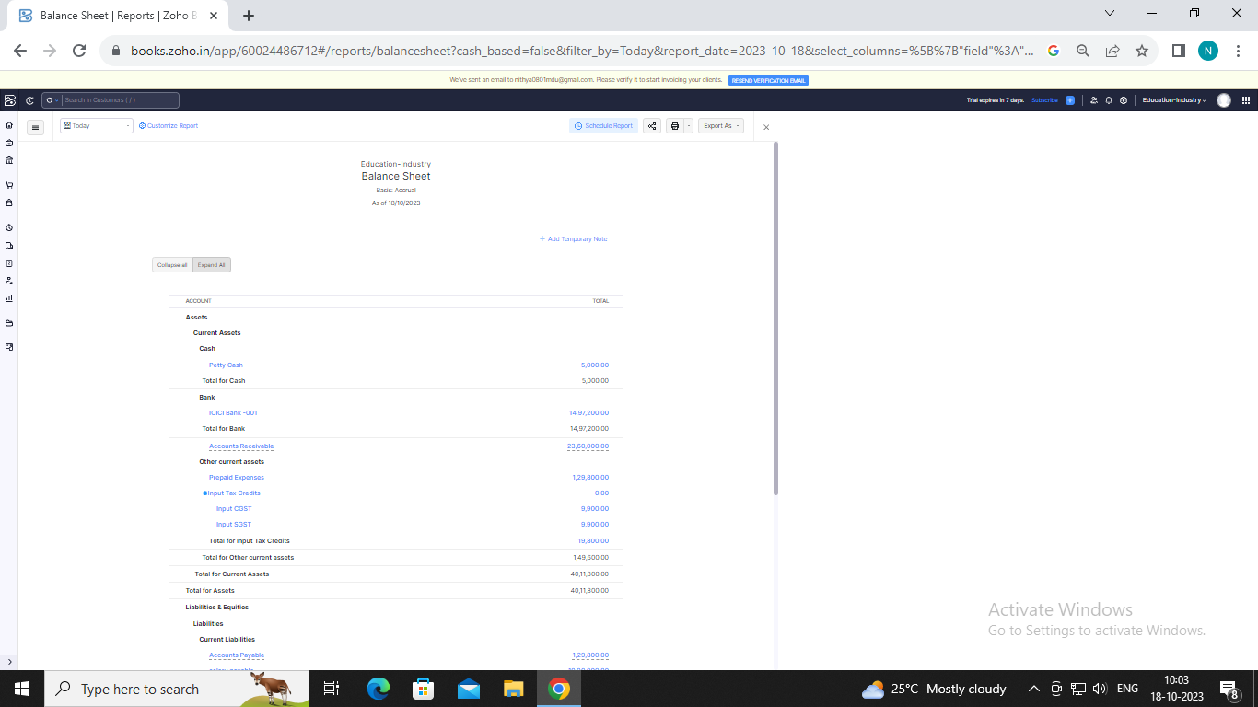

Purchase order:

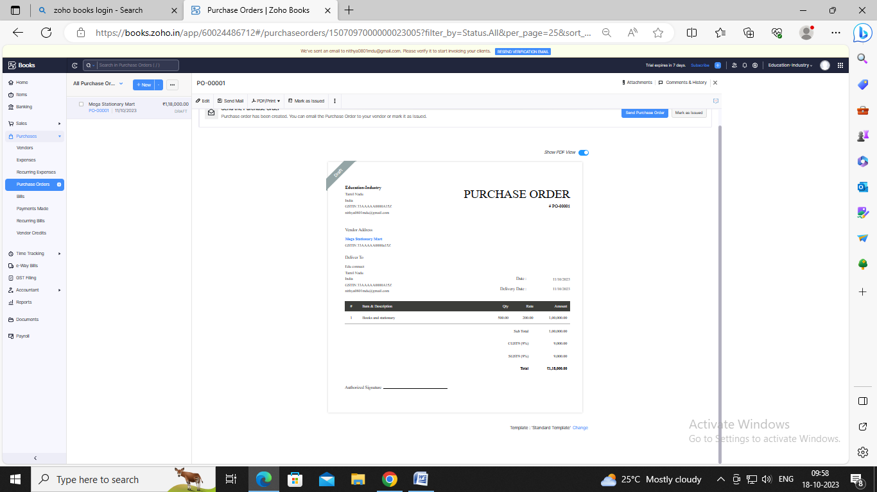

DISADVANTAGES OF EDUCONNET LEARNING CENTRE

* [**May Create a Sense of Isolation**](https://www.getmyuni.com/articles/advantages-and-disadvantages-of-online-education#may-create-a-sense-of-isolation)

ADVANTAGES OF EDUCONNET LEARNING CENTRE

**Free access to online educational courses**

* **Free access to content and streaming tools.**
* **Access to premium entertainment services.**
* **to Access graphic design tools**
* [Inability To Focus On Screens](https://www.getmyuni.com/articles/advantages-and-disadvantages-of-online-education#inability-to-focus-on-screens)
* [Technology Issues](https://www.getmyuni.com/articles/advantages-and-disadvantages-of-online-education#technology-issues)
* [Lack of Interpersonal Communication](https://www.getmyuni.com/articles/advantages-and-disadvantages-of-online-education#lack-of-interpersonal-communication)
* [Procrastination](https://www.getmyuni.com/articles/advantages-and-disadvantages-of-online-education#procrastination).

Appendix

<https://github.com/mathavanarun/edu-connect-learning-centre_NM2023TMID23191>

|  |
| --- |
| <!DOCTYPE html> |
|  | <html lang="en" data-color-mode="auto" data-light-theme="light" data-dark-theme="dark" data-a11y-animated-images="system" data-a11y-link-underlines="true"> |
|  |  |
|  | <style> |
|  | /* for each iteration, uncomment the CSS variable */ |
|  |  |
|  | /* light themes */ |
|  | [data-color-mode="light"][data-light-theme*="light"], |
|  | [data-color-mode="auto"][data-light-theme*="light"] { |
|  | /* iteration 1 */ |
|  | --border-color-iteration-1: #C8CCD0; |
|  | /* iteration 2 */ |
|  | --border-color-iteration-2: #BABFC5; |
|  | /* iteration 3 */ |
|  | --border-color-iteration-3: #A6ADB4; |
|  | /* iteration final */ |
|  | --border-color-iteration-4: #868F99; |
|  |  |
|  | /* the first value is the final step, which falls back to previous iterations */ |
|  | --control-borderColor-rest: var(--border-color-iteration-4, var(--border-color-iteration-3, var(--border-color-iteration-2, var(--border-color-iteration-1)))) !important; |
|  | } |
|  |  |
|  | /* dark themes */ |
|  | [data-color-mode="dark"][data-dark-theme*="dark"], |
|  | [data-color-mode="auto"][data-light-theme*="dark"] { |
|  | /* iteration 1 */ |
|  | --border-color-iteration-1: #363940; |
|  | /* iteration 2 */ |
|  | --border-color-iteration-2: #3F434B; |
|  | /* iteration 3 */ |
|  | --border-color-iteration-3: #4B5159; |
|  | /* iteration final */ |
|  | --border-color-iteration-4: #666E79; |
|  |  |
|  | /* the first value is the final step, which falls back to previous iterations */ |
|  | --control-borderColor-rest: var(--border-color-iteration-4, var(--border-color-iteration-3, var(--border-color-iteration-2, var(--border-color-iteration-1)))) !important; |
|  | } |
|  |  |
|  | [data-color-mode="dark"][data-dark-theme="dark_dimmed"], |
|  | [data-color-mode="dark"][data-dark-theme="light_high_contrast"], |
|  | [data-color-mode="dark"][data-dark-theme="dark_high_contrast"], |
|  | [data-color-mode="light"][data-light-theme="dark_dimmed"], |
|  | [data-color-mode="light"][data-light-theme="light_high_contrast"], |
|  | [data-color-mode="light"][data-light-theme="dark_high_contrast"] { |
|  | /* skip these themes, use the fallback */ |
|  | --control-borderColor-rest: initial !important; |
|  | } |
|  |  |
|  | @media (prefers-color-scheme: dark) { |
|  | /* dark colors in dark mode */ |
|  | [data-color-mode="auto"][data-dark-theme*="dark"] { |
|  | /* iteration 1 */ |
|  | --border-color-iteration-1: #363940; |
|  | /* iteration 2 */ |
|  | --border-color-iteration-2: #3F434B; |
|  | /* iteration 3 */ |
|  | --border-color-iteration-3: #4B5159; |
|  | /* iteration final */ |
|  | --border-color-iteration-4: #666E79; |
|  |  |
|  | /* the first value is the final step, which falls back to previous iterations */ |
|  | --control-borderColor-rest: var(--border-color-iteration-4, var(--border-color-iteration-3, var(--border-color-iteration-2, var(--border-color-iteration-1)))) !important; |
|  | } |
|  |  |
|  | /* light colors in dark mode */ |
|  | [data-color-mode="auto"][data-dark-theme*="light"] { |
|  | /* iteration 1 */ |
|  | --border-color-iteration-1: #C8CCD0; |
|  | /* iteration 2 */ |
|  | --border-color-iteration-2: #BABFC5; |
|  | /* iteration 3 */ |
|  | --border-color-iteration-3: #A6ADB4; |
|  | /* iteration final */ |
|  | --border-color-iteration-4: #868F99; |
|  |  |
|  | /* the first value is the final step, which falls back to previous iterations */ |
|  | --control-borderColor-rest: var(--border-color-iteration-4, var(--border-color-iteration-3, var(--border-color-iteration-2, var(--border-color-iteration-1)))) !important; |
|  | } |
|  |  |
|  | [data-color-mode="auto"][data-dark-theme="dark_dimmed"], |
|  | [data-color-mode="auto"][data-dark-theme="light_high_contrast"], |
|  | [data-color-mode="auto"][data-dark-theme="dark_high_contrast"] { |
|  | /* skip these themes, use the fallback */ |
|  | --control-borderColor-rest: initial !important; |
|  | } |
|  | } |