Instruction to use Weka for time to cure prediction

1. Download and install Weka from:

<https://waikato.github.io/weka-wiki/downloading_weka/>

1. Run Weka, the following window will be displayed:



1. Press “Explorer”:

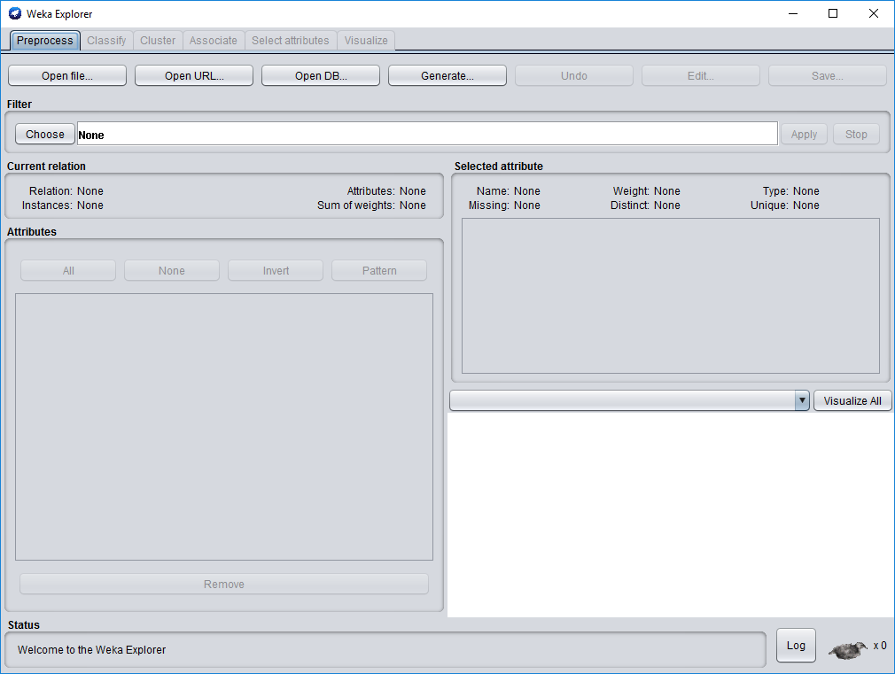

1. Press “Open file” and choose the dataset “artificial_dataset.arff”:

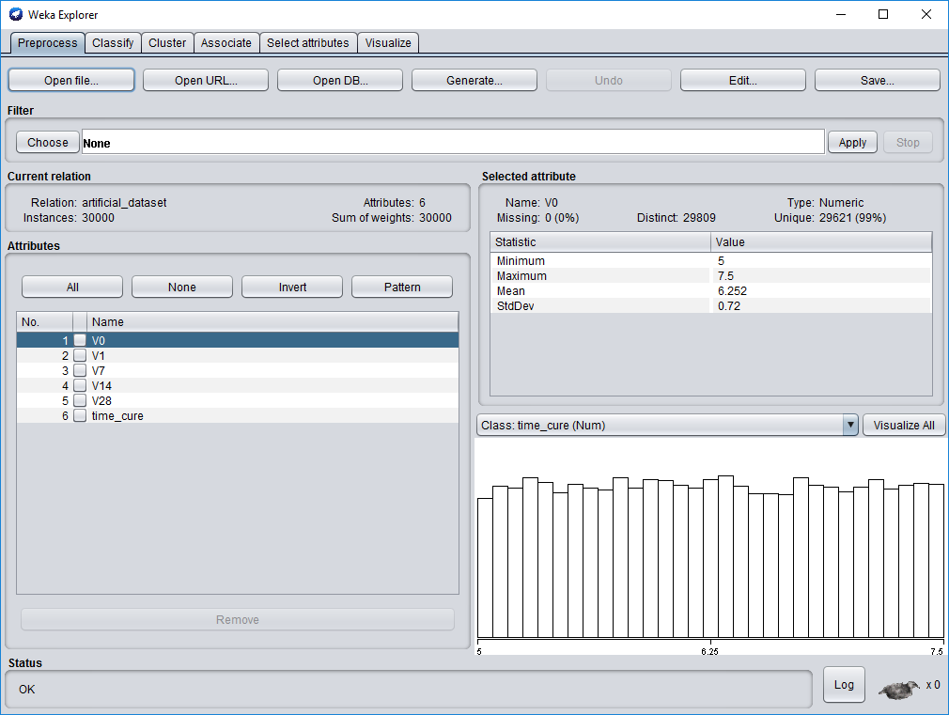

1. In this window you may see the statistics of the parameters and remove some parameters from the dataset.
2. To start learning and testing press “Classify”:

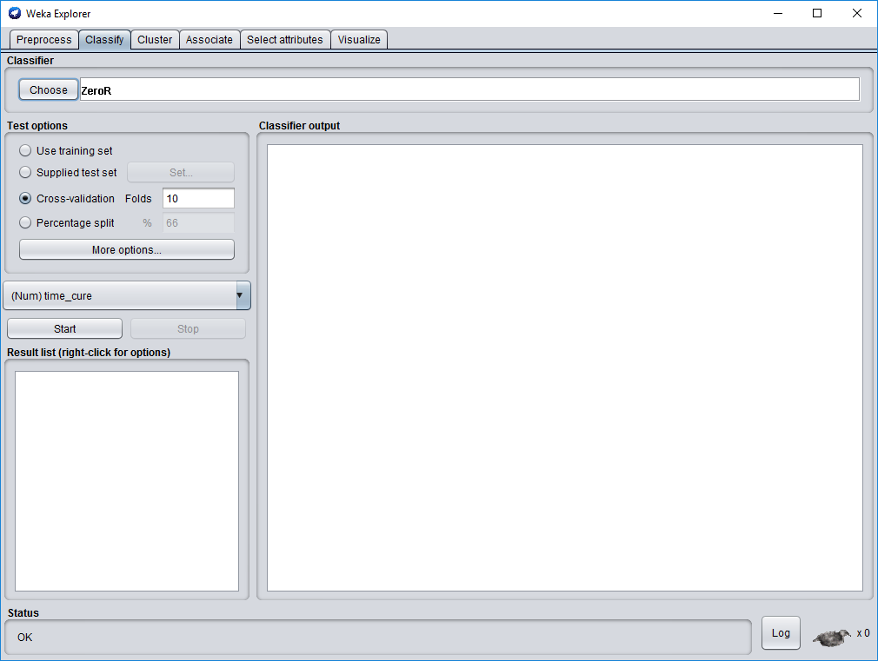

1. Press “Choose” to choose classification algorithm. To choose “RandomForest” go to “trees” and choose “RandomForest”:

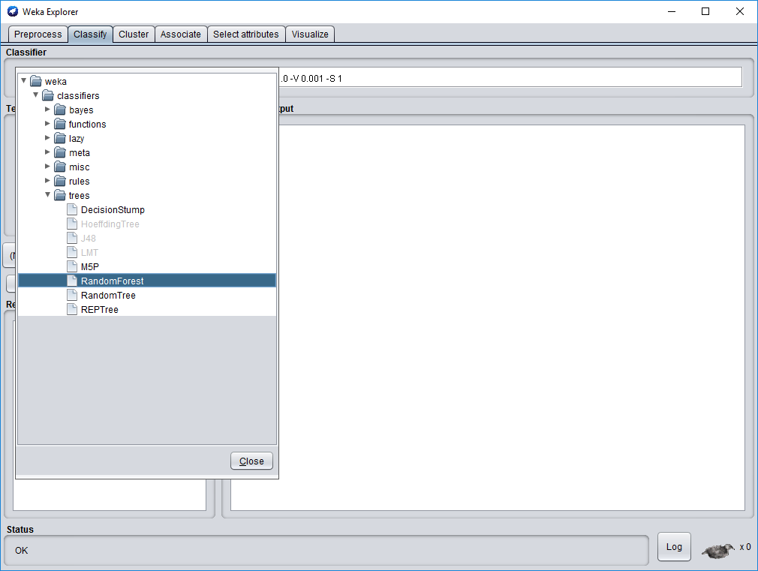

1. To start learning and testing the learned model on the same dataset, choose “Cross validation” or “Percentage split” and press “Start”:

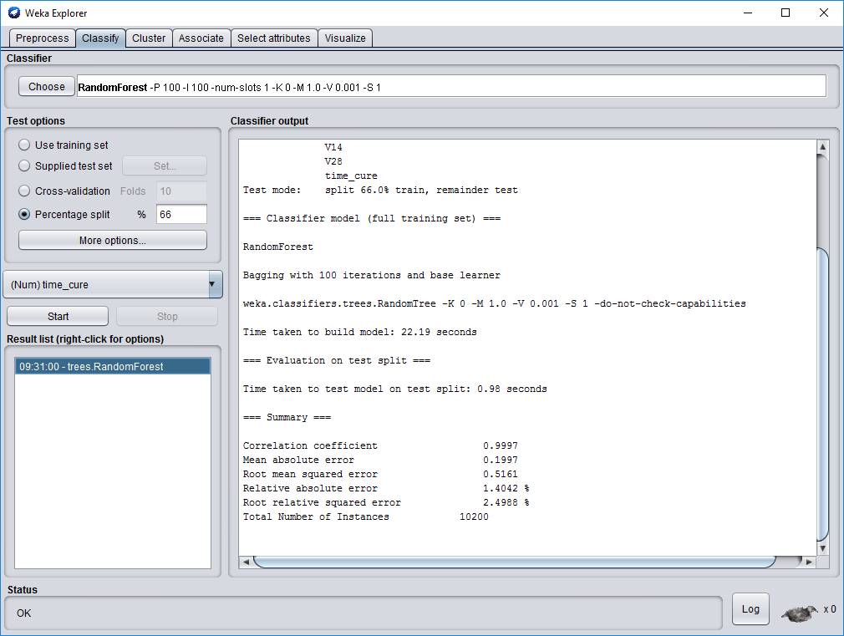

1. After several seconds you will get the answer that RandomForest classification algorithm predicts time to cure in the artificial dataset with 1.4% error in average.
2. In order to test the learned model on other dataset, for example with real data, choose “Supplied test set” in the “Test options”. Press “Set” and choose another dataset file for testing, for example, “real_dataset.arff” file.

