**IT-based Management –**

**CPPI Investment Strategy & PDCA**

**Group 1**

**Mateusz Czernecki (1025504)**

**Name (Student Number)**

**Name (Student Number)**

**Vienna, November 2015**

**Assignment abstract:**

1. Design of the CPPI Optimization Strategy as Mgmt.-Activity Diagram – Max. 5 Points
2. Implementation & Documentation– Max. 15 Points

Table of Contents

1 Design – CPPI 3

1.0 Task 3

1.1 MGT Activity Diagram 3

1.2 Activities and Business Objects 4

2 Documentation of the CPPI Optimization Implementation 5

2.0 Task 5

2.1 Solution 5

# Design – CPPI

## Task

Design the MGT Activity Diagram in UML notation.

* Choose the right structure and design the control and information flows
  + closed **or** open loop **and** single **or** double loop
* Identify and describe the activities (processes), rules and business objects correctly

## MGT Activity Diagram

Closed Single Loop

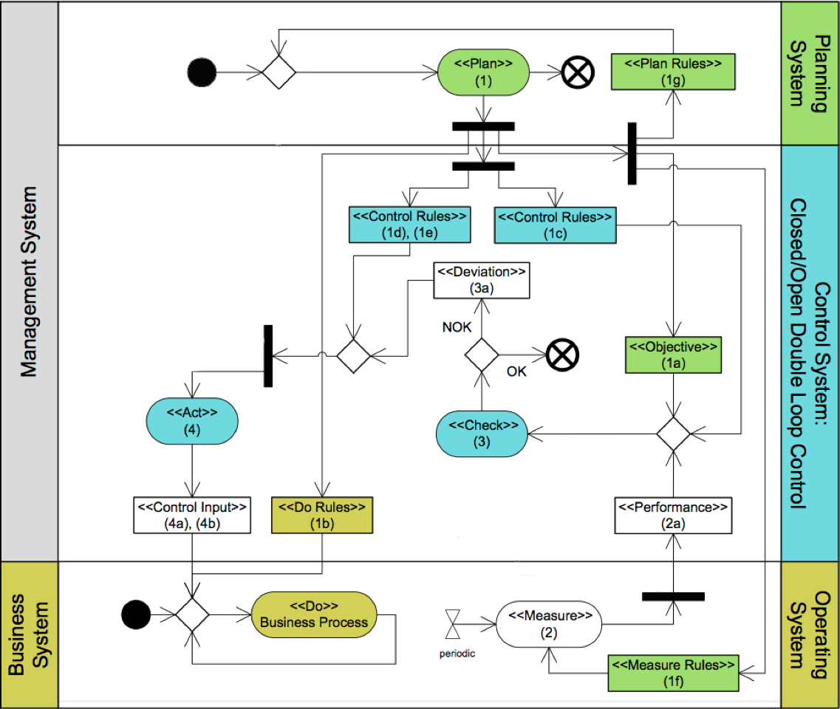



## Activities and Business Objects

|  |  |  |  |  |
| --- | --- | --- | --- | --- |
| **Nr.** | **Stereotype** | **Name** | **Relevant variables** | **Description** |
| 1 | [Plan] | Planning of Floor Value | - | Should never be below the CPPI portfolio value. |
| 1a | [Objective] | Floor Value | $$F_{t}$$ | Floor value at the end of investment period |
| 1b | [Do Rules] | Monitoring | - |  |
| 1c | [Control Rules] | Calculating Rules | $$m,b,C$$ |  |
| 1d,e | [Control Rules] |  | - |  |
| 1f | [Measure Rule] |  | - |  |
| 1g | [Plan Rules] | Configure Basic Variables | $$d, m, R_{0}$$ | Setting of all relevant variables which are needed for further calculations |
| 2 | [Measure] |  | $$S_{t},T_{t,T}$$ |  |
| 2a | [Performance] |  | $$W_{t}$$ |  |
| 3 | [Check] |  | - |  |
| 3a | [Deviation] |  | - |  |
| 4 | [Act] |  | - |  |
| 4a | [Control Input] |  | - |  |

# Documentation of the CPPI Optimization Implementation

## Task

Implement the CPPI strategy. Use the predefined abstract classes and interfaces, which are located in the project template. Log the output (values of cppi model variables) after each optimization period. Finally, document which classes correspond to which CPPI activities and describe their behaviour below (use representative code snippets).

The src folder contains the following packages:

* at.ac.tuwien.imw.pdca
  + Contains the framework classes and interfaces, which you should use implementing the CPPI Optimization considering a PDCA management process infrastructure.
  + Manipulation not allowed.
* at.ac.tuwien.imw.pdca.cppi
  + Contains your implementation. E.g. implement your CPPIActProcess as follows:



* at.ac.tuwien.imw.pdca.cppi.service
* Contains main class for starting the optimization
* Contains the CPPIService context object for saving the current state
* Manipulation allowed.

## Solution