**IT-based Management –**

**CPPI Investment Strategy & PDCA**

**Group 1**

**Mateusz Czernecki (1025504)**

**Andreas Kocman (0302840)**

**Michael Lazarus (1206994)**

**Vienna, February 2016**

**Assignment abstract:**

1. Design of the CPPI Optimization Strategy as Mgmt.-Activity Diagram – Max. 5 Points
2. Implementation & Documentation– Max. 15 Points

Table of Contents

1 Design – CPPI 3

1.0 Task 3

1.1 MGT Activity Diagram 3

1.2 Activities and Business Objects 4

2 Documentation of the CPPI Optimization Implementation 5

2.0 Task 5

2.1 Solution 5

# Design – CPPI

## Task

For the design, we chose the Closed Single Loop.

## MGT Activity Diagram

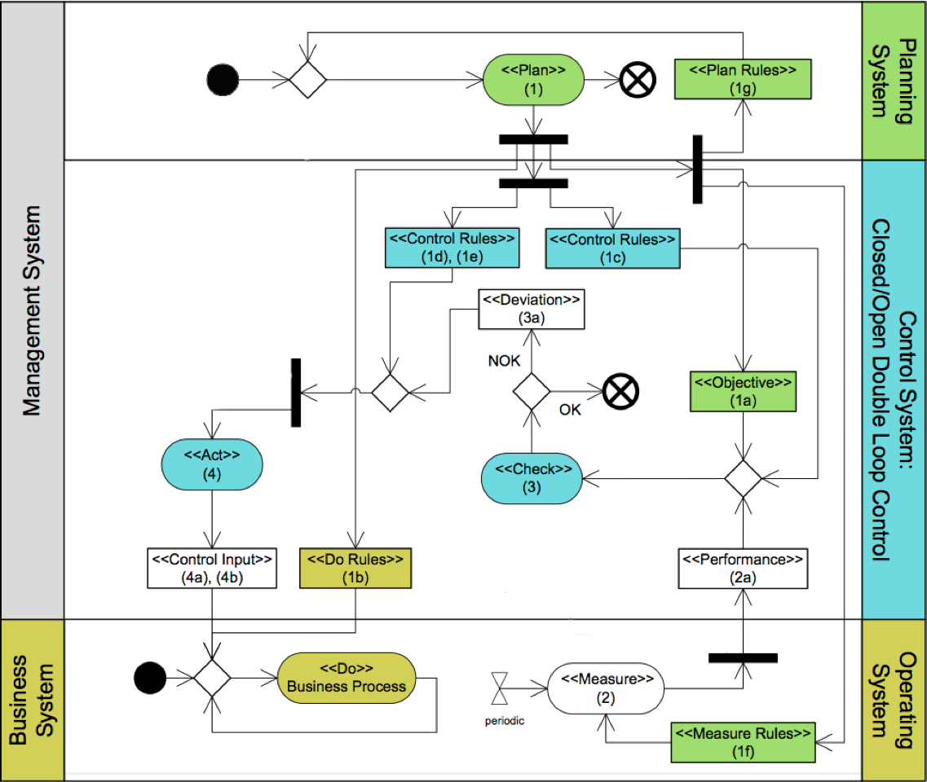

## Activities and Business Objects

|  |  |  |  |  |
| --- | --- | --- | --- | --- |
| **Nr.** | **Stereotype** | **Name** | **Relevant variables** | **Description** |
| 1 | [Plan] | Planning of Floor Value | - | Should never be below the CPPI portfolio value. |
| 1a | [Objective] | Floor Value | $$F_{t},T_{t,T}$$ | Floor value at the end of investment period. $T_{t,T}$ is used to calculate the floor value. |
| 1b | [Do Rules] | Monitoring | - |  |
| 1c | [Control Rules] | Multiplier & Risk | $$m,b$$ | $m$ and $b$ are planned, given values (Multiplier & Risk) by the end-user. |
| 1d,e | [Control Rules] | DeviationToAct | - | Control Rules, which are applied to the deviation. E.g. Notifications |
| 1f | [Measure Rule] | DefineCalculation | $$W_{t}$$ | Is used to define the calculation of the current portfolio wealth. |
| 1g | [Plan Rules] | Configure Basic Variables | $$d, m, R_{0}$$ | Setting of all relevant variables which are needed for further calculations. In our example, the return $R$ is constant. |
| 2 | [Measure] | MeasureStockPrice | - | Measures the current stock price. |
| 2a | [Performance] | CurrentWealth | $$W_{t}$$ | Represents the current wealth. |
| 3 | [Check] | PortfolioChange | TSR | Check a change in the portfolio. |
| 3a | [Deviation] | WealthDeviation | TSR | Check, if the deviation is != 0. |
| 4 | [Act] | DistributionChange | - | Inform about the new distribution. |
| 4a | [Control Input] | NewDistribution | $$X_{ft},X_{rt},C_{t}$$ | Rules in order to calculate the new distribution. Calculate the new distribution and the cushion |

# Documentation of the CPPI Optimization Implementation

## Task

* *CPPIPlanProcess extends the PlanProcess for BigDecimals:*

In creates the plan rules in accordance with the PDCA model.

* *CPPIPlanRules implements PlanningRules for BigDecimals:*

Sets the initial floor and calculates the current TtT

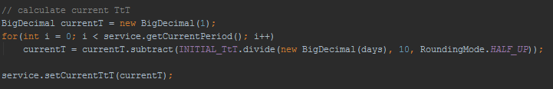

* *CPPIDoProcess extends the DoProcess for BigDecimals:*

Applies the do rules in accordance with the PDCA model. Any regular business process would be implemented here. However, this is not applicable for the CPPI.

* *CPPICheckProcess extends the CheckProcess for BigDecimals:*

Check rules are created and applied in accordance with the PDCA model.

* *CPPICheckRules implement the CheckingRules*

The TSR is being calculated here.

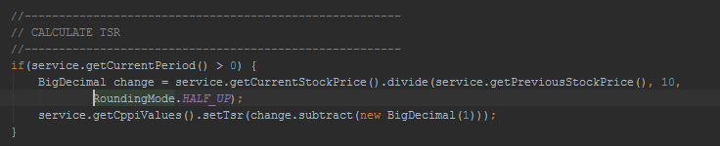

* *CPPIMeasure extends MeasuredPerfomanceValue for BigDecimals:*
* *CPPIMeasureRules extends the Measure Rules*

In accordance with the CPPI the wealth is calculated here:

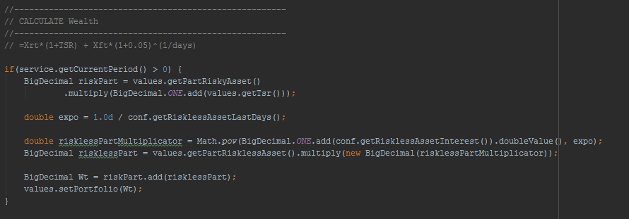

* *CPPIActProcess extends the ActProcess for BigDecimals*

In accordance with the PDCA, ActRules are applied. Furthermore the thread notifies the CPPIService that one PDCACycle is finished, which in turn either shuts down the threads or increases the current period.

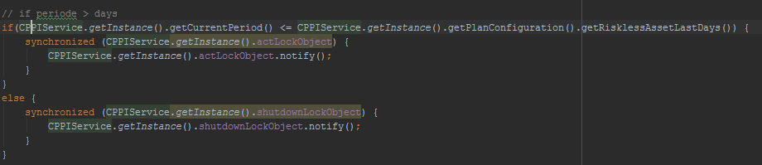

* *CPPIActRules implements the CorrectiveActRules*

The risk asset percentage of the portfolio as well as the cushion are calculated during the creation of the rules.

Portfolio percentages/Exposure calculation:

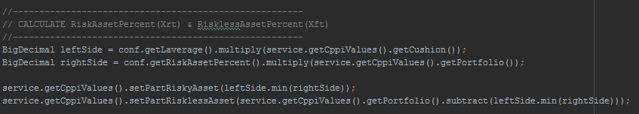

Cushion calculation:

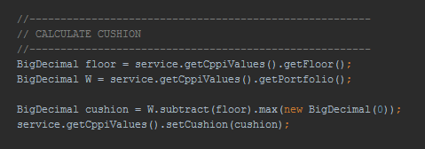

* *CPPIPlanConfiguration*

All initial values are being initialized here in order to prepare the PCCI/PDCA process.

* *CPPIValues:*

Saves the current values of the current period and provides getter and setter methods for all processes.

* *CPPI Simulation:*

Creates the threads, the ExecutorService for the threads (fixed number of threads since they are invariant) and initializes the execution of all threads. Each thread waits for the notification of the previous process to launch. Once the maximum number of days is reached, the executor shuts down and terminates the program.

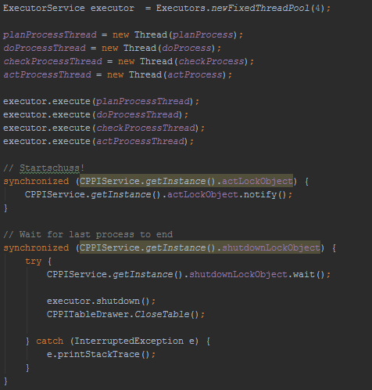

## Solution

+------+---------+----------+----------+----------+----------+-----------+----------+--------------+

| t | T_t,T | Ft | Ct | X_r,t | X_f,t | St | TSR_t | Wt |

+------+---------+----------+----------|----------|----------|-----------+----------+--------------+

| 0 | 1,0000 | 95,24 | 4,76 | 9,52 | 90,48 | 102,00 | 0,00% | 100,00 |

| 1 | 0,9973 | 95,25 | 5,04 | 10,08 | 90,21 | 105,00 | 2,94% | 100,29 |

| 2 | 0,9945 | 95,26 | 5,52 | 11,04 | 89,74 | 110,00 | 4,76% | 100,78 |

| 3 | 0,9918 | 95,28 | 6,02 | 12,04 | 89,25 | 115,00 | 4,55% | 101,30 |

| 4 | 0,9890 | 95,29 | 6,02 | 12,04 | 89,27 | 115,00 | 0,00% | 101,31 |

| 5 | 0,9863 | 95,30 | 6,02 | 12,04 | 89,28 | 115,00 | 0,00% | 101,32 |

| 6 | 0,9836 | 95,31 | 6,23 | 12,46 | 89,09 | 117,00 | 1,74% | 101,54 |

| 7 | 0,9808 | 95,33 | 6,55 | 13,10 | 88,78 | 120,00 | 2,56% | 101,87 |

| 8 | 0,9781 | 95,34 | 6,44 | 12,88 | 88,90 | 119,00 | -0,83% | 101,78 |

| 9 | 0,9753 | 95,35 | 6,11 | 12,22 | 89,24 | 116,00 | -2,52% | 101,46 |

| 10 | 0,9726 | 95,37 | 6,11 | 12,22 | 89,25 | 116,00 | 0,00% | 101,48 |

| 11 | 0,9699 | 95,38 | 6,11 | 12,22 | 89,27 | 116,00 | 0,00% | 101,49 |

| 12 | 0,9671 | 95,39 | 5,90 | 11,80 | 89,49 | 114,00 | -1,72% | 101,29 |

| 13 | 0,9644 | 95,40 | 6,31 | 12,62 | 89,09 | 118,00 | 3,51% | 101,72 |

| 14 | 0,9616 | 95,42 | 6,53 | 13,05 | 88,89 | 120,00 | 1,69% | 101,94 |

| 15 | 0,9589 | 95,43 | 7,07 | 14,14 | 88,36 | 125,00 | 4,17% | 102,50 |

| 16 | 0,9562 | 95,44 | 7,63 | 15,27 | 87,81 | 130,00 | 4,00% | 103,07 |

| 17 | 0,9534 | 95,45 | 6,81 | 13,62 | 88,65 | 123,00 | -5,38% | 102,26 |

| 18 | 0,9507 | 95,47 | 6,37 | 12,73 | 89,10 | 119,00 | -3,25% | 101,83 |

| 19 | 0,9479 | 95,48 | 6,04 | 12,09 | 89,44 | 116,00 | -2,52% | 101,52 |

| 20 | 0,9452 | 95,49 | 5,94 | 11,88 | 89,55 | 115,00 | -0,86% | 101,43 |

| 21 | 0,9425 | 95,51 | 5,83 | 11,67 | 89,67 | 114,00 | -0,87% | 101,34 |

| 22 | 0,9397 | 95,52 | 5,73 | 11,46 | 89,79 | 113,00 | -0,88% | 101,25 |

| 23 | 0,9370 | 95,53 | 6,44 | 12,88 | 89,09 | 120,00 | 6,19% | 101,97 |

| 24 | 0,9342 | 95,54 | 4,51 | 9,02 | 91,04 | 102,00 | -15,00% | 100,05 |

| 25 | 0,9315 | 95,56 | 4,77 | 9,55 | 90,78 | 105,00 | 2,94% | 100,33 |

| 26 | 0,9288 | 95,57 | 5,23 | 10,45 | 90,34 | 110,00 | 4,76% | 100,80 |

| 27 | 0,9260 | 95,58 | 5,70 | 11,40 | 89,88 | 115,00 | 4,55% | 101,28 |

| 28 | 0,9233 | 95,60 | 5,70 | 11,40 | 89,90 | 115,00 | 0,00% | 101,30 |

| 29 | 0,9205 | 95,61 | 5,70 | 11,40 | 89,91 | 115,00 | 0,00% | 101,31 |

| 30 | 0,9178 | 95,62 | 5,90 | 11,79 | 89,72 | 117,00 | 1,74% | 101,52 |

| 31 | 0,9151 | 95,63 | 6,20 | 12,40 | 89,44 | 120,00 | 2,56% | 101,83 |

| 32 | 0,9123 | 95,65 | 6,09 | 12,19 | 89,55 | 119,00 | -0,83% | 101,74 |

| 33 | 0,9096 | 95,66 | 5,79 | 11,57 | 89,87 | 116,00 | -2,52% | 101,45 |

| 34 | 0,9068 | 95,67 | 5,79 | 11,57 | 89,89 | 116,00 | 0,00% | 101,46 |

| 35 | 0,9041 | 95,68 | 5,78 | 11,57 | 89,90 | 116,00 | 0,00% | 101,47 |

| 36 | 0,9014 | 95,70 | 5,58 | 11,17 | 90,11 | 114,00 | -1,72% | 101,28 |

| 37 | 0,8986 | 95,71 | 5,98 | 11,95 | 89,73 | 118,00 | 3,51% | 101,69 |

| 38 | 0,8959 | 95,72 | 6,18 | 12,35 | 89,55 | 120,00 | 1,69% | 101,90 |

| 39 | 0,8932 | 95,74 | 6,69 | 13,38 | 89,04 | 125,00 | 4,17% | 102,43 |

| 40 | 0,8904 | 95,75 | 7,23 | 14,45 | 88,52 | 130,00 | 4,00% | 102,97 |

| 41 | 0,8877 | 95,76 | 6,45 | 12,89 | 89,31 | 123,00 | -5,38% | 102,21 |

| 42 | 0,8849 | 95,77 | 6,03 | 12,05 | 89,75 | 119,00 | -3,25% | 101,80 |

| 43 | 0,8822 | 95,79 | 5,72 | 11,44 | 90,07 | 116,00 | -2,52% | 101,51 |

| 44 | 0,8795 | 95,80 | 5,62 | 11,24 | 90,18 | 115,00 | -0,86% | 101,42 |

| 45 | 0,8767 | 95,81 | 5,52 | 11,05 | 90,29 | 114,00 | -0,87% | 101,34 |

| 46 | 0,8740 | 95,83 | 5,43 | 10,85 | 90,40 | 113,00 | -0,88% | 101,25 |

| 47 | 0,8712 | 95,84 | 6,10 | 12,20 | 89,74 | 120,00 | 6,19% | 101,94 |

| 48 | 0,8685 | 95,85 | 4,27 | 8,54 | 91,58 | 102,00 | -15,00% | 100,12 |

| 49 | 0,8658 | 95,86 | 4,52 | 9,04 | 91,35 | 105,00 | 2,94% | 100,38 |

| 50 | 0,8630 | 95,88 | 4,95 | 9,90 | 90,93 | 110,00 | 4,76% | 100,82 |

| 51 | 0,8603 | 95,89 | 5,40 | 10,79 | 90,49 | 115,00 | 4,55% | 101,29 |

| 52 | 0,8575 | 95,90 | 5,40 | 10,79 | 90,51 | 115,00 | 0,00% | 101,30 |

| 53 | 0,8548 | 95,92 | 5,40 | 10,79 | 90,52 | 115,00 | 0,00% | 101,31 |

| 54 | 0,8521 | 95,93 | 5,58 | 11,16 | 90,35 | 117,00 | 1,74% | 101,51 |

| 55 | 0,8493 | 95,94 | 5,87 | 11,74 | 90,07 | 120,00 | 2,56% | 101,81 |

| 56 | 0,8466 | 95,95 | 5,77 | 11,54 | 90,18 | 119,00 | -0,83% | 101,72 |

| 57 | 0,8438 | 95,97 | 5,48 | 10,96 | 90,49 | 116,00 | -2,52% | 101,44 |

| 58 | 0,8411 | 95,98 | 5,48 | 10,95 | 90,50 | 116,00 | 0,00% | 101,46 |

| 59 | 0,8384 | 95,99 | 5,48 | 10,95 | 90,52 | 116,00 | 0,00% | 101,47 |

| 60 | 0,8356 | 96,01 | 5,29 | 10,57 | 90,72 | 114,00 | -1,72% | 101,29 |

| 61 | 0,8329 | 96,02 | 5,66 | 11,31 | 90,36 | 118,00 | 3,51% | 101,67 |

| 62 | 0,8301 | 96,03 | 5,85 | 11,70 | 90,18 | 120,00 | 1,69% | 101,88 |

| 63 | 0,8274 | 96,04 | 6,33 | 12,67 | 89,71 | 125,00 | 4,17% | 102,38 |

| 64 | 0,8247 | 96,06 | 6,84 | 13,68 | 89,22 | 130,00 | 4,00% | 102,90 |

| 65 | 0,8219 | 96,07 | 6,10 | 12,21 | 89,97 | 123,00 | -5,38% | 102,17 |

| 66 | 0,8192 | 96,08 | 5,71 | 11,41 | 90,38 | 119,00 | -3,25% | 101,79 |

| 67 | 0,8164 | 96,09 | 5,42 | 10,83 | 90,68 | 116,00 | -2,52% | 101,51 |

| 68 | 0,8137 | 96,11 | 5,32 | 10,65 | 90,79 | 115,00 | -0,86% | 101,43 |

| 69 | 0,8110 | 96,12 | 5,23 | 10,46 | 90,89 | 114,00 | -0,87% | 101,35 |

| 70 | 0,8082 | 96,13 | 5,14 | 10,27 | 91,00 | 113,00 | -0,88% | 101,27 |

| 71 | 0,8055 | 96,15 | 5,77 | 11,55 | 90,37 | 120,00 | 6,19% | 101,92 |

| 72 | 0,8027 | 96,16 | 4,04 | 8,08 | 92,12 | 102,00 | -15,00% | 100,20 |

| 73 | 0,8000 | 96,17 | 4,28 | 8,55 | 91,89 | 105,00 | 2,94% | 100,45 |

| 74 | 0,7973 | 96,18 | 4,68 | 9,37 | 91,50 | 110,00 | 4,76% | 100,87 |

| 75 | 0,7945 | 96,20 | 5,11 | 10,22 | 91,09 | 115,00 | 4,55% | 101,31 |

| 76 | 0,7918 | 96,21 | 5,11 | 10,22 | 91,10 | 115,00 | 0,00% | 101,32 |

| 77 | 0,7890 | 96,22 | 5,11 | 10,22 | 91,12 | 115,00 | 0,00% | 101,33 |

| 78 | 0,7863 | 96,24 | 5,28 | 10,57 | 90,95 | 117,00 | 1,74% | 101,52 |

| 79 | 0,7836 | 96,25 | 5,55 | 11,11 | 90,69 | 120,00 | 2,56% | 101,80 |

| 80 | 0,7808 | 96,26 | 5,46 | 10,92 | 90,80 | 119,00 | -0,83% | 101,72 |

| 81 | 0,7781 | 96,27 | 5,19 | 10,37 | 91,09 | 116,00 | -2,52% | 101,46 |

| 82 | 0,7753 | 96,29 | 5,18 | 10,37 | 91,10 | 116,00 | 0,00% | 101,47 |

| 83 | 0,7726 | 96,30 | 5,18 | 10,37 | 91,12 | 116,00 | 0,00% | 101,48 |

| 84 | 0,7699 | 96,31 | 5,00 | 10,01 | 91,31 | 114,00 | -1,72% | 101,32 |

| 85 | 0,7671 | 96,33 | 5,36 | 10,71 | 90,97 | 118,00 | 3,51% | 101,68 |

| 86 | 0,7644 | 96,34 | 5,54 | 11,07 | 90,80 | 120,00 | 1,69% | 101,88 |

| 87 | 0,7616 | 96,35 | 6,00 | 11,99 | 90,36 | 125,00 | 4,17% | 102,35 |

| 88 | 0,7589 | 96,37 | 6,48 | 12,95 | 89,89 | 130,00 | 4,00% | 102,84 |

| 89 | 0,7562 | 96,38 | 5,78 | 11,55 | 90,60 | 123,00 | -5,38% | 102,16 |

| 90 | 0,7534 | 96,39 | 5,40 | 10,80 | 90,99 | 119,00 | -3,25% | 101,79 |

| 91 | 0,7507 | 96,40 | 5,13 | 10,26 | 91,28 | 116,00 | -2,52% | 101,53 |

| 92 | 0,7479 | 96,42 | 5,04 | 10,08 | 91,38 | 115,00 | -0,86% | 101,46 |

| 93 | 0,7452 | 96,43 | 4,95 | 9,90 | 91,48 | 114,00 | -0,87% | 101,38 |

| 94 | 0,7425 | 96,44 | 4,86 | 9,73 | 91,58 | 113,00 | -0,88% | 101,31 |

| 95 | 0,7397 | 96,46 | 5,46 | 10,93 | 90,99 | 120,00 | 6,19% | 101,92 |

| 96 | 0,7370 | 96,47 | 3,82 | 7,65 | 92,64 | 102,00 | -15,00% | 100,29 |

| 97 | 0,7342 | 96,48 | 4,05 | 8,10 | 92,43 | 105,00 | 2,94% | 100,53 |

| 98 | 0,7315 | 96,49 | 4,43 | 8,87 | 92,06 | 110,00 | 4,76% | 100,93 |

| 99 | 0,7288 | 96,51 | 4,84 | 9,67 | 91,67 | 115,00 | 4,55% | 101,34 |

| 100 | 0,7260 | 96,52 | 4,84 | 9,67 | 91,68 | 115,00 | 0,00% | 101,36 |

| 101 | 0,7233 | 96,53 | 4,84 | 9,67 | 91,70 | 115,00 | 0,00% | 101,37 |

| 102 | 0,7205 | 96,55 | 5,00 | 10,01 | 91,54 | 117,00 | 1,74% | 101,55 |

| 103 | 0,7178 | 96,56 | 5,26 | 10,52 | 91,30 | 120,00 | 2,56% | 101,82 |

| 104 | 0,7151 | 96,57 | 5,17 | 10,34 | 91,40 | 119,00 | -0,83% | 101,74 |

| 105 | 0,7123 | 96,58 | 4,91 | 9,82 | 91,68 | 116,00 | -2,52% | 101,49 |

| 106 | 0,7096 | 96,60 | 4,91 | 9,82 | 91,69 | 116,00 | 0,00% | 101,51 |

| 107 | 0,7068 | 96,61 | 4,91 | 9,82 | 91,70 | 116,00 | 0,00% | 101,52 |

| 108 | 0,7041 | 96,62 | 4,74 | 9,48 | 91,89 | 114,00 | -1,72% | 101,36 |

| 109 | 0,7014 | 96,64 | 5,07 | 10,14 | 91,57 | 118,00 | 3,51% | 101,71 |

| 110 | 0,6986 | 96,65 | 5,24 | 10,48 | 91,41 | 120,00 | 1,69% | 101,89 |

| 111 | 0,6959 | 96,66 | 5,68 | 11,35 | 90,98 | 125,00 | 4,17% | 102,34 |

| 112 | 0,6932 | 96,67 | 6,13 | 12,26 | 90,54 | 130,00 | 4,00% | 102,80 |

| 113 | 0,6904 | 96,69 | 5,47 | 10,94 | 91,22 | 123,00 | -5,38% | 102,16 |

| 114 | 0,6877 | 96,70 | 5,11 | 10,23 | 91,59 | 119,00 | -3,25% | 101,81 |

| 115 | 0,6849 | 96,71 | 4,85 | 9,71 | 91,86 | 116,00 | -2,52% | 101,57 |

| 116 | 0,6822 | 96,73 | 4,77 | 9,54 | 91,96 | 115,00 | -0,86% | 101,50 |

| 117 | 0,6795 | 96,74 | 4,69 | 9,37 | 92,05 | 114,00 | -0,87% | 101,43 |

| 118 | 0,6767 | 96,75 | 4,60 | 9,21 | 92,15 | 113,00 | -0,88% | 101,36 |

| 119 | 0,6740 | 96,77 | 5,17 | 10,35 | 91,59 | 120,00 | 6,19% | 101,94 |

| 120 | 0,6712 | 96,78 | 3,62 | 7,24 | 93,16 | 102,00 | -15,00% | 100,40 |

| 121 | 0,6685 | 96,79 | 3,83 | 7,67 | 92,96 | 105,00 | 2,94% | 100,62 |

| 122 | 0,6658 | 96,80 | 4,20 | 8,40 | 92,61 | 110,00 | 4,76% | 101,00 |

| 123 | 0,6630 | 96,82 | 4,58 | 9,16 | 92,24 | 115,00 | 4,55% | 101,40 |

| 124 | 0,6603 | 96,83 | 4,58 | 9,16 | 92,25 | 115,00 | 0,00% | 101,41 |

| 125 | 0,6575 | 96,84 | 4,58 | 9,15 | 92,27 | 115,00 | 0,00% | 101,42 |

| 126 | 0,6548 | 96,86 | 4,74 | 9,47 | 92,12 | 117,00 | 1,74% | 101,59 |

| 127 | 0,6521 | 96,87 | 4,98 | 9,96 | 91,89 | 120,00 | 2,56% | 101,85 |

| 128 | 0,6493 | 96,88 | 4,89 | 9,79 | 91,99 | 119,00 | -0,83% | 101,78 |

| 129 | 0,6466 | 96,89 | 4,65 | 9,29 | 92,25 | 116,00 | -2,52% | 101,54 |

| 130 | 0,6438 | 96,91 | 4,65 | 9,29 | 92,26 | 116,00 | 0,00% | 101,55 |

| 131 | 0,6411 | 96,92 | 4,65 | 9,29 | 92,27 | 116,00 | 0,00% | 101,57 |

| 132 | 0,6384 | 96,93 | 4,49 | 8,97 | 92,45 | 114,00 | -1,72% | 101,42 |

| 133 | 0,6356 | 96,95 | 4,80 | 9,60 | 92,15 | 118,00 | 3,51% | 101,75 |

| 134 | 0,6329 | 96,96 | 4,96 | 9,92 | 92,00 | 120,00 | 1,69% | 101,92 |

| 135 | 0,6301 | 96,97 | 5,37 | 10,75 | 91,60 | 125,00 | 4,17% | 102,35 |

| 136 | 0,6274 | 96,99 | 5,80 | 11,61 | 91,18 | 130,00 | 4,00% | 102,79 |

| 137 | 0,6247 | 97,00 | 5,18 | 10,36 | 91,82 | 123,00 | -5,38% | 102,18 |

| 138 | 0,6219 | 97,01 | 4,84 | 9,68 | 92,17 | 119,00 | -3,25% | 101,85 |

| 139 | 0,6192 | 97,02 | 4,60 | 9,19 | 92,43 | 116,00 | -2,52% | 101,62 |

| 140 | 0,6164 | 97,04 | 4,52 | 9,03 | 92,52 | 115,00 | -0,86% | 101,55 |

| 141 | 0,6137 | 97,05 | 4,44 | 8,87 | 92,61 | 114,00 | -0,87% | 101,49 |

| 142 | 0,6110 | 97,06 | 4,36 | 8,72 | 92,71 | 113,00 | -0,88% | 101,42 |

| 143 | 0,6082 | 97,08 | 4,90 | 9,79 | 92,18 | 120,00 | 6,19% | 101,97 |

| 144 | 0,6055 | 97,09 | 3,43 | 6,86 | 93,66 | 102,00 | -15,00% | 100,52 |

| 145 | 0,6027 | 97,10 | 3,63 | 7,26 | 93,47 | 105,00 | 2,94% | 100,73 |

| 146 | 0,6000 | 97,12 | 3,97 | 7,95 | 93,14 | 110,00 | 4,76% | 101,09 |

| 147 | 0,5973 | 97,13 | 4,33 | 8,67 | 92,79 | 115,00 | 4,55% | 101,46 |

| 148 | 0,5945 | 97,14 | 4,33 | 8,67 | 92,81 | 115,00 | 0,00% | 101,47 |

| 149 | 0,5918 | 97,15 | 4,33 | 8,67 | 92,82 | 115,00 | 0,00% | 101,49 |

| 150 | 0,5890 | 97,17 | 4,48 | 8,97 | 92,68 | 117,00 | 1,74% | 101,65 |

| 151 | 0,5863 | 97,18 | 4,71 | 9,43 | 92,47 | 120,00 | 2,56% | 101,89 |

| 152 | 0,5836 | 97,19 | 4,63 | 9,27 | 92,56 | 119,00 | -0,83% | 101,83 |

| 153 | 0,5808 | 97,21 | 4,40 | 8,80 | 92,81 | 116,00 | -2,52% | 101,61 |

| 154 | 0,5781 | 97,22 | 4,40 | 8,80 | 92,82 | 116,00 | 0,00% | 101,62 |

| 155 | 0,5753 | 97,23 | 4,40 | 8,80 | 92,83 | 116,00 | 0,00% | 101,63 |

| 156 | 0,5726 | 97,24 | 4,25 | 8,49 | 93,00 | 114,00 | -1,72% | 101,49 |

| 157 | 0,5699 | 97,26 | 4,54 | 9,09 | 92,71 | 118,00 | 3,51% | 101,80 |

| 158 | 0,5671 | 97,27 | 4,70 | 9,39 | 92,57 | 120,00 | 1,69% | 101,97 |

| 159 | 0,5644 | 97,28 | 5,09 | 10,18 | 92,20 | 125,00 | 4,17% | 102,37 |

| 160 | 0,5616 | 97,30 | 5,49 | 10,99 | 91,80 | 130,00 | 4,00% | 102,79 |

| 161 | 0,5589 | 97,31 | 4,90 | 9,80 | 92,41 | 123,00 | -5,38% | 102,21 |

| 162 | 0,5562 | 97,32 | 4,58 | 9,16 | 92,74 | 119,00 | -3,25% | 101,90 |

| 163 | 0,5534 | 97,34 | 4,35 | 8,70 | 92,99 | 116,00 | -2,52% | 101,69 |

| 164 | 0,5507 | 97,35 | 4,27 | 8,55 | 93,07 | 115,00 | -0,86% | 101,62 |

| 165 | 0,5479 | 97,36 | 4,20 | 8,40 | 93,16 | 114,00 | -0,87% | 101,56 |

| 166 | 0,5452 | 97,38 | 4,13 | 8,25 | 93,25 | 113,00 | -0,88% | 101,50 |

| 167 | 0,5425 | 97,39 | 4,64 | 9,27 | 92,75 | 120,00 | 6,19% | 102,02 |

| 168 | 0,5397 | 97,40 | 3,24 | 6,49 | 94,16 | 102,00 | -15,00% | 100,65 |

| 169 | 0,5370 | 97,41 | 3,44 | 6,87 | 93,98 | 105,00 | 2,94% | 100,85 |

| 170 | 0,5342 | 97,43 | 3,76 | 7,52 | 93,67 | 110,00 | 4,76% | 101,19 |

| 171 | 0,5315 | 97,44 | 4,10 | 8,21 | 93,34 | 115,00 | 4,55% | 101,54 |

| 172 | 0,5288 | 97,45 | 4,10 | 8,21 | 93,35 | 115,00 | 0,00% | 101,56 |

| 173 | 0,5260 | 97,47 | 4,10 | 8,20 | 93,36 | 115,00 | 0,00% | 101,57 |

| 174 | 0,5233 | 97,48 | 4,24 | 8,49 | 93,23 | 117,00 | 1,74% | 101,72 |

| 175 | 0,5205 | 97,49 | 4,46 | 8,92 | 93,03 | 120,00 | 2,56% | 101,95 |

| 176 | 0,5178 | 97,51 | 4,39 | 8,77 | 93,12 | 119,00 | -0,83% | 101,89 |

| 177 | 0,5151 | 97,52 | 4,16 | 8,33 | 93,35 | 116,00 | -2,52% | 101,68 |

| 178 | 0,5123 | 97,53 | 4,16 | 8,33 | 93,37 | 116,00 | 0,00% | 101,70 |

| 179 | 0,5096 | 97,54 | 4,16 | 8,33 | 93,38 | 116,00 | 0,00% | 101,71 |

| 180 | 0,5068 | 97,56 | 4,02 | 8,04 | 93,54 | 114,00 | -1,72% | 101,58 |

| 181 | 0,5041 | 97,57 | 4,30 | 8,60 | 93,27 | 118,00 | 3,51% | 101,87 |

| 182 | 0,5014 | 97,58 | 4,45 | 8,89 | 93,14 | 120,00 | 1,69% | 102,03 |

| 183 | 0,4986 | 97,60 | 4,82 | 9,63 | 92,78 | 125,00 | 4,17% | 102,41 |

| 184 | 0,4959 | 97,61 | 5,20 | 10,40 | 92,41 | 130,00 | 4,00% | 102,81 |

| 185 | 0,4932 | 97,62 | 4,64 | 9,28 | 92,98 | 123,00 | -5,38% | 102,26 |

| 186 | 0,4904 | 97,64 | 4,34 | 8,68 | 93,30 | 119,00 | -3,25% | 101,97 |

| 187 | 0,4877 | 97,65 | 4,12 | 8,24 | 93,53 | 116,00 | -2,52% | 101,77 |

| 188 | 0,4849 | 97,66 | 4,05 | 8,09 | 93,61 | 115,00 | -0,86% | 101,71 |

| 189 | 0,4822 | 97,67 | 3,98 | 7,95 | 93,70 | 114,00 | -0,87% | 101,65 |

| 190 | 0,4795 | 97,69 | 3,91 | 7,81 | 93,78 | 113,00 | -0,88% | 101,59 |

| 191 | 0,4767 | 97,70 | 4,39 | 8,78 | 93,31 | 120,00 | 6,19% | 102,09 |

| 192 | 0,4740 | 97,71 | 3,07 | 6,14 | 94,64 | 102,00 | -15,00% | 100,79 |

| 193 | 0,4712 | 97,73 | 3,25 | 6,50 | 94,48 | 105,00 | 2,94% | 100,98 |

| 194 | 0,4685 | 97,74 | 3,56 | 7,12 | 94,18 | 110,00 | 4,76% | 101,30 |

| 195 | 0,4658 | 97,75 | 3,88 | 7,77 | 93,87 | 115,00 | 4,55% | 101,64 |

| 196 | 0,4630 | 97,77 | 3,88 | 7,77 | 93,88 | 115,00 | 0,00% | 101,65 |

| 197 | 0,4603 | 97,78 | 3,88 | 7,77 | 93,90 | 115,00 | 0,00% | 101,66 |

| 198 | 0,4575 | 97,79 | 4,02 | 8,04 | 93,77 | 117,00 | 1,74% | 101,81 |

| 199 | 0,4548 | 97,81 | 4,22 | 8,45 | 93,58 | 120,00 | 2,56% | 102,03 |

| 200 | 0,4521 | 97,82 | 4,15 | 8,31 | 93,67 | 119,00 | -0,83% | 101,97 |

| 201 | 0,4493 | 97,83 | 3,94 | 7,89 | 93,89 | 116,00 | -2,52% | 101,77 |

| 202 | 0,4466 | 97,84 | 3,94 | 7,88 | 93,90 | 116,00 | 0,00% | 101,79 |

| 203 | 0,4438 | 97,86 | 3,94 | 7,88 | 93,92 | 116,00 | 0,00% | 101,80 |

| 204 | 0,4411 | 97,87 | 3,81 | 7,61 | 94,07 | 114,00 | -1,72% | 101,68 |

| 205 | 0,4384 | 97,88 | 4,07 | 8,14 | 93,81 | 118,00 | 3,51% | 101,96 |

| 206 | 0,4356 | 97,90 | 4,21 | 8,42 | 93,69 | 120,00 | 1,69% | 102,11 |

| 207 | 0,4329 | 97,91 | 4,56 | 9,12 | 93,35 | 125,00 | 4,17% | 102,47 |

| 208 | 0,4301 | 97,92 | 4,92 | 9,85 | 93,00 | 130,00 | 4,00% | 102,85 |

| 209 | 0,4274 | 97,94 | 4,39 | 8,79 | 93,54 | 123,00 | -5,38% | 102,33 |

| 210 | 0,4247 | 97,95 | 4,11 | 8,21 | 93,84 | 119,00 | -3,25% | 102,06 |

| 211 | 0,4219 | 97,96 | 3,90 | 7,80 | 94,06 | 116,00 | -2,52% | 101,86 |

| 212 | 0,4192 | 97,98 | 3,83 | 7,66 | 94,14 | 115,00 | -0,86% | 101,81 |

| 213 | 0,4164 | 97,99 | 3,76 | 7,53 | 94,22 | 114,00 | -0,87% | 101,75 |

| 214 | 0,4137 | 98,00 | 3,70 | 7,39 | 94,30 | 113,00 | -0,88% | 101,70 |

| 215 | 0,4110 | 98,01 | 4,15 | 8,31 | 93,86 | 120,00 | 6,19% | 102,17 |

| 216 | 0,4082 | 98,03 | 2,91 | 5,82 | 95,12 | 102,00 | -15,00% | 100,94 |

| 217 | 0,4055 | 98,04 | 3,08 | 6,16 | 94,96 | 105,00 | 2,94% | 101,12 |

| 218 | 0,4027 | 98,05 | 3,37 | 6,74 | 94,68 | 110,00 | 4,76% | 101,43 |

| 219 | 0,4000 | 98,07 | 3,68 | 7,35 | 94,39 | 115,00 | 4,55% | 101,74 |

| 220 | 0,3973 | 98,08 | 3,68 | 7,35 | 94,40 | 115,00 | 0,00% | 101,76 |

| 221 | 0,3945 | 98,09 | 3,68 | 7,35 | 94,42 | 115,00 | 0,00% | 101,77 |

| 222 | 0,3918 | 98,11 | 3,80 | 7,61 | 94,30 | 117,00 | 1,74% | 101,91 |

| 223 | 0,3890 | 98,12 | 4,00 | 8,00 | 94,12 | 120,00 | 2,56% | 102,12 |

| 224 | 0,3863 | 98,13 | 3,93 | 7,86 | 94,20 | 119,00 | -0,83% | 102,06 |

| 225 | 0,3836 | 98,15 | 3,73 | 7,46 | 94,41 | 116,00 | -2,52% | 101,88 |

| 226 | 0,3808 | 98,16 | 3,73 | 7,46 | 94,43 | 116,00 | 0,00% | 101,89 |

| 227 | 0,3781 | 98,17 | 3,73 | 7,46 | 94,44 | 116,00 | 0,00% | 101,90 |

| 228 | 0,3753 | 98,19 | 3,60 | 7,20 | 94,58 | 114,00 | -1,72% | 101,79 |

| 229 | 0,3726 | 98,20 | 3,85 | 7,71 | 94,34 | 118,00 | 3,51% | 102,05 |

| 230 | 0,3699 | 98,21 | 3,98 | 7,97 | 94,23 | 120,00 | 1,69% | 102,20 |

| 231 | 0,3671 | 98,22 | 4,32 | 8,63 | 93,91 | 125,00 | 4,17% | 102,54 |

| 232 | 0,3644 | 98,24 | 4,66 | 9,32 | 93,58 | 130,00 | 4,00% | 102,90 |

| 233 | 0,3616 | 98,25 | 4,16 | 8,32 | 94,09 | 123,00 | -5,38% | 102,41 |

| 234 | 0,3589 | 98,26 | 3,89 | 7,77 | 94,38 | 119,00 | -3,25% | 102,15 |

| 235 | 0,3562 | 98,28 | 3,69 | 7,38 | 94,59 | 116,00 | -2,52% | 101,97 |

| 236 | 0,3534 | 98,29 | 3,63 | 7,25 | 94,66 | 115,00 | -0,86% | 101,92 |

| 237 | 0,3507 | 98,30 | 3,56 | 7,13 | 94,74 | 114,00 | -0,87% | 101,87 |

| 238 | 0,3479 | 98,32 | 3,50 | 7,00 | 94,82 | 113,00 | -0,88% | 101,82 |

| 239 | 0,3452 | 98,33 | 3,93 | 7,87 | 94,40 | 120,00 | 6,19% | 102,26 |

| 240 | 0,3425 | 98,34 | 2,75 | 5,51 | 95,59 | 102,00 | -15,00% | 101,10 |

| 241 | 0,3397 | 98,36 | 2,91 | 5,83 | 95,44 | 105,00 | 2,94% | 101,27 |

| 242 | 0,3370 | 98,37 | 3,19 | 6,38 | 95,18 | 110,00 | 4,76% | 101,56 |

| 243 | 0,3342 | 98,38 | 3,48 | 6,96 | 94,90 | 115,00 | 4,55% | 101,86 |

| 244 | 0,3315 | 98,40 | 3,48 | 6,96 | 94,91 | 115,00 | 0,00% | 101,88 |

| 245 | 0,3288 | 98,41 | 3,48 | 6,96 | 94,93 | 115,00 | 0,00% | 101,89 |

| 246 | 0,3260 | 98,42 | 3,60 | 7,20 | 94,82 | 117,00 | 1,74% | 102,02 |

| 247 | 0,3233 | 98,44 | 3,79 | 7,57 | 94,65 | 120,00 | 2,56% | 102,22 |

| 248 | 0,3205 | 98,45 | 3,72 | 7,44 | 94,73 | 119,00 | -0,83% | 102,17 |

| 249 | 0,3178 | 98,46 | 3,53 | 7,07 | 94,93 | 116,00 | -2,52% | 101,99 |

| 250 | 0,3151 | 98,47 | 3,53 | 7,07 | 94,94 | 116,00 | 0,00% | 102,01 |

| 251 | 0,3123 | 98,49 | 3,53 | 7,06 | 94,96 | 116,00 | 0,00% | 102,02 |

| 252 | 0,3096 | 98,50 | 3,41 | 6,82 | 95,09 | 114,00 | -1,72% | 101,91 |

| 253 | 0,3068 | 98,51 | 3,65 | 7,30 | 94,87 | 118,00 | 3,51% | 102,16 |

| 254 | 0,3041 | 98,53 | 3,77 | 7,54 | 94,75 | 120,00 | 1,69% | 102,30 |

| 255 | 0,3014 | 98,54 | 4,09 | 8,17 | 94,45 | 125,00 | 4,17% | 102,63 |

| 256 | 0,2986 | 98,55 | 4,41 | 8,82 | 94,14 | 130,00 | 4,00% | 102,97 |

| 257 | 0,2959 | 98,57 | 3,94 | 7,87 | 94,63 | 123,00 | -5,38% | 102,50 |

| 258 | 0,2932 | 98,58 | 3,68 | 7,36 | 94,90 | 119,00 | -3,25% | 102,26 |

| 259 | 0,2904 | 98,59 | 3,49 | 6,99 | 95,10 | 116,00 | -2,52% | 102,09 |

| 260 | 0,2877 | 98,61 | 3,43 | 6,87 | 95,17 | 115,00 | -0,86% | 102,04 |

| 261 | 0,2849 | 98,62 | 3,37 | 6,75 | 95,25 | 114,00 | -0,87% | 101,99 |

| 262 | 0,2822 | 98,63 | 3,31 | 6,63 | 95,32 | 113,00 | -0,88% | 101,95 |

| 263 | 0,2795 | 98,65 | 3,72 | 7,45 | 94,92 | 120,00 | 6,19% | 102,37 |

| 264 | 0,2767 | 98,66 | 2,61 | 5,21 | 96,05 | 102,00 | -15,00% | 101,27 |

| 265 | 0,2740 | 98,67 | 2,76 | 5,52 | 95,91 | 105,00 | 2,94% | 101,43 |

| 266 | 0,2712 | 98,69 | 3,02 | 6,04 | 95,66 | 110,00 | 4,76% | 101,71 |

| 267 | 0,2685 | 98,70 | 3,30 | 6,59 | 95,40 | 115,00 | 4,55% | 101,99 |

| 268 | 0,2658 | 98,71 | 3,30 | 6,59 | 95,42 | 115,00 | 0,00% | 102,01 |

| 269 | 0,2630 | 98,72 | 3,29 | 6,59 | 95,43 | 115,00 | 0,00% | 102,02 |

| 270 | 0,2603 | 98,74 | 3,41 | 6,82 | 95,33 | 117,00 | 1,74% | 102,15 |

| 271 | 0,2575 | 98,75 | 3,58 | 7,17 | 95,17 | 120,00 | 2,56% | 102,33 |

| 272 | 0,2548 | 98,76 | 3,52 | 7,05 | 95,24 | 119,00 | -0,83% | 102,29 |

| 273 | 0,2521 | 98,78 | 3,34 | 6,69 | 95,43 | 116,00 | -2,52% | 102,12 |

| 274 | 0,2493 | 98,79 | 3,34 | 6,69 | 95,45 | 116,00 | 0,00% | 102,14 |

| 275 | 0,2466 | 98,80 | 3,34 | 6,69 | 95,46 | 116,00 | 0,00% | 102,15 |

| 276 | 0,2438 | 98,82 | 3,23 | 6,46 | 95,59 | 114,00 | -1,72% | 102,05 |

| 277 | 0,2411 | 98,83 | 3,45 | 6,91 | 95,38 | 118,00 | 3,51% | 102,29 |

| 278 | 0,2384 | 98,84 | 3,57 | 7,14 | 95,27 | 120,00 | 1,69% | 102,41 |

| 279 | 0,2356 | 98,86 | 3,87 | 7,74 | 94,99 | 125,00 | 4,17% | 102,73 |

| 280 | 0,2329 | 98,87 | 4,18 | 8,35 | 94,69 | 130,00 | 4,00% | 103,05 |

| 281 | 0,2301 | 98,88 | 3,73 | 7,45 | 95,16 | 123,00 | -5,38% | 102,61 |

| 282 | 0,2274 | 98,90 | 3,48 | 6,97 | 95,41 | 119,00 | -3,25% | 102,38 |

| 283 | 0,2247 | 98,91 | 3,31 | 6,62 | 95,60 | 116,00 | -2,52% | 102,22 |

| 284 | 0,2219 | 98,92 | 3,25 | 6,50 | 95,67 | 115,00 | -0,86% | 102,17 |

| 285 | 0,2192 | 98,94 | 3,19 | 6,39 | 95,74 | 114,00 | -0,87% | 102,13 |

| 286 | 0,2164 | 98,95 | 3,14 | 6,27 | 95,81 | 113,00 | -0,88% | 102,09 |

| 287 | 0,2137 | 98,96 | 3,53 | 7,05 | 95,44 | 120,00 | 6,19% | 102,49 |

| 288 | 0,2110 | 98,98 | 2,47 | 4,93 | 96,51 | 102,00 | -15,00% | 101,44 |

| 289 | 0,2082 | 98,99 | 2,61 | 5,22 | 96,38 | 105,00 | 2,94% | 101,60 |

| 290 | 0,2055 | 99,00 | 2,86 | 5,72 | 96,14 | 110,00 | 4,76% | 101,86 |

| 291 | 0,2027 | 99,02 | 3,12 | 6,24 | 95,90 | 115,00 | 4,55% | 102,14 |

| 292 | 0,2000 | 99,03 | 3,12 | 6,24 | 95,91 | 115,00 | 0,00% | 102,15 |

| 293 | 0,1973 | 99,04 | 3,12 | 6,24 | 95,92 | 115,00 | 0,00% | 102,16 |

| 294 | 0,1945 | 99,06 | 3,23 | 6,45 | 95,83 | 117,00 | 1,74% | 102,28 |

| 295 | 0,1918 | 99,07 | 3,39 | 6,78 | 95,68 | 120,00 | 2,56% | 102,46 |

| 296 | 0,1890 | 99,08 | 3,34 | 6,67 | 95,75 | 119,00 | -0,83% | 102,42 |

| 297 | 0,1863 | 99,10 | 3,17 | 6,33 | 95,93 | 116,00 | -2,52% | 102,26 |

| 298 | 0,1836 | 99,11 | 3,17 | 6,33 | 95,94 | 116,00 | 0,00% | 102,27 |

| 299 | 0,1808 | 99,12 | 3,17 | 6,33 | 95,96 | 116,00 | 0,00% | 102,29 |

| 300 | 0,1781 | 99,13 | 3,06 | 6,11 | 96,08 | 114,00 | -1,72% | 102,19 |

| 301 | 0,1753 | 99,15 | 3,27 | 6,54 | 95,88 | 118,00 | 3,51% | 102,42 |

| 302 | 0,1726 | 99,16 | 3,38 | 6,76 | 95,78 | 120,00 | 1,69% | 102,54 |

| 303 | 0,1699 | 99,17 | 3,66 | 7,32 | 95,51 | 125,00 | 4,17% | 102,84 |

| 304 | 0,1671 | 99,19 | 3,95 | 7,91 | 95,23 | 130,00 | 4,00% | 103,14 |

| 305 | 0,1644 | 99,20 | 3,53 | 7,06 | 95,67 | 123,00 | -5,38% | 102,73 |

| 306 | 0,1616 | 99,21 | 3,30 | 6,60 | 95,92 | 119,00 | -3,25% | 102,51 |

| 307 | 0,1589 | 99,23 | 3,13 | 6,26 | 96,10 | 116,00 | -2,52% | 102,36 |

| 308 | 0,1562 | 99,24 | 3,08 | 6,15 | 96,16 | 115,00 | -0,86% | 102,32 |

| 309 | 0,1534 | 99,25 | 3,02 | 6,05 | 96,23 | 114,00 | -0,87% | 102,28 |

| 310 | 0,1507 | 99,27 | 2,97 | 5,94 | 96,30 | 113,00 | -0,88% | 102,24 |

| 311 | 0,1479 | 99,28 | 3,34 | 6,67 | 95,94 | 120,00 | 6,19% | 102,62 |

| 312 | 0,1452 | 99,29 | 2,34 | 4,67 | 96,96 | 102,00 | -15,00% | 101,63 |

| 313 | 0,1425 | 99,31 | 2,47 | 4,95 | 96,83 | 105,00 | 2,94% | 101,78 |

| 314 | 0,1397 | 99,32 | 2,71 | 5,42 | 96,61 | 110,00 | 4,76% | 102,03 |

| 315 | 0,1370 | 99,33 | 2,95 | 5,91 | 96,38 | 115,00 | 4,55% | 102,29 |

| 316 | 0,1342 | 99,35 | 2,95 | 5,91 | 96,39 | 115,00 | 0,00% | 102,30 |

| 317 | 0,1315 | 99,36 | 2,95 | 5,91 | 96,41 | 115,00 | 0,00% | 102,31 |

| 318 | 0,1288 | 99,37 | 3,06 | 6,11 | 96,32 | 117,00 | 1,74% | 102,43 |

| 319 | 0,1260 | 99,39 | 3,21 | 6,42 | 96,18 | 120,00 | 2,56% | 102,60 |

| 320 | 0,1233 | 99,40 | 3,16 | 6,31 | 96,24 | 119,00 | -0,83% | 102,56 |

| 321 | 0,1205 | 99,41 | 3,00 | 6,00 | 96,42 | 116,00 | -2,52% | 102,41 |

| 322 | 0,1178 | 99,43 | 3,00 | 5,99 | 96,43 | 116,00 | 0,00% | 102,42 |

| 323 | 0,1151 | 99,44 | 3,00 | 5,99 | 96,44 | 116,00 | 0,00% | 102,44 |

| 324 | 0,1123 | 99,45 | 2,89 | 5,79 | 96,56 | 114,00 | -1,72% | 102,35 |

| 325 | 0,1096 | 99,47 | 3,10 | 6,19 | 96,37 | 118,00 | 3,51% | 102,56 |

| 326 | 0,1068 | 99,48 | 3,20 | 6,40 | 96,28 | 120,00 | 1,69% | 102,68 |

| 327 | 0,1041 | 99,49 | 3,47 | 6,93 | 96,03 | 125,00 | 4,17% | 102,96 |

| 328 | 0,1014 | 99,51 | 3,74 | 7,49 | 95,76 | 130,00 | 4,00% | 103,25 |

| 329 | 0,0986 | 99,52 | 3,34 | 6,68 | 96,18 | 123,00 | -5,38% | 102,86 |

| 330 | 0,0959 | 99,53 | 3,12 | 6,24 | 96,41 | 119,00 | -3,25% | 102,66 |

| 331 | 0,0932 | 99,55 | 2,96 | 5,93 | 96,58 | 116,00 | -2,52% | 102,51 |

| 332 | 0,0904 | 99,56 | 2,91 | 5,83 | 96,65 | 115,00 | -0,86% | 102,47 |

| 333 | 0,0877 | 99,57 | 2,86 | 5,72 | 96,71 | 114,00 | -0,87% | 102,43 |

| 334 | 0,0849 | 99,59 | 2,81 | 5,62 | 96,78 | 113,00 | -0,88% | 102,40 |

| 335 | 0,0822 | 99,60 | 3,16 | 6,32 | 96,44 | 120,00 | 6,19% | 102,76 |

| 336 | 0,0795 | 99,61 | 2,21 | 4,42 | 97,40 | 102,00 | -15,00% | 101,82 |

| 337 | 0,0767 | 99,63 | 2,34 | 4,68 | 97,29 | 105,00 | 2,94% | 101,97 |

| 338 | 0,0740 | 99,64 | 2,56 | 5,13 | 97,08 | 110,00 | 4,76% | 102,20 |

| 339 | 0,0712 | 99,65 | 2,80 | 5,59 | 96,86 | 115,00 | 4,55% | 102,45 |

| 340 | 0,0685 | 99,67 | 2,80 | 5,59 | 96,87 | 115,00 | 0,00% | 102,46 |

| 341 | 0,0658 | 99,68 | 2,80 | 5,59 | 96,88 | 115,00 | 0,00% | 102,47 |

| 342 | 0,0630 | 99,69 | 2,89 | 5,78 | 96,80 | 117,00 | 1,74% | 102,59 |

| 343 | 0,0603 | 99,71 | 3,04 | 6,08 | 96,67 | 120,00 | 2,56% | 102,75 |

| 344 | 0,0575 | 99,72 | 2,99 | 5,98 | 96,73 | 119,00 | -0,83% | 102,71 |

| 345 | 0,0548 | 99,73 | 2,84 | 5,68 | 96,90 | 116,00 | -2,52% | 102,57 |

| 346 | 0,0521 | 99,75 | 2,84 | 5,67 | 96,91 | 116,00 | 0,00% | 102,58 |

| 347 | 0,0493 | 99,76 | 2,84 | 5,67 | 96,92 | 116,00 | 0,00% | 102,60 |

| 348 | 0,0466 | 99,77 | 2,74 | 5,48 | 97,03 | 114,00 | -1,72% | 102,51 |

| 349 | 0,0438 | 99,79 | 2,93 | 5,86 | 96,86 | 118,00 | 3,51% | 102,72 |

| 350 | 0,0411 | 99,80 | 3,03 | 6,06 | 96,77 | 120,00 | 1,69% | 102,83 |

| 351 | 0,0384 | 99,81 | 3,28 | 6,56 | 96,53 | 125,00 | 4,17% | 103,09 |

| 352 | 0,0356 | 99,83 | 3,54 | 7,09 | 96,28 | 130,00 | 4,00% | 103,37 |

| 353 | 0,0329 | 99,84 | 3,16 | 6,32 | 96,68 | 123,00 | -5,38% | 103,00 |

| 354 | 0,0301 | 99,85 | 2,96 | 5,91 | 96,90 | 119,00 | -3,25% | 102,81 |

| 355 | 0,0274 | 99,87 | 2,81 | 5,61 | 97,06 | 116,00 | -2,52% | 102,67 |

| 356 | 0,0247 | 99,88 | 2,76 | 5,51 | 97,12 | 115,00 | -0,86% | 102,64 |

| 357 | 0,0219 | 99,89 | 2,71 | 5,42 | 97,18 | 114,00 | -0,87% | 102,60 |

| 358 | 0,0192 | 99,91 | 2,66 | 5,32 | 97,25 | 113,00 | -0,88% | 102,57 |

| 359 | 0,0164 | 99,92 | 2,99 | 5,98 | 96,93 | 120,00 | 6,19% | 102,91 |

| 360 | 0,0137 | 99,93 | 2,09 | 4,19 | 97,84 | 102,00 | -15,00% | 102,03 |

| 361 | 0,0110 | 99,95 | 2,22 | 4,43 | 97,73 | 105,00 | 2,94% | 102,16 |

| 362 | 0,0082 | 99,96 | 2,43 | 4,85 | 97,53 | 110,00 | 4,76% | 102,39 |

| 363 | 0,0055 | 99,97 | 2,65 | 5,29 | 97,33 | 115,00 | 4,55% | 102,62 |

| 364 | 0,0027 | 99,99 | 2,65 | 5,29 | 97,34 | 115,00 | 0,00% | 102,63 |

| 365 | 0,0000 | 100,00 | 2,65 | 5,29 | 97,35 | 115,00 | 0,00% | 102,65 |

+------+---------+----------+----------+----------+----------+-----------+----------+--------------+