**IT-based Management –**

**CPPI Investment Strategy & PDCA**

**Group 1**

**Mateusz Czernecki (1025504)**

**Name (Student Number)**

**Name (Student Number)**

**Vienna, November 2015**

**Assignment abstract:**

1. Design of the CPPI Optimization Strategy as Mgmt.-Activity Diagram – Max. 5 Points
2. Implementation & Documentation– Max. 15 Points

Table of Contents

1 Design – CPPI 3

1.0 Task 3

1.1 MGT Activity Diagram 3

1.2 Activities and Business Objects 4

2 Documentation of the CPPI Optimization Implementation 5

2.0 Task 5

2.1 Solution 5

# Design – CPPI

## Task

Design the MGT Activity Diagram in UML notation.

* Choose the right structure and design the control and information flows
  + closed **or** open loop **and** single **or** double loop
* Identify and describe the activities (processes), rules and business objects correctly

## MGT Activity Diagram

Closed Single Loop

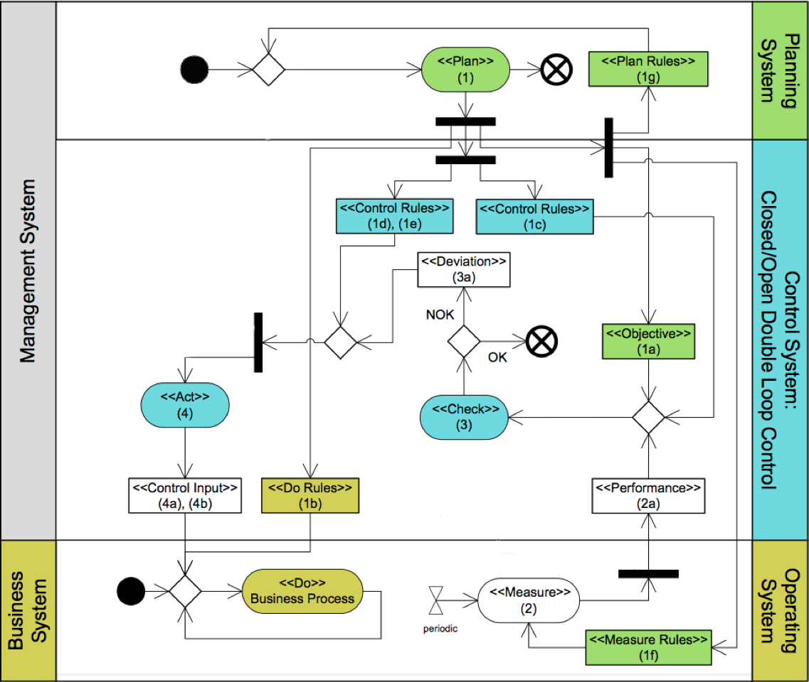

reference model



## Activities and Business Objects

|  |  |  |  |  |
| --- | --- | --- | --- | --- |
| **Nr.** | **Stereotype** | **Name** | **Relevant variables** | **Description** |
| 1 | [Plan] | Planning of Floor Value | - | Should never be below the CPPI portfolio value. |
| 1a | [Objective] | Floor Value | $$F_{t}$$ | Floor value at the end of investment period |
| 1b | [Do Rules] | Monitoring | - |  |
| 1c | [Control Rules] | Calculating Rules | $$m,b,C$$ |  |
| 1d,e | [Control Rules] |  | - |  |
| 1f | [Measure Rule] |  | - |  |
| 1g | [Plan Rules] | Configure Basic Variables | $$d, m, R_{0}$$ | Setting of all relevant variables which are needed for further calculations |
| 2 | [Measure] |  | $$S_{t},T_{t,T}$$ |  |
| 2a | [Performance] |  | $$W_{t}$$ |  |
| 3 | [Check] |  | - |  |
| 3a | [Deviation] |  | - |  |
| 4 | [Act] |  | - |  |
| 4a | [Control Input] |  | - |  |

# Documentation of the CPPI Optimization Implementation

## Task

Implement the CPPI strategy. Use the predefined abstract classes and interfaces, which are located in the project template. Log the output (values of cppi model variables) after each optimization period. Finally, document which classes correspond to which CPPI activities and describe their behaviour below (use representative code snippets).

The src folder contains the following packages:

* at.ac.tuwien.imw.pdca
  + Contains the framework classes and interfaces, which you should use implementing the CPPI Optimization considering a PDCA management process infrastructure.
  + Manipulation not allowed.
* at.ac.tuwien.imw.pdca.cppi
  + Contains your implementation. E.g. implement your CPPIActProcess as follows:



* at.ac.tuwien.imw.pdca.cppi.service
* Contains main class for starting the optimization
* Contains the CPPIService context object for saving the current state
* Manipulation allowed.
* *CPPIPlanProcess extends the PlanProcess for BigDecimals:*

In creates the plan rules in accordance with the PDCA model.

* *CPPIPlanRules implements PlanningRules for BigDecimals:*

Sets the initial floor and calculates the currentTtT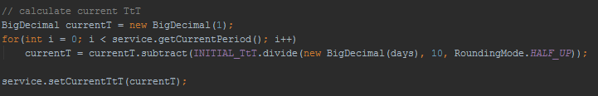

* *CPPIDoProcess extends the DoProcess for BigDecimals:*

Applies the do rules in accordance with the PDCA model. Any regular business process would be implemented here. However, this is not applicable for the CPPI.

* *CPPICheckProcess extends the CheckProcess for BigDecimals:*

Check rules are created and applied in accordance with the PDCA model.

* *CPPICheckRules implement the CheckingRules*

The TSR is being calculated here.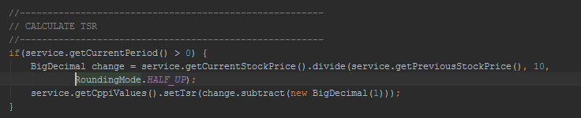

* *CPPIMeasure extends MeasuredPerfomanceValue for BigDecimals:*
* *CPPIMeasureRules extends the Measure Rules*

In accordance with the CPPI the wealth is calculated here:

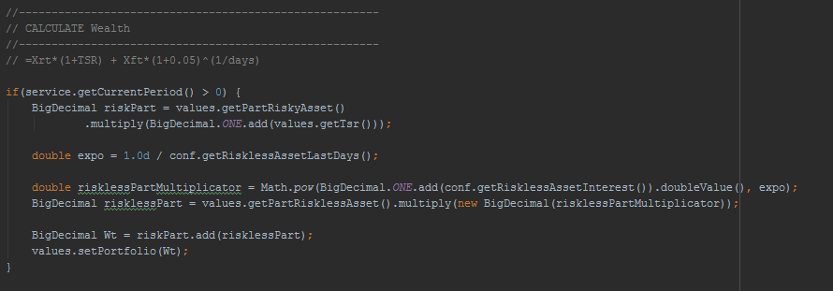

* *CPPIActProcess extends the ActProcess for BigDecimals*

In accordance with the PDCA, ActRules are applied. Furthermore the thread notifies the CPPIService that one PDCACycle is finished, which in turn either shuts down the threads or increases the current period.

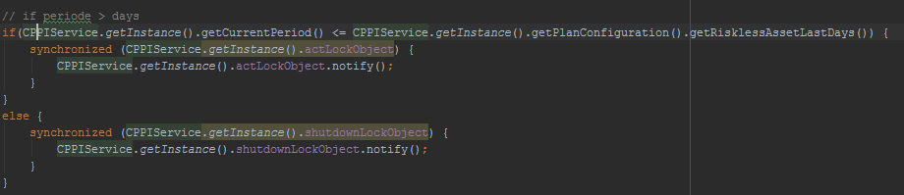

* *CPPIActRules implements the CorrectiveActRules*

The risk asset percentage of the portfolio as well as the cushion are calculated during the creation of the rules.

Portfolio percentages/Exposure calculation:

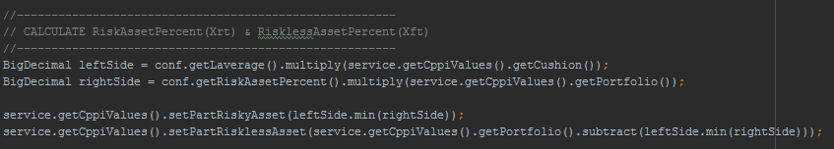

Cushion calculation:

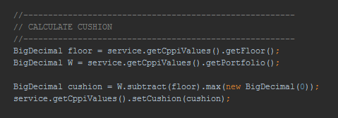

* *CPPIPlanConfiguration*

All initial values are being initialized here in order to prepare the PCCI/PDCA process.

* *CPPIValues:*

Saves the current values of the current period and provides getter and setter methods for all processes.

* *CPPI Simulation:*

Creates the threads, the ExecutorService for the threads (fixed number of threads since they are invariant) and initializes the execution of all threads. Each thread waits for the notification of the previous process to launch. Once the maximum number of days is reached, the executor shuts down and terminates the program.

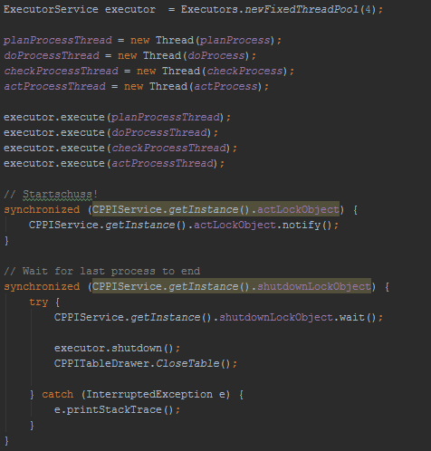

## Solution

+------+---------+----------+----------+----------+----------+-----------+----------+--------------+

| t | T_t,T | Ft | Ct | X_r,t | X_f,t | St | TSR_t | Wt |

+------+---------+----------+----------|----------|----------|-----------+----------+--------------+

| 0 | 1,0000 | 95,24 | 4,76 | 9,52 | 90,48 | 102,00 | 0,00% | 100,00 |

| 1 | 0,9973 | 95,25 | 5,04 | 10,08 | 90,21 | 105,00 | 2,94% | 100,29 |

| 2 | 0,9945 | 95,26 | 5,52 | 11,04 | 89,74 | 110,00 | 4,76% | 100,78 |

| 3 | 0,9918 | 95,28 | 6,02 | 12,04 | 89,25 | 115,00 | 4,55% | 101,30 |

| 4 | 0,9890 | 95,29 | 6,02 | 12,04 | 89,27 | 115,00 | 0,00% | 101,31 |

| 5 | 0,9863 | 95,30 | 6,02 | 12,04 | 89,28 | 115,00 | 0,00% | 101,32 |

| 6 | 0,9836 | 95,31 | 6,23 | 12,46 | 89,09 | 117,00 | 1,74% | 101,54 |

| 7 | 0,9808 | 95,33 | 6,55 | 13,10 | 88,78 | 120,00 | 2,56% | 101,87 |

| 8 | 0,9781 | 95,34 | 6,44 | 12,88 | 88,90 | 119,00 | -0,83% | 101,78 |

| 9 | 0,9753 | 95,35 | 6,11 | 12,22 | 89,24 | 116,00 | -2,52% | 101,46 |

| 10 | 0,9726 | 95,37 | 6,11 | 12,22 | 89,25 | 116,00 | 0,00% | 101,48 |

| 11 | 0,9699 | 95,38 | 6,11 | 12,22 | 89,27 | 116,00 | 0,00% | 101,49 |

| 12 | 0,9671 | 95,39 | 5,90 | 11,80 | 89,49 | 114,00 | -1,72% | 101,29 |

| 13 | 0,9644 | 95,40 | 6,31 | 12,62 | 89,09 | 118,00 | 3,51% | 101,72 |

| 14 | 0,9616 | 95,42 | 6,53 | 13,05 | 88,89 | 120,00 | 1,69% | 101,94 |

| 15 | 0,9589 | 95,43 | 7,07 | 14,14 | 88,36 | 125,00 | 4,17% | 102,50 |

| 16 | 0,9562 | 95,44 | 7,63 | 15,27 | 87,81 | 130,00 | 4,00% | 103,07 |

| 17 | 0,9534 | 95,45 | 6,81 | 13,62 | 88,65 | 123,00 | -5,38% | 102,26 |

| 18 | 0,9507 | 95,47 | 6,37 | 12,73 | 89,10 | 119,00 | -3,25% | 101,83 |

| 19 | 0,9479 | 95,48 | 6,04 | 12,09 | 89,44 | 116,00 | -2,52% | 101,52 |

| 20 | 0,9452 | 95,49 | 5,94 | 11,88 | 89,55 | 115,00 | -0,86% | 101,43 |

| 21 | 0,9425 | 95,51 | 5,83 | 11,67 | 89,67 | 114,00 | -0,87% | 101,34 |

| 22 | 0,9397 | 95,52 | 5,73 | 11,46 | 89,79 | 113,00 | -0,88% | 101,25 |

| 23 | 0,9370 | 95,53 | 6,44 | 12,88 | 89,09 | 120,00 | 6,19% | 101,97 |

| 24 | 0,9342 | 95,54 | 4,51 | 9,02 | 91,04 | 102,00 | -15,00% | 100,05 |

| 25 | 0,9315 | 95,56 | 4,77 | 9,55 | 90,78 | 105,00 | 2,94% | 100,33 |

| 26 | 0,9288 | 95,57 | 5,23 | 10,45 | 90,34 | 110,00 | 4,76% | 100,80 |

| 27 | 0,9260 | 95,58 | 5,70 | 11,40 | 89,88 | 115,00 | 4,55% | 101,28 |

| 28 | 0,9233 | 95,60 | 5,70 | 11,40 | 89,90 | 115,00 | 0,00% | 101,30 |

| 29 | 0,9205 | 95,61 | 5,70 | 11,40 | 89,91 | 115,00 | 0,00% | 101,31 |

| 30 | 0,9178 | 95,62 | 5,90 | 11,79 | 89,72 | 117,00 | 1,74% | 101,52 |

| 31 | 0,9151 | 95,63 | 6,20 | 12,40 | 89,44 | 120,00 | 2,56% | 101,83 |

| 32 | 0,9123 | 95,65 | 6,09 | 12,19 | 89,55 | 119,00 | -0,83% | 101,74 |

| 33 | 0,9096 | 95,66 | 5,79 | 11,57 | 89,87 | 116,00 | -2,52% | 101,45 |

| 34 | 0,9068 | 95,67 | 5,79 | 11,57 | 89,89 | 116,00 | 0,00% | 101,46 |

| 35 | 0,9041 | 95,68 | 5,78 | 11,57 | 89,90 | 116,00 | 0,00% | 101,47 |

| 36 | 0,9014 | 95,70 | 5,58 | 11,17 | 90,11 | 114,00 | -1,72% | 101,28 |

| 37 | 0,8986 | 95,71 | 5,98 | 11,95 | 89,73 | 118,00 | 3,51% | 101,69 |

| 38 | 0,8959 | 95,72 | 6,18 | 12,35 | 89,55 | 120,00 | 1,69% | 101,90 |

| 39 | 0,8932 | 95,74 | 6,69 | 13,38 | 89,04 | 125,00 | 4,17% | 102,43 |

| 40 | 0,8904 | 95,75 | 7,23 | 14,45 | 88,52 | 130,00 | 4,00% | 102,97 |

| 41 | 0,8877 | 95,76 | 6,45 | 12,89 | 89,31 | 123,00 | -5,38% | 102,21 |

| 42 | 0,8849 | 95,77 | 6,03 | 12,05 | 89,75 | 119,00 | -3,25% | 101,80 |

| 43 | 0,8822 | 95,79 | 5,72 | 11,44 | 90,07 | 116,00 | -2,52% | 101,51 |

| 44 | 0,8795 | 95,80 | 5,62 | 11,24 | 90,18 | 115,00 | -0,86% | 101,42 |

| 45 | 0,8767 | 95,81 | 5,52 | 11,05 | 90,29 | 114,00 | -0,87% | 101,34 |

| 46 | 0,8740 | 95,83 | 5,43 | 10,85 | 90,40 | 113,00 | -0,88% | 101,25 |

| 47 | 0,8712 | 95,84 | 6,10 | 12,20 | 89,74 | 120,00 | 6,19% | 101,94 |

| 48 | 0,8685 | 95,85 | 4,27 | 8,54 | 91,58 | 102,00 | -15,00% | 100,12 |

| 49 | 0,8658 | 95,86 | 4,52 | 9,04 | 91,35 | 105,00 | 2,94% | 100,38 |

| 50 | 0,8630 | 95,88 | 4,95 | 9,90 | 90,93 | 110,00 | 4,76% | 100,82 |

| 51 | 0,8603 | 95,89 | 5,40 | 10,79 | 90,49 | 115,00 | 4,55% | 101,29 |

| 52 | 0,8575 | 95,90 | 5,40 | 10,79 | 90,51 | 115,00 | 0,00% | 101,30 |

| 53 | 0,8548 | 95,92 | 5,40 | 10,79 | 90,52 | 115,00 | 0,00% | 101,31 |

| 54 | 0,8521 | 95,93 | 5,58 | 11,16 | 90,35 | 117,00 | 1,74% | 101,51 |

| 55 | 0,8493 | 95,94 | 5,87 | 11,74 | 90,07 | 120,00 | 2,56% | 101,81 |

| 56 | 0,8466 | 95,95 | 5,77 | 11,54 | 90,18 | 119,00 | -0,83% | 101,72 |

| 57 | 0,8438 | 95,97 | 5,48 | 10,96 | 90,49 | 116,00 | -2,52% | 101,44 |

| 58 | 0,8411 | 95,98 | 5,48 | 10,95 | 90,50 | 116,00 | 0,00% | 101,46 |

| 59 | 0,8384 | 95,99 | 5,48 | 10,95 | 90,52 | 116,00 | 0,00% | 101,47 |

| 60 | 0,8356 | 96,01 | 5,29 | 10,57 | 90,72 | 114,00 | -1,72% | 101,29 |

| 61 | 0,8329 | 96,02 | 5,66 | 11,31 | 90,36 | 118,00 | 3,51% | 101,67 |

| 62 | 0,8301 | 96,03 | 5,85 | 11,70 | 90,18 | 120,00 | 1,69% | 101,88 |

| 63 | 0,8274 | 96,04 | 6,33 | 12,67 | 89,71 | 125,00 | 4,17% | 102,38 |

| 64 | 0,8247 | 96,06 | 6,84 | 13,68 | 89,22 | 130,00 | 4,00% | 102,90 |

| 65 | 0,8219 | 96,07 | 6,10 | 12,21 | 89,97 | 123,00 | -5,38% | 102,17 |

| 66 | 0,8192 | 96,08 | 5,71 | 11,41 | 90,38 | 119,00 | -3,25% | 101,79 |

| 67 | 0,8164 | 96,09 | 5,42 | 10,83 | 90,68 | 116,00 | -2,52% | 101,51 |

| 68 | 0,8137 | 96,11 | 5,32 | 10,65 | 90,79 | 115,00 | -0,86% | 101,43 |

| 69 | 0,8110 | 96,12 | 5,23 | 10,46 | 90,89 | 114,00 | -0,87% | 101,35 |

| 70 | 0,8082 | 96,13 | 5,14 | 10,27 | 91,00 | 113,00 | -0,88% | 101,27 |

| 71 | 0,8055 | 96,15 | 5,77 | 11,55 | 90,37 | 120,00 | 6,19% | 101,92 |

| 72 | 0,8027 | 96,16 | 4,04 | 8,08 | 92,12 | 102,00 | -15,00% | 100,20 |

| 73 | 0,8000 | 96,17 | 4,28 | 8,55 | 91,89 | 105,00 | 2,94% | 100,45 |

| 74 | 0,7973 | 96,18 | 4,68 | 9,37 | 91,50 | 110,00 | 4,76% | 100,87 |

| 75 | 0,7945 | 96,20 | 5,11 | 10,22 | 91,09 | 115,00 | 4,55% | 101,31 |

| 76 | 0,7918 | 96,21 | 5,11 | 10,22 | 91,10 | 115,00 | 0,00% | 101,32 |

| 77 | 0,7890 | 96,22 | 5,11 | 10,22 | 91,12 | 115,00 | 0,00% | 101,33 |

| 78 | 0,7863 | 96,24 | 5,28 | 10,57 | 90,95 | 117,00 | 1,74% | 101,52 |

| 79 | 0,7836 | 96,25 | 5,55 | 11,11 | 90,69 | 120,00 | 2,56% | 101,80 |

| 80 | 0,7808 | 96,26 | 5,46 | 10,92 | 90,80 | 119,00 | -0,83% | 101,72 |

| 81 | 0,7781 | 96,27 | 5,19 | 10,37 | 91,09 | 116,00 | -2,52% | 101,46 |

| 82 | 0,7753 | 96,29 | 5,18 | 10,37 | 91,10 | 116,00 | 0,00% | 101,47 |

| 83 | 0,7726 | 96,30 | 5,18 | 10,37 | 91,12 | 116,00 | 0,00% | 101,48 |

| 84 | 0,7699 | 96,31 | 5,00 | 10,01 | 91,31 | 114,00 | -1,72% | 101,32 |

| 85 | 0,7671 | 96,33 | 5,36 | 10,71 | 90,97 | 118,00 | 3,51% | 101,68 |

| 86 | 0,7644 | 96,34 | 5,54 | 11,07 | 90,80 | 120,00 | 1,69% | 101,88 |

| 87 | 0,7616 | 96,35 | 6,00 | 11,99 | 90,36 | 125,00 | 4,17% | 102,35 |

| 88 | 0,7589 | 96,37 | 6,48 | 12,95 | 89,89 | 130,00 | 4,00% | 102,84 |

| 89 | 0,7562 | 96,38 | 5,78 | 11,55 | 90,60 | 123,00 | -5,38% | 102,16 |

| 90 | 0,7534 | 96,39 | 5,40 | 10,80 | 90,99 | 119,00 | -3,25% | 101,79 |

| 91 | 0,7507 | 96,40 | 5,13 | 10,26 | 91,28 | 116,00 | -2,52% | 101,53 |

| 92 | 0,7479 | 96,42 | 5,04 | 10,08 | 91,38 | 115,00 | -0,86% | 101,46 |

| 93 | 0,7452 | 96,43 | 4,95 | 9,90 | 91,48 | 114,00 | -0,87% | 101,38 |

| 94 | 0,7425 | 96,44 | 4,86 | 9,73 | 91,58 | 113,00 | -0,88% | 101,31 |

| 95 | 0,7397 | 96,46 | 5,46 | 10,93 | 90,99 | 120,00 | 6,19% | 101,92 |

| 96 | 0,7370 | 96,47 | 3,82 | 7,65 | 92,64 | 102,00 | -15,00% | 100,29 |

| 97 | 0,7342 | 96,48 | 4,05 | 8,10 | 92,43 | 105,00 | 2,94% | 100,53 |

| 98 | 0,7315 | 96,49 | 4,43 | 8,87 | 92,06 | 110,00 | 4,76% | 100,93 |

| 99 | 0,7288 | 96,51 | 4,84 | 9,67 | 91,67 | 115,00 | 4,55% | 101,34 |

| 100 | 0,7260 | 96,52 | 4,84 | 9,67 | 91,68 | 115,00 | 0,00% | 101,36 |

| 101 | 0,7233 | 96,53 | 4,84 | 9,67 | 91,70 | 115,00 | 0,00% | 101,37 |

| 102 | 0,7205 | 96,55 | 5,00 | 10,01 | 91,54 | 117,00 | 1,74% | 101,55 |

| 103 | 0,7178 | 96,56 | 5,26 | 10,52 | 91,30 | 120,00 | 2,56% | 101,82 |

| 104 | 0,7151 | 96,57 | 5,17 | 10,34 | 91,40 | 119,00 | -0,83% | 101,74 |

| 105 | 0,7123 | 96,58 | 4,91 | 9,82 | 91,68 | 116,00 | -2,52% | 101,49 |

| 106 | 0,7096 | 96,60 | 4,91 | 9,82 | 91,69 | 116,00 | 0,00% | 101,51 |

| 107 | 0,7068 | 96,61 | 4,91 | 9,82 | 91,70 | 116,00 | 0,00% | 101,52 |

| 108 | 0,7041 | 96,62 | 4,74 | 9,48 | 91,89 | 114,00 | -1,72% | 101,36 |

| 109 | 0,7014 | 96,64 | 5,07 | 10,14 | 91,57 | 118,00 | 3,51% | 101,71 |

| 110 | 0,6986 | 96,65 | 5,24 | 10,48 | 91,41 | 120,00 | 1,69% | 101,89 |

| 111 | 0,6959 | 96,66 | 5,68 | 11,35 | 90,98 | 125,00 | 4,17% | 102,34 |

| 112 | 0,6932 | 96,67 | 6,13 | 12,26 | 90,54 | 130,00 | 4,00% | 102,80 |

| 113 | 0,6904 | 96,69 | 5,47 | 10,94 | 91,22 | 123,00 | -5,38% | 102,16 |

| 114 | 0,6877 | 96,70 | 5,11 | 10,23 | 91,59 | 119,00 | -3,25% | 101,81 |

| 115 | 0,6849 | 96,71 | 4,85 | 9,71 | 91,86 | 116,00 | -2,52% | 101,57 |

| 116 | 0,6822 | 96,73 | 4,77 | 9,54 | 91,96 | 115,00 | -0,86% | 101,50 |

| 117 | 0,6795 | 96,74 | 4,69 | 9,37 | 92,05 | 114,00 | -0,87% | 101,43 |

| 118 | 0,6767 | 96,75 | 4,60 | 9,21 | 92,15 | 113,00 | -0,88% | 101,36 |

| 119 | 0,6740 | 96,77 | 5,17 | 10,35 | 91,59 | 120,00 | 6,19% | 101,94 |

| 120 | 0,6712 | 96,78 | 3,62 | 7,24 | 93,16 | 102,00 | -15,00% | 100,40 |

| 121 | 0,6685 | 96,79 | 3,83 | 7,67 | 92,96 | 105,00 | 2,94% | 100,62 |

| 122 | 0,6658 | 96,80 | 4,20 | 8,40 | 92,61 | 110,00 | 4,76% | 101,00 |

| 123 | 0,6630 | 96,82 | 4,58 | 9,16 | 92,24 | 115,00 | 4,55% | 101,40 |

| 124 | 0,6603 | 96,83 | 4,58 | 9,16 | 92,25 | 115,00 | 0,00% | 101,41 |

| 125 | 0,6575 | 96,84 | 4,58 | 9,15 | 92,27 | 115,00 | 0,00% | 101,42 |

| 126 | 0,6548 | 96,86 | 4,74 | 9,47 | 92,12 | 117,00 | 1,74% | 101,59 |

| 127 | 0,6521 | 96,87 | 4,98 | 9,96 | 91,89 | 120,00 | 2,56% | 101,85 |

| 128 | 0,6493 | 96,88 | 4,89 | 9,79 | 91,99 | 119,00 | -0,83% | 101,78 |

| 129 | 0,6466 | 96,89 | 4,65 | 9,29 | 92,25 | 116,00 | -2,52% | 101,54 |

| 130 | 0,6438 | 96,91 | 4,65 | 9,29 | 92,26 | 116,00 | 0,00% | 101,55 |

| 131 | 0,6411 | 96,92 | 4,65 | 9,29 | 92,27 | 116,00 | 0,00% | 101,57 |

| 132 | 0,6384 | 96,93 | 4,49 | 8,97 | 92,45 | 114,00 | -1,72% | 101,42 |

| 133 | 0,6356 | 96,95 | 4,80 | 9,60 | 92,15 | 118,00 | 3,51% | 101,75 |

| 134 | 0,6329 | 96,96 | 4,96 | 9,92 | 92,00 | 120,00 | 1,69% | 101,92 |

| 135 | 0,6301 | 96,97 | 5,37 | 10,75 | 91,60 | 125,00 | 4,17% | 102,35 |

| 136 | 0,6274 | 96,99 | 5,80 | 11,61 | 91,18 | 130,00 | 4,00% | 102,79 |

| 137 | 0,6247 | 97,00 | 5,18 | 10,36 | 91,82 | 123,00 | -5,38% | 102,18 |

| 138 | 0,6219 | 97,01 | 4,84 | 9,68 | 92,17 | 119,00 | -3,25% | 101,85 |

| 139 | 0,6192 | 97,02 | 4,60 | 9,19 | 92,43 | 116,00 | -2,52% | 101,62 |

| 140 | 0,6164 | 97,04 | 4,52 | 9,03 | 92,52 | 115,00 | -0,86% | 101,55 |

| 141 | 0,6137 | 97,05 | 4,44 | 8,87 | 92,61 | 114,00 | -0,87% | 101,49 |

| 142 | 0,6110 | 97,06 | 4,36 | 8,72 | 92,71 | 113,00 | -0,88% | 101,42 |

| 143 | 0,6082 | 97,08 | 4,90 | 9,79 | 92,18 | 120,00 | 6,19% | 101,97 |

| 144 | 0,6055 | 97,09 | 3,43 | 6,86 | 93,66 | 102,00 | -15,00% | 100,52 |

| 145 | 0,6027 | 97,10 | 3,63 | 7,26 | 93,47 | 105,00 | 2,94% | 100,73 |

| 146 | 0,6000 | 97,12 | 3,97 | 7,95 | 93,14 | 110,00 | 4,76% | 101,09 |

| 147 | 0,5973 | 97,13 | 4,33 | 8,67 | 92,79 | 115,00 | 4,55% | 101,46 |

| 148 | 0,5945 | 97,14 | 4,33 | 8,67 | 92,81 | 115,00 | 0,00% | 101,47 |

| 149 | 0,5918 | 97,15 | 4,33 | 8,67 | 92,82 | 115,00 | 0,00% | 101,49 |

| 150 | 0,5890 | 97,17 | 4,48 | 8,97 | 92,68 | 117,00 | 1,74% | 101,65 |

| 151 | 0,5863 | 97,18 | 4,71 | 9,43 | 92,47 | 120,00 | 2,56% | 101,89 |

| 152 | 0,5836 | 97,19 | 4,63 | 9,27 | 92,56 | 119,00 | -0,83% | 101,83 |

| 153 | 0,5808 | 97,21 | 4,40 | 8,80 | 92,81 | 116,00 | -2,52% | 101,61 |

| 154 | 0,5781 | 97,22 | 4,40 | 8,80 | 92,82 | 116,00 | 0,00% | 101,62 |

| 155 | 0,5753 | 97,23 | 4,40 | 8,80 | 92,83 | 116,00 | 0,00% | 101,63 |

| 156 | 0,5726 | 97,24 | 4,25 | 8,49 | 93,00 | 114,00 | -1,72% | 101,49 |

| 157 | 0,5699 | 97,26 | 4,54 | 9,09 | 92,71 | 118,00 | 3,51% | 101,80 |

| 158 | 0,5671 | 97,27 | 4,70 | 9,39 | 92,57 | 120,00 | 1,69% | 101,97 |

| 159 | 0,5644 | 97,28 | 5,09 | 10,18 | 92,20 | 125,00 | 4,17% | 102,37 |

| 160 | 0,5616 | 97,30 | 5,49 | 10,99 | 91,80 | 130,00 | 4,00% | 102,79 |

| 161 | 0,5589 | 97,31 | 4,90 | 9,80 | 92,41 | 123,00 | -5,38% | 102,21 |

| 162 | 0,5562 | 97,32 | 4,58 | 9,16 | 92,74 | 119,00 | -3,25% | 101,90 |

| 163 | 0,5534 | 97,34 | 4,35 | 8,70 | 92,99 | 116,00 | -2,52% | 101,69 |

| 164 | 0,5507 | 97,35 | 4,27 | 8,55 | 93,07 | 115,00 | -0,86% | 101,62 |

| 165 | 0,5479 | 97,36 | 4,20 | 8,40 | 93,16 | 114,00 | -0,87% | 101,56 |

| 166 | 0,5452 | 97,38 | 4,13 | 8,25 | 93,25 | 113,00 | -0,88% | 101,50 |

| 167 | 0,5425 | 97,39 | 4,64 | 9,27 | 92,75 | 120,00 | 6,19% | 102,02 |

| 168 | 0,5397 | 97,40 | 3,24 | 6,49 | 94,16 | 102,00 | -15,00% | 100,65 |

| 169 | 0,5370 | 97,41 | 3,44 | 6,87 | 93,98 | 105,00 | 2,94% | 100,85 |

| 170 | 0,5342 | 97,43 | 3,76 | 7,52 | 93,67 | 110,00 | 4,76% | 101,19 |

| 171 | 0,5315 | 97,44 | 4,10 | 8,21 | 93,34 | 115,00 | 4,55% | 101,54 |

| 172 | 0,5288 | 97,45 | 4,10 | 8,21 | 93,35 | 115,00 | 0,00% | 101,56 |

| 173 | 0,5260 | 97,47 | 4,10 | 8,20 | 93,36 | 115,00 | 0,00% | 101,57 |

| 174 | 0,5233 | 97,48 | 4,24 | 8,49 | 93,23 | 117,00 | 1,74% | 101,72 |

| 175 | 0,5205 | 97,49 | 4,46 | 8,92 | 93,03 | 120,00 | 2,56% | 101,95 |

| 176 | 0,5178 | 97,51 | 4,39 | 8,77 | 93,12 | 119,00 | -0,83% | 101,89 |

| 177 | 0,5151 | 97,52 | 4,16 | 8,33 | 93,35 | 116,00 | -2,52% | 101,68 |

| 178 | 0,5123 | 97,53 | 4,16 | 8,33 | 93,37 | 116,00 | 0,00% | 101,70 |

| 179 | 0,5096 | 97,54 | 4,16 | 8,33 | 93,38 | 116,00 | 0,00% | 101,71 |

| 180 | 0,5068 | 97,56 | 4,02 | 8,04 | 93,54 | 114,00 | -1,72% | 101,58 |

| 181 | 0,5041 | 97,57 | 4,30 | 8,60 | 93,27 | 118,00 | 3,51% | 101,87 |

| 182 | 0,5014 | 97,58 | 4,45 | 8,89 | 93,14 | 120,00 | 1,69% | 102,03 |

| 183 | 0,4986 | 97,60 | 4,82 | 9,63 | 92,78 | 125,00 | 4,17% | 102,41 |

| 184 | 0,4959 | 97,61 | 5,20 | 10,40 | 92,41 | 130,00 | 4,00% | 102,81 |

| 185 | 0,4932 | 97,62 | 4,64 | 9,28 | 92,98 | 123,00 | -5,38% | 102,26 |

| 186 | 0,4904 | 97,64 | 4,34 | 8,68 | 93,30 | 119,00 | -3,25% | 101,97 |

| 187 | 0,4877 | 97,65 | 4,12 | 8,24 | 93,53 | 116,00 | -2,52% | 101,77 |

| 188 | 0,4849 | 97,66 | 4,05 | 8,09 | 93,61 | 115,00 | -0,86% | 101,71 |

| 189 | 0,4822 | 97,67 | 3,98 | 7,95 | 93,70 | 114,00 | -0,87% | 101,65 |

| 190 | 0,4795 | 97,69 | 3,91 | 7,81 | 93,78 | 113,00 | -0,88% | 101,59 |

| 191 | 0,4767 | 97,70 | 4,39 | 8,78 | 93,31 | 120,00 | 6,19% | 102,09 |

| 192 | 0,4740 | 97,71 | 3,07 | 6,14 | 94,64 | 102,00 | -15,00% | 100,79 |

| 193 | 0,4712 | 97,73 | 3,25 | 6,50 | 94,48 | 105,00 | 2,94% | 100,98 |

| 194 | 0,4685 | 97,74 | 3,56 | 7,12 | 94,18 | 110,00 | 4,76% | 101,30 |

| 195 | 0,4658 | 97,75 | 3,88 | 7,77 | 93,87 | 115,00 | 4,55% | 101,64 |

| 196 | 0,4630 | 97,77 | 3,88 | 7,77 | 93,88 | 115,00 | 0,00% | 101,65 |

| 197 | 0,4603 | 97,78 | 3,88 | 7,77 | 93,90 | 115,00 | 0,00% | 101,66 |

| 198 | 0,4575 | 97,79 | 4,02 | 8,04 | 93,77 | 117,00 | 1,74% | 101,81 |

| 199 | 0,4548 | 97,81 | 4,22 | 8,45 | 93,58 | 120,00 | 2,56% | 102,03 |

| 200 | 0,4521 | 97,82 | 4,15 | 8,31 | 93,67 | 119,00 | -0,83% | 101,97 |

| 201 | 0,4493 | 97,83 | 3,94 | 7,89 | 93,89 | 116,00 | -2,52% | 101,77 |

| 202 | 0,4466 | 97,84 | 3,94 | 7,88 | 93,90 | 116,00 | 0,00% | 101,79 |

| 203 | 0,4438 | 97,86 | 3,94 | 7,88 | 93,92 | 116,00 | 0,00% | 101,80 |

| 204 | 0,4411 | 97,87 | 3,81 | 7,61 | 94,07 | 114,00 | -1,72% | 101,68 |

| 205 | 0,4384 | 97,88 | 4,07 | 8,14 | 93,81 | 118,00 | 3,51% | 101,96 |

| 206 | 0,4356 | 97,90 | 4,21 | 8,42 | 93,69 | 120,00 | 1,69% | 102,11 |

| 207 | 0,4329 | 97,91 | 4,56 | 9,12 | 93,35 | 125,00 | 4,17% | 102,47 |

| 208 | 0,4301 | 97,92 | 4,92 | 9,85 | 93,00 | 130,00 | 4,00% | 102,85 |

| 209 | 0,4274 | 97,94 | 4,39 | 8,79 | 93,54 | 123,00 | -5,38% | 102,33 |

| 210 | 0,4247 | 97,95 | 4,11 | 8,21 | 93,84 | 119,00 | -3,25% | 102,06 |

| 211 | 0,4219 | 97,96 | 3,90 | 7,80 | 94,06 | 116,00 | -2,52% | 101,86 |

| 212 | 0,4192 | 97,98 | 3,83 | 7,66 | 94,14 | 115,00 | -0,86% | 101,81 |

| 213 | 0,4164 | 97,99 | 3,76 | 7,53 | 94,22 | 114,00 | -0,87% | 101,75 |

| 214 | 0,4137 | 98,00 | 3,70 | 7,39 | 94,30 | 113,00 | -0,88% | 101,70 |

| 215 | 0,4110 | 98,01 | 4,15 | 8,31 | 93,86 | 120,00 | 6,19% | 102,17 |

| 216 | 0,4082 | 98,03 | 2,91 | 5,82 | 95,12 | 102,00 | -15,00% | 100,94 |

| 217 | 0,4055 | 98,04 | 3,08 | 6,16 | 94,96 | 105,00 | 2,94% | 101,12 |

| 218 | 0,4027 | 98,05 | 3,37 | 6,74 | 94,68 | 110,00 | 4,76% | 101,43 |

| 219 | 0,4000 | 98,07 | 3,68 | 7,35 | 94,39 | 115,00 | 4,55% | 101,74 |

| 220 | 0,3973 | 98,08 | 3,68 | 7,35 | 94,40 | 115,00 | 0,00% | 101,76 |

| 221 | 0,3945 | 98,09 | 3,68 | 7,35 | 94,42 | 115,00 | 0,00% | 101,77 |

| 222 | 0,3918 | 98,11 | 3,80 | 7,61 | 94,30 | 117,00 | 1,74% | 101,91 |

| 223 | 0,3890 | 98,12 | 4,00 | 8,00 | 94,12 | 120,00 | 2,56% | 102,12 |

| 224 | 0,3863 | 98,13 | 3,93 | 7,86 | 94,20 | 119,00 | -0,83% | 102,06 |

| 225 | 0,3836 | 98,15 | 3,73 | 7,46 | 94,41 | 116,00 | -2,52% | 101,88 |

| 226 | 0,3808 | 98,16 | 3,73 | 7,46 | 94,43 | 116,00 | 0,00% | 101,89 |

| 227 | 0,3781 | 98,17 | 3,73 | 7,46 | 94,44 | 116,00 | 0,00% | 101,90 |

| 228 | 0,3753 | 98,19 | 3,60 | 7,20 | 94,58 | 114,00 | -1,72% | 101,79 |

| 229 | 0,3726 | 98,20 | 3,85 | 7,71 | 94,34 | 118,00 | 3,51% | 102,05 |

| 230 | 0,3699 | 98,21 | 3,98 | 7,97 | 94,23 | 120,00 | 1,69% | 102,20 |

| 231 | 0,3671 | 98,22 | 4,32 | 8,63 | 93,91 | 125,00 | 4,17% | 102,54 |

| 232 | 0,3644 | 98,24 | 4,66 | 9,32 | 93,58 | 130,00 | 4,00% | 102,90 |

| 233 | 0,3616 | 98,25 | 4,16 | 8,32 | 94,09 | 123,00 | -5,38% | 102,41 |

| 234 | 0,3589 | 98,26 | 3,89 | 7,77 | 94,38 | 119,00 | -3,25% | 102,15 |

| 235 | 0,3562 | 98,28 | 3,69 | 7,38 | 94,59 | 116,00 | -2,52% | 101,97 |

| 236 | 0,3534 | 98,29 | 3,63 | 7,25 | 94,66 | 115,00 | -0,86% | 101,92 |

| 237 | 0,3507 | 98,30 | 3,56 | 7,13 | 94,74 | 114,00 | -0,87% | 101,87 |

| 238 | 0,3479 | 98,32 | 3,50 | 7,00 | 94,82 | 113,00 | -0,88% | 101,82 |

| 239 | 0,3452 | 98,33 | 3,93 | 7,87 | 94,40 | 120,00 | 6,19% | 102,26 |

| 240 | 0,3425 | 98,34 | 2,75 | 5,51 | 95,59 | 102,00 | -15,00% | 101,10 |

| 241 | 0,3397 | 98,36 | 2,91 | 5,83 | 95,44 | 105,00 | 2,94% | 101,27 |

| 242 | 0,3370 | 98,37 | 3,19 | 6,38 | 95,18 | 110,00 | 4,76% | 101,56 |

| 243 | 0,3342 | 98,38 | 3,48 | 6,96 | 94,90 | 115,00 | 4,55% | 101,86 |

| 244 | 0,3315 | 98,40 | 3,48 | 6,96 | 94,91 | 115,00 | 0,00% | 101,88 |

| 245 | 0,3288 | 98,41 | 3,48 | 6,96 | 94,93 | 115,00 | 0,00% | 101,89 |

| 246 | 0,3260 | 98,42 | 3,60 | 7,20 | 94,82 | 117,00 | 1,74% | 102,02 |

| 247 | 0,3233 | 98,44 | 3,79 | 7,57 | 94,65 | 120,00 | 2,56% | 102,22 |

| 248 | 0,3205 | 98,45 | 3,72 | 7,44 | 94,73 | 119,00 | -0,83% | 102,17 |

| 249 | 0,3178 | 98,46 | 3,53 | 7,07 | 94,93 | 116,00 | -2,52% | 101,99 |

| 250 | 0,3151 | 98,47 | 3,53 | 7,07 | 94,94 | 116,00 | 0,00% | 102,01 |

| 251 | 0,3123 | 98,49 | 3,53 | 7,06 | 94,96 | 116,00 | 0,00% | 102,02 |

| 252 | 0,3096 | 98,50 | 3,41 | 6,82 | 95,09 | 114,00 | -1,72% | 101,91 |

| 253 | 0,3068 | 98,51 | 3,65 | 7,30 | 94,87 | 118,00 | 3,51% | 102,16 |

| 254 | 0,3041 | 98,53 | 3,77 | 7,54 | 94,75 | 120,00 | 1,69% | 102,30 |

| 255 | 0,3014 | 98,54 | 4,09 | 8,17 | 94,45 | 125,00 | 4,17% | 102,63 |

| 256 | 0,2986 | 98,55 | 4,41 | 8,82 | 94,14 | 130,00 | 4,00% | 102,97 |

| 257 | 0,2959 | 98,57 | 3,94 | 7,87 | 94,63 | 123,00 | -5,38% | 102,50 |

| 258 | 0,2932 | 98,58 | 3,68 | 7,36 | 94,90 | 119,00 | -3,25% | 102,26 |

| 259 | 0,2904 | 98,59 | 3,49 | 6,99 | 95,10 | 116,00 | -2,52% | 102,09 |

| 260 | 0,2877 | 98,61 | 3,43 | 6,87 | 95,17 | 115,00 | -0,86% | 102,04 |

| 261 | 0,2849 | 98,62 | 3,37 | 6,75 | 95,25 | 114,00 | -0,87% | 101,99 |

| 262 | 0,2822 | 98,63 | 3,31 | 6,63 | 95,32 | 113,00 | -0,88% | 101,95 |

| 263 | 0,2795 | 98,65 | 3,72 | 7,45 | 94,92 | 120,00 | 6,19% | 102,37 |

| 264 | 0,2767 | 98,66 | 2,61 | 5,21 | 96,05 | 102,00 | -15,00% | 101,27 |

| 265 | 0,2740 | 98,67 | 2,76 | 5,52 | 95,91 | 105,00 | 2,94% | 101,43 |

| 266 | 0,2712 | 98,69 | 3,02 | 6,04 | 95,66 | 110,00 | 4,76% | 101,71 |

| 267 | 0,2685 | 98,70 | 3,30 | 6,59 | 95,40 | 115,00 | 4,55% | 101,99 |

| 268 | 0,2658 | 98,71 | 3,30 | 6,59 | 95,42 | 115,00 | 0,00% | 102,01 |

| 269 | 0,2630 | 98,72 | 3,29 | 6,59 | 95,43 | 115,00 | 0,00% | 102,02 |

| 270 | 0,2603 | 98,74 | 3,41 | 6,82 | 95,33 | 117,00 | 1,74% | 102,15 |

| 271 | 0,2575 | 98,75 | 3,58 | 7,17 | 95,17 | 120,00 | 2,56% | 102,33 |

| 272 | 0,2548 | 98,76 | 3,52 | 7,05 | 95,24 | 119,00 | -0,83% | 102,29 |

| 273 | 0,2521 | 98,78 | 3,34 | 6,69 | 95,43 | 116,00 | -2,52% | 102,12 |

| 274 | 0,2493 | 98,79 | 3,34 | 6,69 | 95,45 | 116,00 | 0,00% | 102,14 |

| 275 | 0,2466 | 98,80 | 3,34 | 6,69 | 95,46 | 116,00 | 0,00% | 102,15 |

| 276 | 0,2438 | 98,82 | 3,23 | 6,46 | 95,59 | 114,00 | -1,72% | 102,05 |

| 277 | 0,2411 | 98,83 | 3,45 | 6,91 | 95,38 | 118,00 | 3,51% | 102,29 |

| 278 | 0,2384 | 98,84 | 3,57 | 7,14 | 95,27 | 120,00 | 1,69% | 102,41 |

| 279 | 0,2356 | 98,86 | 3,87 | 7,74 | 94,99 | 125,00 | 4,17% | 102,73 |

| 280 | 0,2329 | 98,87 | 4,18 | 8,35 | 94,69 | 130,00 | 4,00% | 103,05 |

| 281 | 0,2301 | 98,88 | 3,73 | 7,45 | 95,16 | 123,00 | -5,38% | 102,61 |

| 282 | 0,2274 | 98,90 | 3,48 | 6,97 | 95,41 | 119,00 | -3,25% | 102,38 |

| 283 | 0,2247 | 98,91 | 3,31 | 6,62 | 95,60 | 116,00 | -2,52% | 102,22 |

| 284 | 0,2219 | 98,92 | 3,25 | 6,50 | 95,67 | 115,00 | -0,86% | 102,17 |

| 285 | 0,2192 | 98,94 | 3,19 | 6,39 | 95,74 | 114,00 | -0,87% | 102,13 |

| 286 | 0,2164 | 98,95 | 3,14 | 6,27 | 95,81 | 113,00 | -0,88% | 102,09 |

| 287 | 0,2137 | 98,96 | 3,53 | 7,05 | 95,44 | 120,00 | 6,19% | 102,49 |

| 288 | 0,2110 | 98,98 | 2,47 | 4,93 | 96,51 | 102,00 | -15,00% | 101,44 |

| 289 | 0,2082 | 98,99 | 2,61 | 5,22 | 96,38 | 105,00 | 2,94% | 101,60 |

| 290 | 0,2055 | 99,00 | 2,86 | 5,72 | 96,14 | 110,00 | 4,76% | 101,86 |

| 291 | 0,2027 | 99,02 | 3,12 | 6,24 | 95,90 | 115,00 | 4,55% | 102,14 |

| 292 | 0,2000 | 99,03 | 3,12 | 6,24 | 95,91 | 115,00 | 0,00% | 102,15 |

| 293 | 0,1973 | 99,04 | 3,12 | 6,24 | 95,92 | 115,00 | 0,00% | 102,16 |

| 294 | 0,1945 | 99,06 | 3,23 | 6,45 | 95,83 | 117,00 | 1,74% | 102,28 |

| 295 | 0,1918 | 99,07 | 3,39 | 6,78 | 95,68 | 120,00 | 2,56% | 102,46 |

| 296 | 0,1890 | 99,08 | 3,34 | 6,67 | 95,75 | 119,00 | -0,83% | 102,42 |

| 297 | 0,1863 | 99,10 | 3,17 | 6,33 | 95,93 | 116,00 | -2,52% | 102,26 |

| 298 | 0,1836 | 99,11 | 3,17 | 6,33 | 95,94 | 116,00 | 0,00% | 102,27 |

| 299 | 0,1808 | 99,12 | 3,17 | 6,33 | 95,96 | 116,00 | 0,00% | 102,29 |

| 300 | 0,1781 | 99,13 | 3,06 | 6,11 | 96,08 | 114,00 | -1,72% | 102,19 |

| 301 | 0,1753 | 99,15 | 3,27 | 6,54 | 95,88 | 118,00 | 3,51% | 102,42 |

| 302 | 0,1726 | 99,16 | 3,38 | 6,76 | 95,78 | 120,00 | 1,69% | 102,54 |

| 303 | 0,1699 | 99,17 | 3,66 | 7,32 | 95,51 | 125,00 | 4,17% | 102,84 |

| 304 | 0,1671 | 99,19 | 3,95 | 7,91 | 95,23 | 130,00 | 4,00% | 103,14 |

| 305 | 0,1644 | 99,20 | 3,53 | 7,06 | 95,67 | 123,00 | -5,38% | 102,73 |

| 306 | 0,1616 | 99,21 | 3,30 | 6,60 | 95,92 | 119,00 | -3,25% | 102,51 |

| 307 | 0,1589 | 99,23 | 3,13 | 6,26 | 96,10 | 116,00 | -2,52% | 102,36 |

| 308 | 0,1562 | 99,24 | 3,08 | 6,15 | 96,16 | 115,00 | -0,86% | 102,32 |

| 309 | 0,1534 | 99,25 | 3,02 | 6,05 | 96,23 | 114,00 | -0,87% | 102,28 |

| 310 | 0,1507 | 99,27 | 2,97 | 5,94 | 96,30 | 113,00 | -0,88% | 102,24 |

| 311 | 0,1479 | 99,28 | 3,34 | 6,67 | 95,94 | 120,00 | 6,19% | 102,62 |

| 312 | 0,1452 | 99,29 | 2,34 | 4,67 | 96,96 | 102,00 | -15,00% | 101,63 |

| 313 | 0,1425 | 99,31 | 2,47 | 4,95 | 96,83 | 105,00 | 2,94% | 101,78 |

| 314 | 0,1397 | 99,32 | 2,71 | 5,42 | 96,61 | 110,00 | 4,76% | 102,03 |

| 315 | 0,1370 | 99,33 | 2,95 | 5,91 | 96,38 | 115,00 | 4,55% | 102,29 |

| 316 | 0,1342 | 99,35 | 2,95 | 5,91 | 96,39 | 115,00 | 0,00% | 102,30 |

| 317 | 0,1315 | 99,36 | 2,95 | 5,91 | 96,41 | 115,00 | 0,00% | 102,31 |

| 318 | 0,1288 | 99,37 | 3,06 | 6,11 | 96,32 | 117,00 | 1,74% | 102,43 |

| 319 | 0,1260 | 99,39 | 3,21 | 6,42 | 96,18 | 120,00 | 2,56% | 102,60 |

| 320 | 0,1233 | 99,40 | 3,16 | 6,31 | 96,24 | 119,00 | -0,83% | 102,56 |

| 321 | 0,1205 | 99,41 | 3,00 | 6,00 | 96,42 | 116,00 | -2,52% | 102,41 |

| 322 | 0,1178 | 99,43 | 3,00 | 5,99 | 96,43 | 116,00 | 0,00% | 102,42 |

| 323 | 0,1151 | 99,44 | 3,00 | 5,99 | 96,44 | 116,00 | 0,00% | 102,44 |

| 324 | 0,1123 | 99,45 | 2,89 | 5,79 | 96,56 | 114,00 | -1,72% | 102,35 |

| 325 | 0,1096 | 99,47 | 3,10 | 6,19 | 96,37 | 118,00 | 3,51% | 102,56 |

| 326 | 0,1068 | 99,48 | 3,20 | 6,40 | 96,28 | 120,00 | 1,69% | 102,68 |

| 327 | 0,1041 | 99,49 | 3,47 | 6,93 | 96,03 | 125,00 | 4,17% | 102,96 |

| 328 | 0,1014 | 99,51 | 3,74 | 7,49 | 95,76 | 130,00 | 4,00% | 103,25 |

| 329 | 0,0986 | 99,52 | 3,34 | 6,68 | 96,18 | 123,00 | -5,38% | 102,86 |

| 330 | 0,0959 | 99,53 | 3,12 | 6,24 | 96,41 | 119,00 | -3,25% | 102,66 |

| 331 | 0,0932 | 99,55 | 2,96 | 5,93 | 96,58 | 116,00 | -2,52% | 102,51 |

| 332 | 0,0904 | 99,56 | 2,91 | 5,83 | 96,65 | 115,00 | -0,86% | 102,47 |

| 333 | 0,0877 | 99,57 | 2,86 | 5,72 | 96,71 | 114,00 | -0,87% | 102,43 |

| 334 | 0,0849 | 99,59 | 2,81 | 5,62 | 96,78 | 113,00 | -0,88% | 102,40 |

| 335 | 0,0822 | 99,60 | 3,16 | 6,32 | 96,44 | 120,00 | 6,19% | 102,76 |

| 336 | 0,0795 | 99,61 | 2,21 | 4,42 | 97,40 | 102,00 | -15,00% | 101,82 |

| 337 | 0,0767 | 99,63 | 2,34 | 4,68 | 97,29 | 105,00 | 2,94% | 101,97 |

| 338 | 0,0740 | 99,64 | 2,56 | 5,13 | 97,08 | 110,00 | 4,76% | 102,20 |

| 339 | 0,0712 | 99,65 | 2,80 | 5,59 | 96,86 | 115,00 | 4,55% | 102,45 |

| 340 | 0,0685 | 99,67 | 2,80 | 5,59 | 96,87 | 115,00 | 0,00% | 102,46 |

| 341 | 0,0658 | 99,68 | 2,80 | 5,59 | 96,88 | 115,00 | 0,00% | 102,47 |

| 342 | 0,0630 | 99,69 | 2,89 | 5,78 | 96,80 | 117,00 | 1,74% | 102,59 |

| 343 | 0,0603 | 99,71 | 3,04 | 6,08 | 96,67 | 120,00 | 2,56% | 102,75 |

| 344 | 0,0575 | 99,72 | 2,99 | 5,98 | 96,73 | 119,00 | -0,83% | 102,71 |

| 345 | 0,0548 | 99,73 | 2,84 | 5,68 | 96,90 | 116,00 | -2,52% | 102,57 |

| 346 | 0,0521 | 99,75 | 2,84 | 5,67 | 96,91 | 116,00 | 0,00% | 102,58 |

| 347 | 0,0493 | 99,76 | 2,84 | 5,67 | 96,92 | 116,00 | 0,00% | 102,60 |

| 348 | 0,0466 | 99,77 | 2,74 | 5,48 | 97,03 | 114,00 | -1,72% | 102,51 |

| 349 | 0,0438 | 99,79 | 2,93 | 5,86 | 96,86 | 118,00 | 3,51% | 102,72 |

| 350 | 0,0411 | 99,80 | 3,03 | 6,06 | 96,77 | 120,00 | 1,69% | 102,83 |

| 351 | 0,0384 | 99,81 | 3,28 | 6,56 | 96,53 | 125,00 | 4,17% | 103,09 |

| 352 | 0,0356 | 99,83 | 3,54 | 7,09 | 96,28 | 130,00 | 4,00% | 103,37 |

| 353 | 0,0329 | 99,84 | 3,16 | 6,32 | 96,68 | 123,00 | -5,38% | 103,00 |

| 354 | 0,0301 | 99,85 | 2,96 | 5,91 | 96,90 | 119,00 | -3,25% | 102,81 |

| 355 | 0,0274 | 99,87 | 2,81 | 5,61 | 97,06 | 116,00 | -2,52% | 102,67 |

| 356 | 0,0247 | 99,88 | 2,76 | 5,51 | 97,12 | 115,00 | -0,86% | 102,64 |

| 357 | 0,0219 | 99,89 | 2,71 | 5,42 | 97,18 | 114,00 | -0,87% | 102,60 |

| 358 | 0,0192 | 99,91 | 2,66 | 5,32 | 97,25 | 113,00 | -0,88% | 102,57 |

| 359 | 0,0164 | 99,92 | 2,99 | 5,98 | 96,93 | 120,00 | 6,19% | 102,91 |

| 360 | 0,0137 | 99,93 | 2,09 | 4,19 | 97,84 | 102,00 | -15,00% | 102,03 |

| 361 | 0,0110 | 99,95 | 2,22 | 4,43 | 97,73 | 105,00 | 2,94% | 102,16 |

| 362 | 0,0082 | 99,96 | 2,43 | 4,85 | 97,53 | 110,00 | 4,76% | 102,39 |

| 363 | 0,0055 | 99,97 | 2,65 | 5,29 | 97,33 | 115,00 | 4,55% | 102,62 |

| 364 | 0,0027 | 99,99 | 2,65 | 5,29 | 97,34 | 115,00 | 0,00% | 102,63 |

| 365 | 0,0000 | 100,00 | 2,65 | 5,29 | 97,35 | 115,00 | 0,00% | 102,65 |

+------+---------+----------+----------+----------+----------+-----------+----------+--------------+