Business Rules for Developers
Article last updated: July 11, 2025 at 10:33 PM
This is an optional feature; it is not part of the baseline system. You cannot access any of the functionality described here without first purchasing this additional package.
This article helps developers hook the business rule algorithms they create into Prophet 21's business rules (which will display them for users to select in Prophet 21).
This article covers standard, non-web, visual rules. For information on creating web visual rules, see Web Visual Rules for Developers. See Managing Business Rules for how to manage business rules you create, and link them to the Prophet 21 user interface.
The Visual Studio screen shots and instructions in this manual use Visual Studio Express 2013 for Windows Desktop. Instructions and screens may be slightly different for other versions of Visual Studio. Also, because Visual Studio configuration varies depending on each individual user's settings, these screen shots may not show the same tools you see on your screen.
To hook your algorithms into business rules in Prophet 21, you must:
- Create a library project in Visual Studio
- Add a new class to the project; the class must be derived from the Rule class
- Populate the three required methods for the class
- Deploy the library file (the DLL file) to the proper location so Prophet 21 can find and use it
This chapter shows some code, but it does not explain the purpose of most of the code. It explains only the aspects of the code that are key parts of DynaChange business rules.
To fully understand the parts of the Rule class and its public methods and fields, see the API for the business rules, see Rule Class API for more information. It is a good idea to print out the API and have it on hand for reference as you build your business rules.
Create a Visual Studio Project
To create and store your business rule classes, you need to create projects in Visual Studio. Project enables you to build your rules into one or more DLL files that you can access from Prophet 21. While Prophet 21 can use multiple DLLs from multiple Visual Studio projects; it is simplest to use a single solution to store many projects for business rules. See Managing Business Rules for more information on organizing your rules and projects.
Best Practice: One Rule Per Project
In many cases, you may want to create one project for every business rule. This is a good practice because you can develop and deploy business rules separately or together, depending on your needs. While you can have multiple business rules in a single project by creating many Rule classes in the project, the drawback to this is that you cannot build the classes in one project separately; when you build the project, all the classes are built.
There are two problems that can arise if you group many rules into a single project:
- It is difficult to adjust to changing priorities. If you are making major changes to one rule, and you need to quickly make a fix to another rule, you cannot build just the fixed rule into a DLL without the half-finished changes to the other rule. Those half-finished changes may break that business rule. So you have to either wait until both rules are finished, or undo your changes on the original rule.
- Sharing a business rule shares the entire DLL file. If you use (Undefined variable: MyVariables.Product Name)'s sharing business rule feature, the entire DLL ships with any business rule you share, even if there are many unrelated business rules in it. If you have a separate DLL file for each rule, you only share the rule you intended to share.
In Visual Studio Professional (or Visual Studio Express 2013 for Windows Desktop or better), you can create multiple projects in one solution, so you can keep all of your rules in one solution, but in separate projects within the solution. For more information on projects versus solutions, see the Microsoft Developer Network (MSDN) documentation for Visual Studio at msdn.microsoft.com.
- Open Visual Studio Express 2013 for Windows Desktop (Start > All Programs > Visual Studio 2013 > VS Express 2013 for Desktop).
- Click New Project.... The New Project dialog opens.
- Select Class Library.
- Name your project.
- Click OK. Visual Studio creates the project with all of the basic parts of a C# class library.
- Click the Save All button to save the project (or go to File > Save All) to save the project.
- In the Solution Explorer, right-click the name of your project and select Properties. The properties window for your project opens.
You only have to change the framework version in Properties if you are using a version of Visual Studio higher than 2008. Visual Studio 2008 versions default to using the .NET Framework version 3.5, while Visual Studio 2010 and above default to version 4.0 or 4.5.
- Set the Target Framework to .NET Framework 4.0. The Target Framework Change dialog pops up.
- Click Yes. Visual Studio Express closes and reopens the project.
- In the Solution Explorer, open the References folder.
- Right-click the Microsoft.CSharp reference and select Remove.
- Right-click the References folder and select Add Reference.
- Open the Browse option. This shows a list of recently accessed DLLs.
- From the list, select P21.Extensions.
If you do not see Activant.P21.Extensions in the list, you can click the Browse button, go to the folder that contains your Prophet 21 installation (e.g., C:\Program Files\Activant\Prophet 21 12.15), and find the file P21.Extensions.dll, and highlight it. Continue with the next step.
- Click OK. The P21.Extensions DLL is added to your project as a reference. This reference enables you to use the classes, methods, and fields you need to create business rules.
In the past, you might have used Activant.P21.Extensions.dll; this DLL is used for the older non-multi-row version of DynaChange Rules and is no longer necessary for new rules.
- If your DLL folder system setting points to a mapped network drive (see Staging Your System for Business Rules for more information), you must make two modifications to your AssemblyInfo.cs file.
  - In the Solutions Explorer, expand the Properties node.
  - Double-click the AssemblyInfo.cs file.
  - At the top, add the statement using System.Security; if it does not exist.
  - Add the line [assembly: AllowPartiallyTrustedCallers] to the end of the file.
Adding this line does not affect anything if you use rules locally; you can add it without causing any problems for local rules.
- Save the project.
You now have a project to which you can add new business rule classes.
Adding a New Rule Class
All business rules are contained by a class derived from the Rule class. Each time you want to create a new business rule, you must add a new class. For more information on the methods and properties available to your business rule, see Rule Class API for more information.
- Open the project you created above in Create a Visual Studio Project.
- Highlight your project.
- From the Project menu, select Add Class. The Add New Item dialog opens with Class selected as the item to add.
- Change the name of the Class to something that represents your business rule. For example, if you are creating a converter that provides the state and city when you enter the ZIP code, you might call it ZipCodeLookup.cs.
- Click Add. You return to the project with the class file you just created open.
- At the top, where you see other "using" statements, add the following statement:
using P21.Extensions.BusinessRule;
- Change the class declaration from class ZipCodeLookup to:
public class ZipCodeLookup : Rule
The code should now look like this (note your namespace and class name may be different):
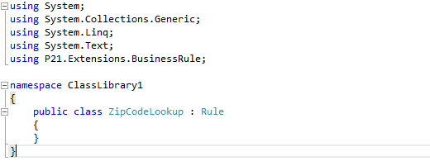
- Save the project.
Creating the Required Class Methods
Every rule class need to have at least three particular methods defined to work properly: GetName(), GetDescription(), and Execute(). If it lacks GetName() or GetDescription(), the rule will not display in Prophet 21. If it lacks Execute(), no code will run, and you will get an error message in Prophet 21.
- In the Rule-based class you just created above, enter the first method:
public override string GetName()
Visual Studio will likely autocomplete the method by creating code that will generate an error that the method has not yet been implemented.
- Create another method:
public override string GetDescription()
- Create the last required method:
public override RuleResult Execute()
The code should now look like this:
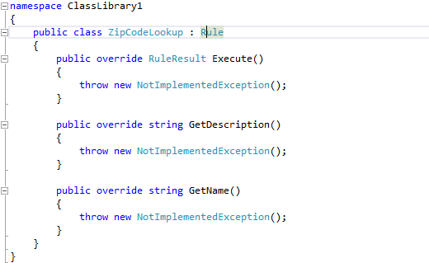
- Change the code in the GetName() and GetDescription() methods to return the name and description for the rule you want to appear in Prophet 21. GetName() returns the name of the rule, and GetDescription() returns a description for the rule. Following is an example:
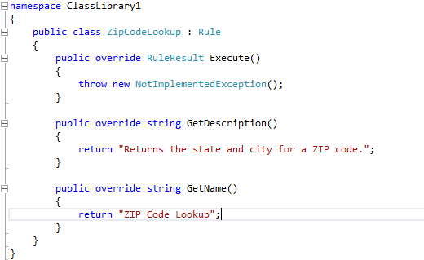
- Replace throw new NotImplementedException(); with:
RuleResult result = new RuleResult();
This code instantiates the RuleResult object that you will return to the Execute method. The Success property of the RuleResult class defaults to true so that you only return a failure to Prophet 21 if your code actually fails.
- You now add the algorithm that does the work of your business rule (or the code that calls another program that contains the algorithm). A very simple example follows. If you have questions about any of the code used, you can find more information in the API (see Rule Class API).
This example is not working code and is not how you would implement this functionality; it has been abbreviated and simplified for the purpose of example, abridging or removing important elements like error handling, comments, and validation.
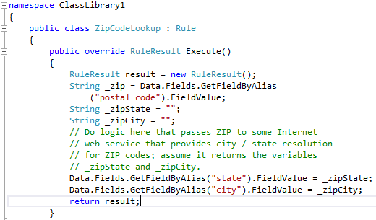
- Save the project.
Creating a Workflow Rule Class
When creating a workflow business rule, you must use an additional method in your class definition: ExecuteAsync(). Code executed in ExecuteAsync() does not return a value to Prophet 21.
This code snippet shows the class and required methods. The rule simply pops up a message box that shows the ExecuteAsync() method successfully executed code. See the ExecuteAsync() method for more information.
Build and Deploy to Prophet 21
Once you have created your business rule, you must build and deploy the class library to the location you specified when you set up Prophet 21, so the system can "see" the rule.
Make sure the Prophet 21 client is not running when you do this.
- Press [F6] to build the library (or Go to Debug > Build Solution). As long as there are no compiler errors in your code, Visual Studio builds the class library into a DLL file (with the same name as your solution).
- Find the DLL file in Windows Explorer. By default, this is located in your My Documents folder (or Documents folder in Windows Vista or higher). From My Documents, find the path:
Visual Studio 2013\Projects\<solution>\<project>\bin\Release\
- Copy the DLL file.
- Find the file path you set up in the DLL Folder field in the Files and Folders node of the System Setup system settings.
- In Windows Explorer, open that folder.
- Paste your DLL file into the folder.
- Next time you open Prophet 21, you will have access to your new business rule. See Sample Business Rules for more information on hooking the business rule into a Prophet 21 field or button.
Sample Rules
Epicorprovides a few sample business rules to demonstrate various types of rules. The rules are provided with both as a DLL file you can hook directly to Prophet 21 and as a Visual Studio solution containing all the source code for the rules.
See Sample Business Rules for more information on the sample rules.

