DynaChange Rules Overview
Article last updated: July 11, 2025 at 10:33 PM
This is an optional feature; it is not part of the baseline system. You cannot access any of the functionality described here without first purchasing this additional package.
DynaChange Business Rules enable you to truly extend and customize the system to fit your business perfectly. You can write algorithms using the programming language of your choice, and link those algorithms into the Prophet 21 user interface. For example, you could write a business rule that takes the postal code you enter for an address, looks up the city and state for you, and populates them in the window automatically.
You can create business rules that apply:
- When you tab out of a field
- When you save a record
- When you click a button
- When you open a window
- Before or after Prophet 21 validates data
- In specific business scenarios when an event occurs in Prophet 21.
Glossary
These articles contain a lot of language that may be unfamiliar to many Prophet 21 users; because DynaChange Rules are a method to add your own programming logic to Prophet 21, programming concepts and language is critical to understanding the engine. The following section addresses some of the terminology used in these articles.
Term | Definition
Algorithm | Programming code that gets business work done. For example, if your business rule populates the city and state based on the postal code, the algorithm is the code that looks up the city and state for the postal code and returns those values.
Business Rule | See What Is a Business Rule for more information.
C# | The programming language used to create the business rule classes. Pronounced "see sharp."
Class | A set of algorithms that work together and, typically, represent some object (such as a business rule).
Class Library | A set of classes that turn into a DLL file when you compile them. The DLL can then be used to access the algorithms inside the classes. Your business rules exist inside class libraries.
Developer | A person who creates software, such as a programmer or software engineer.
Logic | See Algorithm above.
Method | In programming, the function that is used to access an algorithm.
Object | A combination of programming code and data that represents something, typically something in the world (like a business rule, a person, a customer, etc.).
Web Visual Rule | A web visual rule is a rule in Prophet 21 that needs to display some data or window or web page outside of application fields.
ASP.NET MVC | Web development methodology used to create visual rules in the web application.
What Is a Business Rule?
A business rule is a set of logic (programming code) that does some work that serves a business purpose in the system. You can write your own business rules which help your organization streamline processes, prevent errors, and expand capabilities. A business rule can be as simple as requiring a minimum number of characters in a field, or as complicated as creating your own window that will retrieve data from and insert data into your database.
Anatomy of a Business Rule
A business rule has several parts:
- "Hooks" in Prophet 21 that enable the business rule and Prophet 21 to communicate and pass data back and forth
- The business rule class that contains the attributes of your business rule, including the algorithms of your rule that gets your business work done.
- In the case of web visual rules, the rule class is embedded in an asp.net MVC web site
DynaChange Rules
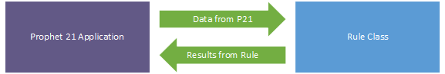
DynaChange Rules – Web Visual Rules
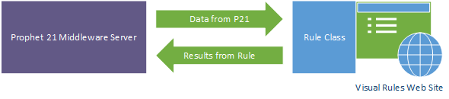
A business rule class is a C# class derived from the Rule class provided by Epicor.
What Business Rules Are Not
While business rules are very flexible and can be used in a lot of ways, there are some things business rules are not, and cannot do.
Business rules are not:
- Able to create a new tab in an existing window
- Able to change existing Prophet 21 logic; they may layer on top of what the system does only
Support
Epicor Software Support supports the Prophet 21 user interface elements of business rules and the link between the Visual Studio business rule class and Prophet 21. Software Support does not support problems in Visual Studio or business rule code or algorithms.

