Scenario: Checkout Book

|  |  |  |  |
| --- | --- | --- | --- |
|  | **Comment** | **System Event** | **Response** |
|  | Authenticate User | Login(username, password) | JobSeeker Session started |
|  | Get a list of jobs that matches the criteria | executeCommand(“Search Job”,  keyword, location, category) | “searchResult size: 3  1) Burger King | Fullerton | Server  2) Starbucks | Fullerton | Barista  3) Health Kitchen | Las Vegas | Chef” |
|  | View selected job information | executeCommand(“Get Job Info”, 1) | “name : Burger King  location : Fullerton  category : Server  type : Part time  descripton : Some descrption about server at Burger King  qualification : over 19  salary : 15$ / hour” |
|  | Apply for job | executeCommand(“Apply for Job”) | “Application Success!” |
|  | View Applications | executeCommand("View Applications") | “Application status for Hyejin  1) job name: Burger King | status: reviewed  2) job name: Starbucks | status: applied” |
|  | End session | signoff() | System exists |

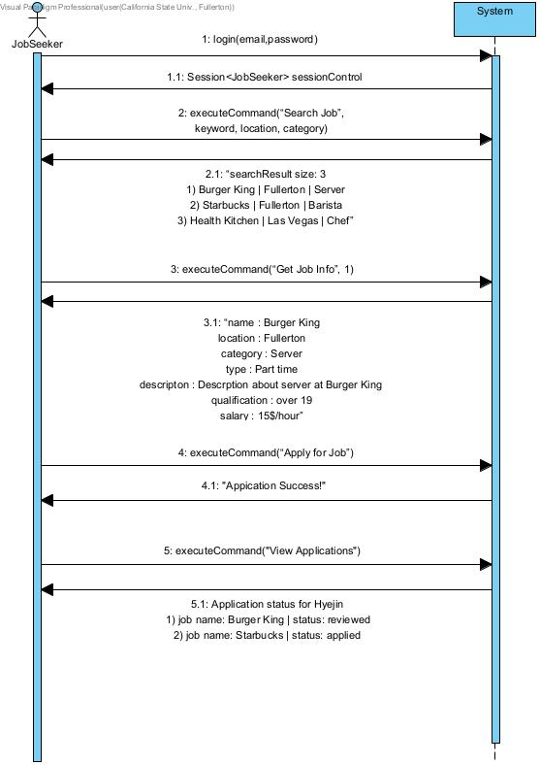

Static View

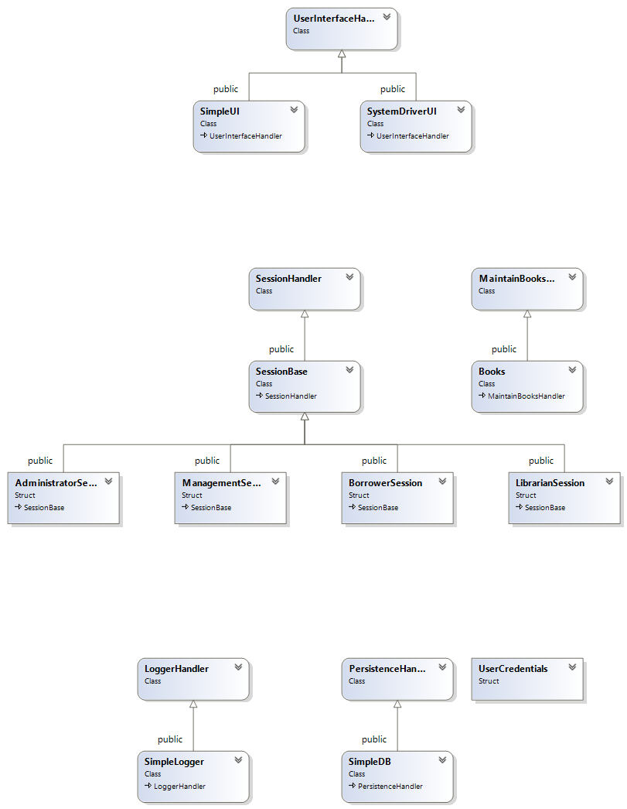

UI

Layer

Domain

Layer

Technical  
Services

Layer

File and layer dependencies

Notice the only access to a lower layer is through the interface, and that only the interface of the lower layer is visible to the upper layers.

1. main()
2. UI Layer
3. Domain Layer
4. Technical Services Layer

