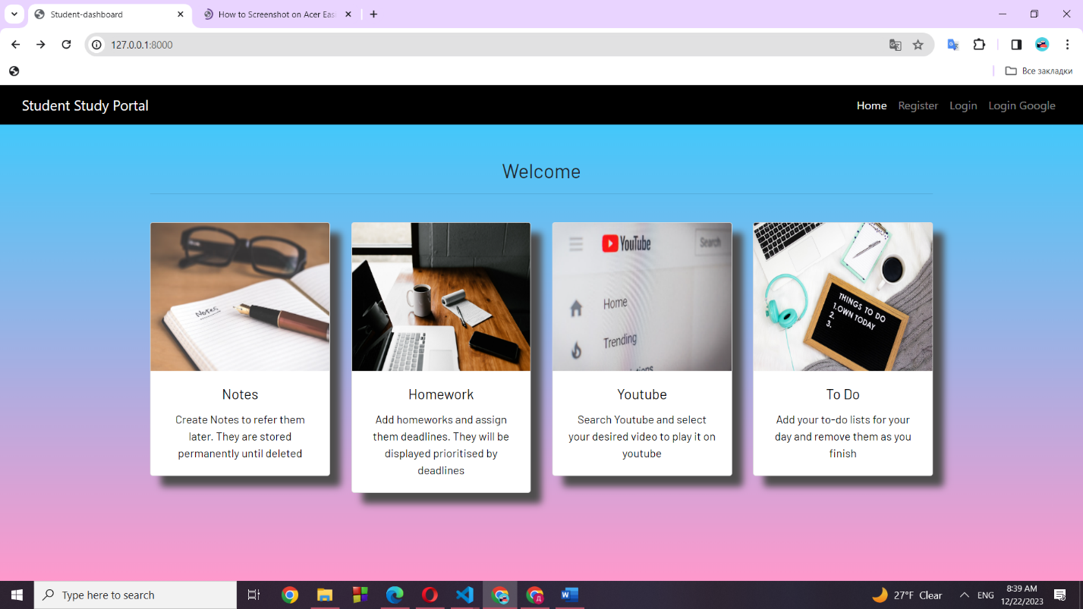

I created a project according to technical specifications:

Project Name: LearningBuddy

Description: LearningBuddy is a basic educational platform for users to access and manage their learning materials, using OAuth2 for secure authentication and authorization. It consists of two parts: the Authentication Server and the Resource Server.

Features:

User Registration and Authentication:

Users can create accounts or log in using email and password. (YES)

Implement OAuth2 for secure authentication via a third-party OAuth2 provider (e.g., Google). (YES)

Resource Management:

Users can upload and manage learning resources (PDFs, documents, etc.).(YES)

Implement basic CRUD operations for resources.

Resource Server:

The Resource Server securely stores and serves the uploaded learning resources. (YES)

Use OAuth2 access tokens issued by the Authentication Server for resource access. (YES)

Dashboard:

Users have a simple dashboard displaying their uploaded resources.

Show basic resource details like title, date uploaded, and file type.

OAuth2 Integration:

Configure the Django Authentication Server to integrate with a third-party OAuth2 provider.

Allow users to log in with their third-party OAuth2 accounts. (YES)

User Profile:

Users can view and edit their profiles (name, email, etc.). (NO)

Security:

Implement basic security measures such as input validation and authentication checks.

Ensure secure OAuth2 integration. (YES)

Responsive Design:

Make the application mobile-friendly with a responsive design. (NO)

Documentation:

Provide simple setup instructions for developers and users.

**REGISTRATION:**

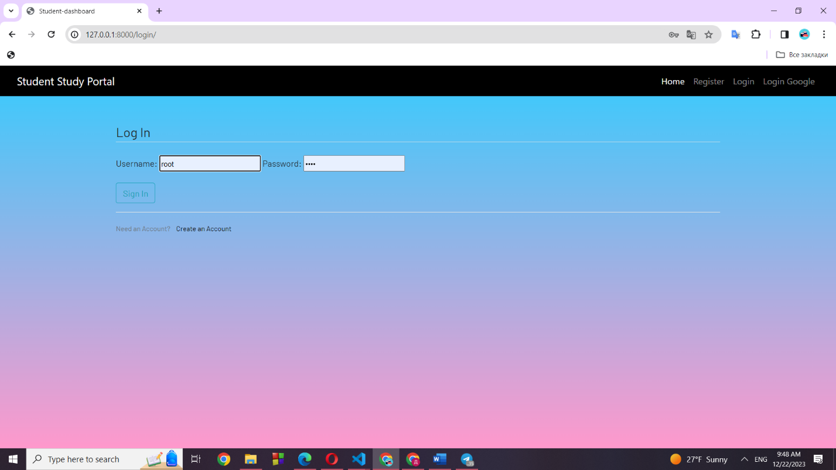

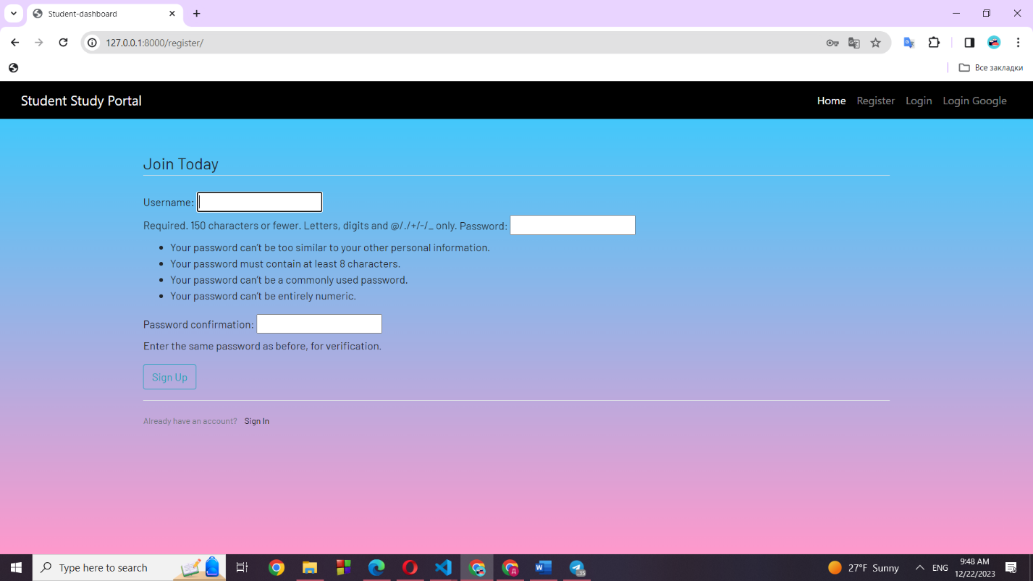

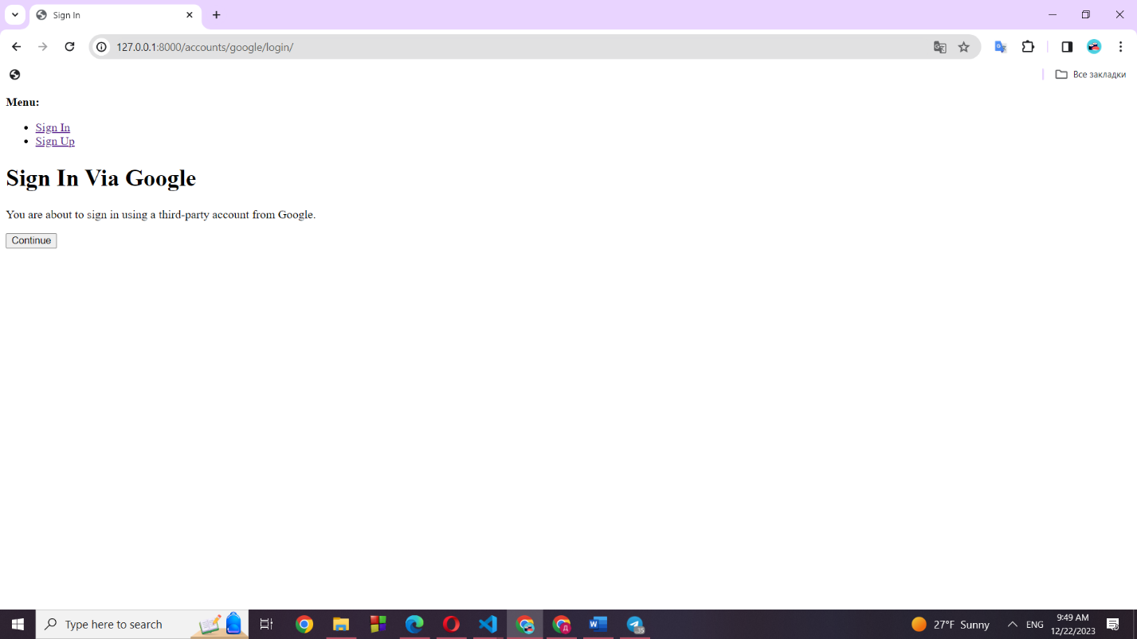

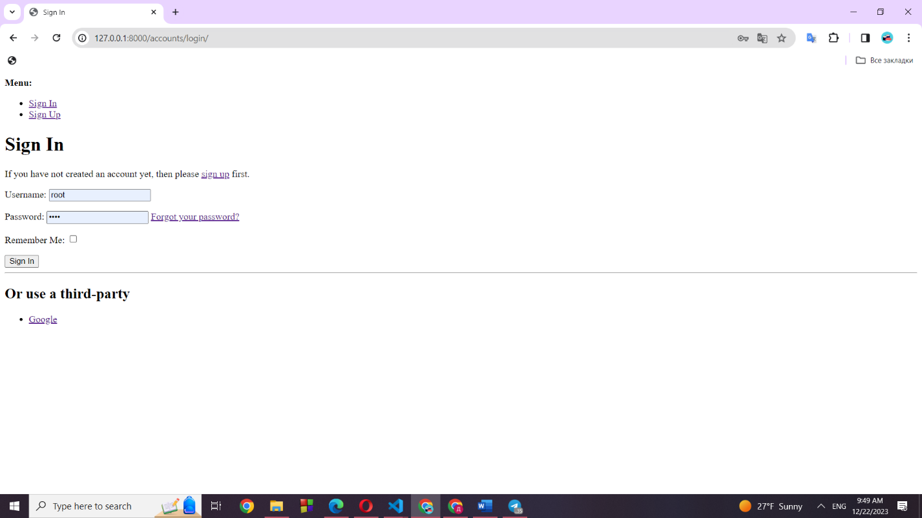

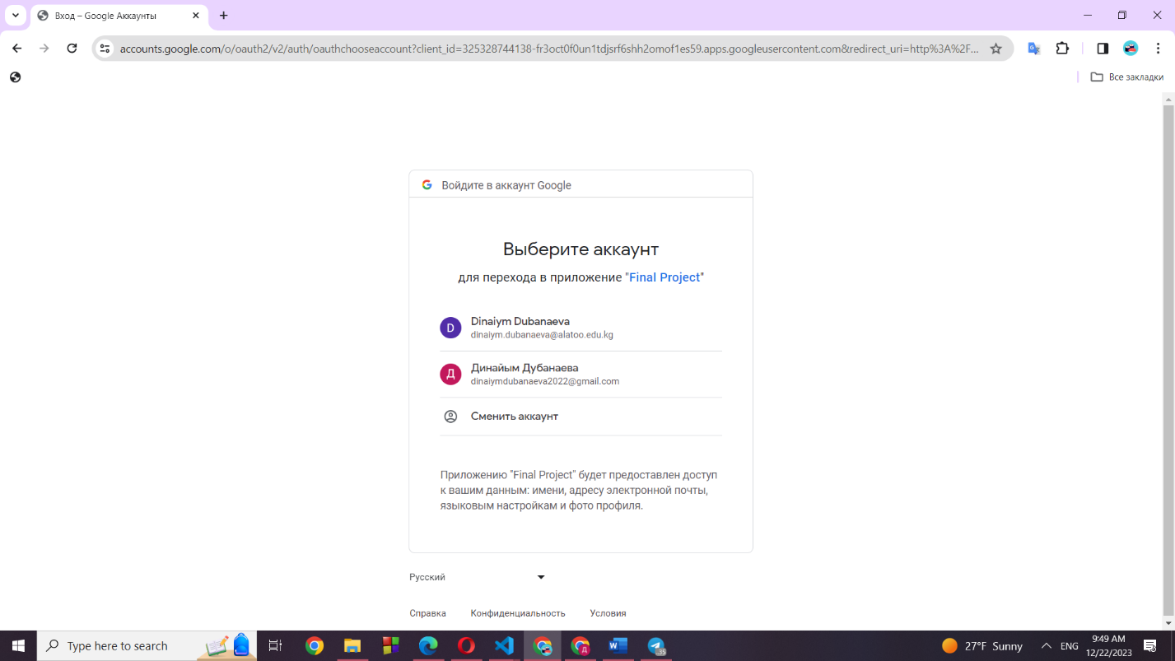

**FUNCTIONALITY:**

