ELECTIFY: A COHORT-ISOLATED
ELECTIVE REGISTRATION SYSTEM WITH
TRANSACTIONAL SEAT ALLOCATION
A PROJECT REPORT SUBMITTED TO
SRM INSTITUTE OF SCIENCE & TECHNOLOGY
IN PARTIAL FULFILMENT OF THE REQUIREMENTS FOR THE
AWARD OF THE DEGREE OF
MASTER OF COMPUTER APPLICATIONS
BY
MATHESHWARAN R (RA2532241010311)
SUHAS C (RA2532241010312)
NITHYASHREE K (RA2532241010329)
DEVANANDA E (RA2532241010332)
UNDER THE GUIDANCE OF
Dr. V. NISHA

DEPARTMENT OF COMPUTER APPLICATIONS
FACULTY OF SCIENCE AND HUMANITIES
SRM INSTITUTE OF SCIENCE & TECHNOLOGY
Kattankulathur – 603 203
Chennai, Tamil Nadu
OCTOBER – 2026

BONAFIDE CERTIFICATE
This is to certify that the project report titled “ELECTIFY: A COHORT-ISOLATED ELECTIVE REGISTRATION SYSTEM WITH TRANSACTIONAL SEAT ALLOCATION” is a bonafide work carried out by
MATHESHWARAN R (RA2532241010311)
SUHAS C (RA2532241010312)
NITHYASHREE K (RA2532241010329)
DEVANANDA E (RA2532241010332)
under my supervision for the award of the Degree of Master of Computer Applications. To my knowledge the work reported herein is the original work done by the students.

Dr. V. Nisha | Dr. P. J. Arul Leena Rose
Assistant Professor | Professor & Head
Department of Computer Applications | Department of Computer Applications
(GUIDE)

INTERNAL EXAMINER | EXTERNAL EXAMINER
ACKNOWLEDGEMENT
We thank the Almighty, and our parents and families, whose encouragement carried us through this project and the rest of the MCA programme.
We are grateful to Dr. T. R. Paarivendhar, Chancellor, SRM Institute of Science and Technology, for the institution and the facilities within which this work was done.
We thank Dr. A. Duraisamy, Dean, and Dr. S. Albert Antony Raj, Deputy Dean, Faculty of Science and Humanities, for supporting project work in the faculty.
We thank Dr. P. J. Arul Leena Rose, Professor and Head, Department of Computer Applications, for her support during the project and its reviews.
Our guide, Dr. V. Nisha, Assistant Professor, Department of Computer Applications, advised us throughout the project. We are grateful for her direction, her suggestions and her patience with our questions.
Finally, we thank the faculty members of the department, whose comments at the reviews improved the work, and our classmates and friends, who supported us while the system was being built.
MATHESHWARAN R
SUHAS C
NITHYASHREE K
DEVANANDA E
TABLE OF CONTENTS
1. INTRODUCTION 1
1.1 Background 1
1.2 Problem Statement 1
1.3 Objectives and Scope 2
1.3.1 Objectives 2
1.3.2 Scope of the Project 2
2. LITERATURE SURVEY 3
2.1 Course Allocation in Higher Education 3
2.2 Transactions and Concurrency Control 3
2.3 Access Control 4
2.4 Authentication and Session Management 4
2.5 Web Application Frameworks 4
2.6 Research Gap 5
Summary of the Literature Survey 5
3. SYSTEM ANALYSIS 6
3.1 Existing System 6
Limitations of the Existing System 6
3.2 Proposed System 6
3.3 Functional and Non-Functional Requirements 7
3.3.1 Functional Requirements 7
3.3.2 Non-Functional Requirements 8
3.4 Advantages of the Proposed System 8
4. SYSTEM ARCHITECTURE AND DESIGN 10
4.1 Overall Architecture 10
4.2 Technology Stack 11
4.3 Data Flow Diagram 11
4.4 Database Design 12
4.5 Module Design 14
4.6 Authentication and Session Design 14
4.7 Role-Based Authorisation and Staff Workspace 15
4.8 User Interface Design 17
4.9 System Design Summary 17
5. ACADEMIC AND ELECTIVE MANAGEMENT 18
5.1 Academic Hierarchy 18
5.2 Year Servers, Cohorts and Study Stages 18
5.3 Class Tutors and Student Onboarding 19
5.4 Registration Events and Their Lifecycle 21
5.5 Elective Groups, Subjects and Seat Capacity 22
5.6 Subject Explorer 23
5.7 Summary 25
6. REGISTRATION PROCESSING AND DATA INTEGRITY 26
6.1 Eligibility of a Student for an Event 26
6.2 The Registration Window Rule 26
6.3 The Registration Transaction 26
6.4 Seat Accounting and Class Quotas 29
6.5 Changing and Cancelling a Registration 29
6.6 Receipts 30
6.7 Database Constraints as a Safety Net 31
6.8 Audit Trail and Registration Replay 32
7. SYSTEM IMPLEMENTATION 34
7.1 Development Environment 34
7.2 Project Structure 34
7.3 Database Schema and Migrations 35
7.4 Authentication Implementation 35
7.5 Student Interface 36
7.6 Staff Interface 36
7.7 Live Monitoring and Realtime Updates 38
7.8 Reports and Exports 39
7.9 Configuration and Deployment Considerations 40
8. TESTING AND RESULTS 41
8.1 Testing Methodology 41
8.2 Test Environment 41
8.3 Server-Side Test Suites 42
8.4 Functional, Concurrency and Access-Control Test Cases 42
8.5 Browser End-to-End Tests 44
8.6 Responsive Layout and Accessibility 45
8.7 Defects Found and Corrected 46
8.8 Limitations of the Testing Approach 47
9. CONCLUSION AND FUTURE ENHANCEMENTS 48
9.1 Conclusion 48
9.2 Future Enhancements 48
10. REFERENCES 49
11. APPENDICES 51
11.1 Selected Source Code 51
11.1.1 src/lib/seat-ops.ts — taking and releasing seats 51
11.1.2 src/lib/registration-window.ts — the window rule 52
11.1.3 src/app/actions/register.ts — locking inside the registration transaction 52
11.2 Additional Screenshots 53
11.3 Automated Test Results 54
11.4 Demonstration Data Used for Screenshots 60
11.5 Glossary 61

ABSTRACT
Elective registration in a university department is a short, intense activity. Within a fixed window, every student of a class must choose a limited number of subjects from groups such as professional and open electives, and each subject has a fixed number of seats. When the process is run with paper forms, spreadsheets or general-purpose online forms, seat limits are applied by hand, several students can be promised the same last seat, and staff have little visibility of who has registered until the window has closed. A further difficulty arises when a department runs several admission batches at once: classes from different years can share a section name, and choices made by one cohort must never consume seats or appear in the records of another.
This project presents Electify, a web-based elective registration system built with Next.js 16, React 19, TypeScript, the Drizzle ORM and PostgreSQL. The academic structure is modelled as faculties, departments, programmes, admission batches and classes, and each academic year is managed as a separate “Year Server” workspace in which staff see only the classes they are responsible for. Students join their class with a signup code issued by the class tutor, sign in with their register number and password, explore the subjects offered to their class, and submit their choices during the registration window. Every submission is processed in a single database transaction that locks the chosen subject rows, applies the subject capacity and any class quota, records the choice and issues a receipt. Changes and cancellations follow the same discipline, so a seat is either held by exactly one student or returned to the pool.
Class tutors, course coordinators and administrators have role-specific tools for managing classes, events, subjects, seat quotas, live monitoring, reports, an audit log and a replay of registration activity. The implementation was checked at two levels. At the server level, 136 automated tests in 18 suites, run against a PostgreSQL database, cover cohort isolation, concurrent access to the last seat, changes and cancellations, onboarding, password policy, access control and data migrations. At the browser level, 36 end-to-end tests drive the application in Google Chrome with synthetic data: they reload every important page for each role, follow a student from sign-in to cancellation while checking the database, and examine layout at seven screen sizes and accessibility with an automated checker. All tests passed in the runs reported here. Defects found while building these tests were corrected and given regression tests; they are described in Chapter 8 together with the limits of the testing.
Keywords: Elective registration, seat allocation, concurrency control, PostgreSQL transactions, role-based access control, Next.js, cohort isolation, web application.
LIST OF TABLES
Table 3.1 User Roles and Responsibilities 7
Table 3.2 Functional Requirements 7
Table 3.3 Non-Functional Requirements 8
Table 4.1 Technology Stack 11
Table 4.2 Principal Database Tables 13
Table 4.3 Server Action Modules 14
Table 4.4 Summary of Role Permissions 16
Table 5.1 Event Statuses and Window States 22
Table 6.1 Conditions for a Student to Be Eligible for an Event 26
Table 6.2 Principal Integrity Constraints 31
Table 7.1 Development and Test Environment 34
Table 7.2 Project Directory Structure 34
Table 7.3 Database Migrations 35
Table 7.4 Authentication Parameters 36
Table 7.5 Configuration Variables 40
Table 8.1 Test Environment for the Reported Runs 41
Table 8.2 Server-Side Test Suites and Results 42
Table 8.3 Representative Functional Test Cases 42
Table 8.4 Concurrency and Integrity Test Cases 43
Table 8.5 Access Control and Isolation Test Cases 43
Table 8.6 Browser End-to-End Test Files and Results 44
Table 8.7 Responsive Layout Problems Found and Corrected 45
Table 8.8 Accessibility Problems Found and Corrected 45
Table 8.9 Defects Found and Corrected 46
Table 8.10 Seat Consistency Check After the Walkthrough 47
Table 8.11 Testing Not Executed 47
Table 11.1 Complete List of Server-Side Tests and Results 55
Table 11.2 Complete List of Browser End-to-End Tests and Results 59
Table 11.3 Fictional Demonstration Data 61
Table 11.4 Glossary of Terms 61

LIST OF FIGURES
Figure 4.1 System Architecture of Electify 10
Figure 4.2 Level-1 Data Flow Diagram 12
Figure 4.3 Entity-Relationship Diagram of the Principal Tables 13
Figure 4.4 Staff Authorisation and Workspace Resolution 16
Figure 4.5 Sign-in Page with Student and Staff Forms 17
Figure 5.1 Year Server Chooser Shown After Staff Sign-in 19
Figure 5.2 Academic Years Page, Where Administrators Manage Year Servers 19
Figure 5.3 Student Onboarding with a Class Signup Code 20
Figure 5.4 Join Page After a Valid Class Signup Code Is Entered 21
Figure 5.5 Registration Event Status and Window Lifecycle 22
Figure 5.6 Coordinator View of Elective Baskets, Subjects and Seat Allotments 23
Figure 5.7 Subject Explorer Listing the Subjects Offered to a Class 24
Figure 5.8 Subject Detail Page with Official Details and Labelled Guidance 25
Figure 6.1 Steps of the Registration Transaction and the takeSeat Rule 27
Figure 6.2 Elective Picker with One Subject Selected in Each Basket 28
Figure 6.3 Confirmation Dialog Shown Before a Registration Is Submitted 29
Figure 6.4 Seat Handling When a Choice Is Changed or Cancelled 30
Figure 6.5 Registration Record and Receipt Shown After a Successful Submission 31
Figure 6.6 Registration Replay for an Event 32
Figure 6.7 Audit Log Viewed by an Administrator 33
Figure 7.1 Class Tutor Dashboard for the Active Class 37
Figure 7.2 Live Window Page Used by a Class Tutor to Control Registration 38
Figure 7.3 Live Registration Monitor for the Semester 3 Event 39
Figure 7.4 Coordinator Reports Page with Allotments by Student 40
Figure 11.1 Class Page with the Student Roster and Class Tools 54
Figure 11.2 Subjects and Groups Page with Seat Counts per Subject 54

1. INTRODUCTION

1.1 Background
Most postgraduate and undergraduate programmes include elective courses. An elective allows a student to shape part of the programme around an area of interest, and it allows a department to offer specialised subjects without making them compulsory for everyone. In a typical semester a class is asked to choose one subject from a group of professional electives and one from a group of open electives, while each subject can accept only as many students as its teaching resources allow.
Collecting these choices sounds simple, but the activity has several properties that make it difficult to run well. Registration happens inside a short window, and many students act in the first few minutes because popular subjects fill quickly. Seat limits must be respected exactly; if two students are told that they have the last seat in a subject, one of them has to be moved later, which is unfair to the student and creates extra work for staff. Students also need clear information about each subject before they choose, and staff need an accurate, current view of who has registered and who has not.
A department rarely runs a single cohort at a time. In a two-year MCA programme, for example, the first-year and second-year batches are both active, and each may have classes with the same section letter. The registration for one cohort's third semester must not be visible to, or consume seats from, the other cohort. The same faculty member may also be the class tutor of classes in different batches, so the system must keep the classes apart while still allowing one account to manage both.
Web technology now makes it practical for a department to run this process on its own system. Modern frameworks allow the user interface and the server logic to live in one code base, and relational databases such as PostgreSQL provide transactions and row-level locks that can enforce seat limits even when many requests arrive at the same moment [14], [15]. Electify was developed to apply these capabilities to the specific problem of elective registration in a department, with attention to correctness under concurrency, separation of cohorts and clear role boundaries for staff.

1.2 Problem Statement
When elective registration is handled through paper forms, shared spreadsheets or general online form tools, the seat limit of a subject is not enforced at the moment a student submits a choice. Allocation is decided afterwards by staff, often on a first-come basis reconstructed from timestamps, and disputes are resolved manually. Students cannot see how many seats remain, staff cannot see progress while the window is open, and a record of what was chosen and changed is difficult to reconstruct.
A simple web form backed by a database does not solve the problem by itself. If the application reads the remaining seat count, checks it and then writes a new value in separate steps, two simultaneous requests can both read the same count and both succeed, producing an overbooked subject; this is the classic lost-update problem described in the database literature [7], [10]. In addition, a system that serves several batches must make sure that a student only sees the event meant for their own class, that staff can act only on the classes assigned to them, and that a value supplied by the browser (such as a cookie naming a class) can never widen a user's access.
The problem addressed by this project can therefore be stated as follows: to design and implement a departmental elective registration system that enforces subject capacity and class quotas exactly under concurrent use, keeps admission cohorts and academic years isolated from each other, gives each staff role only the access it needs, and provides students with clear subject information and a verifiable record of their registration.

1.3 Objectives and Scope

1.3.1 Objectives
The main objective of the project is to build a working elective registration system for a department and to verify its behaviour with automated tests. The specific objectives are:
- To model the academic structure of faculties, departments, programmes, admission batches and classes, and to organise each academic year as a separate workspace.
- To let students join their own class securely using a tutor-issued signup code, and to sign in with their register number and a password that meets a defined policy.
- To allow staff to create registration events for specific classes, with elective groups, subjects, seat capacities and optional class quotas.
- To enforce the registration window on the server and to process every registration, change and cancellation as a single database transaction that cannot overbook a subject.
- To issue a receipt for each confirmed registration and to keep an audit log and a replay record of registration activity.
- To give class tutors, course coordinators and administrators role-specific dashboards, live monitoring and reports limited to the classes they manage.
- To provide students with a subject explorer that shows the subjects offered to their class, the remaining seats and supplementary guidance about each subject.
- To verify the system with automated tests that cover cohort isolation, concurrency, access control, onboarding and data migrations.

1.3.2 Scope of the Project
The project covers the full registration workflow of a department: setting up the academic structure and Year Servers, onboarding students into classes, preparing registration events, running the registration window, monitoring progress, and producing reports and receipts. It supports four roles — system administrator, course coordinator, class tutor and student — and keeps the data of different cohorts and academic years separate.
Allocation in the current version follows the order in which confirmed requests are committed: a student who submits while seats remain receives a seat, and the database guarantees that the capacity is never exceeded. Preference-based allocation schemes, such as ranking several subjects and running an assignment algorithm after the window closes, are outside the scope of this version and are discussed as future work.
The project does not integrate with the university's central student information or examination systems, and it does not send e-mail or SMS notifications. It has been developed and tested on development databases with fictional data; it has not been deployed for an actual registration cycle, and no claims are made about its performance under production load.

2. LITERATURE SURVEY
This chapter reviews the published work and technical standards that informed the design of Electify. The survey covers four areas: how courses and electives can be allocated to students, how databases keep shared data consistent under concurrent access, how access to a multi-user system is controlled, and how passwords and sessions should be handled. It closes with the gap that the project addresses.

2.1 Course Allocation in Higher Education
Assigning students to courses with limited capacity is a well-studied allocation problem. Gale and Shapley's work on stable matching [1] introduced the idea of matching two sides of a market according to preferences, and it remains the starting point for many admission and assignment schemes. Course allocation differs from simple matching because each student usually needs several courses and each course accepts many students.
Budish and Cantillon studied the course allocation mechanism used at Harvard Business School, in which students take turns choosing courses in a draft [2]. Their analysis showed that students behave strategically under such mechanisms and that a mechanism which looks fair on paper can produce unequal outcomes in practice. Budish later proposed the approximate competitive equilibrium from equal incomes mechanism, in which students receive equal budgets of artificial currency and courses are priced so that demand matches capacity [3]. These studies show that the choice of allocation rule has real consequences for fairness and efficiency.
Many departments, however, use a simpler rule: students register during a window and seats are given in the order in which confirmed requests arrive. This rule is easy to explain and requires no ranking of preferences, but it is only fair if the system applies it exactly — every confirmed seat must correspond to a real seat, and the order must be decided by the system rather than reconstructed afterwards. Electify implements this rule and makes its enforcement a property of the database transaction, while leaving room for more elaborate mechanisms in future versions.

2.2 Transactions and Concurrency Control
Codd's relational model [4] and the entity-relationship approach proposed by Chen [5] provide the conceptual basis for storing structured academic data, such as programmes, batches, classes and registrations, as related tables with keys and constraints. Textbooks such as Silberschatz, Korth and Sudarshan [6] describe how these concepts are realised in relational database systems, including referential integrity and check constraints.
When many users update the same data at the same time, the database must decide how their operations interleave. Eswaran, Gray, Lorie and Traiger formalised the notion of consistency and the role of locking in achieving serialisable execution [7], and Gray and Reuter's treatment of transaction processing [8] describes the locking, logging and recovery techniques used by commercial systems. Berenson and colleagues showed that the isolation levels defined in the SQL standard permit anomalies, such as lost updates and write skew, that developers often assume are impossible [9].
Kleppmann discusses these anomalies from the point of view of application developers and recommends explicit locking, for example SELECT … FOR UPDATE, or atomic update statements when an application must read a value and then write a value that depends on it [10]. The PostgreSQL documentation describes the row-level locks, advisory locks and isolation levels that the database provides [14], [15]. Electify follows this guidance: every seat change locks the affected subject rows, the locks are always taken in the same order to avoid deadlocks, and check constraints reject any negative seat count as a final safeguard.

2.3 Access Control
Saltzer and Schroeder's principles for the protection of information [11] include least privilege, complete mediation (every access is checked) and fail-safe defaults. These principles remain the basis of modern access-control design. Role-based access control, introduced by Ferraiolo and Kuhn [12] and developed into a family of models by Sandhu and colleagues [13], grants permissions to roles rather than to individual users, which matches the way a department assigns responsibilities to administrators, coordinators and class tutors.
Pure role-based control is not sufficient for a departmental system, because two class tutors share the same role but must manage different classes. The permission therefore depends on both the role and the user's relationship to the data, which is sometimes described as attribute-based or relationship-based control. The OWASP Top 10 lists broken access control as the most common serious weakness in web applications [16], and many of its examples involve exactly this situation: a user with a valid role who can reach another user's records by changing an identifier in a request. Electify addresses this by deriving each staff member's scope from trusted database records on every request and by checking the scope inside each server action.

2.4 Authentication and Session Management
Passwords should never be stored in recoverable form. Provos and Mazières designed bcrypt, an adaptive hashing function whose cost can be increased as hardware becomes faster [17]. The current NIST guideline on authenticators, SP 800-63B-4, asks verifiers to screen new passwords against lists of commonly used or compromised values, to limit failed attempts, and not to force periodic changes. It sets a minimum of 15 characters for a password that is the only authentication factor, and it rules out composition rules such as requiring particular character classes [18]. Section 4.6 compares Electify's password policy with these requirements. The OWASP Application Security Verification Standard provides a checklist of requirements for authentication and session management [19].
JSON Web Tokens, defined in RFC 7519 [20], are a compact way to carry signed claims, such as a user identifier and role, between the server and the browser. A signed token proves that the server issued it, but it cannot by itself be revoked before it expires; a system that needs revocation must keep some server-side state as well. Section 4.6 describes how Electify pairs a short-lived token with a session identifier held in the database for this reason.

2.5 Web Application Frameworks
The project uses Next.js [21], a React-based framework [22] in which pages can be rendered on the server and in which server-side functions, called Server Actions, can be invoked directly from user-interface components. This keeps validation and database access on the server while avoiding a separate hand-written API layer. Database access uses the Drizzle ORM [23], which describes tables in TypeScript and produces typed SQL queries, and live updates use Supabase Realtime, which broadcasts database changes to subscribed browsers over WebSockets [24]. Server-side tests use the test runner built into Node.js [25]. Browser-level tests are written with Playwright [26], and accessibility is checked with axe-core [27], which tests rendered pages against rules derived from the Web Content Accessibility Guidelines (WCAG) 2.1 [28].

2.6 Research Gap
The sources reviewed above address the parts of the problem separately. The allocation literature [1]–[3] concentrates on the rules that decide who receives which course, and assumes that the chosen rule is carried out correctly. The database literature [7]–[10], [14], [15] explains how to keep shared data consistent but is not specific to course registration. The access-control literature [11]–[13], [16] gives general principles that must be translated into concrete checks for a particular organisation.
For a department that wants to run elective registration on its own system, these ideas have to be combined in one place: the seat rule must be enforced inside a transaction, the data of each cohort and academic year must be kept apart, and staff permissions must follow the department's assignment of classes. Electify was built to bring these concerns together in a single, testable application, and this report documents how each of them is implemented and verified.

Summary of the Literature Survey
The survey identifies first-come allocation as a simple and widely understood rule whose fairness depends on exact enforcement; explicit row locking and database constraints as the standard means of enforcing such a rule under concurrency; role- and relationship-based checks as the basis of access control; and adaptive password hashing, rate limiting and revocable sessions as current practice for authentication. These findings directly shaped the design described in the following chapters.

3. SYSTEM ANALYSIS

3.1 Existing System
Where a department has no dedicated system, elective choices are commonly collected in one of three ways: on paper forms returned to the class tutor, in a shared spreadsheet that students or tutors edit, or through a general-purpose online form whose responses are exported to a spreadsheet. In each case the form records a request, and the decision about whether a seat is available is taken later by a member of staff.
These approaches have the advantage of needing no development effort, and they work adequately for small classes with generous seat limits. Their weaknesses appear when demand for a subject exceeds its capacity, when several classes share subjects, and when students change their minds during the window.

Limitations of the Existing System
- Seat limits are not checked when a choice is made, so more students may select a subject than it can accept.
- Allocation is reconstructed afterwards from submission times or by hand, which is slow and difficult to justify to students.
- Students cannot see how many seats remain, so they cannot make an informed second choice.
- Staff have no live view of who has registered and who still needs a reminder.
- Changes and withdrawals are handled informally, and there is no reliable record of what was changed and when.
- When several batches are active, the responses of different cohorts can be mixed in the same sheet or form.
- Access to a shared sheet is all-or-nothing; a person who can edit it can alter anyone's entry.

3.2 Proposed System
Electify replaces the form-and-spreadsheet process with a web application in which the seat rule is enforced at the moment of submission. Staff prepare a registration event for one or more classes of a cohort, define elective groups and subjects with their capacities, and set the opening and closing times. Students see only the event for their own class. When a student confirms a choice, the server locks the subject rows, checks the remaining seats and either confirms the registration and issues a receipt or reports that the seat has just been taken, all within one transaction.
Each academic year is handled as a Year Server: a workspace that contains the cohorts studying in that year and the events created for them. Staff choose a Year Server when they sign in, and every page and action is limited to the classes they manage inside it. The system distinguishes four roles, summarised in Table 3.1.
Table 3.1 User Roles and Responsibilities
Role | Main responsibilities
System Administrator | Creates Year Servers, faculties, departments, programmes and staff accounts; issues staff invite codes; sets how many classes a tutor may manage; has access to every class, the audit log, the database tools and maintenance mode. The root administrator account cannot be deleted, deactivated or demoted.
Course Coordinator | Manages the classes of their programme: registration events, elective groups, subjects, seat allocations and class quotas, event templates, live monitoring and programme-wide reports.
Class Tutor | Claims and manages classes of any programme in their department, up to the administrator's limit: class roster, signup codes, password-reset approvals, registration window timers, live window, manual registration on behalf of a student, and class reports.
Student | Joins a class with a signup code, explores subjects, registers, changes or cancels choices while the window is open, and downloads a receipt.

The proposed system follows the overall flow shown below. The detailed design of each part is presented in Chapters 4 to 6.
- An administrator creates a Year Server and links the cohorts that study in it; staff accounts are created through invite codes.
- A class tutor issues a class signup code; students use it to create accounts that are attached to that class.
- A coordinator or tutor prepares a registration event for the class, with groups, subjects, seats and the registration window.
- Students explore the subjects and, once the window opens, submit their choices; each submission is confirmed or rejected atomically.
- Staff watch progress live, follow up with students who have not registered, and export reports when the window closes.

3.3 Functional and Non-Functional Requirements

3.3.1 Functional Requirements
The functional requirements identified for the system are listed in Table 3.2. Each requirement is implemented in the current version of the application.
Table 3.2 Functional Requirements
ID | Requirement
FR1 | The system shall allow an administrator to create Year Servers and to link admission cohorts to them with their study year and semester.
FR2 | The system shall allow a class tutor to generate, list and revoke class signup codes with an expiry date and a maximum number of uses.
FR3 | The system shall let a student create an account only through a valid signup code, attaching the account to the class named by the code.
FR4 | The system shall authenticate students by register number and password, and staff by e-mail address and password.
FR5 | The system shall let staff create registration events for selected classes of one cohort, with elective groups, subjects, seat capacities and opening and closing times.
FR6 | The system shall allow coordinators to reserve seats of a subject for particular classes (class quotas).
FR7 | The system shall show a student only the events and subjects offered to the student's own class.
FR8 | The system shall accept a registration only while the window is open, and only if a seat is available to the student.
FR9 | The system shall allow a student to change or cancel a choice while the window is open, subject to the event's settings.
FR10 | The system shall issue a receipt with a unique number for every confirmed registration.
FR11 | The system shall provide staff with live monitoring, a list of students who have not registered, and exportable reports.
FR12 | The system shall record significant actions in an audit log and registration activity in a replay log.
FR13 | The system shall support a tutor-authorised password reset for students.
FR14 | The system shall let a tutor claim classes from any programme of the tutor's department, up to a limit set by the administrator, and keep each class's roster separate.

3.3.2 Non-Functional Requirements
Table 3.3 Non-Functional Requirements
Quality | Requirement
Correctness | The number of confirmed registrations for a subject or class quota must never exceed its capacity, even when requests arrive simultaneously.
Isolation | Data belonging to one cohort or Year Server must not be visible to, or modifiable by, users who are not responsible for it.
Security | Passwords must be hashed with an adaptive function; sign-in attempts must be rate limited; every server action must check the caller's role and scope.
Auditability | Registrations, changes, cancellations and administrative actions must leave a durable record.
Usability | Students must be able to complete registration with a small number of clear steps and see seat availability before confirming.
Reliability | A failed submission must leave no partial data; the student's selections must be preserved so that the attempt can be repeated.
Maintainability | Business rules such as the registration window and seat accounting must be defined once and reused by every page and action.

3.4 Advantages of the Proposed System
- Exact seat enforcement – capacity and class quotas are checked inside a locked transaction, so a subject cannot be overbooked.
- Cohort and year isolation – events, subjects, seats and reports are tied to a class and a Year Server, so batches do not interfere with each other.
- Scoped staff access – each staff member can act only on the classes their role and assignments allow.
- Transparency for students – remaining seats and subject information are visible before and during registration, and every confirmation produces a receipt.
- Live visibility for staff – tutors and coordinators can see progress and pending students while the window is open.
- Traceability – audit and replay logs record who did what and how seat counts changed.
- Single source of rules – the window rule and seat accounting are implemented once and shared by the user interface and the server.

4. SYSTEM ARCHITECTURE AND DESIGN

4.1 Overall Architecture
Electify is a full-stack web application organised in four tiers, shown in Figure 4.1. Students and staff use the application through a browser. Every request first passes through a small edge function, src/proxy.ts, which verifies the signed session cookie and sends users who are not signed in, or who request a page for another role, to the appropriate place. The application tier is a Next.js 16 App Router application: pages are React Server Components that read data on the server, and all changes are made through Server Actions, which are server-side functions called from the user interface [21].
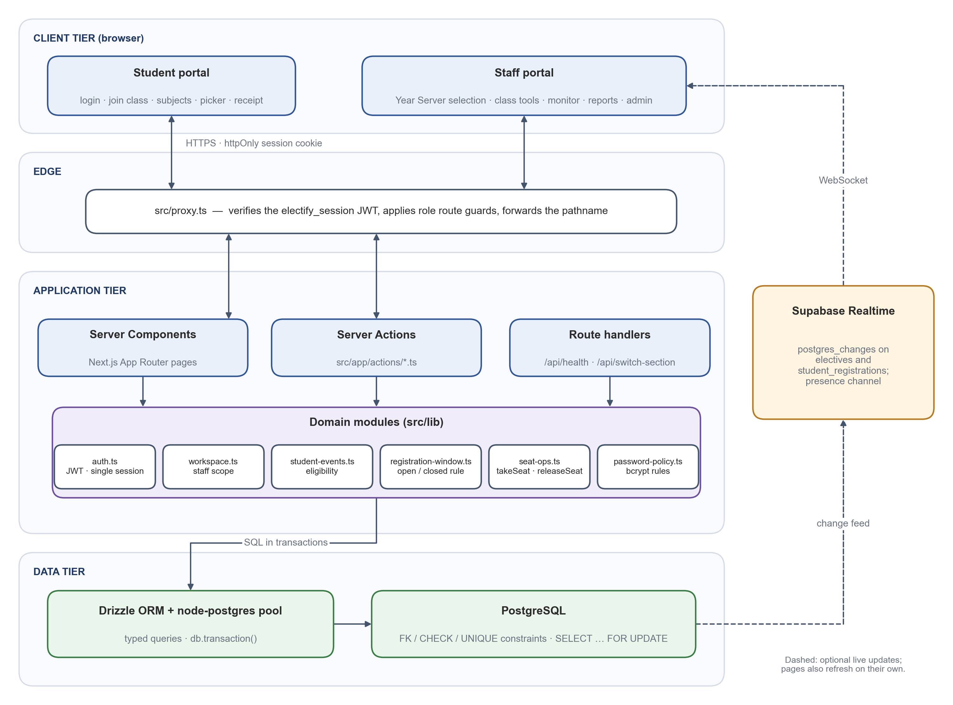
Figure 4.1 System Architecture of Electify
The business rules are kept in a small set of domain modules under src/lib. The most important are auth.ts (session tokens and the single-session check), workspace.ts (the classes a staff member may manage), student-events.ts (which events a student may see), registration-window.ts (whether a window is open), seat-ops.ts (taking and releasing seats) and password-policy.ts. Pages and actions call these modules rather than repeating the rules, so the user interface and the server always agree.
The data tier is a PostgreSQL database accessed through the Drizzle ORM and a node-postgres connection pool. Integrity rules that must never be broken, such as non-negative seat counts and the requirement that a class belongs to its cohort, are written as database constraints in addition to being checked in code. Supabase Realtime is used as an optional side channel: when subject or registration rows change, subscribed browsers are notified and refresh their seat counts. Pages also refresh on their own, so the application remains correct when the realtime channel is unavailable.

4.2 Technology Stack
The technologies used in the project are listed in Table 4.1. Versions are those declared in the project's package.json at the time of writing.
Table 4.1 Technology Stack
Layer | Technology (version) | Purpose in Electify
Language | TypeScript 5 | Static typing for the whole code base, shared by client and server.
Framework | Next.js 16.2 (App Router, Turbopack) | Server-rendered pages, Server Actions, route handlers and the edge proxy.
User interface | React 19.2, Tailwind CSS 4, Base UI, Lucide icons, Framer Motion | Components, layout, styling, accessible primitives and motion.
Forms and validation | React Hook Form 7, Zod 4 | Form state on the client; input validation on the server.
Database | PostgreSQL | Relational storage, transactions, row locks and constraints.
Data access | Drizzle ORM 0.45, drizzle-kit 0.31, node-postgres 8 | Typed schema and queries; schema synchronisation.
Authentication | jose 6 (JWT), bcryptjs 3 | Signed session tokens; password hashing.
Live updates | Supabase JS client 2 (Realtime) | Change notifications and presence for dashboards.
Documents | jsPDF 4, jspdf-autotable 5 | Receipt and report PDFs generated in the browser.
Charts and notifications | Recharts 3, Sonner 2 | Dashboard charts and toast messages.
Testing | Node.js test runner via tsx 4; Playwright 1.64; axe-core 4 | Server-side tests against PostgreSQL; browser tests, responsive checks and accessibility checks.

4.3 Data Flow Diagram
Figure 4.2 presents the level-1 data flow diagram. The four external actors interact with five processes. Students authenticate and onboard through process 1.0 and register through process 3.0, which reads the offerings prepared by coordinators and tutors in process 2.0. Process 3.0 writes registrations and, in the same transaction, the replay and audit records. Process 4.0 reads these stores to produce live monitoring, reports and the registration replay. Administrators maintain Year Servers, cohorts and accounts through process 5.0, and the class and cohort data it maintains are used by process 3.0 to decide eligibility.
The diagram shows an important design decision: no process accepts a student's class or cohort from the browser. The class always comes from stored data — the signup code at onboarding and the user record afterwards.
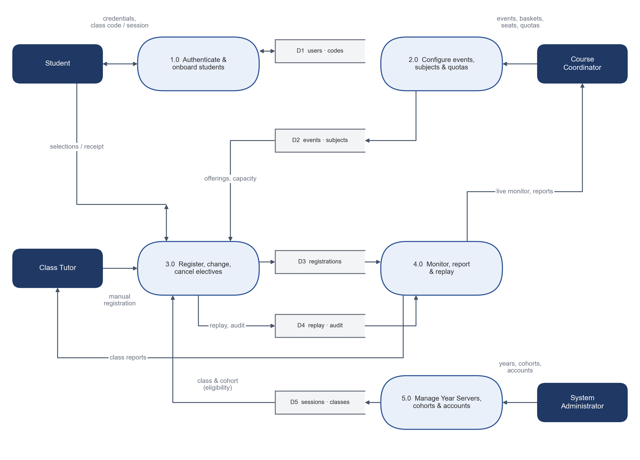
Figure 4.2 Level-1 Data Flow Diagram

4.4 Database Design
The database schema is defined in src/lib/db/schema.ts. Figure 4.3 shows the principal tables and their relationships, and Table 4.2 summarises their purpose. The academic hierarchy runs from faculties to departments, programmes, admission batches (cohorts) and sections (classes). A cohort is identified by its programme and admission year and does not change as students progress; the study year and semester of a cohort in a given academic year are stored separately in cohort_session_terms, linked to academic_sessions, which represent Year Servers.
A registration event belongs to exactly one cohort and one academic session. The classes it is open to are listed in event_sections, which repeats the cohort identifier so that composite foreign keys can guarantee that every targeted class belongs to the event's own cohort. The same technique is used on users and invite_codes, so a student or a signup code can never point to a class of a different cohort. Elective groups belong to an event, subjects (electives) belong to a group, and optional class quotas are stored in elective_seat_allocations.
Each student's registration for an event is represented by one row in registrations, which holds the overall status, the receipt number and a JSON snapshot of the receipt, and by one row per elective group in student_registrations. A unique constraint on student, event and group ensures that a student can hold at most one choice per group.
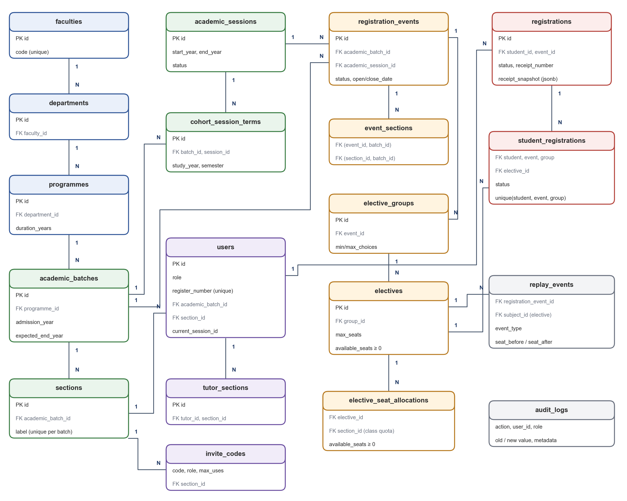
Figure 4.3 Entity-Relationship Diagram of the Principal Tables
Table 4.2 Principal Database Tables
Table | Purpose
faculties, departments, programmes | Academic hierarchy of the institution.
academic_batches | Admission cohorts: programme, admission year and expected end year.
sections | Classes within a cohort (for example MCA F of the 2025 cohort).
academic_sessions | Year Servers (academic years) with status PLANNED, ACTIVE or ARCHIVED.
cohort_session_terms | Which cohorts study in a Year Server, with their study year and semester.
users | All accounts and roles; students are linked to their cohort and class.
tutor_sections | Assignment of staff members to the classes they tutor.
invite_codes | Staff invite codes and class signup codes with expiry and usage limits.
registration_events, event_sections | Registration events and the classes each event is open to.
elective_groups, electives | Elective baskets and subjects with capacity and remaining seats.
elective_seat_allocations | Seats of a subject reserved for a particular class.
registrations, student_registrations | Each student's registration, receipt and per-group choices.
replay_events, audit_logs | Registration activity with seat counts; administrative audit trail.
login_attempts, pin_reset_requests | Sign-in rate limiting; tutor-authorised password resets.
subject_profiles, event_templates | Student-facing subject guidance; reusable event blueprints.

4.5 Module Design
The server-side logic is divided into Server Action modules under src/app/actions, each serving one area of the application. Every exported action begins by establishing who the caller is and what they may access, and only then reads or writes data. Table 4.3 lists the modules.
Table 4.3 Server Action Modules
Module | Responsibility
auth.ts | Staff and student sign-in, staff registration with invite codes, class-code validation and student signup, password upgrade and password reset.
register.ts | Student registration, change, cancellation and registration details (receipt).
tutor.ts | Class roster, signup codes, registration window and timers, manual registration, password-reset approvals, class reports.
coordinator.ts | Events, elective groups, subjects, class quotas, student status and programme reports.
admin.ts | Faculties, departments, users, invite codes, audit log and maintenance mode.
year-servers.ts, academic-sessions.ts | Year Servers, cohort terms, event targeting and review of historical data.
monitor.ts, replay.ts | Live monitoring data, pending-student lists, window status changes, replay and activity export.
templates.ts, subjects.ts | Event templates and subject profiles shown in the subject explorer.
dashboard.ts, database.ts, workspace.ts, user.ts | Role dashboards, scoped maintenance operations, Year Server selection and profile updates.

4.6 Authentication and Session Design
Students sign in with their register number and password, and staff with their e-mail address and password. Passwords are hashed with bcrypt using a cost factor of 12 [17]. After a successful sign-in the server issues a JSON Web Token signed with HS256 [20] and valid for two hours, and stores it in an HTTP-only cookie with the SameSite=Lax attribute; the cookie is marked Secure in production. The token carries the user's identifier, role and a random session identifier.
Each user record holds the identifier of the user's current session. On every request the server compares the identifier in the token with the stored value and also checks that the account is still active. A new sign-in replaces the stored value, so an older session on another device stops working at its next request, and deactivating an account ends its sessions. When this check fails while a page is being rendered, the server cannot delete cookies (Next.js only allows that in Server Actions and route handlers), so it redirects the browser to the sign-in page with a notice, and the routing proxy clears the cookies on that request. This combination keeps the convenience of a signed token while allowing it to be revoked.
Failed sign-in attempts are counted per identifier; after five failures the identifier is locked for fifteen minutes. The password policy is defined once in password-policy.ts and used by the sign-up, reset and profile forms and by the server. It requires at least eight characters including a letter and a number, rejects the student's register number and a list of common or previously issued default passwords, and refuses passwords longer than the 72 bytes that bcrypt can process instead of silently truncating them. Measured against NIST SP 800-63B-4 [18], the blocklist, the rate limit and the absence of forced periodic changes are consistent with the guideline, but two rules are not: the guideline requires at least 15 characters for a password used as the only factor, and it prohibits composition rules such as requiring a letter and a number. Aligning the policy is listed as future work in Chapter 9.

4.7 Role-Based Authorisation and Staff Workspace
Authorisation is enforced at three levels. The edge proxy keeps students out of staff pages and staff out of student pages. Each page and Server Action then checks the caller's role. Finally, for staff, every action resolves a workspace: the Year Server being worked in and the set of classes the user may manage in it. Figure 4.4 shows how the workspace is resolved and the checks that actions apply.
The scope is always computed from trusted data. The role is read from the user's database record rather than from the token, so a change of role takes effect at once. An administrator's scope is every class; a course coordinator's scope is every class of the programme recorded on their account plus any classes they tutor; a class tutor's scope is the set of classes assigned to them in tutor_sections. The selected Year Server is remembered in a cookie for convenience, but the cookie is treated purely as navigation state: it is validated on every request, and naming a class or Year Server outside the user's scope has no effect. Table 4.4 summarises the resulting permissions. One account is treated specially: the root administrator, identified by a fixed e-mail address in lib/auth.ts, cannot be deleted, deactivated, given another role or moved to another e-mail address through the user-management actions, so the system always keeps at least one administrator.
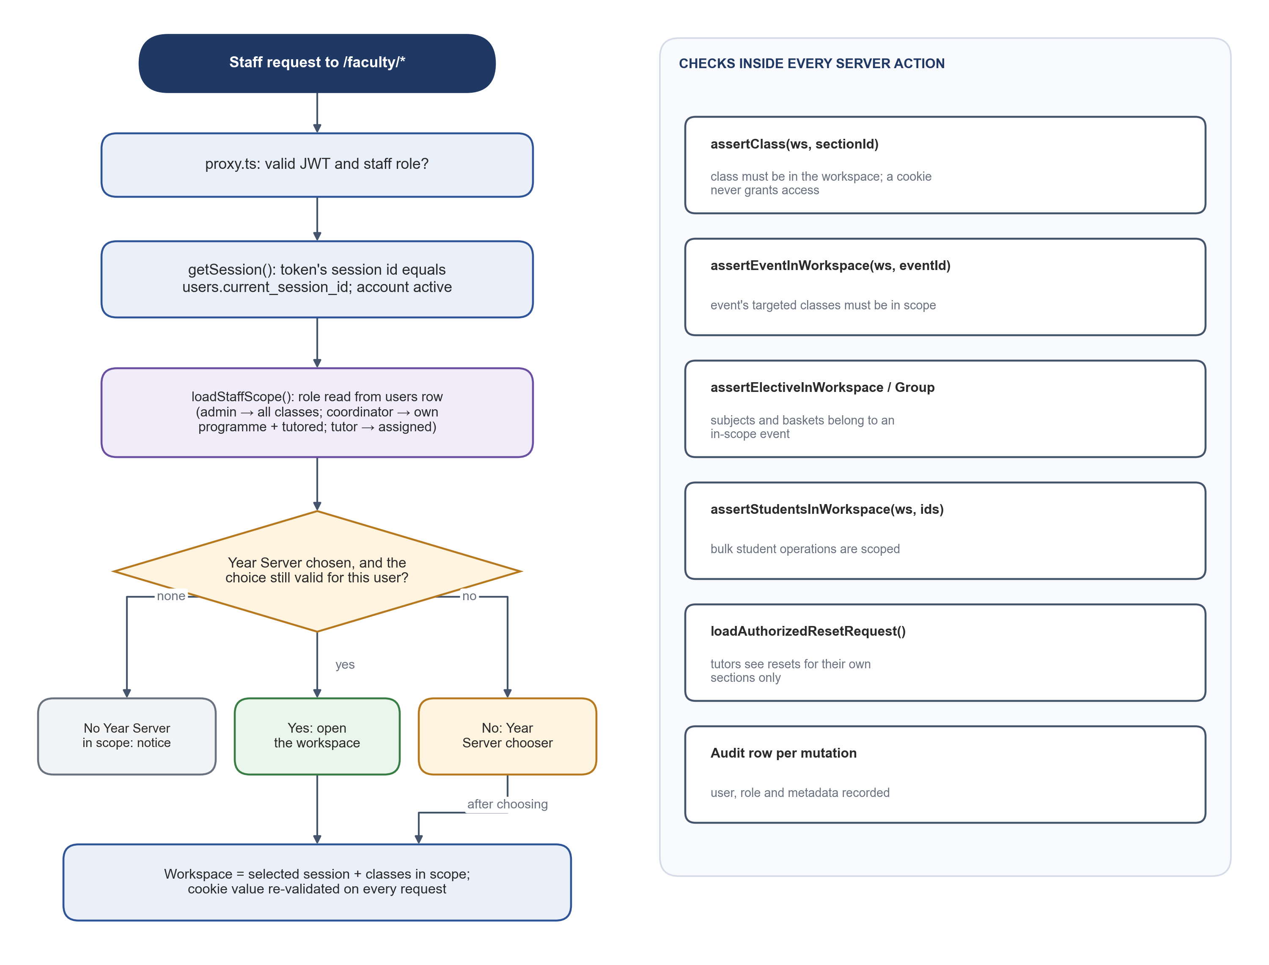
Figure 4.4 Staff Authorisation and Workspace Resolution
Table 4.4 Summary of Role Permissions
Capability | Admin | Coordinator | Tutor | Student
Create Year Servers, faculties, departments, staff accounts | Yes | No | No | No
Create and edit registration events | All classes | Own programme | Own classes | No
Define groups, subjects and seats | All classes | Own programme | Own classes | No
Set class quotas for a subject | Yes | Own programme | No | No
Issue class signup codes; approve password resets | All classes | Own programme | Own classes | No
Live monitor, reports, replay | All classes | Own programme | Own classes | No
Audit log and maintenance mode | Yes | No | No | No
Bulk tools (reset seats, clear registrations) | All classes | Own programme | No | No
Register, change or cancel electives | No | No | Manual entry for own class | Own registration

4.8 User Interface Design
The interface was designed around the tasks each role performs most often. The student side has a deliberately small number of pages: sign-in, joining a class, the subject explorer, the elective picker and the registration record. The staff side uses a sidebar layout with the current Year Server and class always visible at the top, and with navigation grouped into session control, academic registry and administration. Figure 4.5 shows the sign-in page, which offers separate student and staff forms.
Several principles guided the design. Seat availability is shown in the same terms everywhere — “available”, “few seats left” or “full” — using a shared function so that the subject explorer, the picker and the server agree. Destructive or irreversible actions require confirmation. Errors returned by the server carry a machine-readable code, so the interface can, for example, highlight the subject that has just filled instead of showing a generic message. Pages are responsive and work on mobile screens, which matters because many students register from their phones.
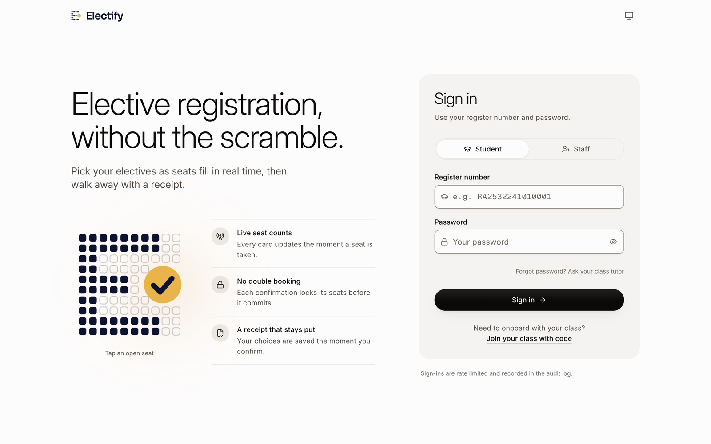
Figure 4.5 Sign-in Page with Student and Staff Forms

4.9 System Design Summary
The design separates concerns along clear lines. The edge proxy handles coarse routing, Server Actions handle requests, domain modules hold the rules, and the database holds the data together with the constraints that protect it. Correctness under concurrency is achieved through transactions and row locks rather than through checks in the browser, and isolation between cohorts and years is achieved through both scoped queries and composite foreign keys. Live updates improve the experience but are not relied upon for correctness.

5. ACADEMIC AND ELECTIVE MANAGEMENT
This chapter describes how the academic structure, classes, registration events and subjects are set up and managed before and during a registration window.

5.1 Academic Hierarchy
The institution is modelled as faculties, departments and programmes. Each programme records its degree type, duration in years and number of semesters. An administrator manages this hierarchy from the Departments page, where faculties can be expanded to show their departments, programmes and classes.
Students are organised into admission batches, referred to in this report as cohorts. A cohort is a programme together with an admission year and an expected end year, for example the MCA cohort of 2025–2027. Each cohort has one or more sections, which are the classes students belong to, such as MCA F. Because two cohorts can each have a section F, the application always labels a class with its full identity, for example “MCA F · 2025–2027”, using a single labelling function in src/lib/academic.ts.

5.2 Year Servers, Cohorts and Study Stages
Each academic year is managed as a Year Server, stored as an academic session with a start year, an end year one year later, and a status of PLANNED, ACTIVE or ARCHIVED. A cohort studies in several consecutive Year Servers, and its study year and current semester in each one are stored in cohort_session_terms. When an administrator creates a Year Server, cohorts whose admission year matches are linked to it automatically as first-year cohorts; other cohorts can be added with their stage. Creation of new Year Servers is limited to two years ahead of the current year, so that planning stays realistic.
After signing in, staff choose a Year Server explicitly on the selection page (Figure 5.1); the interface labels it the academic year. Only Year Servers that contain classes within the user's scope are listed. By default the page shows the previous, current and next year; others can be found with the search box or the “All” view. Archived Year Servers cannot be entered. The choice is kept in a cookie for up to twelve hours and re-checked against the user's assignments on every request, so reloading a page keeps the same year but a cookie can never widen access. The current Year Server and class remain visible in the sidebar, and if the selection is changed in another browser tab, the open page notices and refreshes, so staff never act on data from a different year by mistake. Administrators manage Year Servers from the page shown in Figure 5.2, which shows the number of programmes, classes, students and events in each.
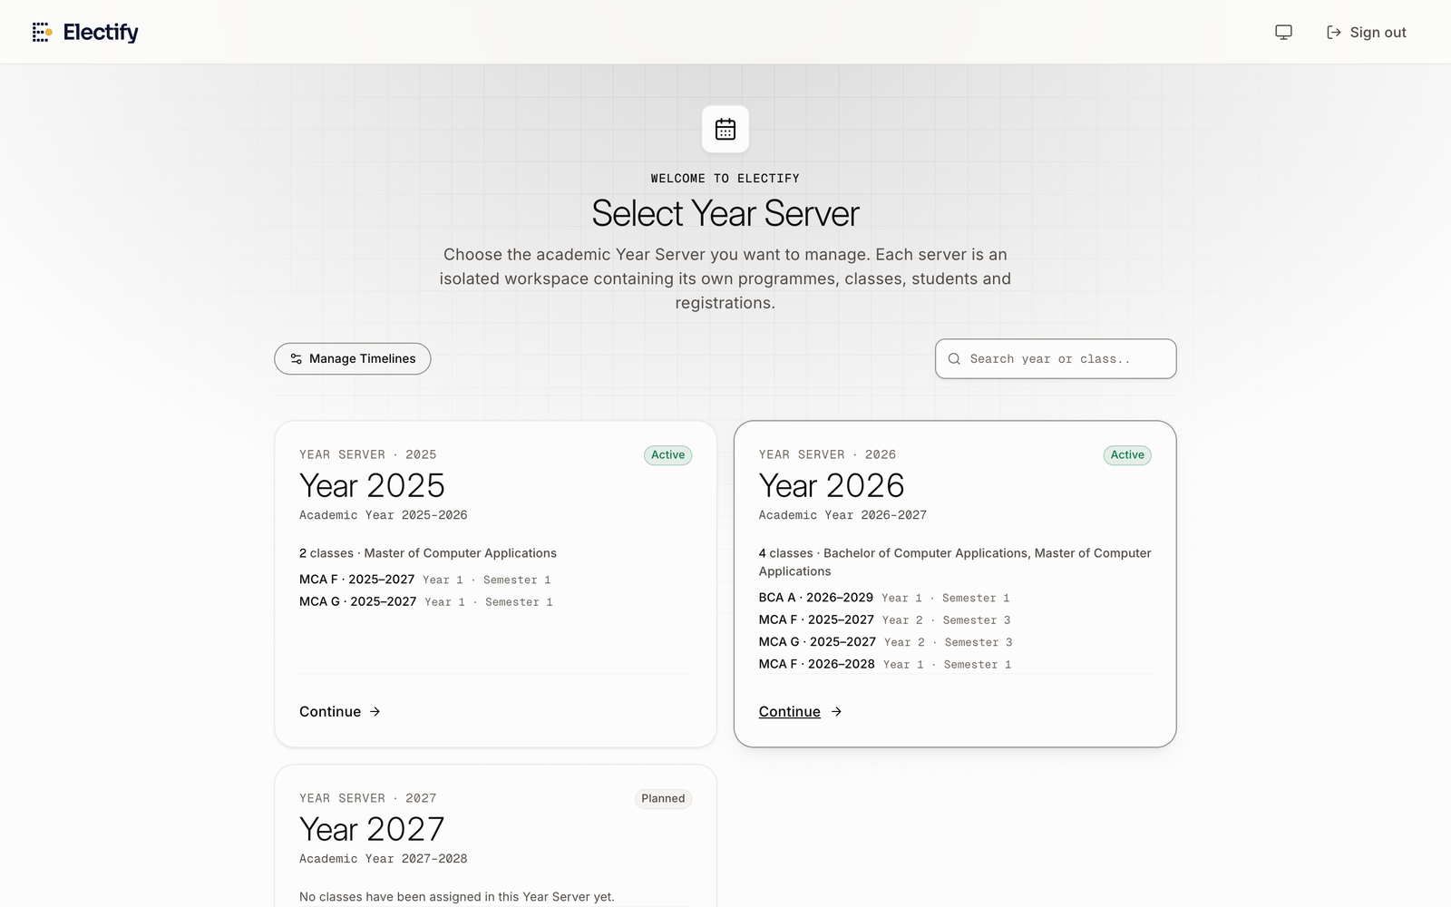
Figure 5.1 Year Server Chooser Shown After Staff Sign-in
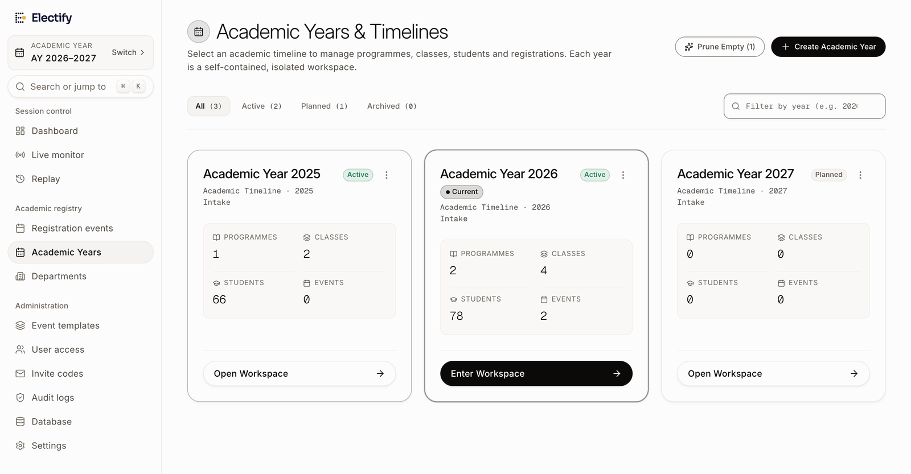
Figure 5.2 Academic Years Page, Where Administrators Manage Year Servers

5.3 Class Tutors and Student Onboarding
Staff accounts are linked to the classes they tutor through the tutor_sections table. A tutor can claim classes from any programme of their department, for example both MCA F and MSc IT F, and from different cohorts and Year Servers; the server refuses classes outside the department and stops a tutor at a limit that the administrator sets (ten classes by default). Each class keeps its own roster, so switching between classes never mixes students. A class tutor brings students into the system by generating a class signup code, for example EF-MCA-F-7K2Q. Each code names exactly one class, has an expiry date and a maximum number of uses (at most one hundred), and can be revoked at any time.
Figure 5.3 shows the onboarding flow. When a student enters a code on the Join page, the server checks it and, if it is valid, shows the class, programme, department and tutor it belongs to (Figure 5.4). The student then supplies an e-mail address, register number, name and password. The account is created in a single transaction that first claims one use of the code with a conditional update — succeeding only while the code is active, unexpired and below its limit — and then inserts the user with the class and cohort taken from the code. This guarantees that two students signing up at the same moment cannot exceed the limit, and that a student can never choose their own class. If an account with the same register number or e-mail address already exists, the signup is refused, so a code cannot be used to move an existing student to another class.
Students who forget their password request a reset with their register number. The request appears in the class tutor's queue; the tutor verifies the student and authorises the reset, which produces a one-time code valid for twenty-four hours. The student enters this code with a new password. Responses to reset requests are the same whether or not the register number exists, to avoid revealing which accounts are registered, and repeated wrong codes lock the reset form in the same way as failed sign-ins.
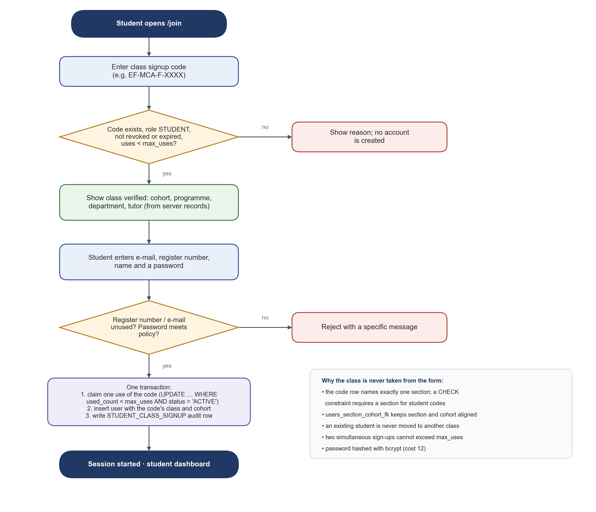
Figure 5.3 Student Onboarding with a Class Signup Code
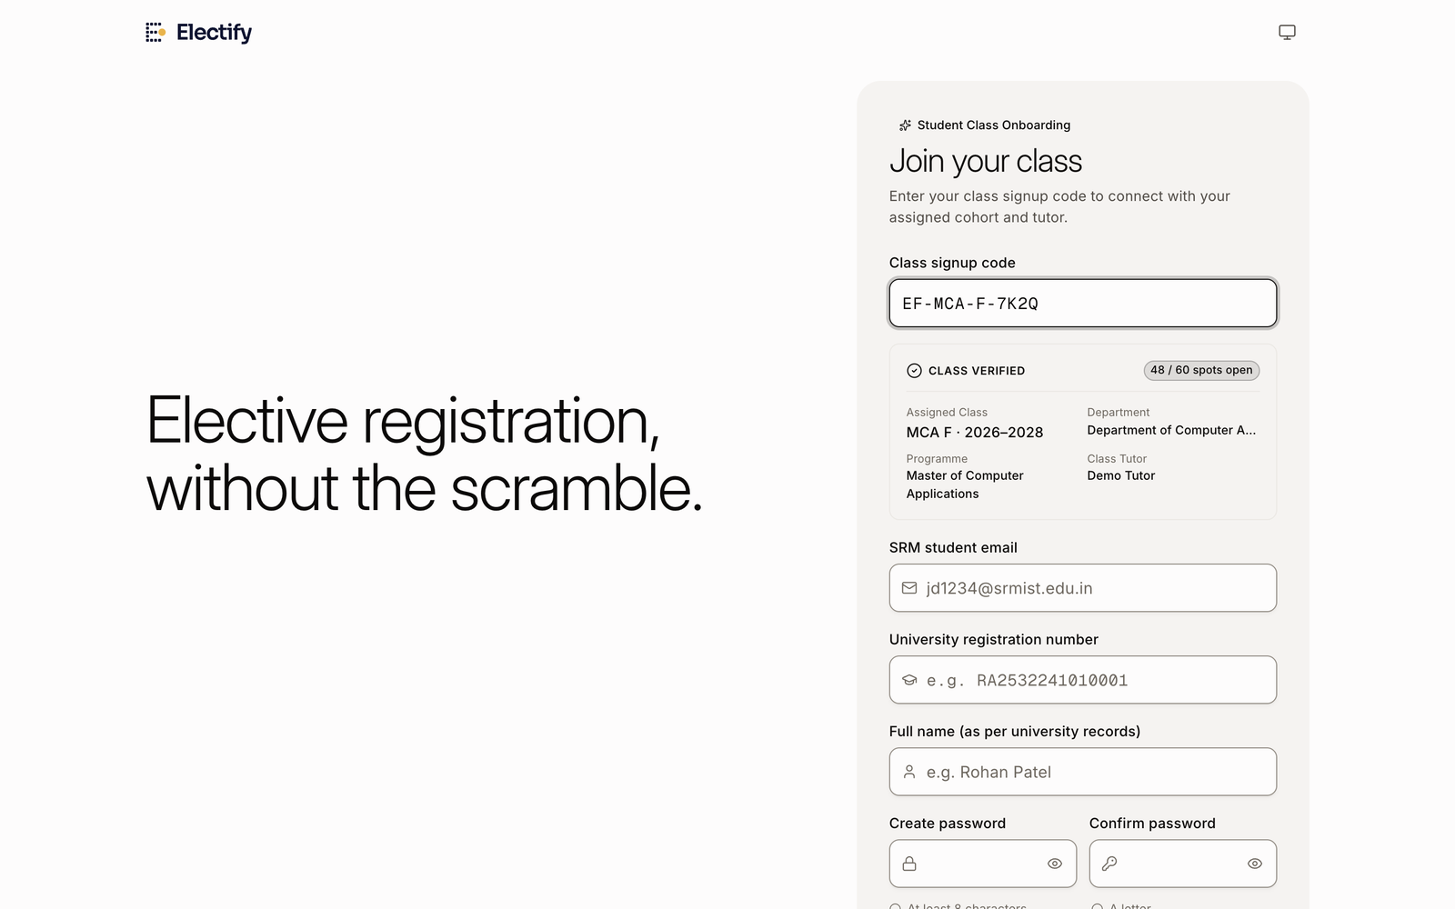
Figure 5.4 Join Page After a Valid Class Signup Code Is Entered

5.4 Registration Events and Their Lifecycle
A registration event represents one registration exercise for one cohort in one Year Server, such as the Semester 3 elective registration for the 2025 MCA cohort. It records the semester, the opening and closing times, whether students may change their choices after confirming, and whether the window should close automatically at the closing time. By default an event is created for a single class; it can be opened to several classes of the same cohort, but never to classes of another cohort.
The status of an event and the registration window derived from it are shown in Figure 5.5 and Table 5.1. A coordinator moves an event from DRAFT to PUBLISHED. A published event is visible to its students; whether they may register is then decided by the window rule in registration-window.ts: the window is upcoming before the opening time, open from the opening time until the closing time, and closed afterwards if automatic closing is enabled. Staff can also open, pause, resume or close a window manually from the live window or the monitor. Both pages decide which controls to show from the same window rule the server applies to students, so a published event whose opening time has passed is shown as open and can be paused. The statuses VERIFICATION and FINALIZED are recognised by the rule as closed states, but no action in the current version sets them.
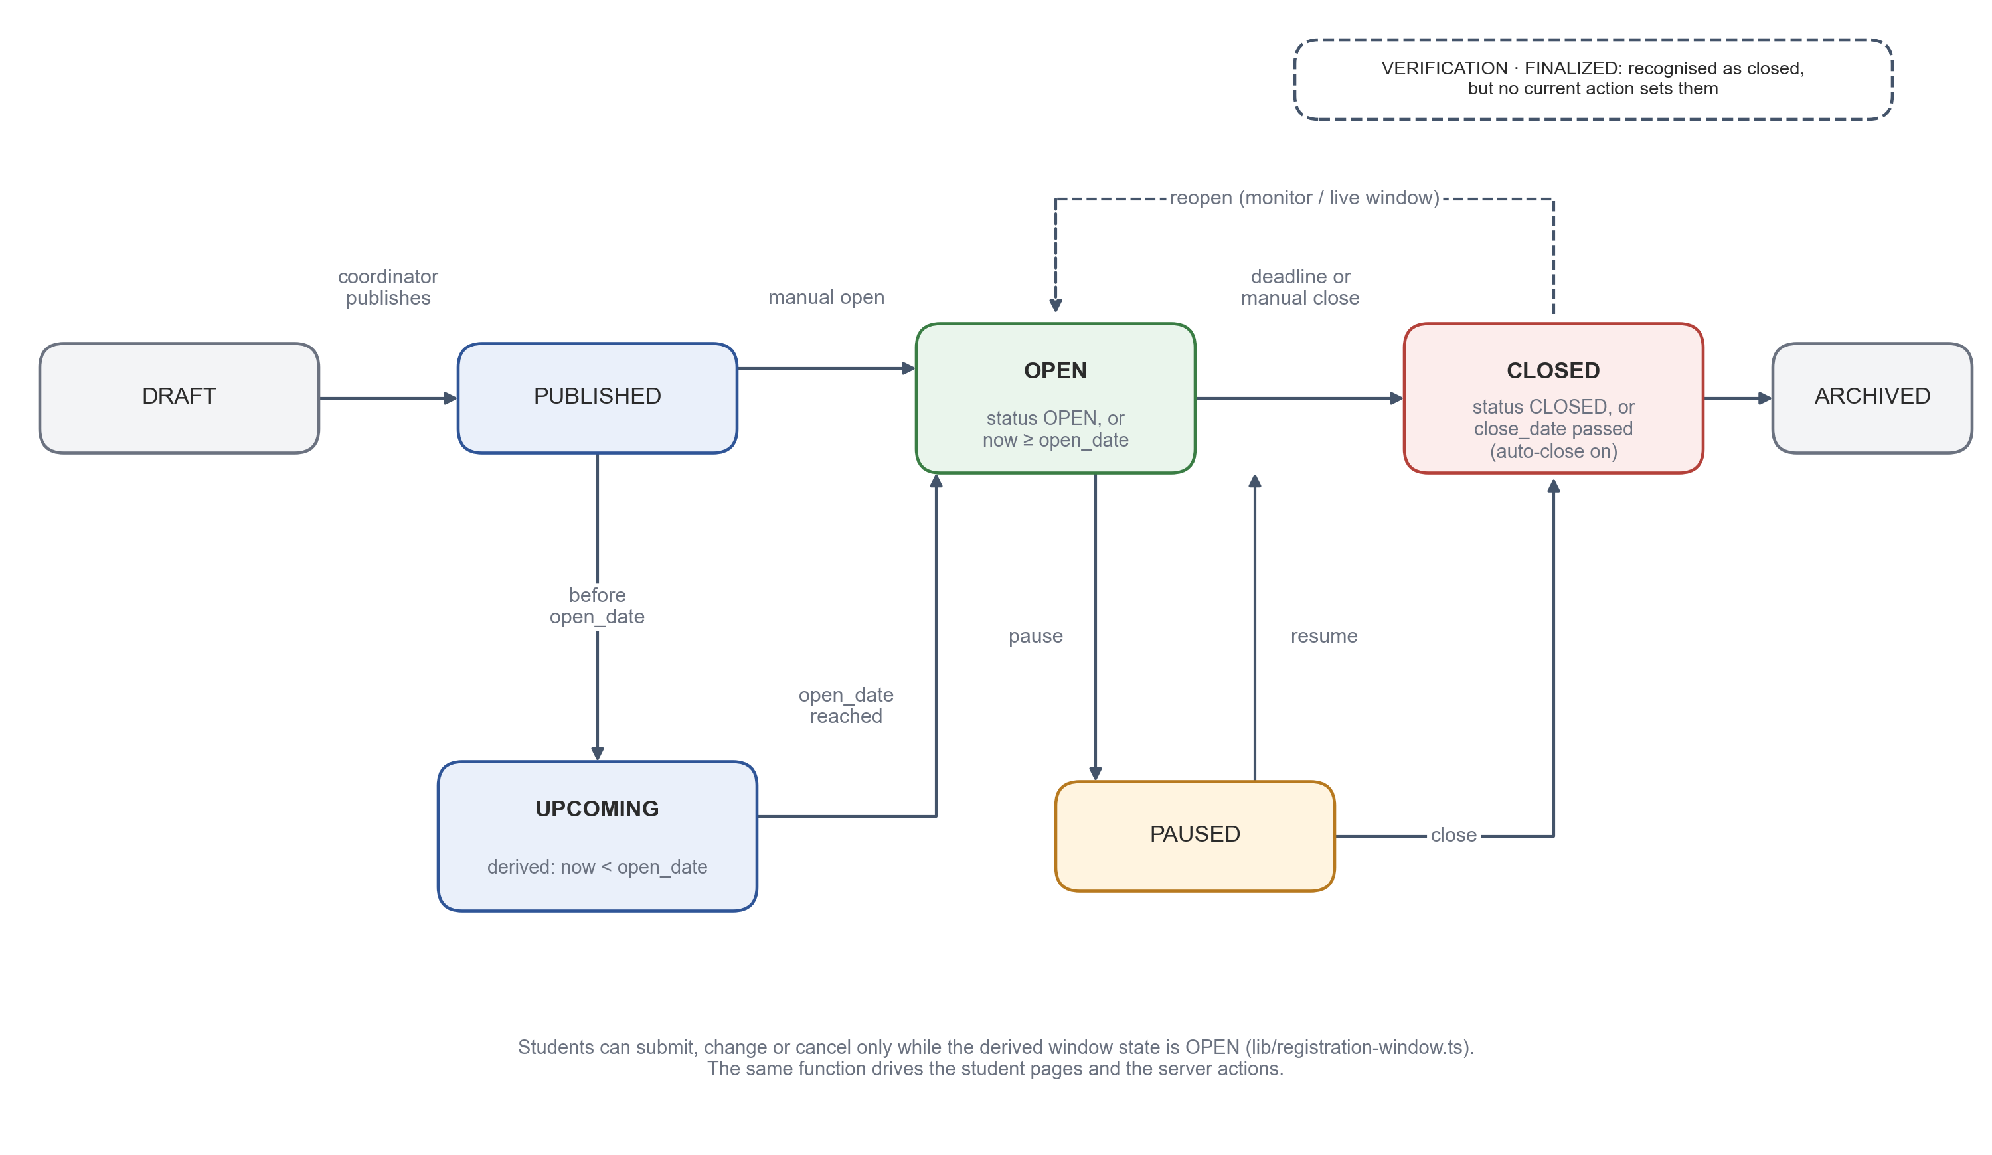
Figure 5.5 Registration Event Status and Window Lifecycle
Table 5.1 Event Statuses and Window States
Status / state | Meaning | Set by
DRAFT | Being prepared; not visible to students. | Created by staff
PUBLISHED | Visible to students; window state follows the opening and closing times. | Coordinator
UPCOMING (derived) | Published, before the opening time; students can browse subjects but not submit. | Window rule
OPEN | Students may submit, change and cancel; set manually or reached at the opening time. | Tutor / monitor or window rule
PAUSED | Temporarily closed for submissions; confirmed registrations are kept. | Tutor / monitor
CLOSED | No further changes; reached manually or after the closing time with automatic closing. | Staff or window rule
ARCHIVED | Retained for records; not active. | Coordinator
VERIFICATION, FINALIZED | Recognised as closed by the window rule; not set by any current action. | —

5.5 Elective Groups, Subjects and Seat Capacity
Within an event, subjects are arranged in elective groups, also called baskets, such as Professional Elective I and Open Elective I. Each group defines how many subjects a student must choose; the current registration logic accepts one choice per group. Each subject has a name, an optional course code, credits, a description, a maximum number of seats and a count of seats still available. Subjects are created per event, so the same subject offered to two cohorts in two events has two independent seat counters.
A coordinator can reserve part of a subject's capacity for particular classes by defining class quotas. For example, a subject with sixteen seats may reserve eight seats for class F and eight for class G. A student of a class with a quota draws from that quota; a student of a class without a quota may only use seats that are not reserved for other classes. Figure 5.6 shows the coordinator's Electives and Seats page, which lists each basket with its subjects, seats taken, and class allotments.
Events can also be created from event templates. A template stores a set of baskets and subjects that can be reused, for example when the same elective structure is offered to a new cohort. Templates are scoped to a programme; a template can be deleted only by an administrator, by a coordinator of that programme, or by the coordinator who created it.
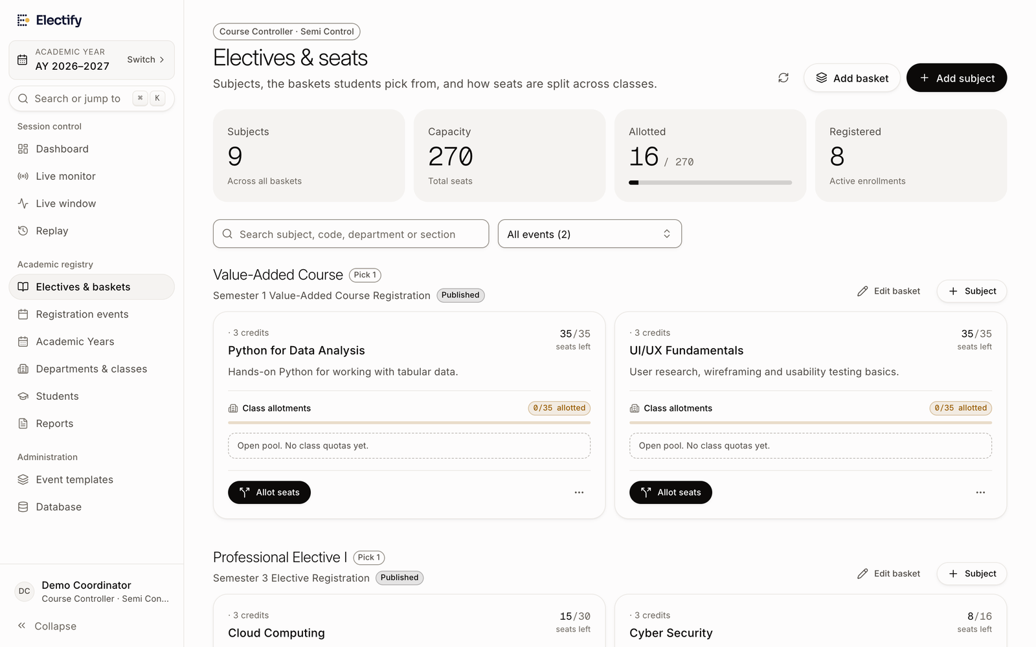
Figure 5.6 Coordinator View of Elective Baskets, Subjects and Seat Allotments

5.6 Subject Explorer
Students often choose electives with little information beyond a subject name. The subject explorer addresses this by listing every subject offered to the student's class, with its basket, credits, remaining seats and a short description (Figure 5.7). The page is available as soon as the event is published, so students can read about the subjects before the window opens. Seat counts refresh every thirty seconds and, when realtime updates are available, immediately after a change. Opening a subject page never reserves a seat.
Selecting a subject opens a detail page (Figure 5.8). Official facts — name, credits, basket, programme, department and seats — always come from the event data. Supplementary guidance, such as an overview, example topics, learning outcomes, prerequisites, an estimate of difficulty, career relevance and external learning resources, comes from a subject profile. Each section of a profile carries a label indicating whether it is official or proposed guidance, and the page states that the faculty-approved syllabus takes precedence. In the current version one bundled profile, for Cloud Computing, is included; its content is explicitly marked as not verified by faculty.
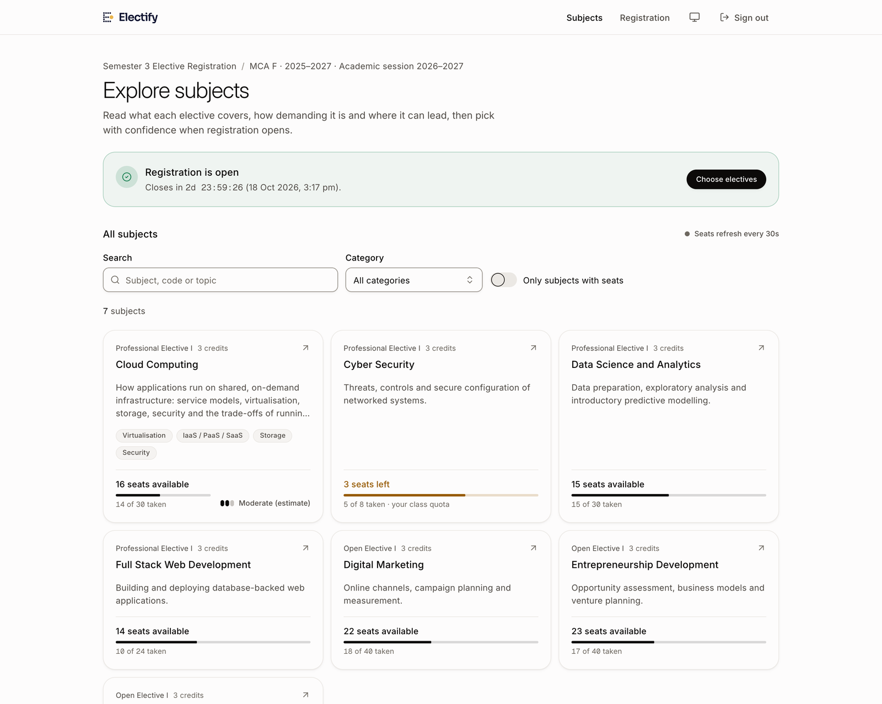
Figure 5.7 Subject Explorer Listing the Subjects Offered to a Class
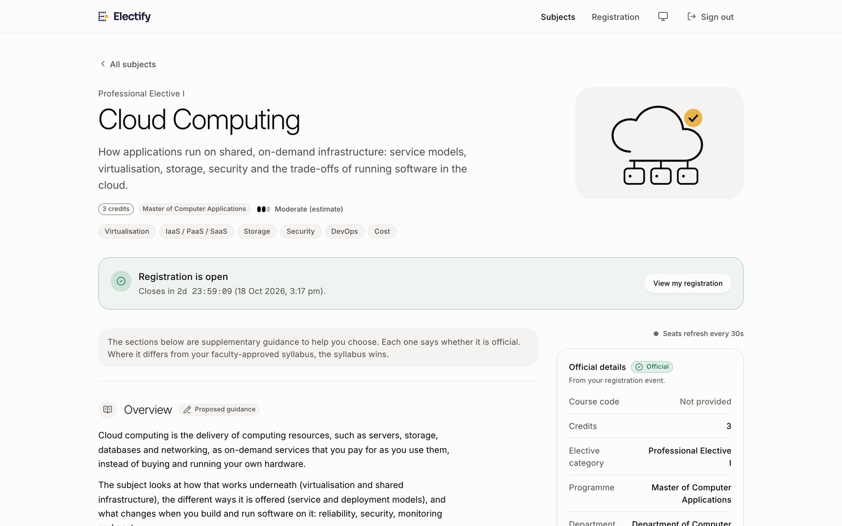
Figure 5.8 Subject Detail Page with Official Details and Labelled Guidance

5.7 Summary
Setting up a registration in Electify therefore involves a small number of well-defined steps: the administrator prepares the Year Server and links the cohorts, tutors bring students into their classes with signup codes, and coordinators or tutors prepare the event, baskets, subjects and quotas. Because every object is attached to a class, a cohort and a Year Server, the data of different batches stays separate throughout the process. The next chapter describes what happens when students register.

6. REGISTRATION PROCESSING AND DATA INTEGRITY
This chapter explains how a registration is processed, how seats are accounted for, and how the system keeps its data consistent when many students act at once. The behaviour described here is implemented in src/app/actions/register.ts, src/lib/seat-ops.ts, src/lib/registration-window.ts and src/lib/student-events.ts.

6.1 Eligibility of a Student for an Event
Before a student can see or act on an event, the system decides whether the event is meant for that student. The decision is made by a single query in isStudentEligibleForEvent, which succeeds only if all the conditions in Table 6.1 hold. The same query is used to build the student's list of events and, inside the registration transaction, to re-check eligibility on the same database snapshot as the write. An identifier supplied in a request — for example an event or subject belonging to another cohort — therefore cannot be used to register outside the student's own class.
Table 6.1 Conditions for a Student to Be Eligible for an Event
Condition | How it is checked
The user is a student | The account's role is STUDENT.
The student's class belongs to the student's cohort | The section joined to the user must have the same cohort as the user record.
The event targets the student's class | A row must exist in event_sections for the event and the student's section.
The event belongs to the student's cohort | The event's cohort must equal the student's cohort.
The account is active and eligible | Checked by the registration actions before the transaction starts.

6.2 The Registration Window Rule
Whether students may submit, change or cancel is decided by getRegistrationWindow, a pure function of the event's status, opening time, closing time and automatic-closing flag, evaluated against the server's clock at the moment of the request. A paused event is closed; an event in a closed status is closed; otherwise the window opens at the opening time (or immediately if a member of staff has opened it manually) and closes after the closing time if automatic closing is enabled.
The student pages use the same function to decide what to display, and the countdown shown to students is synchronised with the server's clock. These displays are conveniences only: every Server Action calls the function again with its own clock, so a request sent from a page that was left open after the deadline, or from a modified browser, is rejected. The tests confirm that registration opens exactly at the opening time and not a millisecond earlier.

6.3 The Registration Transaction
Figure 6.1 shows the steps of registerElectives. Inexpensive checks are made first, without taking any locks: the caller must be a student, maintenance mode must be off, the account must be active and eligible, the event must target the student's class and cohort, the window must be open, and the selections must contain at most one subject per group, each belonging to the event. If any check fails, the action returns a specific error code and nothing is written.
The remaining work is done inside one database transaction. The student's registration row for the event is locked with SELECT … FOR UPDATE, and the request is rejected if the student has already confirmed a registration. Eligibility is checked again on the transaction's snapshot. The chosen subjects are then locked, always in ascending order of their identifiers; taking locks in a fixed order means that two transactions that need the same subjects cannot each hold one and wait for the other, which would cause a deadlock. For each choice a seat is taken, the choice is written to student_registrations, and a replay event recording the seat count before and after is inserted. Finally the receipt is created and an audit record is written. If any step fails — for example because a seat ran out — the whole transaction is rolled back, and no seat, choice, receipt or log entry from the attempt remains.
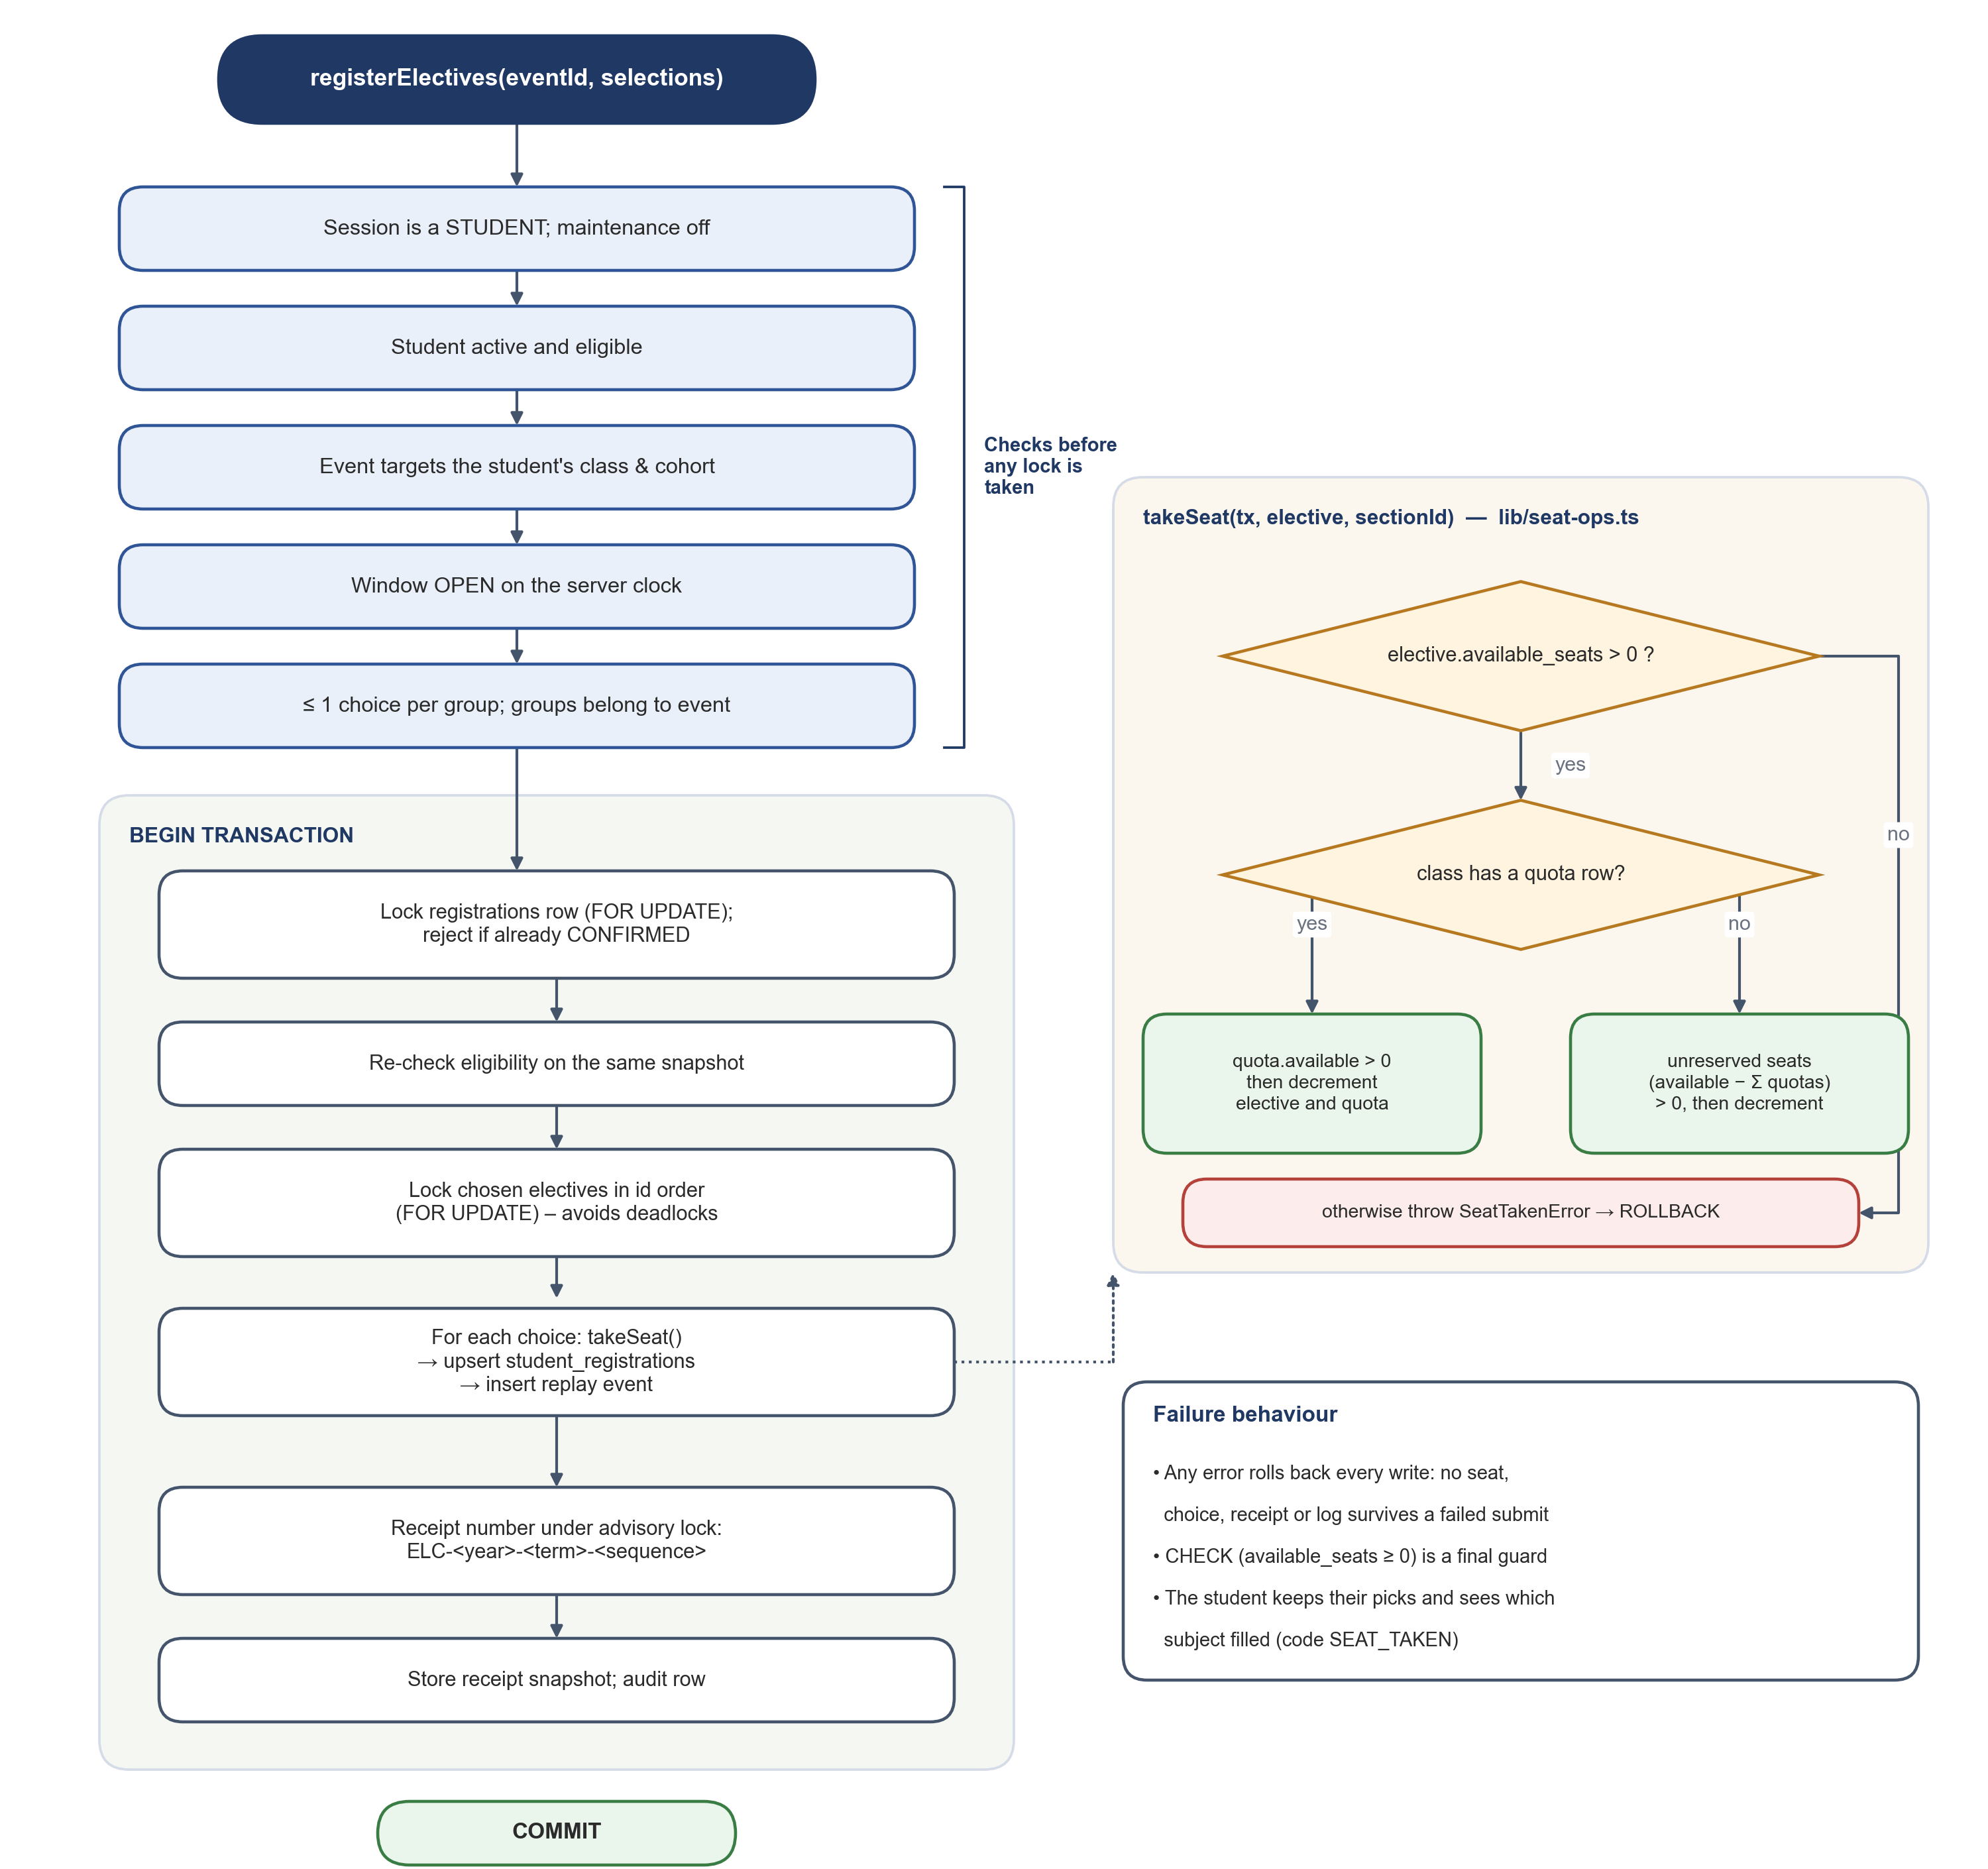
Figure 6.1 Steps of the Registration Transaction and the takeSeat Rule
From the student's point of view the process is short. The picker shows each basket with its subjects and remaining seats, and a progress indicator shows which baskets still need a choice (Figure 6.2). When every basket has a choice, the student reviews the selection in a confirmation dialog that lists the subjects and total credits (Figure 6.3). If a chosen subject fills while the dialog is open, the server returns the code SEAT_TAKEN with the identifier of the subject, and the picker highlights that subject while keeping the student's other choices.
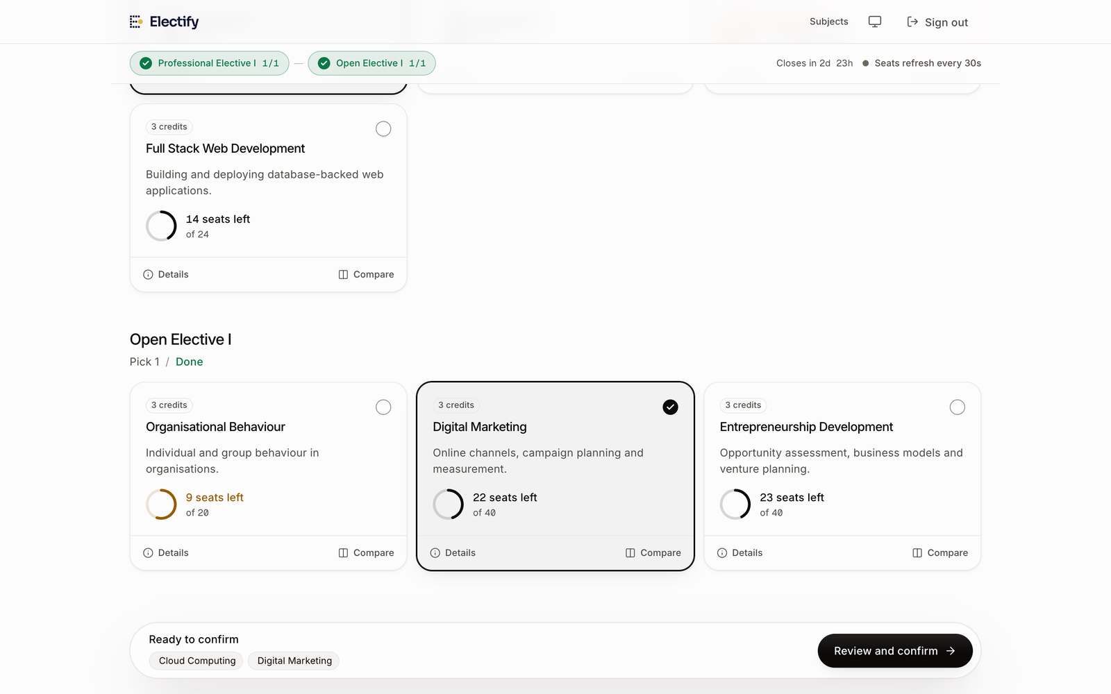
Figure 6.2 Elective Picker with One Subject Selected in Each Basket
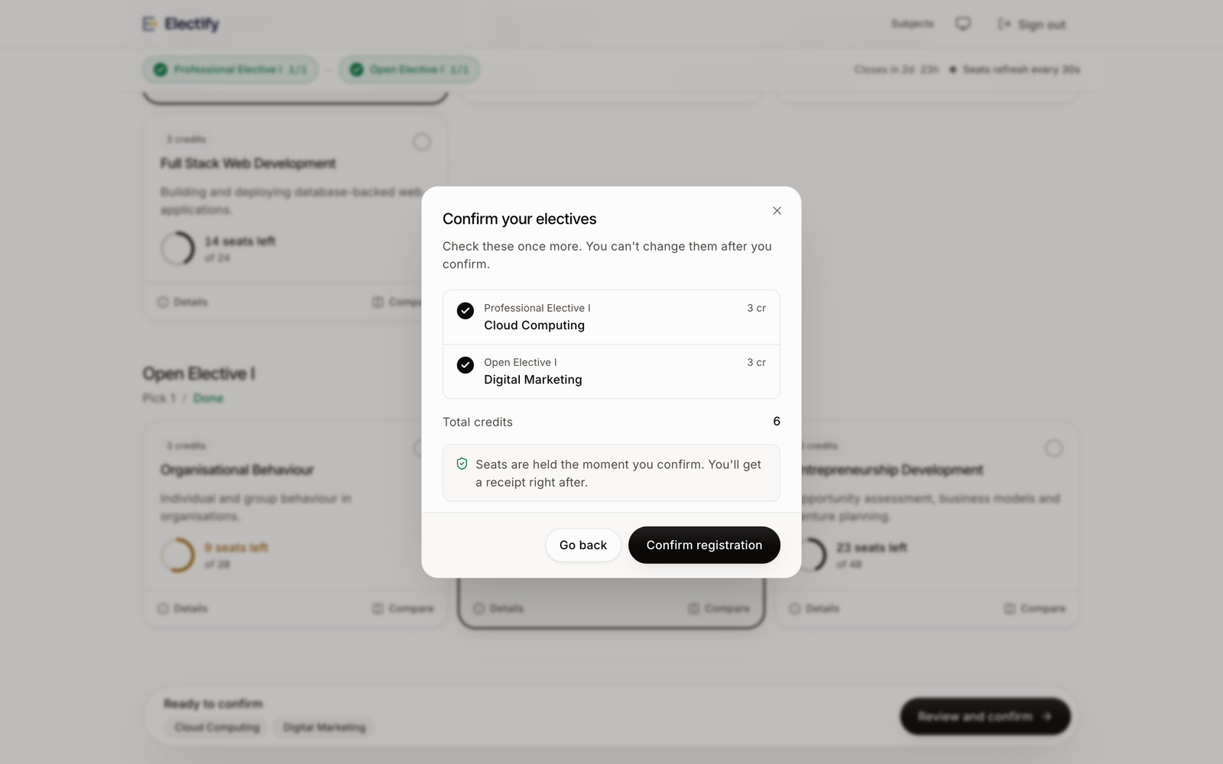
Figure 6.3 Confirmation Dialog Shown Before a Registration Is Submitted

6.4 Seat Accounting and Class Quotas
Seats are taken and returned only through two functions in seat-ops.ts, takeSeat and releaseSeat, which must be called inside a transaction that already holds the lock on the subject row. takeSeat first checks that the subject has a seat. It then locks any class quota rows for the subject. If the student's class has a quota, the quota must also have a seat, and both the subject counter and the quota counter are decremented. If the student's class has no quota but other classes do, the student may only use seats that are not still reserved: the seats available on the subject minus the seats still available in all quotas must be positive. The decrement is written as an SQL expression on the locked row, and the subject is marked full when its count reaches zero.
releaseSeat increments the subject counter and, if the student's class has a quota, the quota counter, using LEAST(available + 1, maximum) so that a counter can never rise above its capacity even if a release were attempted twice. Because both functions run under row locks, the remaining-seat count read by a transaction cannot change before the transaction commits, which rules out the lost-update anomaly described in Section 2.2.
As a final safeguard, the database itself rejects any update that would make a seat counter negative, through check constraints on both electives and elective_seat_allocations. In correct operation these constraints are never triggered, but they ensure that a defect in application code could not silently overbook a subject.

6.5 Changing and Cancelling a Registration
While the window is open, a student can change a choice to another subject in the same basket, cancel a single choice, or cancel the whole registration; changes are allowed only if the event permits editing. Figure 6.4 summarises the two flows. A change locks the current choice and both subjects, takes a seat in the new subject first and releases the old seat only after that has succeeded. If the new subject is full, the transaction is rolled back and the student keeps the original seat; the student is never left without a seat because of a failed change.
A cancellation releases the seat and marks the choice as CANCELLED rather than deleting it, so the history remains available. If no active choices remain, the parent registration also becomes CANCELLED, and the receipt snapshot marks the cancelled line. Because the action first checks that the choice is not already cancelled, repeating a cancellation request does not return the seat twice. Every change and cancellation writes replay and audit records in the same transaction.
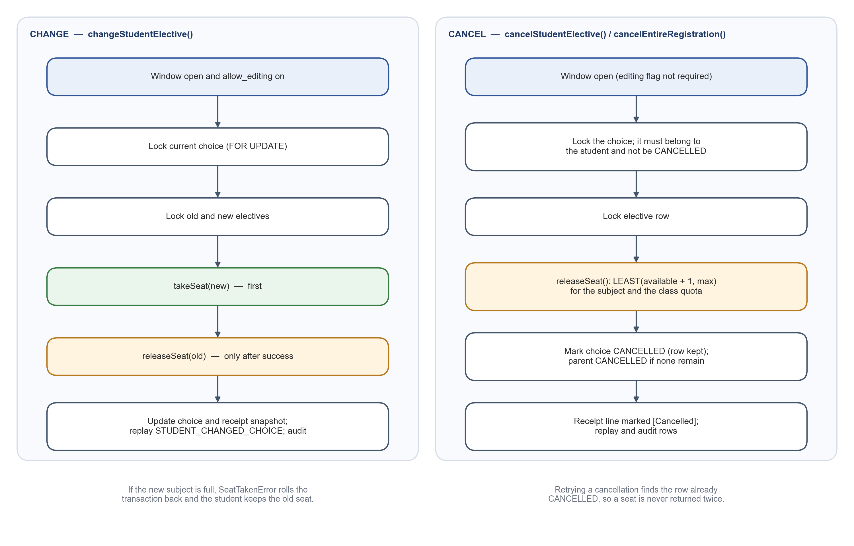
Figure 6.4 Seat Handling When a Choice Is Changed or Cancelled

6.6 Receipts
Every confirmed registration receives a receipt number of the form ELC-<year>-<term>-<sequence>, where the term is ODD or EVEN according to the event's semester; a Semester 3 registration in 2026 is numbered like ELC-2026-ODD-000048. The sequence is computed from the highest existing number while holding a PostgreSQL advisory lock, so two confirmations committed at the same moment cannot receive the same number; a unique constraint on the receipt number provides a further guarantee. The receipt is also stored as a JSON snapshot containing the student's details, the full class, cohort, Year Server and semester, and the confirmed subjects. Because it is a snapshot, the receipt continues to show what was confirmed even if the student's records or the subject names change later.
Students see their registration record and receipt immediately after confirming (Figure 6.5) and can download it as a PDF, which is generated in the browser with jsPDF, or print it. An earlier version took the term from the event's name, so the Semester 3 event in the demonstration data received an EVEN number; the term now comes from the semester stored on the event, and the name is used only for older events created without one (defect D3 in Chapter 8).
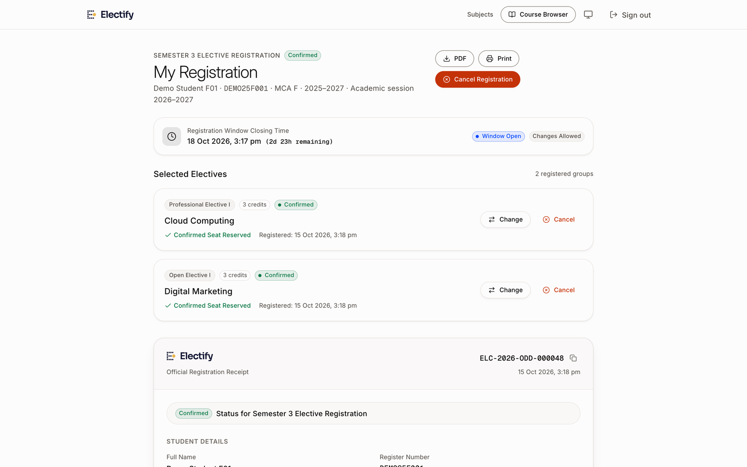
Figure 6.5 Registration Record and Receipt Shown After a Successful Submission

6.7 Database Constraints as a Safety Net
Application checks are complemented by constraints in the database, so that the most important rules hold even if a future change to the code is incorrect. The principal constraints are listed in Table 6.2.
Table 6.2 Principal Integrity Constraints
Constraint | Table | Rule enforced
electives_available_seats_nonnegative | electives | Remaining seats can never be negative.
allocations_available_seats_nonnegative | elective_seat_allocations | A class quota can never be overdrawn.
student_registrations_unique | student_registrations | One choice per student, event and group.
student_event_registration_unique | registrations | One registration record per student and event.
receipt_number (unique) | registrations | No two registrations share a receipt number.
event_sections_*_cohort_fk | event_sections | A targeted class must belong to the event's cohort.
users_section_cohort_fk | users | A student's class must belong to the student's cohort.
invite_codes_student_section_check / _cohort_fk | invite_codes | A student signup code must name one class inside its cohort.
academic_sessions_years_check | academic_sessions | An academic year spans exactly one year (end = start + 1).
cohort_session_terms checks | cohort_session_terms | Study year 1–6 and semester 1–12 when set.

6.8 Audit Trail and Registration Replay
Two complementary logs are kept. The audit log records administrative and security-relevant actions, such as sign-ins, account creation, signup-code use, password-reset approvals, event status changes and registrations, with the user, role and a structured description of the change (Figure 6.7). Authorisation codes themselves are never written to the log. The replay log records registration activity for each event — registrations, changes, cancellations and resets — together with the seat count before and after each step.
The replay log supports the Registration Replay page (Figure 6.6), which lets staff step through the order in which students registered, distinguish student submissions from manual entries made by tutors, and export the activity. This makes it possible to answer questions such as who took the last seat in a subject and when, which is difficult to establish with form-based processes. The audit log also records the address a sign-in came from, taken from the proxy headers of the request. It is kept for information only: access decisions never depend on it, because such headers can be forged unless a trusted proxy sets them.
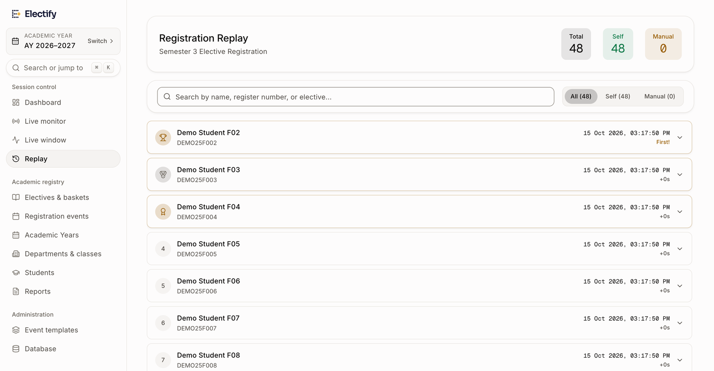
Figure 6.6 Registration Replay for an Event
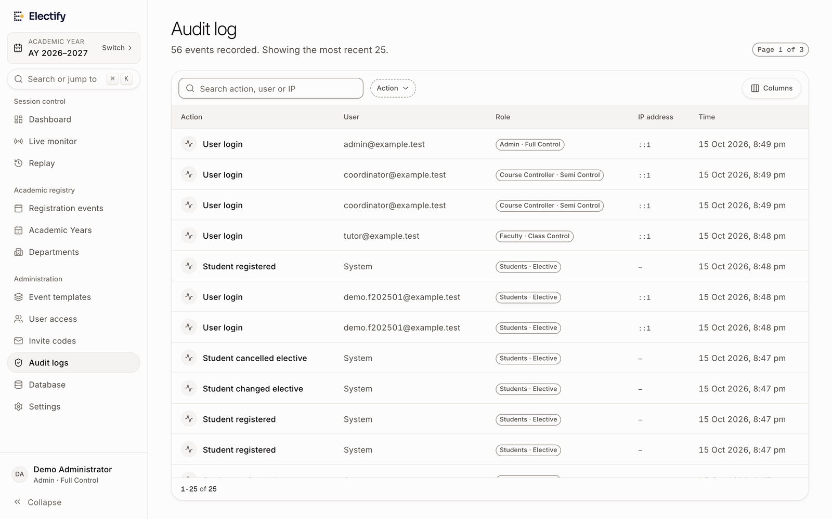
Figure 6.7 Audit Log Viewed by an Administrator

7. SYSTEM IMPLEMENTATION

7.1 Development Environment
The system was developed and tested in the environment summarised in Table 7.1.
Table 7.1 Development and Test Environment
Item | Details
Operating system | macOS 26.6 (Apple silicon)
Runtime | Node.js 24.16.0
Databases (tests and screenshots) | PostgreSQL 18.4 on the local machine: separate throwaway databases for the server-side tests, the browser tests and the demonstration data
Database (development) | A hosted Supabase PostgreSQL project used by the team as its development database
Package manager and tools | npm, tsx, drizzle-kit, ESLint, TypeScript compiler
Browser automation | Playwright 1.64 driving Google Chrome, used for the end-to-end tests and to capture the screenshots in this report [26]
Version control | Git; the results in this report refer to commit bfd9bd8

7.2 Project Structure
The repository follows the conventions of the Next.js App Router. The principal directories are described in Table 7.2.
Table 7.2 Project Directory Structure
Path | Contents
src/app/login, src/app/join | Sign-in page and the class signup (join) page.
src/app/dashboard | Student pages: event overview, subject explorer, elective picker, registration record and receipt.
src/app/faculty/(authenticated) | Staff pages: dashboards, Year Servers, class roster, live window, monitor, events, electives, reports, replay, audit, users and settings.
src/app/actions | Server Actions grouped by area (Table 4.3).
src/app/api | Route handlers: health check and class switching.
src/lib | Domain modules (authentication, workspace, eligibility, window rule, seat operations, password policy) and the database client and schema in src/lib/db.
src/hooks, src/types | Shared React hooks (for example the server-clock hook used by countdowns) and shared TypeScript types for sessions, registrations and API responses.
src/components | Reusable interface components: layout shell, subject explorer, tutor tools, form controls and data tables.
src/proxy.ts | Edge function that verifies the session cookie and guards routes by role.
drizzle | Generated and hand-written SQL migrations, with rollback scripts in drizzle/rollback.
scripts | Maintenance scripts: applying SQL migrations, seeding subject profiles, data clean-up.
tests | Server-side tests and their fixture helper tests/helpers/world.ts; browser tests, synthetic fixtures and helpers in tests/e2e (configured in playwright.config.ts).

7.3 Database Schema and Migrations
The schema is declared in TypeScript with Drizzle in src/lib/db/schema.ts, from which drizzle-kit can create or synchronise tables. Changes that alter existing data are written as reviewed SQL files and applied with a small script, scripts/db/apply-sql.ts, which runs each file inside a single transaction so that a failure leaves the database unchanged. Each data-changing migration has a matching rollback script. Table 7.3 lists the migrations.
Migrations that rewrite data are written to be safe to run more than once, and they archive any row they change before changing it. For example, migration 0004, which retired an earlier waitlist feature, copies every affected row into an archive table as JSON, converts waitlisted choices — which never held a seat — into cancelled choices, and only then drops the waitlist columns. Migration 0006 introduced academic sessions and cohort targeting; where it could not map existing data with confidence, it left the data unchanged and recorded it for review by an administrator rather than guessing. Drizzle-kit's own migration runner is not used for existing databases: its journal records only the first three generated files (0000–0002), and on a database whose tables were created from the schema it stops with an error. Databases are therefore created from the schema with db:push and updated with the reviewed SQL files.
Table 7.3 Database Migrations
File | Change | Rollback
0000–0002 (generated) | Initial schema and early additions generated by drizzle-kit. | —
0003_careful_cancellation.sql | Adds a status to each per-group choice so cancelled choices are kept rather than deleted. | —
0004_remove_waitlist.sql | Retires the waitlist: archives affected rows, converts waitlisted choices to cancelled, drops waitlist columns. | Yes
0005_subject_profiles.sql | Adds subject profiles for the subject explorer. | Yes
0006_academic_sessions.sql | Adds academic sessions (Year Servers), cohort terms, cohort dates, event targeting and composite foreign keys. | Yes

7.4 Authentication Implementation
Sign-in, signup and password management are implemented in src/app/actions/auth.ts, using src/lib/auth.ts for tokens and sessions. Table 7.4 lists the principal parameters. Student accounts that were created before the move from six-digit PINs to passwords, or that were created by a tutor with a default password, can still prove their old credential once; they then receive a ten-minute ticket that only allows them to set a proper password. The ticket is signed with a key derived for that purpose alone and is bound to the current password hash, so it stops working as soon as the password changes and can never be used as a session token.
In production, the application refuses to sign tokens if the JWT_SECRET environment variable is missing or still set to the development fallback value. The edge proxy, however, verifies tokens with the same fallback when the variable is absent; setting a strong secret is therefore a deployment requirement, as noted in Section 7.9.
Table 7.4 Authentication Parameters
Parameter | Value
Password hashing | bcrypt, cost factor 12
Password policy | At least 8 characters, a letter and a number; not the register number or a blocked common password; at most 72 bytes
Session token | JWT, HS256, valid for 2 hours, in an HTTP-only, SameSite=Lax cookie (Secure in production)
Single active session | Random session identifier per sign-in, compared with the user record on every request
Sign-in rate limit | 5 failed attempts per identifier, then locked for 15 minutes
Password upgrade ticket | Separate signing key, 10-minute validity, bound to the current password hash
Tutor-authorised reset code | Format RST-XXXXXX from an unambiguous alphabet, valid for 24 hours, not written to logs

7.5 Student Interface
After signing in, a student is taken to the event for their class. If the event has not yet opened, the application sends the student to a countdown page that follows the server's clock and moves the student to the picker when the window opens. (An earlier version of this page failed with a server error on every load; see defect D1 in Chapter 8.) The picker is a client component that keeps the student's selections in memory, shows the remaining seats for each subject, offers a details view and a side-by-side comparison of subjects, and enables the confirmation button only when every basket has a choice. When the picker receives a realtime notification that a subject's seats have changed, it updates the counts and disables subjects that have become full. It also asks the server for fresh data every thirty seconds and whenever the tab becomes visible again, and it uses the new counts each time, so the display stays current even where realtime is not configured.
The registration record page (Figure 6.5) shows the confirmed choices with buttons to change or cancel each one while the window is open, the closing time, and the receipt with a copy button for the receipt number. Errors are shown in plain language and identify what the student can do next, for example when the student is offline or when the window has closed.

7.6 Staff Interface
Staff pages share an application shell with a collapsible sidebar, a command palette for quick navigation, and the current Year Server and class at the top. The class tutor's dashboard (Figure 7.1) summarises the current event for the active class: the number of students registered, the number of subjects and baskets, the share of seats allocated, the latest registrations and the students who have not yet registered, with a button to copy their e-mail addresses for a reminder.
The Live Window page (Figure 7.2) is where a tutor controls the registration window: it shows the time remaining, the progress of the event through its stages, the number of students registered and seats filled, a chart of the distribution of choices across subjects, and the settings for the opening and closing times and whether editing is allowed. The class page lists the students of the class with their submission status and provides the tools to add students, import a CSV file, issue signup codes and handle password resets.
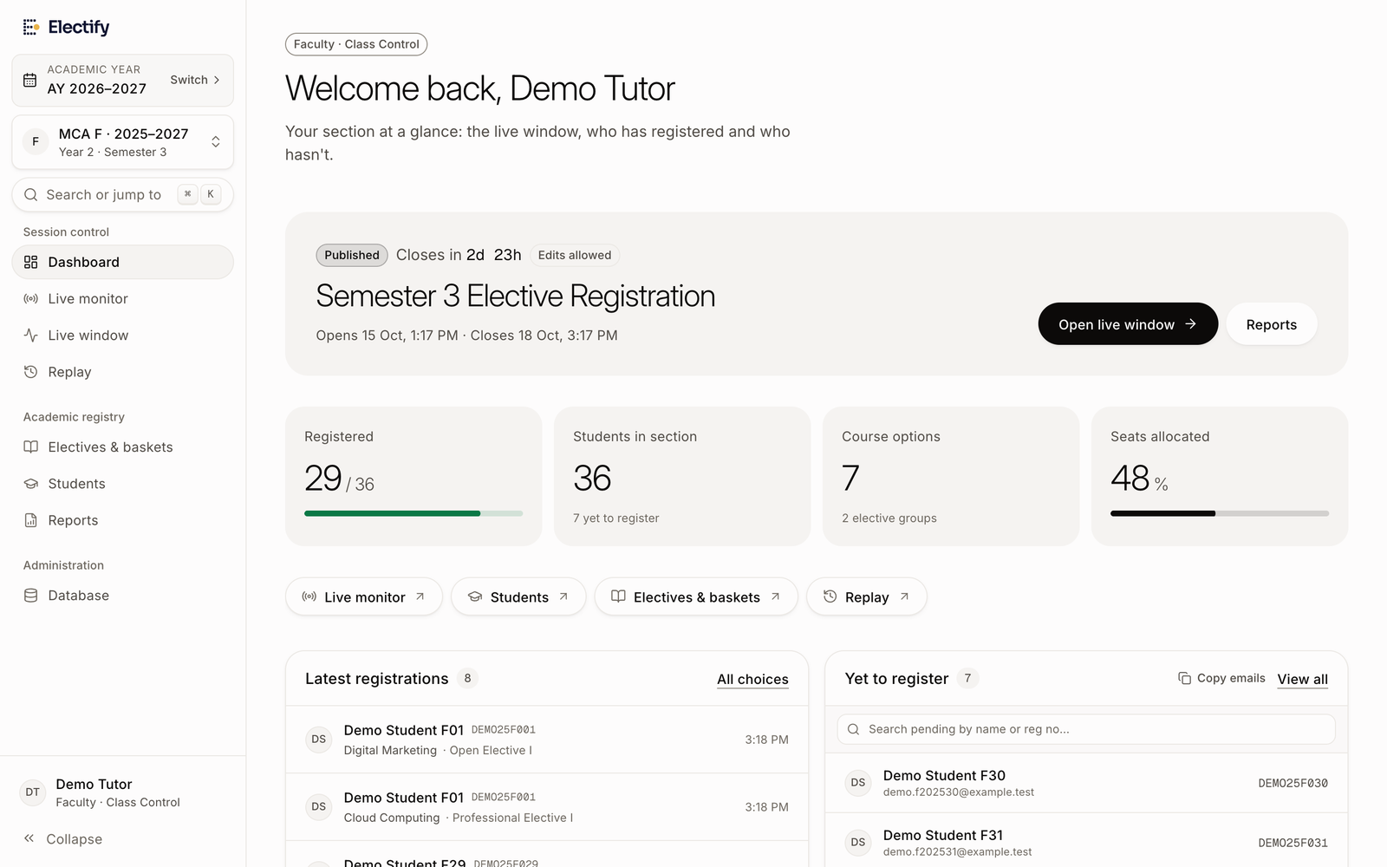
Figure 7.1 Class Tutor Dashboard for the Active Class
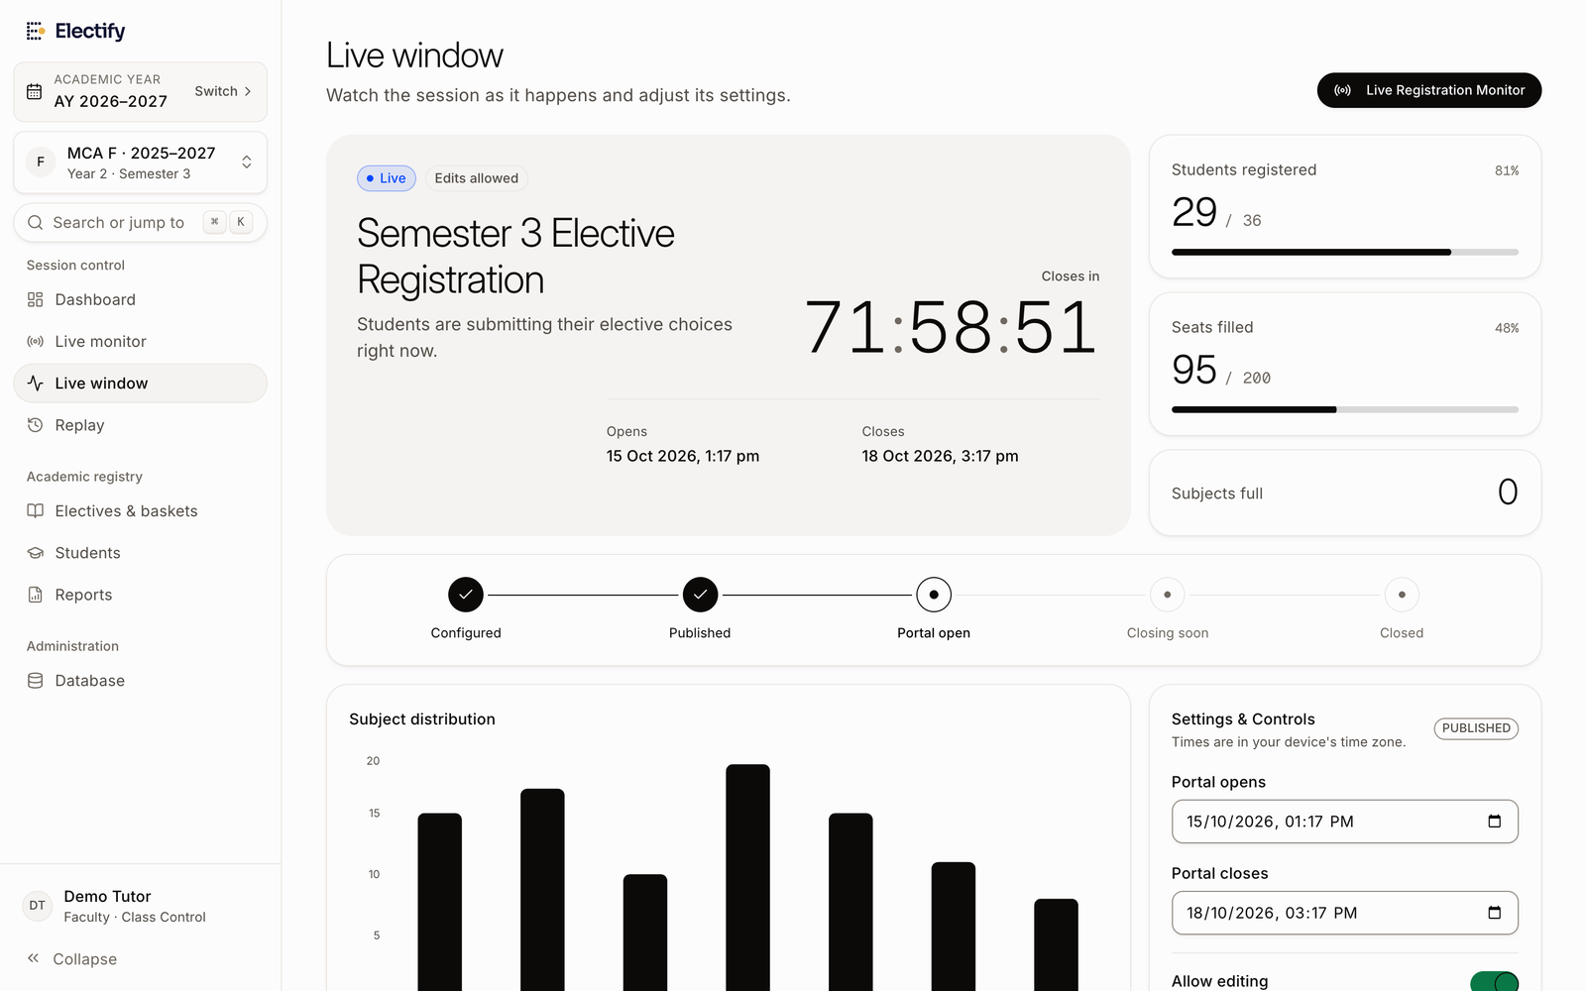
Figure 7.2 Live Window Page Used by a Class Tutor to Control Registration

7.7 Live Monitoring and Realtime Updates
The Live Registration Monitor (Figure 7.3) gives coordinators and tutors a view of an event while it is running: student turnout, submissions per minute, seat saturation, the number of full subjects, participation by class, seat saturation for each subject, and a stream of recent activity that can be filtered to confirmations, changes or cancellations. The page refreshes automatically at a selectable interval, and staff can pause, resume or close the window and export the activity stream as CSV from the same page.
Live updates use Supabase Realtime [24]. The student picker and the subject explorer subscribe to changes on the subject table, and the tutor's class page subscribes to changes in registrations; a presence channel shows which students are currently online. These subscriptions improve responsiveness, but no rule depends on them: the subject explorer also polls every thirty seconds, the monitor polls on its own interval, and every action re-checks seats on the server. Realtime is optional: when no Supabase project is configured, the application opens no channels at all and the pages show that seats refresh every thirty seconds. Realtime was not configured for the screenshots in this report, so that the isolated copy of the application would not connect to the team's hosted project.
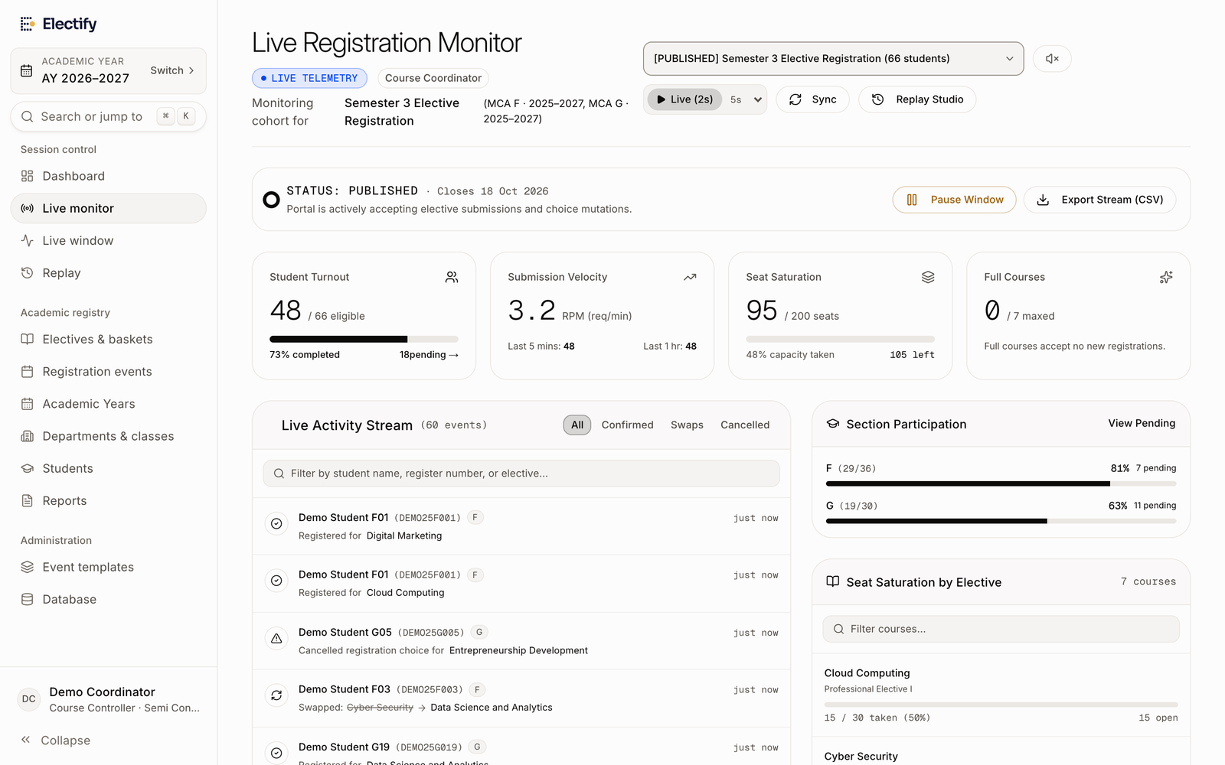
Figure 7.3 Live Registration Monitor for the Semester 3 Event

7.8 Reports and Exports
Coordinators have a programme-level Reports page (Figure 7.4) that lists, for the selected Year Server, each student with their class, allotted subjects and receipt number, with search, filters by class and event, and export to CSV and PDF. Tutors have a class report with the same information for their class, a summary of registration progress and an enrolment chart by subject. Every report carries the full class and Year Server identity, so exported files from different cohorts cannot be confused.
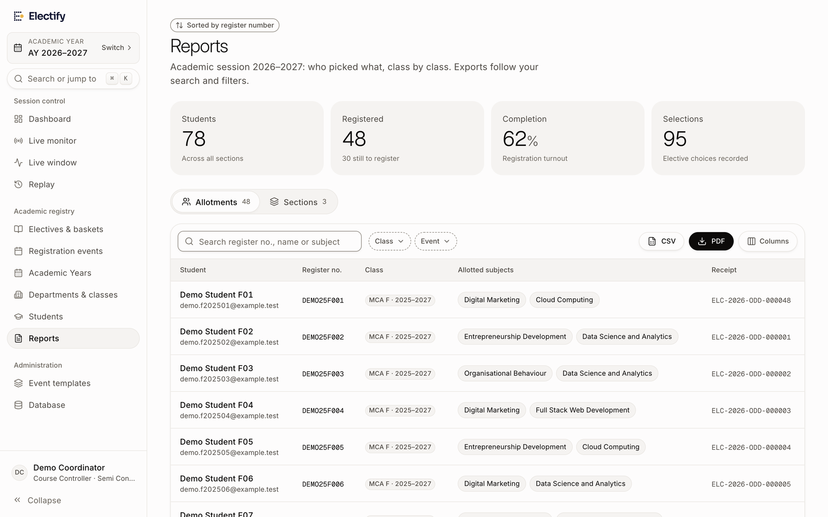
Figure 7.4 Coordinator Reports Page with Allotments by Student

7.9 Configuration and Deployment Considerations
The application is configured through environment variables, listed in Table 7.5. A health endpoint, /api/health, reports whether the database is reachable and whether the expected configuration is present; it can also create the first administrator account, which in production requires a separate setup secret and an explicitly configured initial password, so the well-known development password is never used there. Administrators can switch on maintenance mode, which shows a maintenance page and makes registration actions refuse requests.
The project includes deployment notes for hosting on a Node.js platform with a pooled PostgreSQL connection. At the time of writing the system has been run only in development environments; it has not been deployed for a live registration cycle, and the settings recommended in the deployment notes, such as connection pool sizes, have not been validated under load.
Table 7.5 Configuration Variables
Variable | Purpose
DATABASE_URL | Connection string used by the application (a pooled connection in production).
DIRECT_URL | Direct connection used by drizzle-kit for schema changes.
JWT_SECRET | Secret for signing session tokens; must be a strong random value in production.
NEXT_PUBLIC_SUPABASE_URL, NEXT_PUBLIC_SUPABASE_ANON_KEY | Supabase project used for realtime updates (optional).
SETUP_SECRET, INITIAL_ADMIN_PASSWORD | Controlled creation of the first administrator account through the health endpoint.

8. TESTING AND RESULTS

8.1 Testing Methodology
Electify was tested at three levels. Server-side tests call the application's Server Actions and domain functions directly and then inspect the database. Browser tests drive the running application in Google Chrome as a student or member of staff would, and check both what the page shows and what the database contains afterwards. Static checks with the TypeScript compiler and ESLint run over the whole code base. In addition, the interface was walked through with fictional demonstration data, which is how the screenshots in this report were captured.
Both automated levels use a real PostgreSQL database rather than mocks, because the properties that matter most — row locking, constraints and transactions — exist only in a real database. Server-side tests build their own fixtures through tests/helpers/world.ts, tag every row with a unique suffix, use academic years far in the future (for example 2095–2097) so that they cannot collide with other data, and remove their rows afterwards; the migration tests run each SQL migration and its rollback inside a temporary schema. The browser tests start from a database that is dropped, recreated from the schema and filled with synthetic fixtures before every run, and a guard refuses to run them against anything other than that local database.
Concurrency is tested by starting several Server Action calls at once from the test process. Each call takes its own connection from the pool, so the transactions really do overlap inside PostgreSQL and compete for the same row locks. This exercises the locking logic, but it is not a load test: the number of simultaneous requests is small and no performance measurements are claimed.

8.2 Test Environment
The runs reported in this chapter used the environment in Table 8.1. All databases were local and separate from the team's shared development database.
Table 8.1 Test Environment for the Reported Runs
Item | Details
Date of runs | 2026-10-15 15:10:17 IST (server-side); browser suite on the same day
Code version | Git commit bfd9bd8
Runtime | Node.js 24.16.0; server-side tests with tsx and the node:test runner, run one file at a time
Browser tests | Playwright 1.64 with the locally installed Google Chrome; isolated development server on port 3210
Databases | PostgreSQL 18.4 on localhost: electify_report (server-side) and electify_e2e (browser, recreated each run)
Commands | npm test with DATABASE_URL pointing to the local database; npm run test:e2e
Exit status | server-side exit code 0; browser suite exit code 0

8.3 Server-Side Test Suites
Table 8.2 lists the eighteen server-side suites and their results. All 136 tests passed and 0 failed; none were skipped. The complete list of test names is in Appendix 11.3.
Table 8.2 Server-Side Test Suites and Results
No. | Suite | File | Tests | Passed | Failed
1 | Academic sessions and cohort-isolated registration | academic-sessions.test.ts | 15 | 15 | 0
2 | Migration 0006: academic sessions and cohort targeting | academic-sessions-migration.test.ts | 5 | 5 | 0
3 | Class-Based Student Self-Onboarding and Password Security | class-student-onboarding.test.ts | 15 | 15 | 0
4 | Event Management: Delete Event & Reset Registrations | event-delete-and-reset.test.ts | 3 | 3 | 0
5 | Live Event Registration Monitor & Surveillance Module | live-monitor.test.ts | 6 | 6 | 0
6 | Multi-Programme Class Tutor Assignments & Isolation | multi-programme-tutor.test.ts | 10 | 10 | 0
7 | Student password policy | password-policy.test.ts | 6 | 6 | 0
8 | Receipt term (QA: receipts for odd semesters were numbered EVEN) | qa-regressions.test.ts | 2 | 2 | 0
9 | Staff window phase follows the student window rule (QA: no Pause for an open published event) | qa-regressions.test.ts | 4 | 4 | 0
10 | Registration changes, cancellations and capacity (no waitlist) | registration-modifications.test.ts | 13 | 13 | 0
11 | Migration 0004: remove waitlist | remove-waitlist-migration.test.ts | 3 | 3 | 0
12 | Role-Based Unique Invite Codes | role-based-invite-codes.test.ts | 4 | 4 | 0
13 | Subject explorer and preview mode | subject-explorer.test.ts | 11 | 11 | 0
14 | Subject content validation | subject-explorer.test.ts | 3 | 3 | 0
15 | Registration window rule | subject-explorer.test.ts | 4 | 4 | 0
16 | Role-Based Event Template Deletion & Access Controls | template-role-deletion.test.ts | 8 | 8 | 0
17 | Year Server Selection Flow & Complete Workspace Isolation | year-server-selection-flow.test.ts | 15 | 15 | 0
18 | Year Servers System — Simplified Annual Workspaces | year-servers.test.ts | 9 | 9 | 0
 | Total |  | 136 | 136 | 0

8.4 Functional, Concurrency and Access-Control Test Cases
Tables 8.3 to 8.5 show representative cases from these suites. The names are those used in the code, the expected behaviour summarises what each test asserts, and the result is the one recorded in the reported run.
Table 8.3 Representative Functional Test Cases
ID | Test case | Expected behaviour | Result
TC01 | Student signup with a class code | Account created with a hashed password; class and cohort taken from the code, not from the form. | Passed
TC02 | Duplicate register number or e-mail | A second signup with the same register number or e-mail is rejected. | Passed
TC03 | Student sign-in | Students sign in with register number and password only. | Passed
TC04 | Tutor-authorised password reset | Request, tutor authorisation and new password complete in sequence. | Passed
TC05 | Browse subjects before opening | Catalogue visible before the window opens; opening a subject reserves nothing. | Passed
TC06 | Submit before opening time | The server rejects a submission made before the window opens. | Passed
TC07 | Window opening boundary | The window opens exactly at the opening time, not a millisecond earlier. | Passed
TC08 | Register for a full subject | Rejected with SEAT_TAKEN; no records are created. | Passed
TC09 | Change to a subject with seats | The seat moves to the new subject in one step. | Passed
TC10 | Change to a full subject | Change rejected; the student keeps the current seat. | Passed
TC11 | Cancel one choice | Seat released; the choice is kept with status CANCELLED. | Passed
TC12 | Change after the deadline | Modification rejected and nothing changes. | Passed
TC13 | Receipt identity | Receipts and reports carry the full class, cohort and Year Server. | Passed
TC14 | Tutor with classes in two programmes | One tutor manages MCA F and MSc IT F with separate rosters. | Passed

Table 8.4 Concurrency and Integrity Test Cases
ID | Test | Expected behaviour | Result
CI01 | Concurrent registrations for the last seat | Exactly one succeeds; the others receive SEAT_TAKEN; seats end at 0; one confirmed row. | Passed
CI02 | Concurrent changes into the last seat | Exactly one change succeeds; the others keep their original seats. | Passed
CI03 | Concurrent registration across a cohort event | Capacity is never exceeded; one confirmed choice holds the seat. | Passed
CI04 | Repeated cancellation | A retried cancellation does not release the seat twice. | Passed
CI05 | Failed multi-group registration | If one basket fails, the whole registration rolls back. | Passed
CI06 | Simultaneous confirmations | No two confirmations share a receipt number. | Passed
CI07 | Signup code activation limit | Enrolment is refused once the code's limit is reached. | Passed
CI08 | Independent seat counters | The same subject offered to two cohorts keeps separate counts. | Passed

Table 8.5 Access Control and Isolation Test Cases
ID | Test | Result
AC01 | A student cannot see or register for another cohort's event. | Passed
AC02 | Crafted requests cannot bypass class targeting or mix offerings. | Passed
AC03 | A signup code never moves an existing student to another cohort. | Passed
AC04 | Staff cannot reach classes, sessions, events, students or reports outside their scope. | Passed
AC05 | A tutor cannot claim classes outside their department. | Passed
AC06 | The administrator's limit on classes per tutor is enforced by the server. | Passed
AC07 | A tutor cannot open an unassigned class of the same department. | Passed
AC08 | A tutor cannot see, authorise or reject resets for another section. | Passed
AC09 | Repeated wrong passwords trigger a temporary lockout. | Passed
AC10 | Students and tutors cannot delete event templates. | Passed
AC11 | Unauthorised users cannot read live monitoring data. | Passed
AC13 | Unauthorised users cannot reset or delete registration events. | Passed
AC12 | Non-administrators cannot delete a Year Server. | Passed

8.5 Browser End-to-End Tests
The browser tests use Playwright [26] and live in tests/e2e. Before each run a global set-up step drops the local test database, recreates it from the schema and seeds synthetic fixtures: an administrator, a coordinator, a tutor who teaches MCA F of the 2025 and 2026 cohorts and MSc IT F, a second tutor, students in each class, an open Semester 3 event for MCA, an open event for MSc IT offering a subject with the same name, and an event that opens in the future. All accounts use the reserved domain example.test.
A shared helper records every browser console error, uncaught exception and server error during a test, and any of them fails the test. Waits are tied to visible content or to the network becoming idle rather than to fixed delays, and database queries confirm the outcome of each workflow. Table 8.6 summarises the eight test files.
Table 8.6 Browser End-to-End Test Files and Results
File | What it checks | Tests | Passed
route-reload.spec.ts | Route inventory: direct navigation and reload for every important page and role; protected routes without a session | 14 | 14
student-workflow.spec.ts | Complete student journey with database assertions after each step | 1 | 1
staff-isolation.spec.ts | Year Server and class restoration, forged class cookie, configuration change, cohort isolation, URL tampering | 4 | 4
session.spec.ts | Sign-out and Back, tampered cookie, superseded and deactivated sessions, double submission, audit address | 6 | 6
freshness.spec.ts | Picker seat counts follow new server data without a reload | 1 | 1
mobile-layout.spec.ts | 22 pages at 7 screen sizes: overflow, navigation pattern, countdown fit | 5 | 5
accessibility.spec.ts | axe-core WCAG 2.0/2.1 A and AA rules on 15 pages at desktop and phone width | 3 | 3
navigation-a11y.spec.ts | Keyboard and focus behaviour of the phone and tablet navigation | 2 | 2
Total |  | 36 | 36

The route test opens each page of the inventory by its address, waits for its main content, reloads it and checks the content again for students, tutors, coordinators and administrators; it also confirms that eight protected addresses answer an unauthenticated request with a redirect to the sign-in page rather than any content. The student workflow signs in, reloads, browses subjects, keeps its picks across a reload, registers, reloads the receipt, presses Back, changes one subject and cancels another, and after each step compares the page with the seat counters and choices stored in the database. The staff tests check that the selected Year Server and class survive reloads, that a forged class cookie is ignored, and that pausing a window persists across a reload and is seen by a student.

8.6 Responsive Layout and Accessibility
Phones are the most likely device for many students, so layout was checked at seven representative sizes from 320 × 568 to 1440 × 900 pixels. For each of 22 pages and each size, the test measures any horizontal overflow of the page and of the staff shell's scrolling area, names the elements that cause it, and checks the navigation pattern expected at that width: a bottom bar on phones, a drawer on tablets and a sidebar on wider screens. These sizes are representative browser dimensions, not a guarantee for every device.
The first audit found eleven overflow failures on five pages and two problems that the measurement could not see: countdown digits clipped by their container on phones, and page headers whose actions squeezed the title into a single-word column on tablets. Table 8.7 lists them with their corrections. After the corrections, none of the 154 measurements showed overflow.
Table 8.7 Responsive Layout Problems Found and Corrected
Page | Widths | Problem found | Correction
Subject list and detail | 320–390 | Header row 23–93 px wider than the screen | Logo mark only on phones; narrower links; icon-only sign-out
Live monitor | 320–390 | Event selector 13–83 px too wide | Full-width selector on phones
Year Servers | 320 | Cards 4 px too wide | Title row wraps; smaller padding
Join page | 320 | Decorative mark 2 px too wide | Negative margin only on wider screens
Countdown | 320–430 | Timer digits clipped | Digits scale with screen width
Pages with several actions | 640–1023 | Title squeezed into a narrow column | Shared page header stacks below 1024 px

Accessibility was checked with axe-core [27] against the WCAG 2.0 and 2.1 level A and AA rules [28] on 15 pages, each at desktop and phone width. The first run reported the three problems in Table 8.8; after the corrections it reported no violations of any severity. Keyboard and focus behaviour of the compact navigation was tested separately: the phone menu and the tablet drawer open from the keyboard, close with Escape and return focus to their button, and the bottom-bar targets are at least 44 pixels tall. Automated checks cannot judge everything; use with a screen reader was not tested.
Table 8.8 Accessibility Problems Found and Corrected
Rule (impact) | Where | Correction
select-name (critical) | Two drop-down lists on the live monitor had no accessible name | Labels added
color-contrast (serious) | A pulsing badge faded its own text; faded counts on the Year Servers tabs | Pulse removed from the text; counts use the muted text colour
definition-list, dlitem (serious) | Countdown summary wrapped its terms in extra elements | Icons moved inside the terms, same appearance

8.7 Defects Found and Corrected
Building the tests above, and walking through the interface, revealed the defects in Table 8.9. Each defect except D7 was reproduced, traced to a cause, corrected with the smallest change that addressed the cause, and, where the environment allowed, covered by a test that was confirmed to pass afterwards. D7 was found and traced to its cause while the screenshots for this report were being captured; it is not yet corrected and is listed in Chapter 9. D8 was a security defect: a member of staff or a student whose session had been replaced by a sign-in elsewhere, or whose account had been deactivated, could still load protected pages, because the code that should have rejected the session failed while trying to delete cookies and fell back to a weaker check.
Table 8.9 Defects Found and Corrected
ID | Defect | Cause | Regression check | Status
D1 | Countdown page failed on every load and reload | A Server Component called a function exported from a client-only module | Route reload test | Fixed
D2 | Subject not-found page failed the same way | Same cause | Code review | Fixed
D3 | Odd-semester receipts numbered EVEN | Term taken from the event name | Unit and workflow tests | Fixed
D4 | Monitor said “closed” for an open event; offered “Reopen” for an event not yet open | Stored status used instead of the window rule | Staff workflow test | Fixed
D5 | Audit log address always “client-ip” | Hard-coded placeholder | Session test | Fixed
D6 | Unhandled error from the picker's realtime subscription (development) | Cleanup could run before the lazily loaded client was ready | Code review; realtime not enabled in tests | Fixed, not exercised
D7 | Hydration warning on the sign-in and join pages when the browser asks for reduced motion | The decorative seat graphic renders a different style on the server and in the browser | None yet; the browser tests run without the reduced-motion preference | Open
D8 | Replaced or deactivated sessions could still load pages (security) | Cookie deletion throws during page rendering; the error fell through to a weaker check | Session tests | Fixed
D9 | Picker kept showing old seat counts | Counts copied into state once; no refresh without realtime | Freshness test (fails without the fix) | Fixed
D10 | No Pause control for a published event that was open | Controls required the stored status OPEN | Staff workflow and unit tests | Fixed
D11 | Tutor class limit and maintenance mode not saved on a new database | Update of a settings row that did not exist | Server test | Fixed
D12 | Administrators never saw the unlock control on the class page | Comparison with a role name that does not exist | Code review | Fixed
D13 | Endless connection errors and “Reconnecting” when realtime is not configured | Client connected to a placeholder host | Route reload test | Fixed
D14 | Server-side suite failed intermittently | Test files ran in parallel against one database and raced on Year Servers | Repeated full runs | Fixed

After the walkthrough used for the screenshots, the seat counters were compared with the stored choices directly in the database. For every subject, the number of seats taken (capacity minus available seats) equalled the number of confirmed choices, as Table 8.10 shows.
Table 8.10 Seat Consistency Check After the Walkthrough
Subject | Capacity | Available | Taken | Confirmed choices | Consistent
Cloud Computing | 30 | 15 | 15 | 15 | Yes
Cyber Security | 16 | 8 | 8 | 8 | Yes
Data Science and Analytics | 30 | 15 | 15 | 15 | Yes
Digital Marketing | 40 | 21 | 19 | 19 | Yes
Entrepreneurship Development | 40 | 23 | 17 | 17 | Yes
Full Stack Web Development | 24 | 14 | 10 | 10 | Yes
Organisational Behaviour | 20 | 9 | 11 | 11 | Yes
Python for Data Analysis | 35 | 35 | 0 | 0 | Yes
UI/UX Fundamentals | 35 | 35 | 0 | 0 | Yes

8.8 Limitations of the Testing Approach
The results show that the implemented rules behave as intended in the cases tested. They do not establish everything that would be needed before a live registration cycle. Table 8.11 lists what was not tested.
Table 8.11 Testing Not Executed
Type of testing | Status | Remarks
Load and performance under realistic numbers of students | Not executed | No throughput or response-time measurements are claimed.
Realtime updates with a configured Supabase project | Not executed | Realtime was disabled in the isolated environments; correctness does not depend on it.
Other browsers and real devices | Not executed | Google Chrome only, with emulated screen sizes.
Screen-reader use | Not executed | Automated accessibility checks and keyboard tests only.
Student signup and password reset through the browser | Not executed | Covered by server-side tests only.
Running the setup on Windows | Not executed | Setup guide prepared and checked on macOS only.
Independent security assessment and user acceptance testing | Not executed | Access-control tests exist; no external assessment or pilot with real users.
Receipt PDF content | Not executed | The download was not opened and inspected.

9. CONCLUSION AND FUTURE ENHANCEMENTS

9.1 Conclusion
This project set out to build an elective registration system for a department that enforces seat limits exactly, keeps cohorts and academic years separate, and gives each role only the access it needs. Electify meets these aims in its current form. Registration, changes and cancellations are processed in single transactions that lock the affected subject rows in a fixed order, apply subject capacities and class quotas, and either complete fully or leave no trace. Composite foreign keys and scoped queries keep each cohort's events, seats and reports apart, and staff permissions are derived on every request from the department's own assignment of classes rather than from anything the browser sends.
The surrounding features follow the order in which a department actually runs a registration. Administrators open a Year Server and link its cohorts; tutors, who may look after classes in more than one programme, bring students in with signup codes and handle forgotten passwords; coordinators prepare subjects and reserve seats for particular classes; students read about the subjects before choosing; and while the window is open, staff can follow progress live and afterwards export reports, consult the audit log or replay how the seats were taken.
Testing at two levels proved its worth. The server-side tests verify the rules that depend on real row locks and constraints, such as the outcome when several students compete for the last seat. The browser tests, which reload every important page and follow complete workflows, found defects that the server-side tests could not see — among them a page that failed on every load and a security fault that let replaced sessions keep loading pages. Those defects were corrected and now have regression tests, and the remaining gaps in the testing are stated plainly in Chapter 8.

9.2 Future Enhancements
- Password policy – align the policy with NIST SP 800-63B-4 [18]: at least 15 characters for passwords used alone, no character-class rules, and a larger blocklist; or add a second factor.
- Load and acceptance testing – measure behaviour with realistic numbers of simultaneous students and run a pilot registration with one class before wider use.
- Preference-based allocation – let students rank several subjects and run an allocation mechanism after the window closes, drawing on the course allocation literature [2], [3], as an alternative to first-come allocation.
- Multiple choices per basket – extend the registration logic to baskets that require more than one subject.
- Verification workflow – implement the VERIFICATION and FINALIZED stages so that staff can review and formally close an event.
- Notifications – remind students who have not registered and send receipt confirmations by e-mail.
- Integration – import student lists and subject data from the university's central systems instead of entering them manually.
- Reduced-motion rendering – make the decorative graphic on the sign-in and join pages render identically on the server and in the browser (defect D7), and run the browser tests with the reduced-motion preference as well.
- Wider verification – test realtime updates with a configured project, other browsers, real phones, screen readers and the Windows setup.

10. REFERENCES
[1] D. Gale and L. S. Shapley, “College admissions and the stability of marriage,” The American Mathematical Monthly, vol. 69, no. 1, pp. 9–15, 1962.
[2] E. Budish and E. Cantillon, “The multi-unit assignment problem: Theory and evidence from course allocation at Harvard,” American Economic Review, vol. 102, no. 5, pp. 2237–2271, 2012.
[3] E. Budish, “The combinatorial assignment problem: Approximate competitive equilibrium from equal incomes,” Journal of Political Economy, vol. 119, no. 6, pp. 1061–1103, 2011.
[4] E. F. Codd, “A relational model of data for large shared data banks,” Communications of the ACM, vol. 13, no. 6, pp. 377–387, 1970.
[5] P. P.-S. Chen, “The entity-relationship model—Toward a unified view of data,” ACM Transactions on Database Systems, vol. 1, no. 1, pp. 9–36, 1976.
[6] A. Silberschatz, H. F. Korth, and S. Sudarshan, Database System Concepts, 7th ed. New York, NY, USA: McGraw-Hill Education, 2020.
[7] K. P. Eswaran, J. N. Gray, R. A. Lorie, and I. L. Traiger, “The notions of consistency and predicate locks in a database system,” Communications of the ACM, vol. 19, no. 11, pp. 624–633, 1976.
[8] J. Gray and A. Reuter, Transaction Processing: Concepts and Techniques. San Mateo, CA, USA: Morgan Kaufmann, 1993.
[9] H. Berenson, P. Bernstein, J. Gray, J. Melton, E. O’Neil, and P. O’Neil, “A critique of ANSI SQL isolation levels,” in Proc. ACM SIGMOD Int. Conf. on Management of Data, San Jose, CA, USA, 1995, pp. 1–10.
[10] M. Kleppmann, Designing Data-Intensive Applications. Sebastopol, CA, USA: O’Reilly Media, 2017.
[11] J. H. Saltzer and M. D. Schroeder, “The protection of information in computer systems,” Proceedings of the IEEE, vol. 63, no. 9, pp. 1278–1308, 1975.
[12] D. F. Ferraiolo and D. R. Kuhn, “Role-based access controls,” in Proc. 15th National Computer Security Conference, Baltimore, MD, USA, 1992, pp. 554–563.
[13] R. S. Sandhu, E. J. Coyne, H. L. Feinstein, and C. E. Youman, “Role-based access control models,” IEEE Computer, vol. 29, no. 2, pp. 38–47, 1996.
[14] The PostgreSQL Global Development Group, “Explicit locking,” PostgreSQL Documentation, ch. 13.3. [Online]. Available: https://www.postgresql.org/docs/current/explicit-locking.html (accessed Oct. 13, 2026).
[15] The PostgreSQL Global Development Group, “Transaction isolation,” PostgreSQL Documentation, ch. 13.2. [Online]. Available: https://www.postgresql.org/docs/current/transaction-iso.html (accessed Oct. 13, 2026).
[16] OWASP Foundation, “OWASP Top 10:2021.” [Online]. Available: https://owasp.org/Top10/ (accessed Oct. 13, 2026).
[17] N. Provos and D. Mazières, “A future-adaptable password scheme,” in Proc. USENIX Annual Technical Conference, FREENIX Track, Monterey, CA, USA, 1999, pp. 81–92.
[18] D. Temoshok et al., “Digital identity guidelines: Authentication and authenticator management,” National Institute of Standards and Technology, Gaithersburg, MD, USA, NIST Special Publication 800-63B-4, Jul. 2025, doi: 10.6028/NIST.SP.800-63B-4.
[19] OWASP Foundation, “Application Security Verification Standard 5.0.0,” May 2025. [Online]. Available: https://owasp.org/www-project-application-security-verification-standard/ (accessed Oct. 15, 2026).
[20] M. Jones, J. Bradley, and N. Sakimura, “JSON Web Token (JWT),” Internet Engineering Task Force, RFC 7519, May 2015.
[21] Vercel, “Next.js documentation.” [Online]. Available: https://nextjs.org/docs (accessed Oct. 13, 2026).
[22] Meta Open Source, “React documentation.” [Online]. Available: https://react.dev (accessed Oct. 13, 2026).
[23] Drizzle Team, “Drizzle ORM documentation.” [Online]. Available: https://orm.drizzle.team/docs/overview (accessed Oct. 13, 2026).
[24] Supabase, “Realtime,” Supabase Documentation. [Online]. Available: https://supabase.com/docs/guides/realtime (accessed Oct. 13, 2026).
[25] OpenJS Foundation, “Test runner,” Node.js Documentation. [Online]. Available: https://nodejs.org/api/test.html (accessed Oct. 13, 2026).
[26] Microsoft, “Playwright documentation.” [Online]. Available: https://playwright.dev/docs/intro (accessed Oct. 13, 2026).
[27] Deque Systems, “axe-core: Accessibility engine for automated web UI testing.” [Online]. Available: https://github.com/dequelabs/axe-core (accessed Oct. 15, 2026).
[28] World Wide Web Consortium, “Web Content Accessibility Guidelines (WCAG) 2.1,” W3C Recommendation, 2018. [Online]. Available: https://www.w3.org/TR/WCAG21/ (accessed Oct. 15, 2026).

11. APPENDICES

11.1 Selected Source Code
This appendix reproduces the parts of the source code that implement the central rules discussed in Chapter 6. The excerpts are copied unchanged from the repository at the commit used for testing; lines omitted for brevity are marked with “// …”.

11.1.1 src/lib/seat-ops.ts — taking and releasing seats
/** Takes one seat in `elective` (a row the caller has locked) for a student of `sectionId`. */
export async function takeSeat(tx: Tx, elective: ElectiveRow, sectionId: string | null) {
if (elective.availableSeats <= 0) throw new SeatTakenError(elective.id, elective.name);

const quotas = await tx
.select()
.from(electiveSeatAllocations)
.where(and(eq(electiveSeatAllocations.electiveId, elective.id), isNotNull(electiveSeatAllocations.sectionId)))
.for("update");

const own = sectionId ? quotas.find((q) => q.sectionId === sectionId) : undefined;
if (own) {
if (own.availableSeats <= 0) throw new SeatTakenError(elective.id, elective.name);
} else if (quotas.length > 0) {
// Seats still held back for classes with a quota are not open to others.
const reserved = quotas.reduce((sum, q) => sum + Math.max(0, q.availableSeats), 0);
if (elective.availableSeats - reserved <= 0) throw new SeatTakenError(elective.id, elective.name);
}

await tx
.update(electives)
.set({
availableSeats: sql`${electives.availableSeats} - 1`,
isFull: sql`CASE WHEN ${electives.availableSeats} - 1 <= 0 THEN true ELSE false END`,
updatedAt: new Date(),
})
.where(eq(electives.id, elective.id));

if (own) {
await tx
.update(electiveSeatAllocations)
.set({
availableSeats: sql`${electiveSeatAllocations.availableSeats} - 1`,
isFull: sql`CASE WHEN ${electiveSeatAllocations.availableSeats} - 1 <= 0 THEN true ELSE false END`,
updatedAt: new Date(),
})
.where(eq(electiveSeatAllocations.id, own.id));
}
}

/** Returns one confirmed seat to the subject and, if it has one, the student's class quota. Never above capacity. */
export async function releaseSeat(tx: Tx, electiveId: string, sectionId: string | null) {
await tx
.update(electives)
.set({ availableSeats: sql`LEAST(${electives.availableSeats} + 1, ${electives.maxSeats})`, isFull: false, updatedAt: new Date() })
.where(eq(electives.id, electiveId));

if (sectionId) {
await tx
.update(electiveSeatAllocations)
.set({
availableSeats: sql`LEAST(${electiveSeatAllocations.availableSeats} + 1, ${electiveSeatAllocations.maxSeats})`,
isFull: false,
updatedAt: new Date(),
})
.where(and(eq(electiveSeatAllocations.electiveId, electiveId), eq(electiveSeatAllocations.sectionId, sectionId)));
}
}

11.1.2 src/lib/registration-window.ts — the window rule
export function getRegistrationWindow(event: WindowEventFields, now: Date = new Date()): RegistrationWindow {
const opensAt = toDate(event.openDate)
const closesAt = toDate(event.closeDate)
const base = { opensAt, closesAt }

if (event.status === "PAUSED") {
return { ...base, state: "PAUSED", isOpen: false, reason: "Registration is currently paused by faculty." }
}

if (CLOSED_STATUSES.has(event.status)) {
return { ...base, state: "CLOSED", isOpen: false, reason: "Registration has closed." }
}

const started = (opensAt !== null && now.getTime() >= opensAt.getTime()) || event.status === "OPEN" || event.status === "ACTIVE"

if (!started) {
return opensAt
? { ...base, state: "UPCOMING", isOpen: false, reason: "Registration has not opened yet." }
: { ...base, state: "UNSCHEDULED", isOpen: false, reason: "Registration has not been scheduled yet." }
}

const autoClose = event.autoClose ?? true
if (closesAt !== null && now.getTime() > closesAt.getTime() && autoClose) {
return { ...base, state: "CLOSED", isOpen: false, reason: "The registration deadline has passed. Modifications are closed." }
}

return { ...base, state: "OPEN", isOpen: true }
}

11.1.3 src/app/actions/register.ts — locking inside the registration transaction
// 6. Transaction: locks, seat checks, records, receipt
await db.transaction(async (tx) => {
const [existingReg] = await tx
.select()
.from(registrations)
.where(and(eq(registrations.studentId, studentId), eq(registrations.eventId, eventId)))
.limit(1)
.for("update");

if (existingReg && !REREGISTERABLE_STATUSES.has(existingReg.status)) {
throw new RegistrationRuleError("ALREADY_REGISTERED", "Registration already completed.");
}

// Re-check eligibility on the transaction's snapshot (the class or the
// event's targeting may have changed since the first check).
if (!(await isStudentEligibleForEvent(tx, studentId, eventId))) {
throw new RegistrationRuleError("WRONG_EVENT", "This registration event is not open to your class.");
}
// …
// Lock chosen electives in a stable order so concurrent submissions cannot deadlock.
const ordered = [...selections].sort((a, b) => a.electiveId.localeCompare(b.electiveId));
const lockedElectives = await tx
.select()
.from(electives)
.where(inArray(electives.id, ordered.map((s) => s.electiveId)))
.orderBy(asc(electives.id))
.for("update");
const lockedById = new Map(lockedElectives.map((e) => [e.id, e]));

const electiveSnapshots: {
groupId: string;
groupName: string;
electiveId: string;
electiveName: string;
courseCode?: string;
status: "CONFIRMED";
}[] = [];

for (const sel of ordered) {
const elective = lockedById.get(sel.electiveId);
if (!elective || !elective.isActive) {
throw new RegistrationRuleError("INVALID_SELECTION", "Selected elective is invalid or inactive.");
}
if (elective.groupId !== sel.groupId) {
throw new RegistrationRuleError("INVALID_SELECTION", "Elective does not belong to the correct group.");
}

await takeSeat(tx, elective, student.sectionId);

// …
// Receipt number. The advisory lock serialises allocation so two simultaneous
// confirmations can never compute the same number.
const semester = receiptTerm(event);
const year = new Date().getFullYear();

let receiptNumber = existingReg?.receiptNumber;
if (!receiptNumber) {
await tx.execute(sql`SELECT pg_advisory_xact_lock(hashtext('electify_receipt_number'))`);
const [seqRow] = await tx
.select({
maxSeq: sql<number>`COALESCE(MAX(CAST(NULLIF(SUBSTRING(${registrations.receiptNumber} FROM '^ELC-[0-9]+-[A-Za-z]+-([0-9]+)$'), '') AS BIGINT)), 0)`,
})
.from(registrations);

const nextSeq = Number(seqRow?.maxSeq || 0) + 1;
receiptNumber = `ELC-${year}-${semester}-${String(nextSeq).padStart(6, "0")}`;
}

const receiptSnapshot = {

11.2 Additional Screenshots
The following screenshots show further staff pages captured during the walkthrough with fictional data.
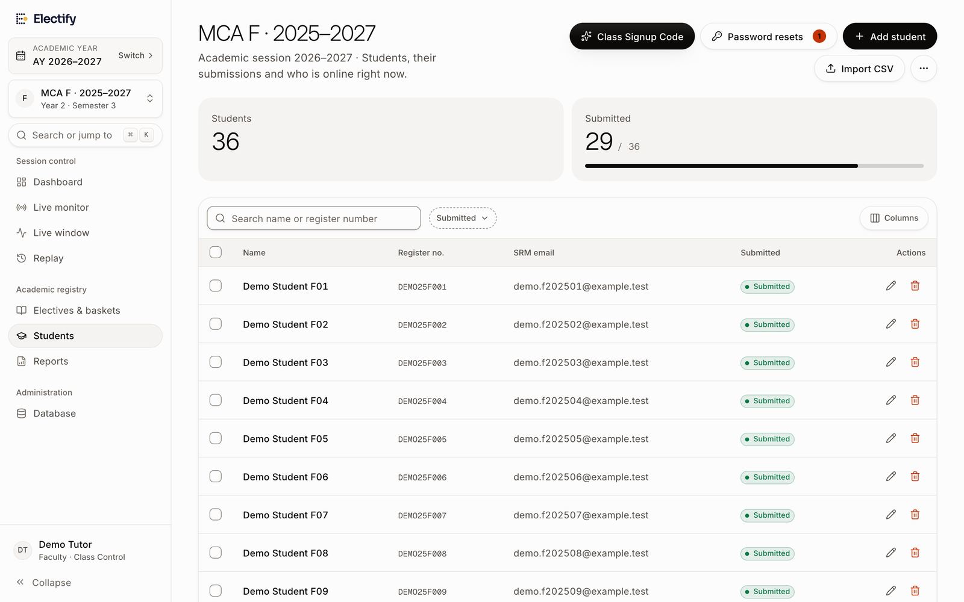
Figure 11.1 Class Page with the Student Roster and Class Tools
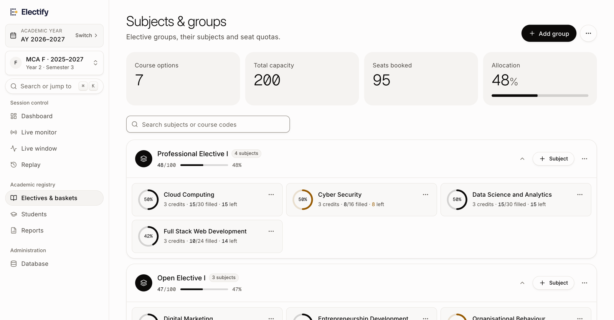
Figure 11.2 Subjects and Groups Page with Seat Counts per Subject

11.3 Automated Test Results
Table 11.1 lists every server-side test in the reported run (2026-10-15 15:10:17 IST, commit bfd9bd8), grouped by suite, with its recorded result. Table 11.2 lists the browser tests from the run on the same day.
Table 11.1 Complete List of Server-Side Tests and Results
No. | Suite | Test | Result
1 | Academic sessions and cohort-isolated registration | 1. One tutor account manages both MCA F cohorts, each with its full identity | Passed
2 | Academic sessions and cohort-isolated registration | 2. The selected academic session filters the workspace | Passed
3 | Academic sessions and cohort-isolated registration | 3. Same-named classes stay distinct; a class from another session cannot be made active | Passed
4 | Academic sessions and cohort-isolated registration | 4. The two cohorts have their own offerings, capacities, semesters and windows | Passed
5 | Academic sessions and cohort-isolated registration | 5. Simultaneous events route each student only to their own class | Passed
6 | Academic sessions and cohort-isolated registration | 6. A student cannot see or register for another cohort's event | Passed
7 | Academic sessions and cohort-isolated registration | 7. Crafted requests cannot bypass class targeting or mix offerings | Passed
8 | Academic sessions and cohort-isolated registration | 8. Seat counts of the same subject in two cohorts are independent | Passed
9 | Academic sessions and cohort-isolated registration | 9. Concurrent registration never exceeds capacity | Passed
10 | Academic sessions and cohort-isolated registration | 10. Receipts and reports carry the full cohort and session identity | Passed
11 | Academic sessions and cohort-isolated registration | 11. Cancelling returns the seat and keeps the audit trail | Passed
12 | Academic sessions and cohort-isolated registration | 12. A signup code never moves an existing student to another cohort | Passed
13 | Academic sessions and cohort-isolated registration | 13. Staff cannot reach classes, sessions, events, students or reports outside their scope | Passed
14 | Academic sessions and cohort-isolated registration | 14. Event creation is limited to classes managed in the selected session | Passed
15 | Academic sessions and cohort-isolated registration | 15. The waitlist does not come back | Passed
16 | Migration 0006: academic sessions and cohort targeting | maps only what it can map confidently | Passed
17 | Migration 0006: academic sessions and cohort targeting | event targeting is consistent and contradictions are archived, not lost | Passed
18 | Migration 0006: academic sessions and cohort targeting | inconsistent existing rows are flagged (NOT VALID), and records are untouched | Passed
19 | Migration 0006: academic sessions and cohort targeting | is idempotent | Passed
20 | Migration 0006: academic sessions and cohort targeting | rollback restores the previous structure and the archived targeting | Passed
21 | Class-Based Student Self-Onboarding and Password Security | 1. generateClassSignupCode produces EF-[PROG]-[SEC]-[RAND4] format | Passed
22 | Class-Based Student Self-Onboarding and Password Security | 2. Class tutor creates a signup code for their section with max 100 limit | Passed
23 | Class-Based Student Self-Onboarding and Password Security | 3. validateClassSignupCode returns safe, read-only class metadata | Passed
24 | Class-Based Student Self-Onboarding and Password Security | 4. Student signup enforces @srmist.edu.in email domain and the password policy | Passed
25 | Class-Based Student Self-Onboarding and Password Security | 5. Successful student onboarding securely hashes the password and assigns class server-side | Passed
26 | Class-Based Student Self-Onboarding and Password Security | 6. Deduplication: Reusing code with an already-enrolled registration number or email is rejected | Passed
27 | Class-Based Student Self-Onboarding and Password Security | 7. Student login: register number and password only | Passed
28 | Class-Based Student Self-Onboarding and Password Security | 8. Rate limiting: Repeated wrong passwords trigger temporary account lockout | Passed
29 | Class-Based Student Self-Onboarding and Password Security | 9. Hard server-side limit of activations: Reject enrollment once limit is reached | Passed
30 | Class-Based Student Self-Onboarding and Password Security | 10. Tutor-authorized password reset: Request -> Tutor Authorization -> New Password | Passed
31 | Class-Based Student Self-Onboarding and Password Security | 11. Tutor can revoke class signup code | Passed
32 | Class-Based Student Self-Onboarding and Password Security | 12. A legacy 6-digit PIN signs in only to choose a new password | Passed
33 | Class-Based Student Self-Onboarding and Password Security | 13. Tutor-created accounts (register number as password) must also choose a password | Passed
34 | Class-Based Student Self-Onboarding and Password Security | 14. A tutor cannot see, authorize or reject resets for another section | Passed
35 | Class-Based Student Self-Onboarding and Password Security | 15. Guessing reset codes locks the reset form | Passed
36 | Event Management: Delete Event & Reset Registrations | 1. Unauthorized users or students cannot reset or delete events | Passed
37 | Event Management: Delete Event & Reset Registrations | 2. Resetting an event clears registrations and restores seats without deleting the event | Passed
38 | Event Management: Delete Event & Reset Registrations | 3. Deleting an event permanently purges event, baskets, electives, allocations, and logs | Passed
39 | Live Event Registration Monitor & Surveillance Module | 1. Unauthorized users or students cannot access live monitoring data | Passed
40 | Live Event Registration Monitor & Surveillance Module | 2. Admin can retrieve monitor events and full live telemetry | Passed
41 | Live Event Registration Monitor & Surveillance Module | 3. Coordinator has access to programme live events and course saturation | Passed
42 | Live Event Registration Monitor & Surveillance Module | 4. Live feed updates polling returns fresh stream events and counts | Passed
43 | Live Event Registration Monitor & Surveillance Module | 5. Querying unregistered students identifies pending cohort members | Passed
44 | Live Event Registration Monitor & Surveillance Module | 6. Toggling event window status from monitor (Pause / Resume) | Passed
45 | Multi-Programme Class Tutor Assignments & Isolation | 1. One tutor can claim and manage multiple classes across different programmes (MCA F and MSc IT F) | Passed
46 | Multi-Programme Class Tutor Assignments & Isolation | 2. One tutor can manage classes from different admission batches (2025 and 2026) | Passed
47 | Multi-Programme Class Tutor Assignments & Isolation | 3. Search and discovery (getAllAvailableSections) returns all programmes in authorized department with clear statuses | Passed
48 | Multi-Programme Class Tutor Assignments & Isolation | 4. Server rejects claiming classes outside tutor's authorized department | Passed
49 | Multi-Programme Class Tutor Assignments & Isolation | 5. Server enforces configurable max tutor sections limit | Passed
50 | Multi-Programme Class Tutor Assignments & Isolation | 6. Year Server navigation presents only authorized classes active in that Year Server | Passed
51 | Multi-Programme Class Tutor Assignments & Isolation | 7. Class switching updates active section and strictly isolates student rosters | Passed
52 | Multi-Programme Class Tutor Assignments & Isolation | 8. Signup codes are bound strictly to intended class and prevent cross-class enrollment | Passed
53 | Multi-Programme Class Tutor Assignments & Isolation | 9. A tutor cannot access an unassigned section even in the same department | Passed
54 | Multi-Programme Class Tutor Assignments & Isolation | 10. Exiting a class safely removes assignment and keeps underlying students intact | Passed
55 | Student password policy | Accepts a reasonable password | Passed
56 | Student password policy | Rejects legacy PINs, short, letter-only and number-only passwords | Passed
57 | Student password policy | Rejects the register number and handed-out defaults | Passed
58 | Student password policy | Rejects passwords bcrypt would truncate | Passed
59 | Student password policy | Checklist reports each rule | Passed
60 | Student password policy | Register numbers are normalised and must be letters and digits | Passed
61 | Receipt term (QA: receipts for odd semesters were numbered EVEN) | semester decides the term | Passed
62 | Receipt term (QA: receipts for odd semesters were numbered EVEN) | events without a semester keep the old name-based fallback | Passed
63 | Staff window phase follows the student window rule (QA: no Pause for an open published event) | published with the opening time passed is live | Passed
64 | Staff window phase follows the student window rule (QA: no Pause for an open published event) | published before the opening time is scheduled | Passed
65 | Staff window phase follows the student window rule (QA: no Pause for an open published event) | deadline passed with auto-close is closed, even if the status says OPEN | Passed
66 | Staff window phase follows the student window rule (QA: no Pause for an open published event) | paused, and the other closed statuses, are reported as such | Passed
67 | Registration changes, cancellations and capacity (no waitlist) | 1. Changing to an elective with seats moves the seat in one step | Passed
68 | Registration changes, cancellations and capacity (no waitlist) | 2. Changing to a full elective is rejected and the current seat is kept | Passed
69 | Registration changes, cancellations and capacity (no waitlist) | 3. Registering for a full elective is rejected with SEAT_TAKEN and creates nothing | Passed
70 | Registration changes, cancellations and capacity (no waitlist) | 4. Cancelling a confirmed elective releases the seat and keeps the record | Passed
71 | Registration changes, cancellations and capacity (no waitlist) | 5. Cancelling the entire registration releases every seat | Passed
72 | Registration changes, cancellations and capacity (no waitlist) | 6. Modifications after the deadline are rejected and change nothing | Passed
73 | Registration changes, cancellations and capacity (no waitlist) | 7. A student cannot cancel another student's registration | Passed
74 | Registration changes, cancellations and capacity (no waitlist) | 8. Concurrent registrations for the last seat: exactly one succeeds | Passed
75 | Registration changes, cancellations and capacity (no waitlist) | 9. Concurrent changes into the last seat: exactly one succeeds | Passed
76 | Registration changes, cancellations and capacity (no waitlist) | 10. Retrying a cancellation does not release the seat twice | Passed
77 | Registration changes, cancellations and capacity (no waitlist) | 11. A failed multi-group registration rolls back completely | Passed
78 | Registration changes, cancellations and capacity (no waitlist) | 12. Receipts, replay events and audit stay consistent and waitlist-free | Passed
79 | Registration changes, cancellations and capacity (no waitlist) | 13. Simultaneous confirmations never share a receipt number | Passed
80 | Migration 0004: remove waitlist | applies, archives history and converts legacy waitlist rows | Passed
81 | Migration 0004: remove waitlist | is idempotent | Passed
82 | Migration 0004: remove waitlist | rollback restores the pre-migration state from the archive | Passed
83 | Role-Based Unique Invite Codes | 1. generateRoleBasedCode produces role-specific prefixes | Passed
84 | Role-Based Unique Invite Codes | 2. Admin can create unique role-based invite codes for Faculty, Coordinator, and Admin | Passed
85 | Role-Based Unique Invite Codes | 3. Custom invite code creation with uniqueness validation | Passed
86 | Role-Based Unique Invite Codes | 4. Admin can revoke and permanently delete invite codes | Passed
87 | Subject explorer and preview mode | 1. Students can browse the catalogue before registration opens | Passed
88 | Subject explorer and preview mode | 2. Preview shows real capacity, including section quotas and full subjects | Passed
89 | Subject explorer and preview mode | 3. Opening subject pages never reserves a seat | Passed
90 | Subject explorer and preview mode | 4. Submitting before the window opens is rejected by the server | Passed
91 | Subject explorer and preview mode | 5. Registration works once the opening time has passed | Passed
92 | Subject explorer and preview mode | 6. Late and paused submissions are rejected; confirmed records are kept | Passed
93 | Subject explorer and preview mode | 7. Ineligible students, other batches' events and foreign electives are rejected | Passed
94 | Subject explorer and preview mode | 8. The catalogue never exposes another batch's subjects or unknown ids | Passed
95 | Subject explorer and preview mode | 9. Only published profiles for the student's programme are shown | Passed
96 | Subject explorer and preview mode | 10. Subject profile management is limited to admins and own-programme coordinators | Passed
97 | Subject explorer and preview mode | 11. Monitor feed and unregistered list are staff-only | Passed
98 | Subject content validation | Unsafe or malformed resource links are dropped, valid sections survive | Passed
99 | Subject content validation | Garbage content renders as an empty guide instead of throwing | Passed
100 | Subject content validation | Bundled Cloud Computing guide makes no official claims | Passed
101 | Registration window rule | Opens exactly at openDate, not a millisecond earlier | Passed
102 | Registration window rule | Closes after closeDate when auto-close is on | Passed
103 | Registration window rule | Status overrides: paused, closed and manual open | Passed
104 | Registration window rule | Accepts ISO strings and ignores invalid dates | Passed
105 | Role-Based Event Template Deletion & Access Controls | 1. Unauthenticated user cannot delete templates | Passed
106 | Role-Based Event Template Deletion & Access Controls | 2. STUDENT cannot delete templates | Passed
107 | Role-Based Event Template Deletion & Access Controls | 3. CLASS_TUTOR cannot delete templates | Passed
108 | Role-Based Event Template Deletion & Access Controls | 4. COURSE_COORDINATOR cannot delete a template belonging to another programme and created by someone else | Passed
109 | Role-Based Event Template Deletion & Access Controls | 5. COURSE_COORDINATOR can delete a template belonging to their assigned programme even if created by Admin | Passed
110 | Role-Based Event Template Deletion & Access Controls | 6. COURSE_COORDINATOR can delete a template created by themselves even if assigned to a different programme | Passed
111 | Role-Based Event Template Deletion & Access Controls | 7. SYSTEM_ADMIN has universal permission to delete any template across any programme | Passed
112 | Role-Based Event Template Deletion & Access Controls | 8. getTemplatesWithDetails populates canDelete flag accurately per role | Passed
113 | Year Server Selection Flow & Complete Workspace Isolation | 1. Staff member sees the authorized Year Server selection page after login (no cookie -> SELECT) | Passed
114 | Year Server Selection Flow & Complete Workspace Isolation | 2. All eligible Year Servers are loaded from the database for the staff member's scope | Passed
115 | Year Server Selection Flow & Complete Workspace Isolation | 3. Adding a new Year Server does not require hardcoded UI changes and is dynamically available | Passed
116 | Year Server Selection Flow & Complete Workspace Isolation | 4. Selecting 2026 sets the workspace context to 2026 | Passed
117 | Year Server Selection Flow & Complete Workspace Isolation | 5. Selecting 2025 sets the workspace context to 2025 | Passed
118 | Year Server Selection Flow & Complete Workspace Isolation | 6. Data from one Year Server does not appear in another | Passed
119 | Year Server Selection Flow & Complete Workspace Isolation | 7. A tutor can manage multiple authorized classes within a server | Passed
120 | Year Server Selection Flow & Complete Workspace Isolation | 8. A tutor cannot access a server or class they are not authorized to manage | Passed
121 | Year Server Selection Flow & Complete Workspace Isolation | 9. Refreshing the selection page works and maintains session state | Passed
122 | Year Server Selection Flow & Complete Workspace Isolation | 10. Refreshing a workspace page preserves the correct server context | Passed
123 | Year Server Selection Flow & Complete Workspace Isolation | 11. Direct URL navigation cannot bypass server-side authorization | Passed
124 | Year Server Selection Flow & Complete Workspace Isolation | 12. Switching servers updates class context cleanly | Passed
125 | Year Server Selection Flow & Complete Workspace Isolation | 13. Students remain associated with the correct Year Server through signup code | Passed
126 | Year Server Selection Flow & Complete Workspace Isolation | 14. Archived-server restrictions remain enforced | Passed
127 | Year Server Selection Flow & Complete Workspace Isolation | 15. listClassesForScope sorts and isolates cohort data strictly per server | Passed
128 | Year Servers System — Simplified Annual Workspaces | 1. Year Servers overview returns simple cards with programme, class, student, and event counts | Passed
129 | Year Servers System — Simplified Annual Workspaces | 2. Admin can create a new Year Server with status PLANNED or ACTIVE | Passed
130 | Year Servers System — Simplified Annual Workspaces | 3. Staff can enter a Year Server workspace and view its programmes and classes | Passed
131 | Year Servers System — Simplified Annual Workspaces | 4. One tutor account can manage classes in multiple Year Servers with scoped access | Passed
132 | Year Servers System — Simplified Annual Workspaces | 5. Historical data review report tracks unlinked events and enables administrator linking | Passed
133 | Year Servers System — Simplified Annual Workspaces | 6. getYearServerDeleteImpact calculates accurate impact metrics | Passed
134 | Year Servers System — Simplified Annual Workspaces | 7. deleteYearServer deletes a Year Server and unlinks attached events without data loss | Passed
135 | Year Servers System — Simplified Annual Workspaces | 8. Non-administrators cannot delete a Year Server | Passed
136 | Year Servers System — Simplified Annual Workspaces | 9. deleteEmptyYearServers safely prunes empty test servers | Passed

Table 11.2 Complete List of Browser End-to-End Tests and Results
No. | File | Test | Result
1 | accessibility.spec.ts | public pages | Passed
2 | accessibility.spec.ts | student pages | Passed
3 | accessibility.spec.ts | staff pages | Passed
4 | freshness.spec.ts | picker shows updated seat counts after a background refresh, without a reload | Passed
5 | mobile-layout.spec.ts | public pages | Passed
6 | mobile-layout.spec.ts | student pages | Passed
7 | mobile-layout.spec.ts | student countdown | Passed
8 | mobile-layout.spec.ts | tutor pages | Passed
9 | mobile-layout.spec.ts | coordinator and admin pages | Passed
10 | navigation-a11y.spec.ts | phone: bottom bar and More sheet | Passed
11 | navigation-a11y.spec.ts | tablet: navigation drawer | Passed
12 | route-reload.spec.ts | Unauthenticated access › /dashboard redirects to sign-in without exposing content | Passed
13 | route-reload.spec.ts | Unauthenticated access › /dashboard/subjects redirects to sign-in without exposing content | Passed
14 | route-reload.spec.ts | Unauthenticated access › /dashboard/electives redirects to sign-in without exposing content | Passed
15 | route-reload.spec.ts | Unauthenticated access › /dashboard/my-registration redirects to sign-in without exposing content | Passed
16 | route-reload.spec.ts | Unauthenticated access › /faculty/dashboard redirects to sign-in without exposing content | Passed
17 | route-reload.spec.ts | Unauthenticated access › /faculty/reports redirects to sign-in without exposing content | Passed
18 | route-reload.spec.ts | Unauthenticated access › /faculty/users redirects to sign-in without exposing content | Passed
19 | route-reload.spec.ts | Unauthenticated access › /faculty/section redirects to sign-in without exposing content | Passed
20 | route-reload.spec.ts | Unauthenticated access › public pages load and survive reload | Passed
21 | route-reload.spec.ts | Student routes › open-event student: every page loads and reloads cleanly | Passed
22 | route-reload.spec.ts | Student routes › upcoming-event student: countdown page loads and reloads cleanly | Passed
23 | route-reload.spec.ts | Staff routes › class tutor pages | Passed
24 | route-reload.spec.ts | Staff routes › course coordinator pages | Passed
25 | route-reload.spec.ts | Staff routes › administrator pages | Passed
26 | session.spec.ts | signing out and pressing Back never shows the protected page again | Passed
27 | session.spec.ts | a tampered session cookie is treated as signed out | Passed
28 | session.spec.ts | signing in elsewhere ends the earlier session on reload | Passed
29 | session.spec.ts | a deactivated account loses access on the next page load | Passed
30 | session.spec.ts | double-clicking confirm creates exactly one registration | Passed
31 | session.spec.ts | sign-ins record the request address, not a placeholder, in the audit log | Passed
32 | staff-isolation.spec.ts | tutor workspace: Year Server and class survive reloads and switching | Passed
33 | staff-isolation.spec.ts | tutor configuration change (pause window) persists after reload and reaches students | Passed
34 | staff-isolation.spec.ts | students only see their own class's event and seat counters stay separate | Passed
35 | staff-isolation.spec.ts | a tutor cannot open another class's replay by URL | Passed
36 | student-workflow.spec.ts | student registers, reloads, changes and cancels with consistent seats | Passed

11.4 Demonstration Data Used for Screenshots
All screenshots in this report were taken on 15 October 2026 from an isolated development server running the code described in this report, separate from the team's own server and connected to a local database created for the purpose. The data was created specifically for the walkthrough and is entirely fictional: no real student, staff member, register number, e-mail address or password appears in any screenshot. E-mail addresses use the reserved domain example.test, and register numbers begin with DEMO. The institutional names (faculty, department and programme) were used only to make the screens recognisable. Registrations in the demonstration data were created through the application's own registration action, so seat counts, receipts and logs are those produced by the application. The development-mode indicator that Next.js overlays on pages was hidden in the captures; it is not part of the application's interface. Live updates were not configured for the captures, so that the copy would not connect to the team's hosted project. The demonstration data is summarised in Table 11.3.
Table 11.3 Fictional Demonstration Data
Item | Contents
Staff accounts | Demo Administrator, Demo Coordinator (MCA), Demo Tutor (tutor of MCA F 2025–2027 and MCA F 2026–2028)
Year Servers | 2025 (active), 2026 (active), 2027 (planned)
Cohorts and classes | MCA 2025–2027: classes F and G; MCA 2026–2028: class F; BCA 2026–2029: class A
Students | 36 in MCA F 2025, 30 in MCA G 2025, 12 in MCA F 2026; names of the form “Demo Student F01”
Events | Semester 3 Elective Registration (MCA 2025, classes F and G, open); Semester 1 Value-Added Course Registration (MCA F 2026, opening in the future)
Subjects | Professional Elective I: Cloud Computing, Data Science and Analytics, Cyber Security (8-seat quotas for F and G), Full Stack Web Development; Open Elective I: Digital Marketing, Entrepreneurship Development, Organisational Behaviour
Activity | 47 registrations created through the registration action, including one change and one cancellation, plus one registration completed through the student interface

11.5 Glossary
Table 11.4 Glossary of Terms
Term | Meaning in this report
Cohort (academic batch) | Students of one programme admitted in the same year, for example MCA 2025–2027.
Class (section) | A section of a cohort, for example MCA F of the 2025–2027 cohort.
Year Server | The workspace for one academic year (an academic session), containing the cohorts studying in that year.
Registration event | One registration exercise for one cohort, with its baskets, subjects and window.
Basket (elective group) | A group of subjects from which a student chooses, such as Professional Elective I.
Class quota | Seats of a subject reserved for students of a particular class.
Server Action | A server-side function in Next.js that is called directly from the user interface.
Row lock | A database lock on a row (SELECT … FOR UPDATE) that makes other transactions wait until it is released.
Advisory lock | An application-defined PostgreSQL lock, used here to serialise receipt numbering.
Receipt snapshot | A JSON copy of the confirmed registration stored at the time of confirmation.

